**Chadani Shrestha**

[**cshrestha1@stcloudstate.edu**](mailto:cshrestha1@stcloudstate.edu)

**13159448**

**REPORT**

From this project, I learned how to use inbuilt method to set the imageBox Visible and Invisible. In the second question, I learned how to use “using system IO,” stream, input file. Also, I learned how to use the try catch method. I learned how to convert cups into ounces in the third question using console application. Even though, I had tough time doing Q. 4, I gave my best and tried to output using some of the tricks I learned in Mathematics.

**CARDS:**

**C# Programming:**

public Form1()

{

InitializeComponent();

}

private void showCardButton_Click(object sender, EventArgs e)

{

if (cardListBox.SelectedIndex != -1)

{

Showcard(cardListBox.SelectedItem.ToString());

}

else

{

MessageBox.Show("Select a card from the list to proceed.");

}

}

private void Showcard(string card)

{

switch (card)

{

case "Ace of Spades":

AceSpades();

break;

case "10 of Hearts":

TenHearts();

break;

case "King of Clubs":

KingClubs();

break;

case "King of Spades":

KingSpades();

break;

}

}

private void AceSpades()

{

aceSpadesPictureBox.Visible = true;

tenHeartsPictureBox.Visible = false;

queenHeartspictureBox.Visible = false;

}

private void TenHearts()

{

aceSpadesPictureBox.Visible = false;

tenHeartsPictureBox.Visible = true;

kingClubsPictureBox.Visible = false;

queenHeartspictureBox.Visible = false;

}

private void KingClubs()

{

aceSpadesPictureBox.Visible = false;

tenHeartsPictureBox.Visible = false;

kingClubsPictureBox.Visible = true;

queenHeartspictureBox.Visible = false;

}

private void KingSpades()

{

aceSpadesPictureBox.Visible = false;

tenHeartsPictureBox.Visible = false;

kingClubsPictureBox.Visible = false;

queenHeartspictureBox.Visible = true;

}

private void exitButton_Click(object sender, EventArgs e)

{

this.Close();

}

**RUNTIME SAMPLE:A screenshot of a computer

Description generated with very high confidenceA screenshot of a computer

Description generated with very high confidence**

**NORTH AMERICA:**

**C# Programming:**

namespace North_America

{

public partial class Form1 : Form

{

public Form1()

{

InitializeComponent();

}

private void getCountriesButton_Click(object sender, EventArgs e)

{

try

{

string countryName;

StreamReader inputFile;

inputFile = File.OpenText("NorthAmerica.txt");

countriesListBox.Items.Clear();

while (!inputFile.EndOfStream)

{

countryName = inputFile.ReadLine();

countriesListBox.Items.Add(countryName);

}

inputFile.Close();

}

catch (Exception ex)

{

MessageBox.Show(ex.Message);

}

}

private void exitButton_Click(object sender, EventArgs e)

{

this.Close();

}

}

}

**RUNTIME SAMPLE:**

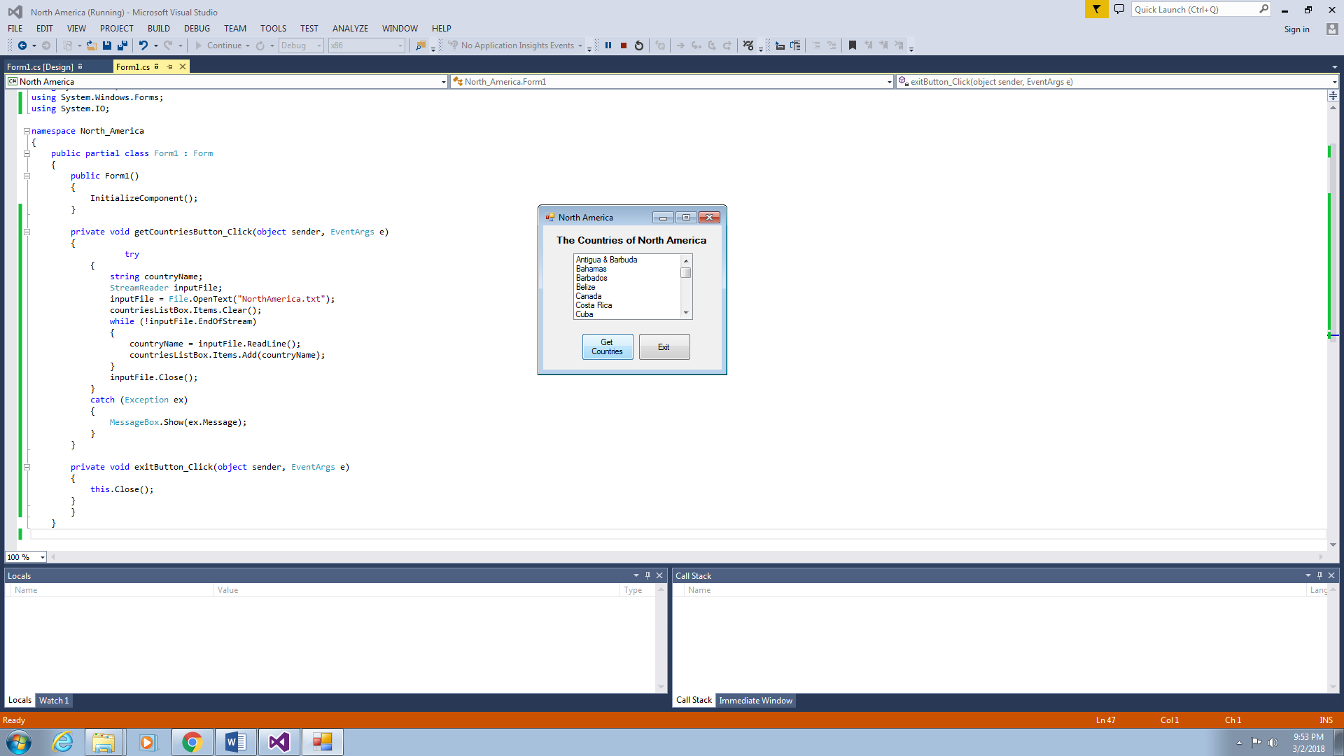

**CUP TO OUNCES:**

**C# Programming:**

public Form1()

{

InitializeComponent();

}

private void convertButton_Click(object sender, EventArgs e)

{

double ounce = double.Parse(cupsTextBox.Text) * 8;

ouncesLabel.Text = ounce.ToString();

} }

}

**RUNTIME SAMPLE:**A screenshot of a computer

Description generated with very high confidence

A screenshot of a computer

Description generated with very high confidence

**STUDENT PROFILE:**

**C# PROGRAMMING:**

class Program

{

public static String FirstName, LastName, DateofBirth, City, State;

public static double ExamScore;

static void Main(string[] args)

{

Console.WriteLine("Hi, Please fill in the following Info. ");

Console.Write("\nStudent's First Name: ");

FirstName = Console.ReadLine();

Console.Write("\nStudent's Last Name: ");

LastName = Console.ReadLine();

Console.Write("\nStudent's Date of Birth(yy/mm/dd): ");

DateofBirth = Console.ReadLine();

Console.Write("\nStudent's City: ");

City = Console.ReadLine();

Console.Write("\nStudent's State: ");

State = Console.ReadLine();

Console.Write("\nStudent's Exam Score(100): ");

ExamScore = double.Parse(Console.ReadLine());

//Displaying User Info

DisplayUser();

//Calculate the Age of the user from his Date of Birth

int age = CalculateAge(DateofBirth);

GradeCalculator(LastName, ExamScore);

Console.Write("\n\nPress any key to Exit. ");

Console.ReadKey();

Environment.Exit(0);

}

static void DisplayUser()

{

Console.WriteLine("\n\nStudent Information: ");

Console.WriteLine("Student Name: " + FirstName + LastName);

Console.WriteLine("Student City: " + City);

Console.WriteLine("Student State: "+ State);

Console.WriteLine(CalculateAge(DateofBirth));

Console.WriteLine("Student Exam Score(100): " + ExamScore + "/100\n\n");

}

static int CalculateAge(string DOB)

{

int Age;

DateTime dob = Convert.ToDateTime(DOB);

Age = DateTime.Now.Year - dob.Year;

if (DateTime.Now.DayOfYear < dob.DayOfYear)

Age = Age - 1;

Console.Write("Student Age(Calculate Age Function): ");

return Age;

}

static void GradeCalculator(String lastName, double ExamScore)

{

Console.WriteLine("\nExam Score of " + lastName + " is: " + ExamScore + "/100. ");

}

**Runtime Sample:A screenshot of a computer

Description generated with very high confidenceA screenshot of a computer

Description generated with very high confidenceA screenshot of a computer

Description generated with very high confidence**