Steps to create a private blockchain network:
Create a folder called Blockchain (not in desktop)
In the folder create a genesis.json file (copy and paste)
Our private blockchain can be done on ethereum (can be done in ethereum only)
Install the following in sequence:
node.js (use current version and not LTS)
Geth (download for windows)
GitBash (for windows only) – for mac there is a terminal window already
Content of the genesis.json file
{
"coinbase" : "0x0000000000000000000000000000000000000001",
"difficulty" : "0x20000",
"extraData" : "",
"gasLimit" : "0x8000000",
"nonce" : "0x0000000000000042",
"mixhash" : "0x0000000000000000000000000000000000000000000000000000000000000000",
"parentHash" : "0x0000000000000000000000000000000000000000000000000000000000000000",
"timestamp" : "0x00",
"alloc": {},
"config": {
"chainId": 15,
"homesteadBlock": 0,
"eip155Block": 0,
"eip158Block": 0
}
}
To set an Ethereum environment we need Geth
Geth provides commands instead of programming languages like golang (need not write golang script)
Node.js is the server environment
genesis.json :
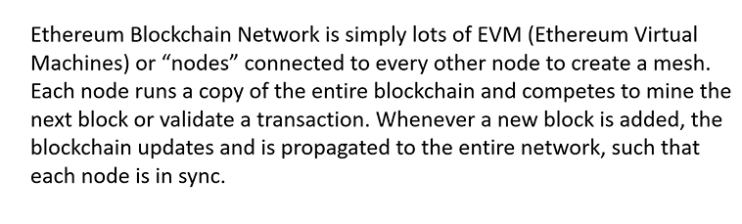
Each node is a EVM
Each node requires node.js, golang and Geth (Geth will replace golang)
The nodes forms a mesh
To test Geth is installed correctly do the following:
- link to download Geth
Open GitBash and Run as Administrator
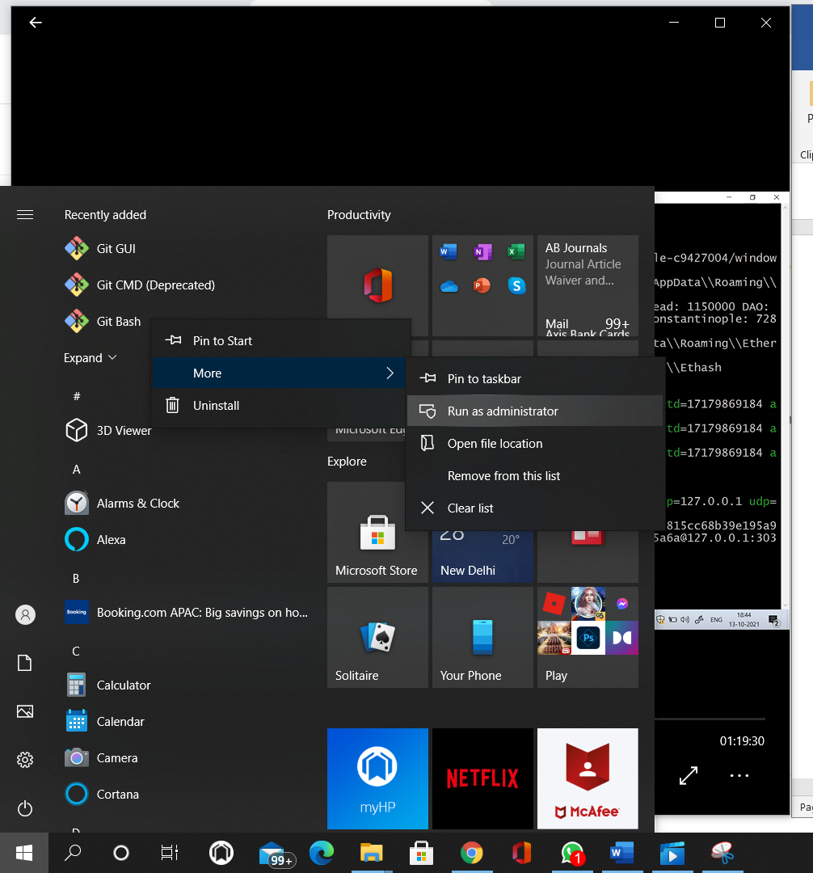

A command prompt opens:
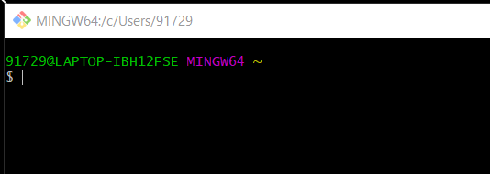

Type geth in $ prompt
$ geth
If we get as follows then Geth is installed correctly
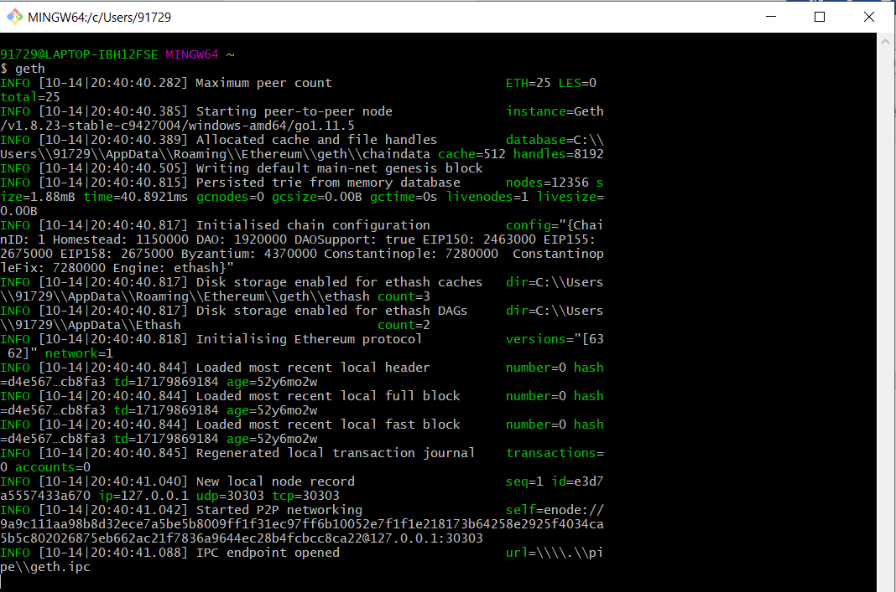
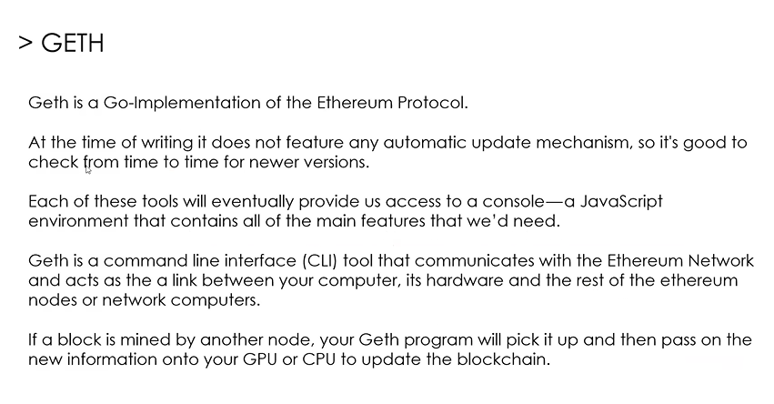
Geth is replacement for Golang
Say I want to do mining we need node.js or a javascript environment – Geth will eventually take us to a console window which is a javascript env where Geth commands needs to be written
To communicate to Ethereum network and start private network we need Geth commands
If a block is mined by another miner then, Geth will take that block and update it in our CPU or GPU as we are the part of Ethereum network (it will send the block to my address)
When geth command was executed we got the above screenshot
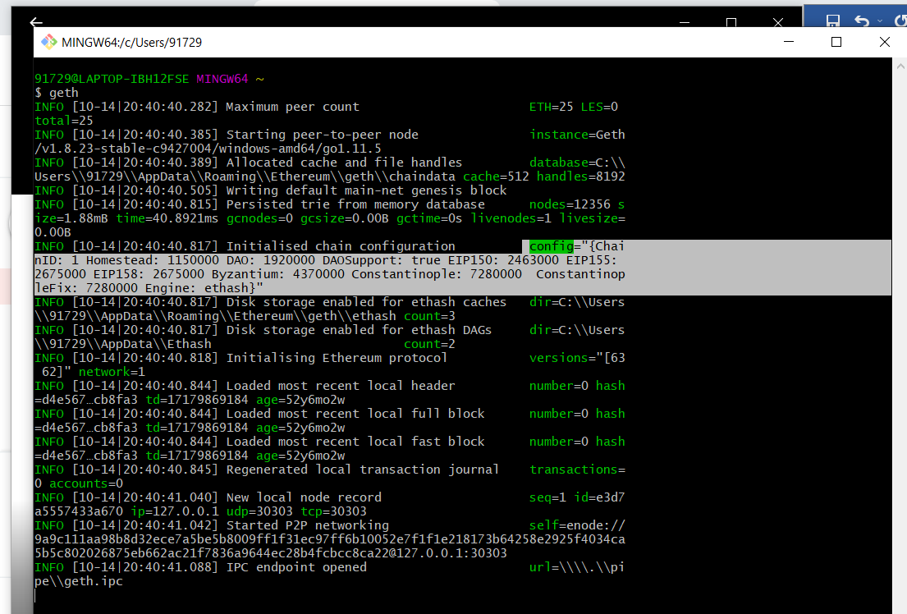
In this screenshot we see default config details for Ethereum network
To change the configuration to the ethereum private network we are going to create we use the genesis.json file
The genesis.json has our configuration in key-value pairs
Now close GitBash
In genesis
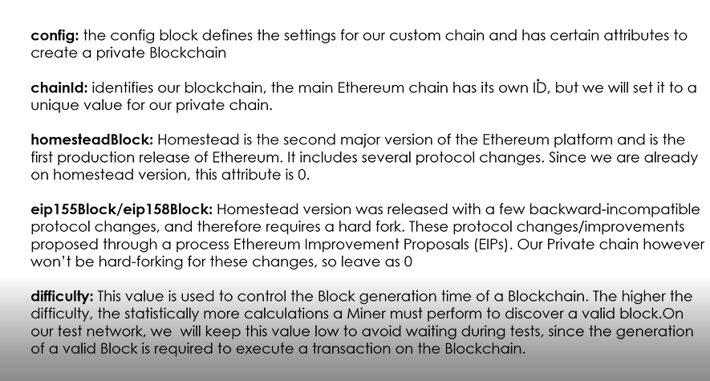
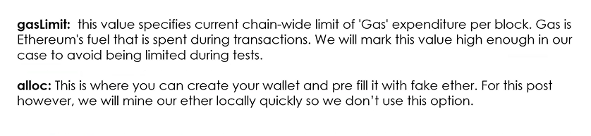

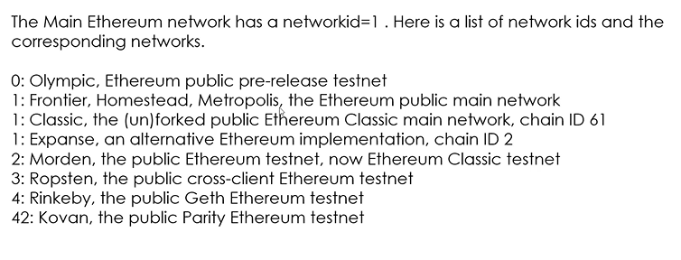

chainId:1 means it is main network (refre up)
so do not choose chainid as 1 - predefine
chainid 2,3,4,42 for testing – do not choose as predefined network id
homesteadblock is the second major version of Ethereum platform-this should be zero, this the version used by Geth so developers are using it
eip – Ethereum improvement proposals – this also zero
hardfork – in private block chain if Ethereum network version changes then all the blocks must follow or update only one version and only one chain of records
softfork – if a new ethereum version is updated in the private network then there will be two chains of blocks, one with older versions and another is new version
difficulty – difficulty in mining level can be configured, the more difficult the more will be reward
gas limit – expense the node has to pay for any transaction, replacement of real power, the fuel needed for mining, so miner will have some ether in his wallet, he spends it for mining as fuel is needed, this is the maximum gas limit, any block we create the price for it should not exceed the gas limit
timestamp – start of the timestamp (say current time)
nonce
coinbase: first hash of the first block
mixhash: parenthash and nonce
parenthash:
The above details are configured in genesis.json
Open GitBash again and change to working directory : C:/Blockchain where we have folder Blockchain with genesis.json
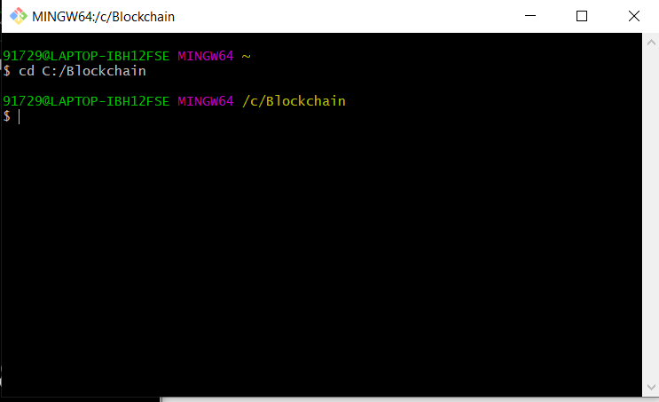

We need to create a chaindata directory and initialize the genesis.json
Chaindata directory will be like a database
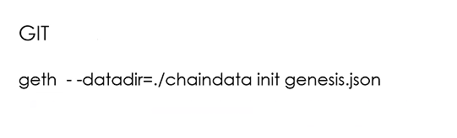
geth –datadir=./chaindata init genesis.json

When we run the above command see the following:
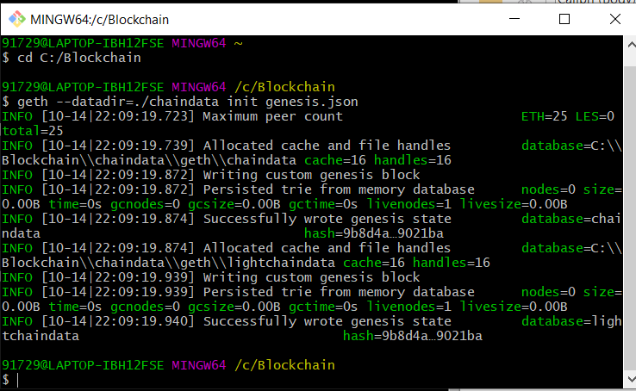
Check if the highlighted success message is there:
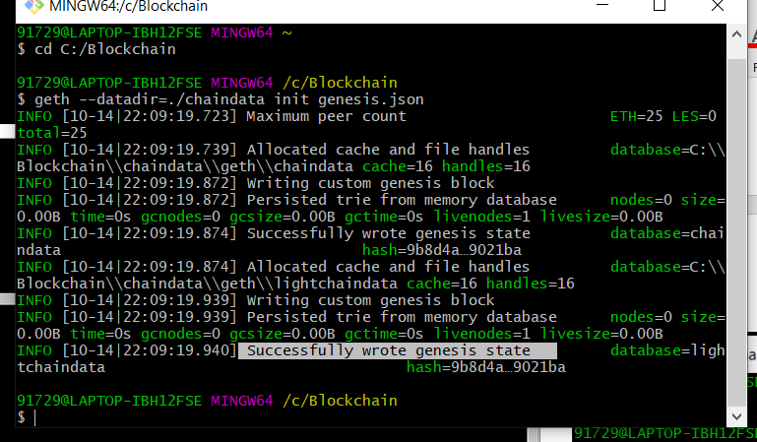

Chaindata is created in C:/Blockchain
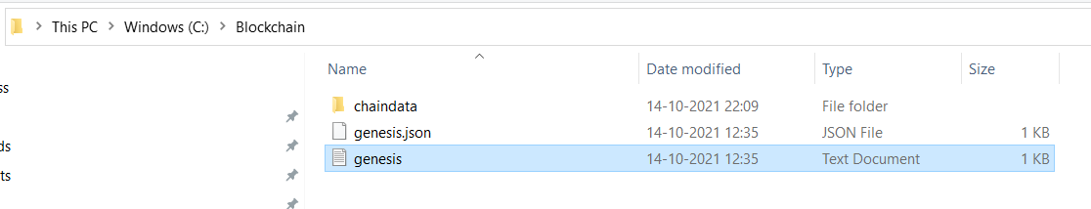

Chaindata will have initially the following two subfolders
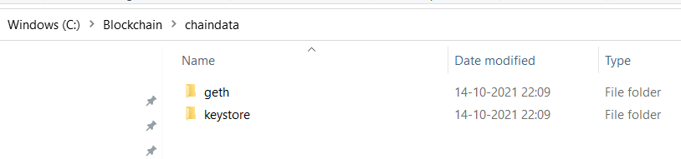
Initially keystore is empty
Chaindata is the database for private blockchain network
Keystore will have addresses of nodes

Now we need to run our network:
In GitBash give the following command
geth –datadir=./chaindata
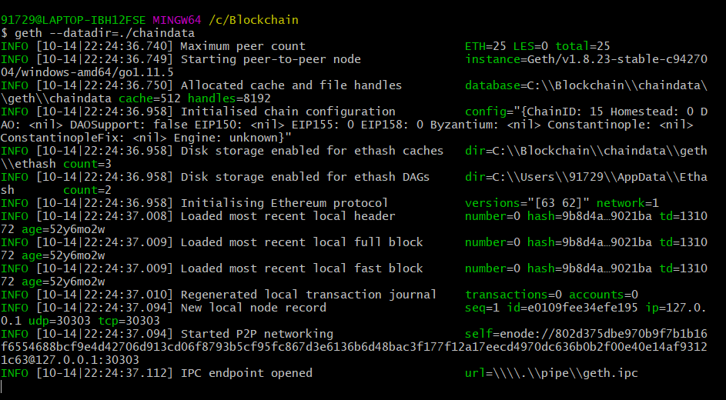
Look at the highlighted part we see the config in genesis.json is applied on the first block
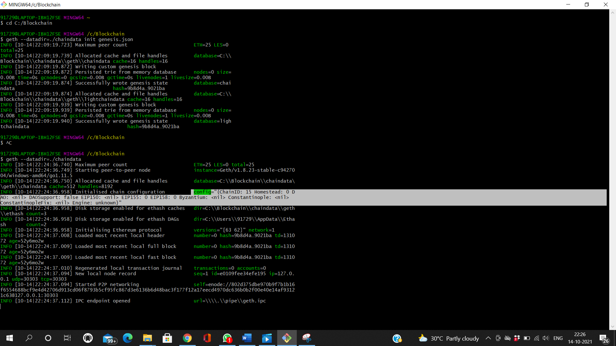
In the last line look at the url generated and copy it:
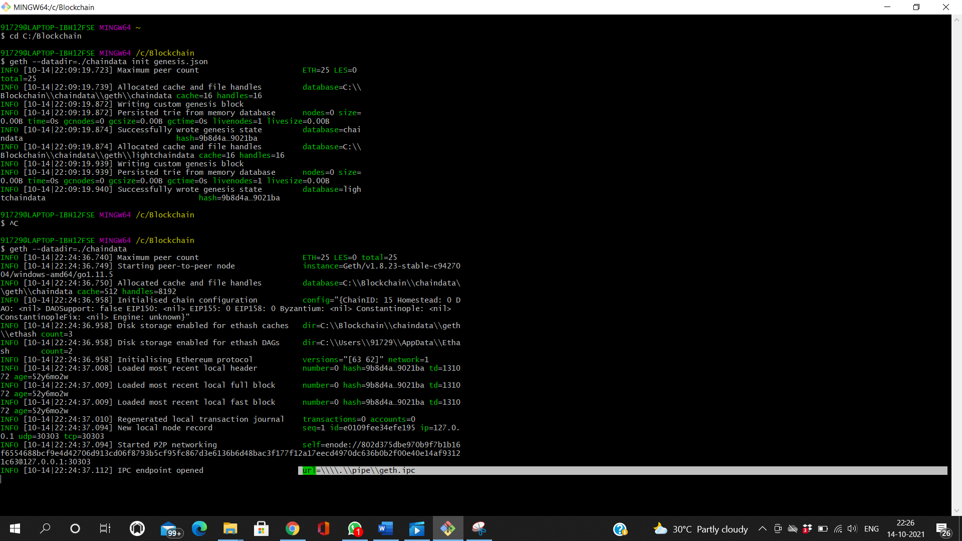

url=\\\\.\\pipe\\geth.ipc

to copy url don’t give ctrl C
the above url is the ip address of the private blockchain network that is running (local ip)
Now we need to create addresses
So create another GitBash terminal
Cd C:/Blockchain
geth –datadir ./datadir account new
then it will ask to enter a passphrase:
12345678
Repeat passphrase: 12345678
So an account with address will be created
Similarly create another addresses
With passphrase: 123456789
These 2 addresses are nothing but nodes
Ensure that 2 GitBash terminals are running
One in which the private blockchain server is running:
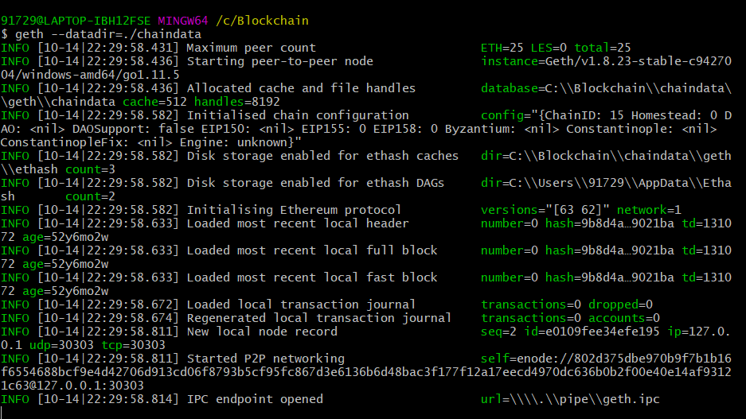
Another where we created 2 nodes or its addresses:
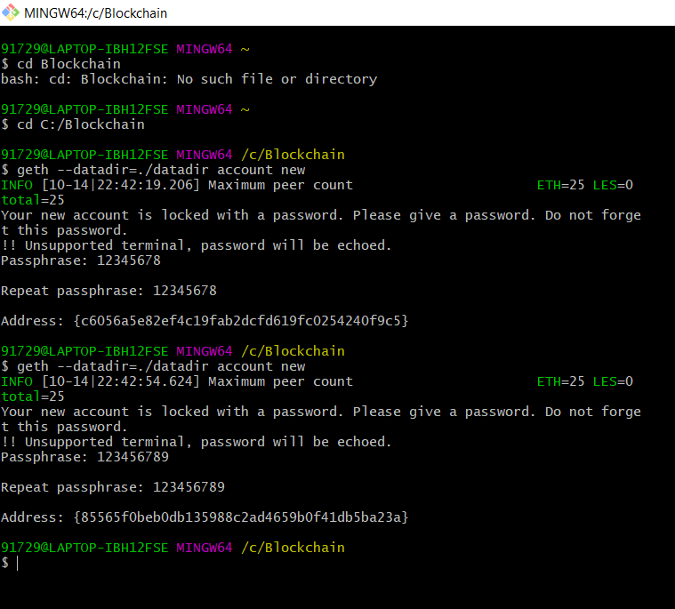

Now these 2 addresses are in c:/Blockchain/datadir
There will be 2 copies of the 2 addreses
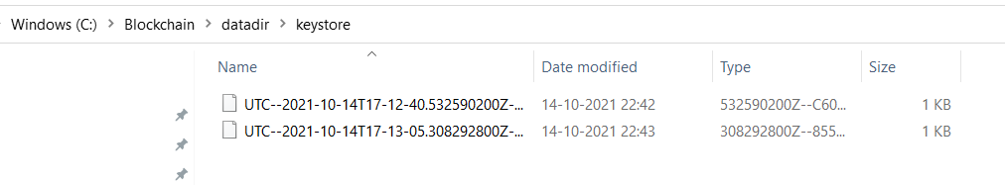
Copy the latest of the 2 addreses of the 2 nodes and paste in
C:/Blockchain/chaindata/keystore
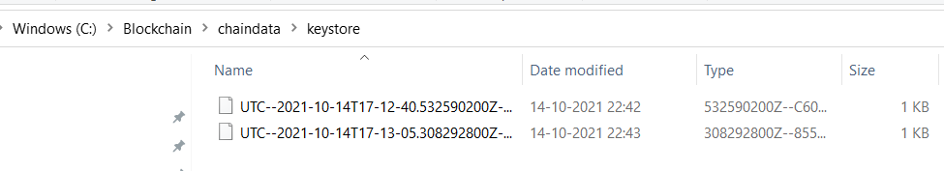

Start the network and we will get javascript console
In GitBash:
geth attach \\\\.\\pipe\\geth.ipc
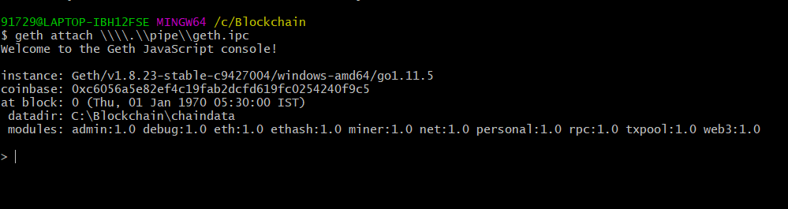
this will connect to javascript
Now check if Ethereum accounts are aready or nodes are ready
eth.accounts
the 2 node addresses created will be displayed

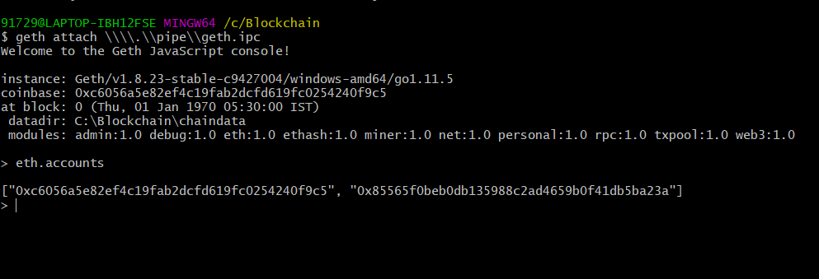
Note above the prompt in the same window changed from $ to >
Bcos now it is javascript

To start and stop mining
In the GitBash with javascript enabled give:
miner.start()
repeat the command till we get null
When we get null check the chaindata GitBash terminal or our private blockchain network we see mining going on
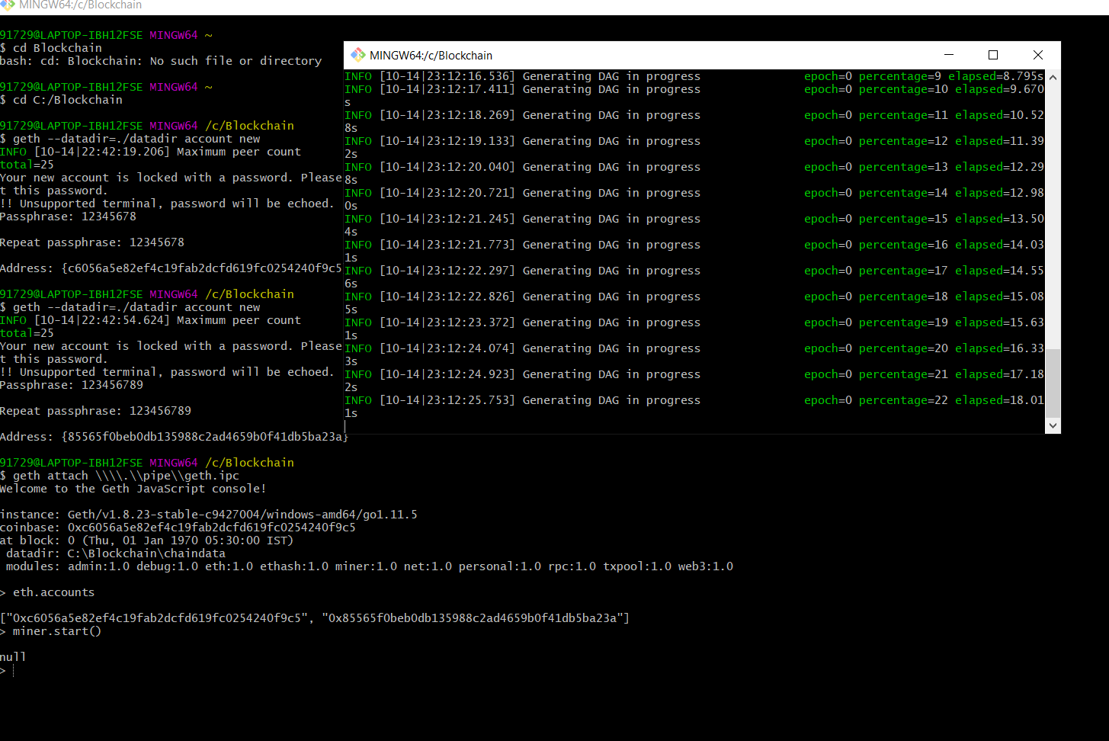

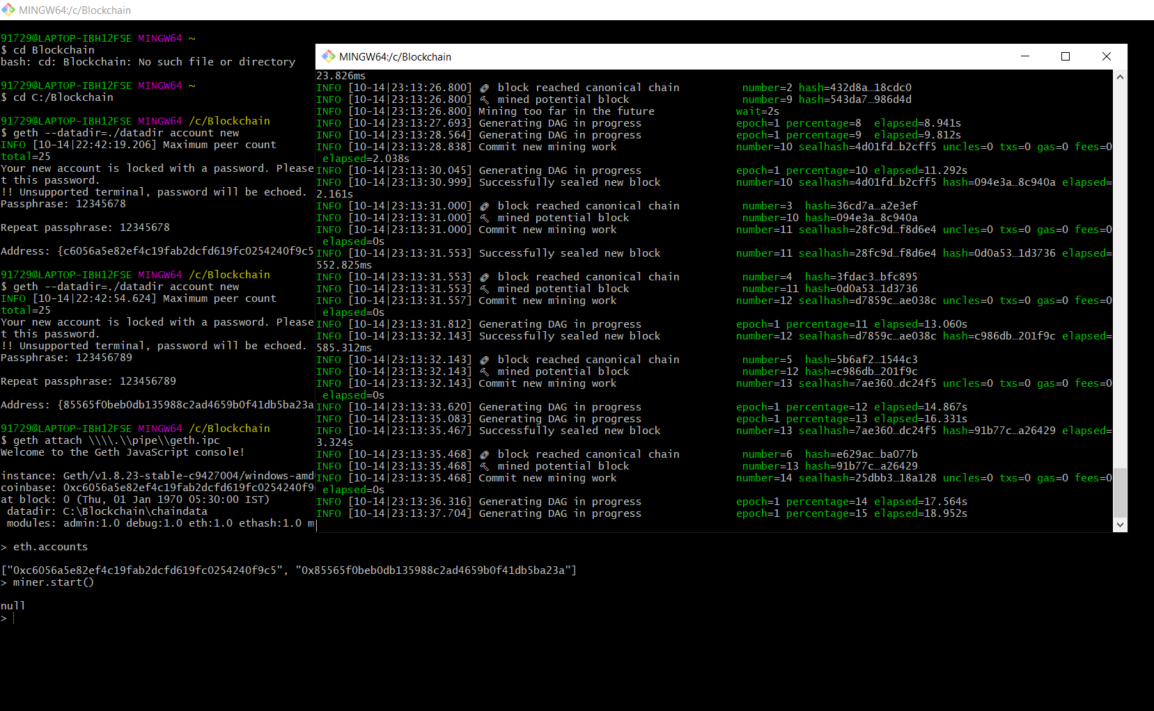

Now I give miner.stop() to stop mining
Notice mining has stopped:
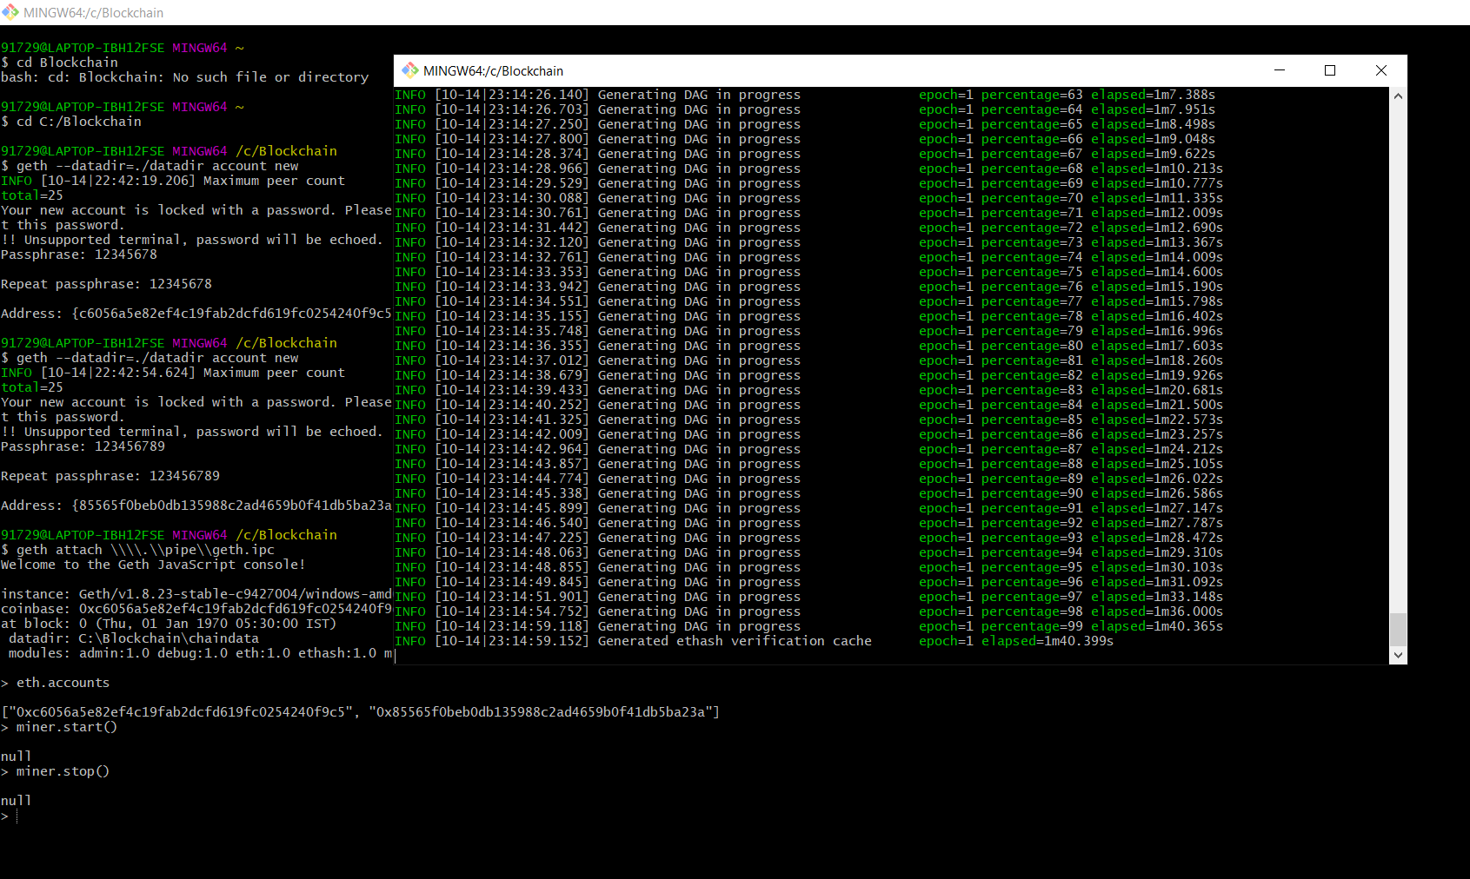

Otherway to do the same exercise we did today is as follows:

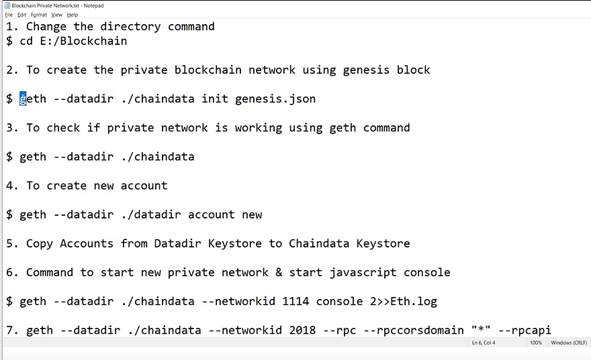
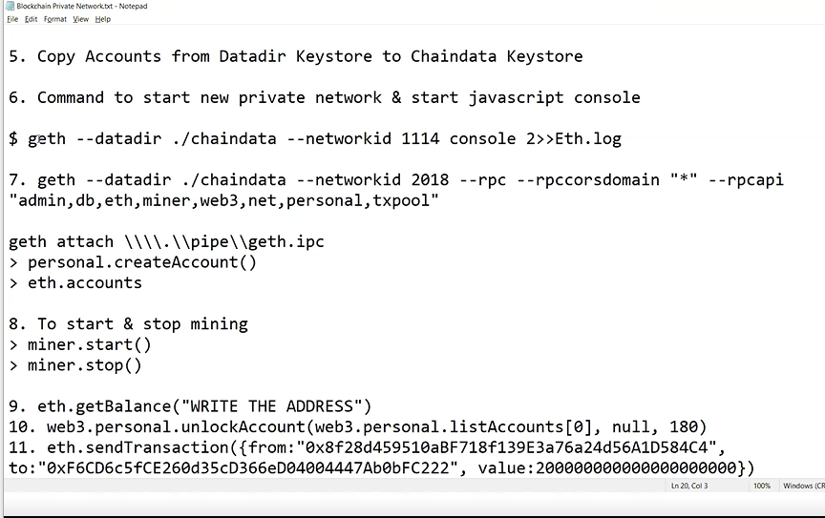

We try to connect to main network:
web3.personal.unlockAccount(web3.personal.listAccounts[0],null,180)
we open first account using its pass phrase: 12345678
here listAccouts[0] is the first account
but I had no balance in this account
but I try to send some value:200000000000 from first account to second
eth.sendTransaction({from:"0xae11ba75fa88647a737f6093e5c4883135ebde1d",to:"0x
3af0584edd457bf858ddb5e0769d72ecf6ab5370",value:2000000000000000})

Here from and to are different from first few screenshots bcos I ran the create account newly. So new accounts are created with new addresses
However in first account there is not balance
So when I try to send some value to the to address I get insuffiecient balance error
Gas*price+value

eth.sendTransaction({from: "0xae11ba75fa88647a737f6093e5c4883135ebde1d",to:"0x3af0584edd457bf858ddb5e0769d72ecf6ab5370" , value:2000000000000000})

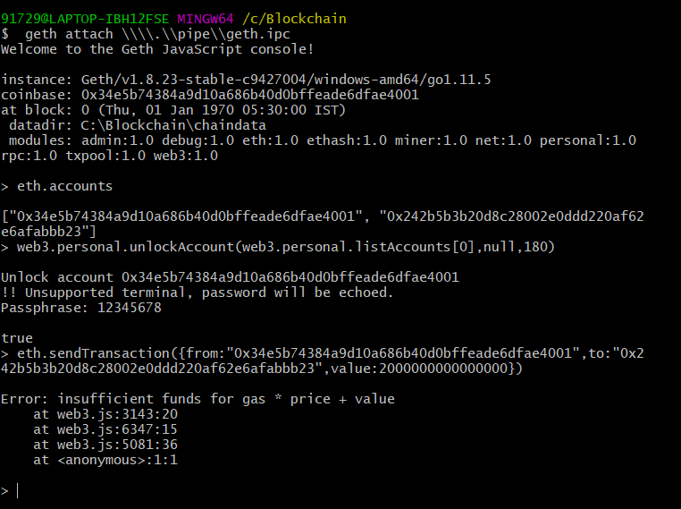

If balance is there then fund will be transferred
As gas*price+value

