Introduction to Java

CS9053 Section I2

Wednesday 6:30 PM – 9 PM

Prof. Dean Christakos

March 23rd, 2023

Due: March 30th, 2023 11:55 PM

**Part I: Working with stacks and queues**

1. A stack parameterized with the type E has the following methods:

boolean empty() – tests if the stack is empty

E peek() – Looks at the object at the top of the stack without removing it from the stack

E pop() – Removes the object at the top of the stack and returns that object as the value of this function

E push(E item) – Pushes an item onto the top of this stack

int search(Object o) – Returns the 1-based position where an object is on this stack. If it is not there, then it returns -1

Implement MyStack<E> by providing these methods using an ArrayList.

Consult the Stack interface <https://docs.oracle.com/javase/8/docs/api/java/util/Stack.html#search-java.lang.Object-> to see how these methods should work.

1. Next, you are going to create a class called Packet which will have a payload, which is an array of 256 bytes, and a priority, which is an integer from 1 to 5. **5** is the **highest** priority Packet and **1** is the **lowest** priority Packet. Then in the main method, create a PriorityQueue of Packet objects, where the highest priority packets will be processed first. I have created some basic code to show what to do. You will have to fill in the rest of the code to properly create packets, and create a PriorityQueue that takes packets and prioritizes packets with the highest priority and prints them out in a human-readable way that lets us know its priority
2. We are going to implement a function called isBalanced(String inString), which you can find in the BalancedParentheses class, which sees if a String of parentheses are balanced. You are going to use a Stack (you can use MyStack or Java’s own Stack implementation) to do it.

**Balanced parentheses** means that each opening symbol has a corresponding closing symbol and the pairs of parentheses are properly nested.

For example, these are balanced parentheses:

(()()()())

(((())))

These are unbalanced:

((((((())

()))

Implement isBalanced(String inString) which returns a boolean **true** if the parentheses string is balanced and **false** if it is not, using a stack

**Part II: Sets**

The reason we like Sets in Java is because they help us think about Sets in a mathematical sense and we can easily implement the functions of Sets that exist in Math—eg, Set intersections and unions. In Python, these set functions are explicit. In Java, they are not, something which I briefly forgot during lecture.

Create a class MathSet which extends HashSet. It should have three methods:

public Set intersection(Set s2): Takes a Set, s2, and returns the intersection of the Set and s2—the elements that are in both sets.

public Set union(Set s2): Takes a Set, s2, and returns the union of the Set and s2—the combination of all elements.

public Set<Pair<T,S>> cartesianProduct(Set s2)

I have provided a Pair class for this. Return the Cartesian Product of the base set, s and s2: s × s2:

A **Cartesian product** of two sets A and B, written as A×B, is the set containing **ordered** pairs from A and B. That is, if C=A×B, then each element of C is of the form (x,y) where x∈A and y∈B:

A×B={(x,y)|x∈A and y∈B}.

For example, if A={1,2,3} and B={H,T}, then

A×B={(1,H),(1,T),(2,H),(2,T),(3,H),(3,T)}

Note that here the pairs are ordered, so for example, (1,H)≠(H,1). Thus A×B is **not** the same as B×A.

**Part III: Maps**

I’ve created an ArrayList of 100 random integers from 0 to 9. Using maps, have the method sortByFrequency sort the ArrayList according to the ascending frequency of the occurrence of the value in the array list. For example, if the Array list contains:

[1, 2, 2, 1, 1, 1, 5]

The sorted result would be:

[5, 2, 2, 1, 1, 1, 1]

Because “5” occurs 1 time, “2” occurs 2 times, and “1” occurs 4 times.

Use a map to solve this problem.

You may get some numbers that aren’t “sorted”. Explain why.

1 point of extra credit if you come up with a way to fix this.

**Part IV: Graphics/UI**

You are going to create a “roll the dice” application. It will look like this:

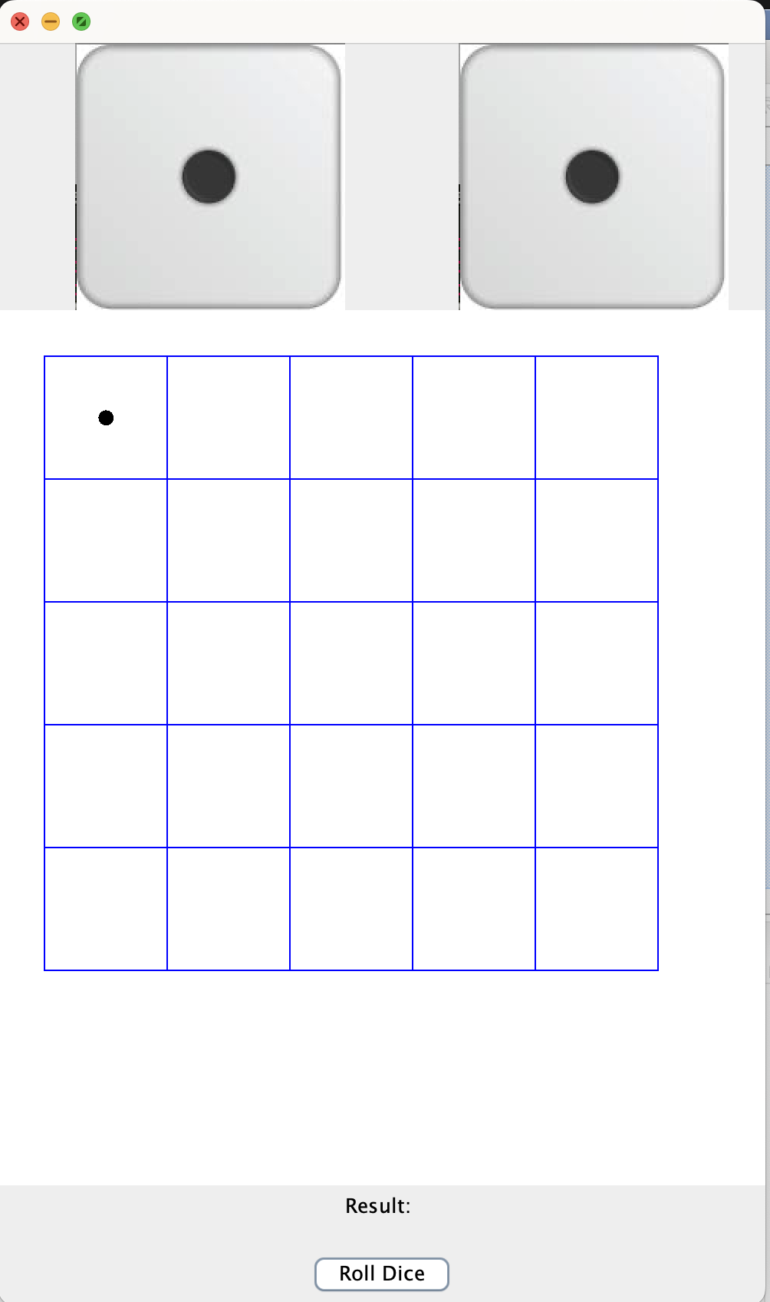

The way it works is that when you click on the “Roll Dice” button, it will cycle through the dice images a random number of times until landing on the final one, which will have the total of the two dice.

At that point, it will show the sum of the dice and move the dot in the upper left hand of the grid that number of steps, from left to right, then to the next row. For example, if the first roll of the dice comes up “6”, then the application should look like this:

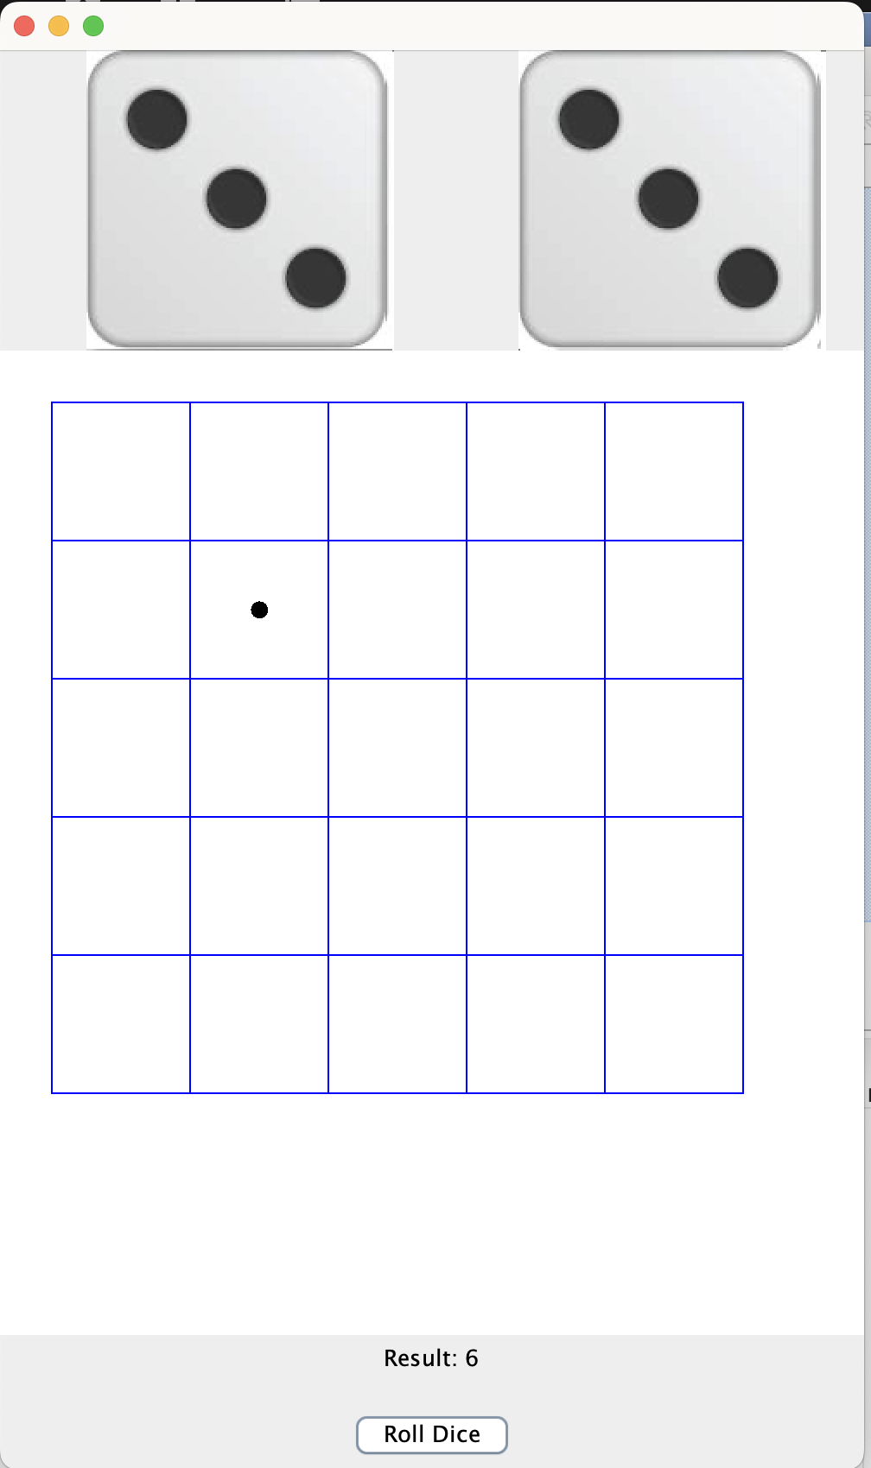

After you have rolled the dice enough that the dot arrives at the lower-right cell of the grid, print “Finished!” in the panel that displays the grid. Further rolls should not move the dot any further.

Hints: Since there’s little “skeleton” code available, modify the “ImagePanel” code. The ActionListeners will update the image in the ImagePanel and repaint() a random number of times before settling on the final value.