BACKEND:
npm install express cors dotenv
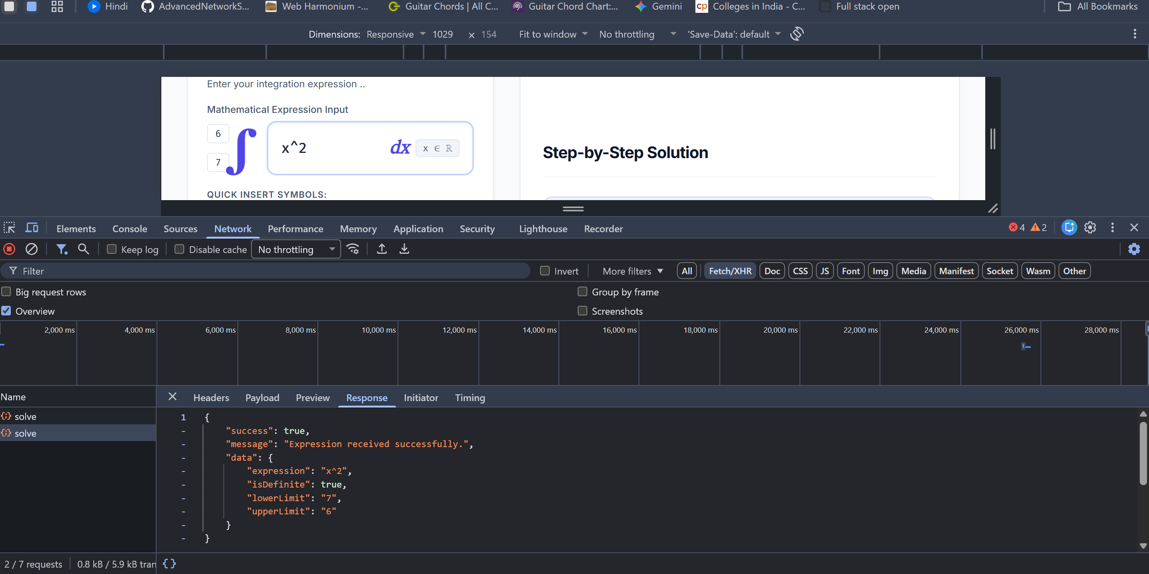

npm install axios
LLM terminal :
Llm app:
pip install langchain langchain-groq langchain-community langchain-huggingface langchain-chroma chromadb sentence-transformers sympy python-dotenv

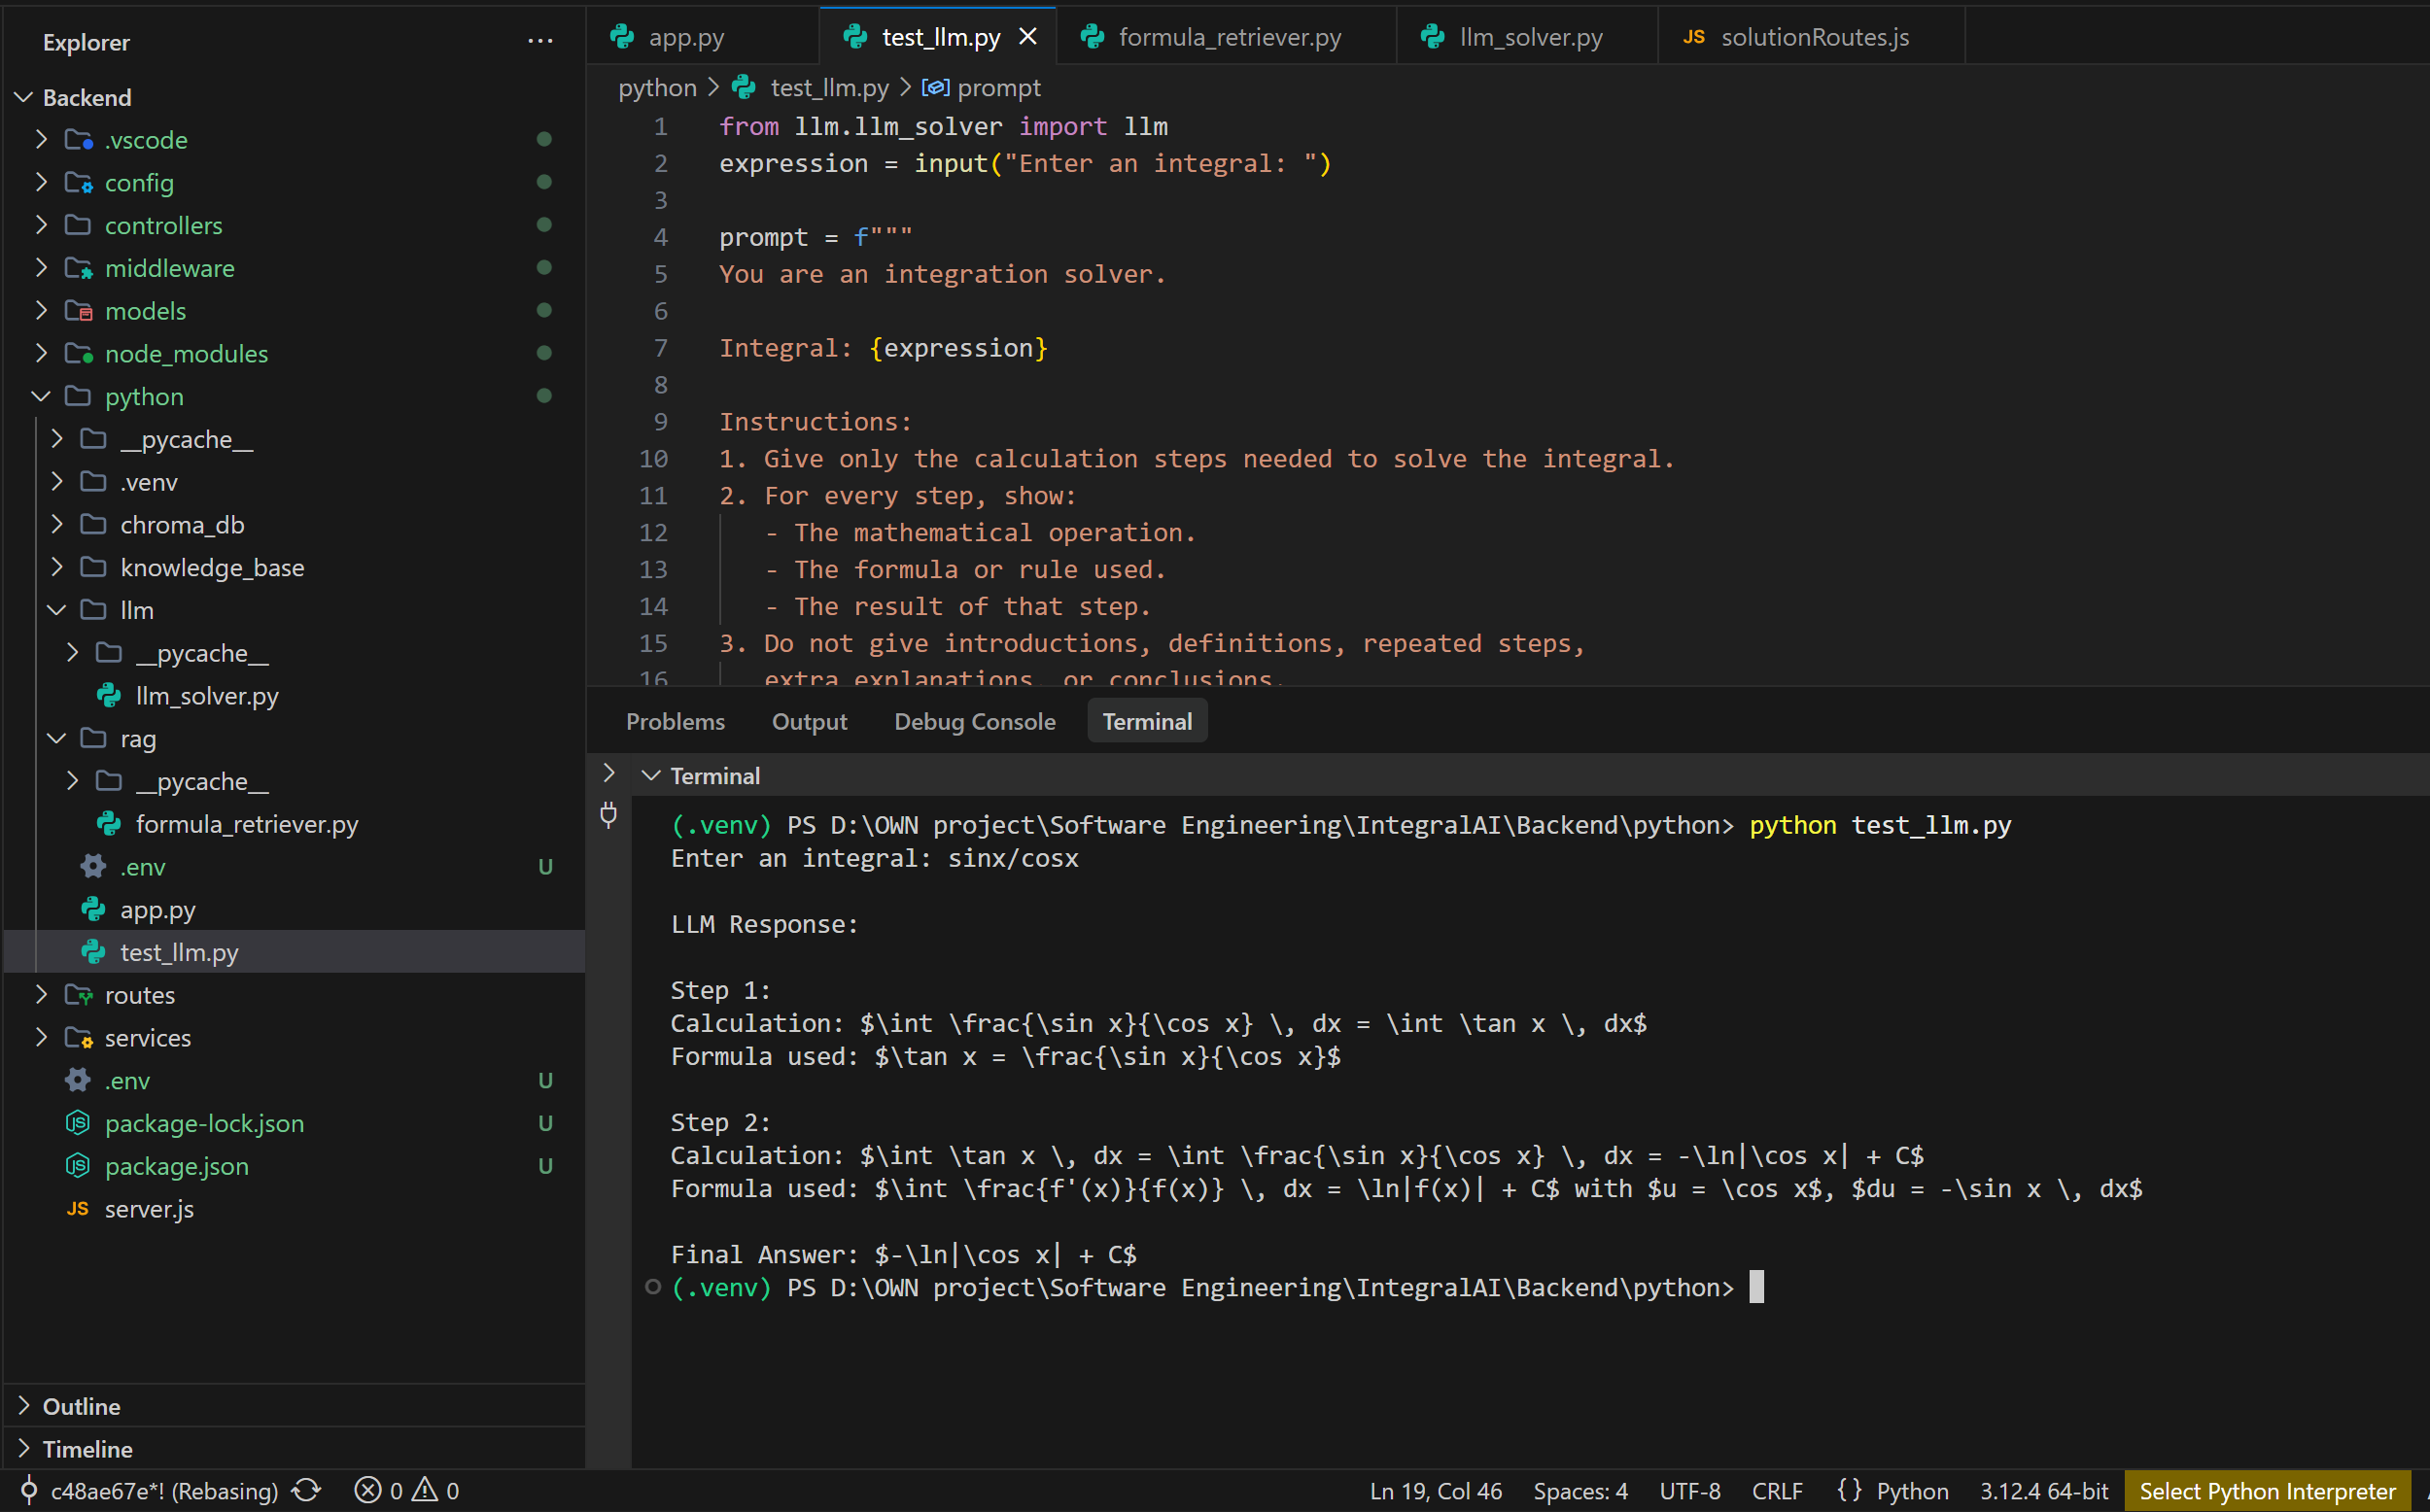

Express – python api pipeline check :
uvicorn app:app --reload --port 8000
npm start
test case:
$body = @{
expression = "sin(x)/cos(x)"
isDefinite = $false
lowerLimit = $null
upperLimit = $null
} | ConvertTo-Json

Invoke-RestMethod -Uri "http://localhost:5000/api/solve" -Method POST -ContentType "application/json" -Body $body

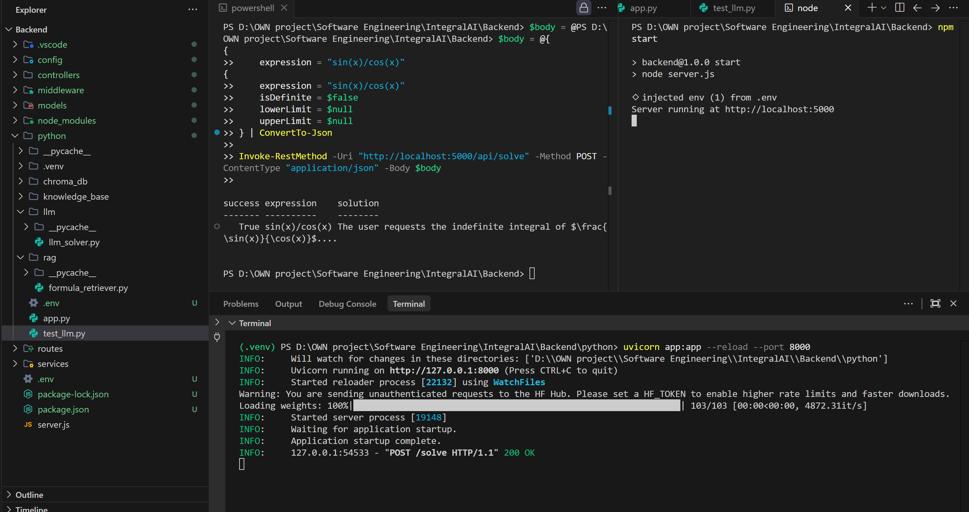
Warning: You are sending unauthenticated requests to the HF Hub. Please set a HF_TOKEN to enable higher rate limits and faster downloads.

Llm -> frontend testing
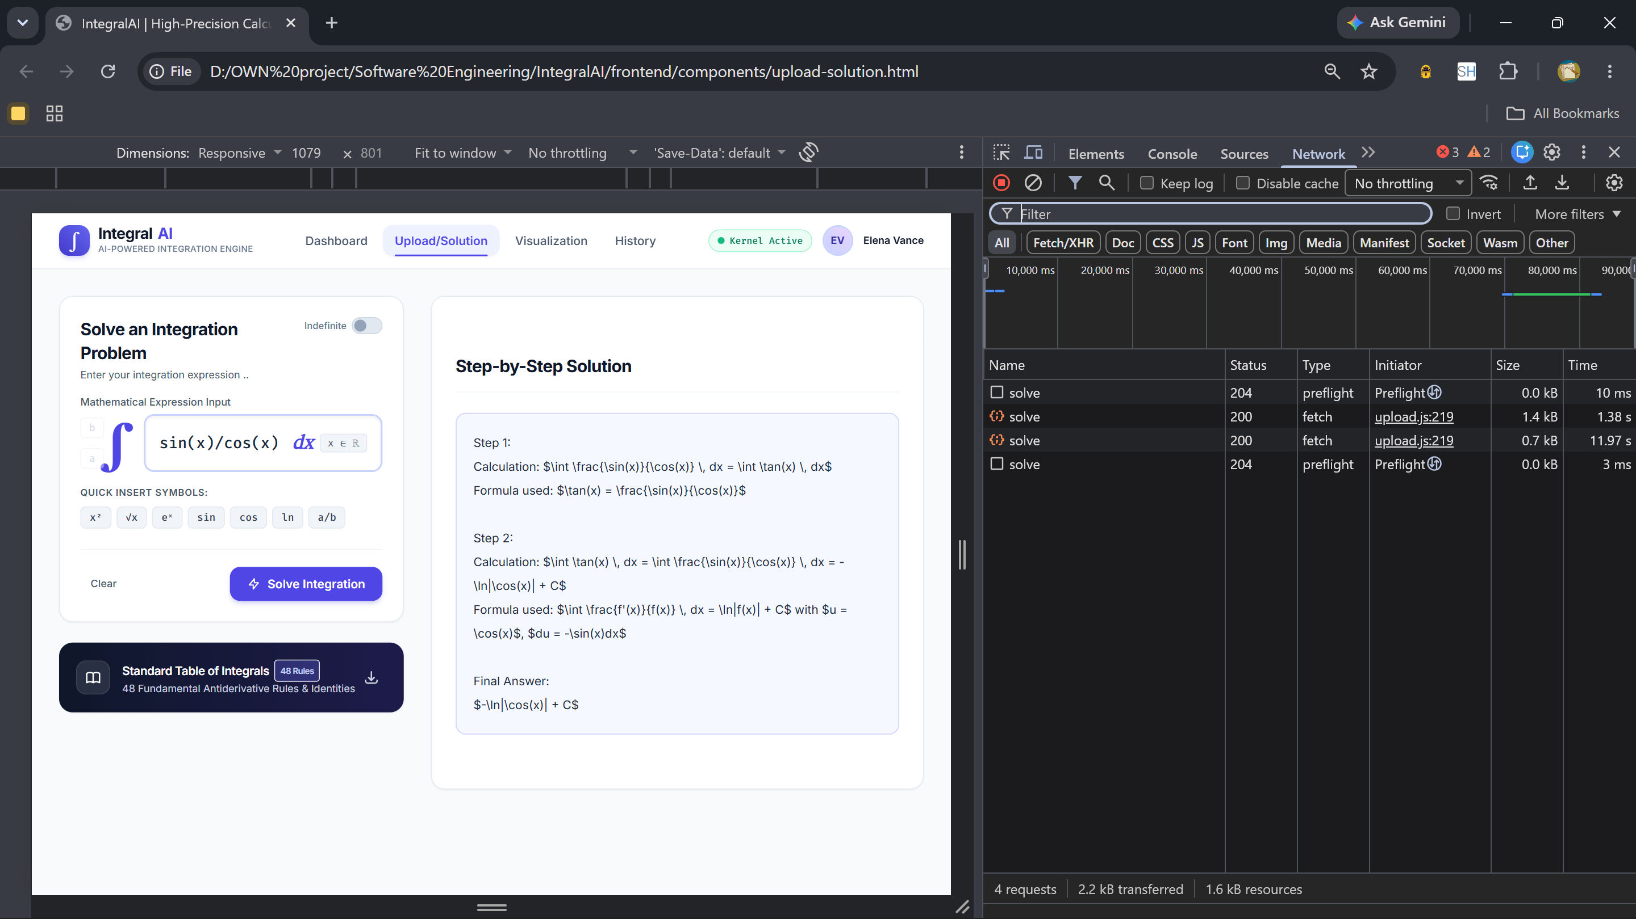

NOTE :
Important: This version rebuilds the Chroma database whenever you call retrieve_formula(), which is fine for an initial test but inefficient for repeated requests. Also, similarity search only finds candidate formulas; it does not prove they are mathematically applicable. Your app.py should reject an inapplicable formula rather than blindly sending it to Qwen.

Graph simulation :
manual url test :
file:///D:/OWN%20project/Software%20Engineering/IntegralAI/frontend/components/visualization.html?expression=sin(x)&isDefinite=true&lowerLimit=0&upperLimit=3.14
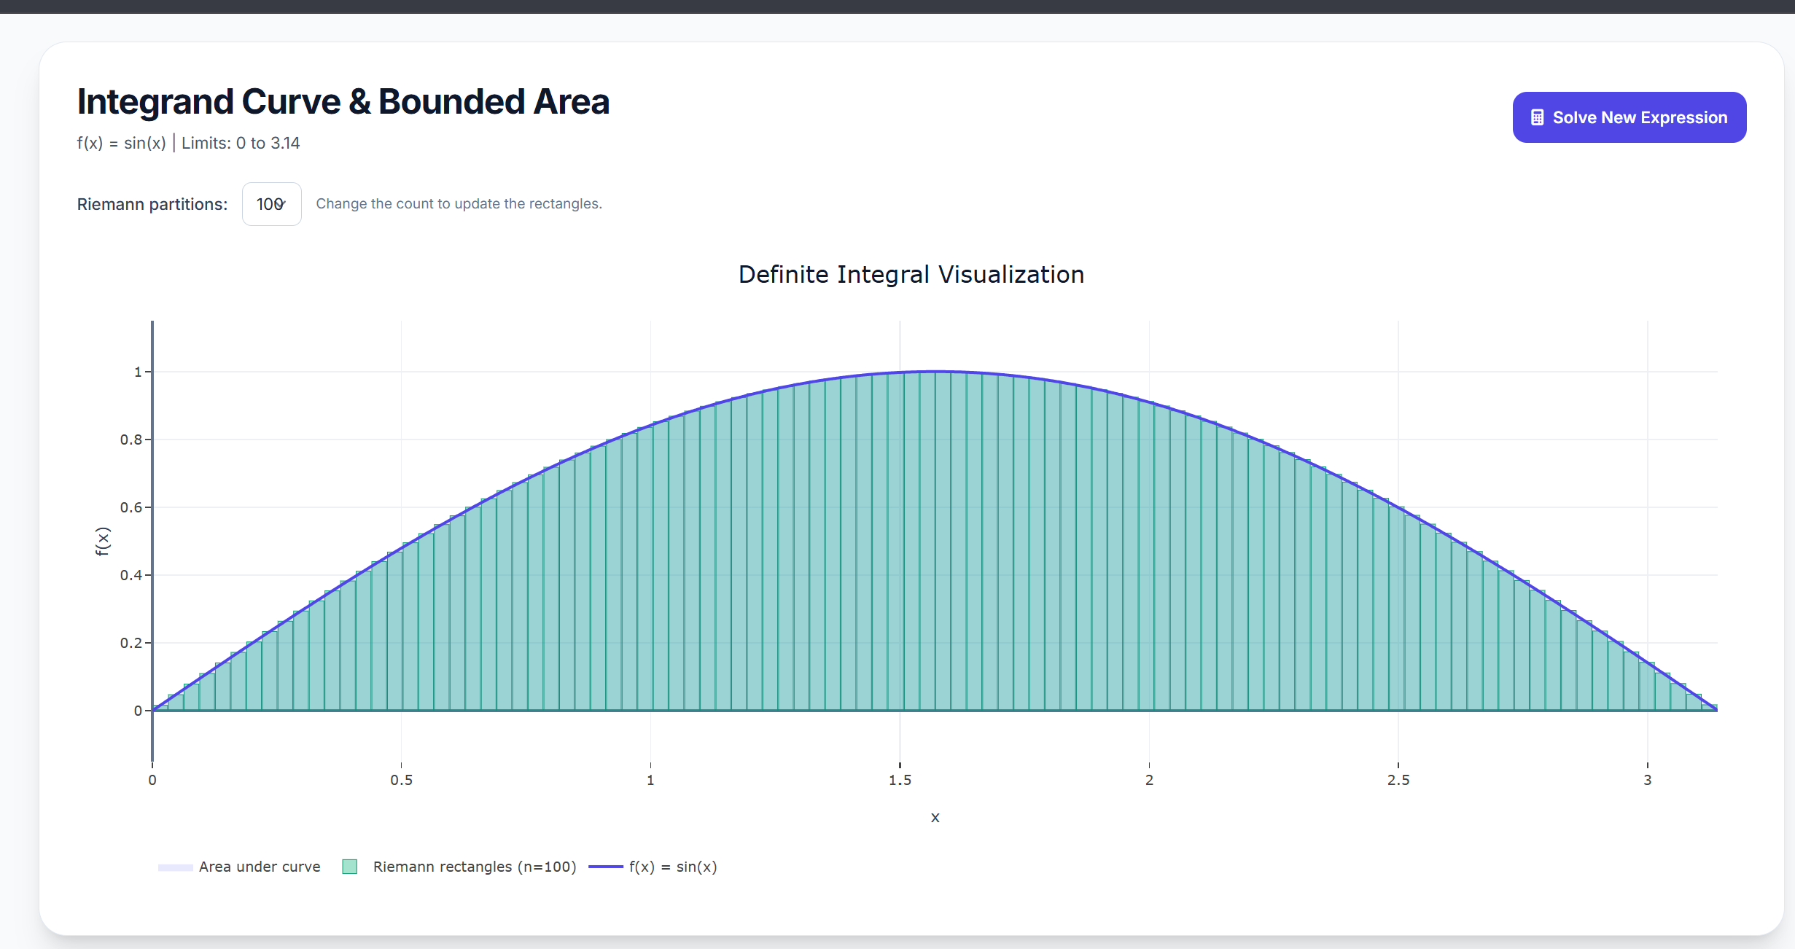
file:///D:/OWN%20project/Software%20Engineering/IntegralAI/Frontend/components/visualization.html?expression=sin%28x%29&isDefinite=false&lowerLimit=&upperLimit=
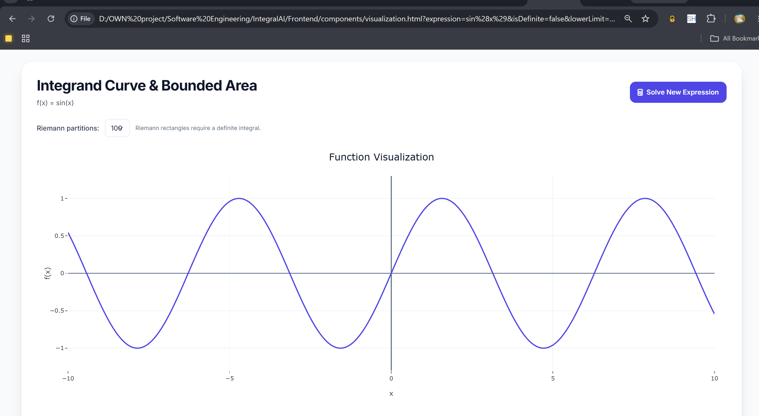

Python terminal:
pip install fastapi uvicorn
uvicorn app:app --reload --port 8000

