**Curriculum Vitae**

**Personal Information**

**Name:** Tresha Bade Shrestha

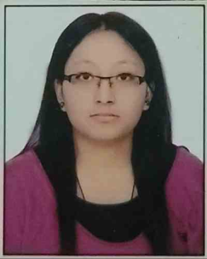**Gender**: Female

**Date of birth**: 2nd March 1994( 18th Falgun 2050)

**Nationality:** Nepalese

**Religion:** Hindu

**Marital status:** Unmarried

**Father name:** Rameshwor Bade Shrestha

**Mother's name:** Leena Bade Shrestha

**Temporary address:** Wokutole, Banepa-2, Kavre, Nepal

**Permanent address:** Wokutole, Banepa-2, Kavre, Nepal

**NMC number:** 21500

**E-mail:** [treshabade@gmail.com](mailto:treshabade@gmail.com)

**Phone number:** +977 9849569912

**Academic qualification:**

|  |  |
| --- | --- |
| **Institution and Dates** | **Degree Obtained** |
| Kathmandu Medical College And Teaching Hospital, Kathmandu(2019-2022) | MS ophthalmology |
| Kathmandu Medical College And Teaching Hospital, Kathmandu(2011-2017) | M.B.B.S |
| Himalayan White House International College(2009-2011) | HSEB(10+2) |
| Kathmandu University High School(2009) | School leaving certificate |

**Work experience:**

**1) Intern doctor**

**Institute: Kathmandu Medical College and Teaching Hospital, Kathmandu**

**Duration: 1 year**

**2) Medical officer: Krishna Prasad hospital, Banepa**

**Duration: 1year**

**Language known**

Nepali, English

**Declaration:**

I hereby declare that above mentioned particulars of information and facts stated here in above are true, correct and complete to the best of my knowledge and belief.