# 2.1 Introduction

In first step of development stage, we need to collect all the information about problem in our project and find out the solution for that we need to do analysis. Analysis is the method or way of collecting data and comparing with the other information system. it helps to identify area of problem and provides solution of how to improve overall quality of that system. This analysis is based on user requirement, find out the issues and developing the product.

This is the most important stage while doing this project which aids to find out goals and purpose. In this analysis step, there are multiple ways like gathering information, identify problem and prototype developing based on this system. In this system, it will need to focus on user requirement rather than technical aspect. I am going to choose CATWOE Analysis which is known as soft approach methodology. Use case and class diagram are used for inexperience person. User requirement is easily show in diagram and that are easier to understand.

In this project, I am using PHP Language for developing the Hotel Booking Management System. This is browser-based web application focuses on user requirement to booked hotel room. This website user can book room and admin can insert, update and delete their hotel features.

In this project, there are some activities which are involved in analysis phase:

1. **Requirement Analysis**

In this stage, we need to find out the requirement analysis of the project and solve the problem with increasing better quality of website. The main purpose of this analysis is to find scope of this project and establish the user experience in our system.

1. **Hardware study**

This hardware study step, we need to find out whether or not,

* Hardware and software are required to execute this project,
* How much time it takes to response and process on it.

1. **System design requirement**

In this stage, the design which is help to describe our project interface. We need to discuss in design includes the logical, objects, database and coding of overall project work.

1. **System implementation**

In this stage, we discuss about core logic implementation part to write a program or code and we will be created database for storing user information.

1. **System Modification**

In this stage we discuss if we will have to change in something then we will change after a certain time based on user requirement and we need to change some requirement, add features or fixing errors then we modify on it.

We need to perform analysis because in development process, there is so many features or requirement need to implement. Analysis is the process of collecting the user requirement that we need to implement in this system. If there are some problem before starts design or coding on project, that helps to completely reduces issues. The main moto of analysis in our system is to increase productivity and enhance quality of work.

# 2.1.3 CATWOE Analysis

I decided to use CATWOE analysis methods for my project because it is the methods of find out the issues and processes. To develop Hotel booking management system user-friendly, the CATWOE analysis methods can able to identify people view because of it is soft approach methodology has focus on user perspectives. CATWOE is an ethical framework which helps to problem solving approach. It is the simplest and easiest method of checklist to find the solution of problems.

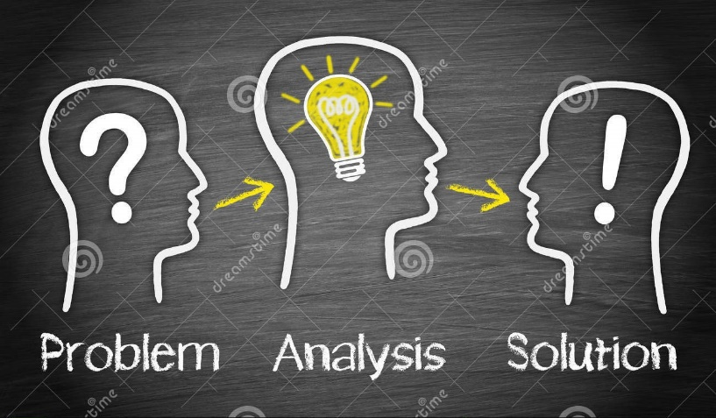

CATWOE analysis have six elements and have different analysis features are:

1. **Client/Customer-** In this project-based client/customer are user. Customer are the most important thing about this system. If customer is directly affected to this system. So, we will need to address immediately to avoid serious consequences.
2. **Actors-** The actor in that case are the employee or admin who controls that system. There is insider employee, admin and outsider are user. We need to find out the role of that actor in system.
3. **Transformations-** In this stage, it describes the process of input and output which is based on system process. We have carefully considered to this step is that, what the input requires and what the result will be.

1. **Worldview-** The worldview in this case is looking for, what problems that we are going to solving from that system. It describes that the problem is long lasting effect or short-term effect. It will help to handle all problems.
2. **Owner-** Owner in this case are admin or manager is the ownership can be able to handle the problem. This owner analysis helps to control the way in rectifying the task problem.
3. **Environment-** In the last step, we faced some environment issues like budget, legal issues are involved in project. Form beginning, we able to solving step by step to filtered problem. Then it helps to solve or clear the problem.

# 2.2 Feasibility Study

Feasibility study is an analysis the skill of developers and evaluate of this project. It is also called test of a system proposal based on its workability. If our project more reliable and user-friendly then we need to do feasibility study in our project. It helps to development save time, money, add new features based on user requirement. Feasibility study identify the valid reason to undertake this project, aids to increase decision making and provide alternative solution in project.

There are some common factors of feasibility study are:

1. **Technical Feasibility**

This study is the project idea that explored in detail to find out its technical feasibility. It evaluates the hardware and software are requirement of this project. If our project is technically feasible or pollution caused by this project. It is also called system feasibility. We will have to developed our project need eco-friendly.

1. **Economic Feasibility**

The economic feasibility is the analysis of cost and income determined based upon effort whether or not it is logical of this project. Basically, it helps to reduce and avoid cost and determine how much time to take in development in system.

1. **Schedule Feasibility**

This hotel booking management system has allocated time to complete task. Schedule feasibility helps to identify whether on not is completed in the available time.

1. **Operational Feasibility**

This stage helps to measure that our project will be able to solve that problem. If our project completely new then user feel comfortable or accepting of the change new system.

1. **Legal Feasibility**

It is the most important for study to know that our system is legal or not. Legal feasibility defines whether our system will fulfill the legal requirements or not. If there is no issue then user can easily communicate with on it.

# 2.3 Requirement analysis

It is the process of achieving the requirement what they want. It is the part of system development life cycle. In this stage, to determines that our system function and process would be comfortable to access a new system.

## 2.3.1 Functional Requirement

The functional requirement is that, the developers implement the software features and function according to user requirements. It also describes the behaviour of system based on the task conditions.

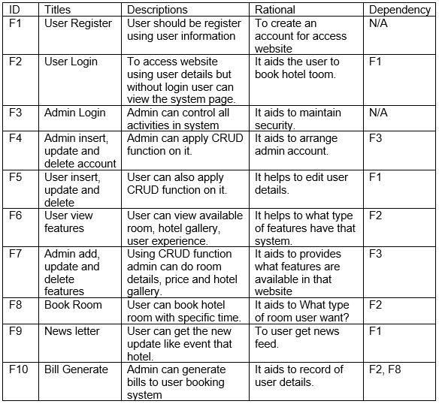

## 2.3.2 Non- Functional Requirement

This non-functional requirement describes that how this system project will do it. It is specifying the system quality of an attribute for a system.

There are some non-functional are listed below in tabular form: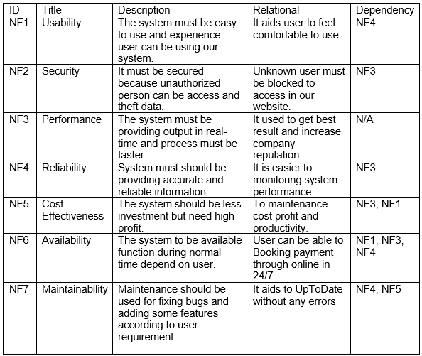

## 2.3.3 MoSCoW Prioritization

MoSCoW is the very important methods in project that develop easy and clear requirement of the user and their priority. This is step by step of gathering the user requirement with listed on it. Then all requirements are ranking with high to low priority topic and solved it. MoSCoW prioritization helps to provide security and increase performance of the system.

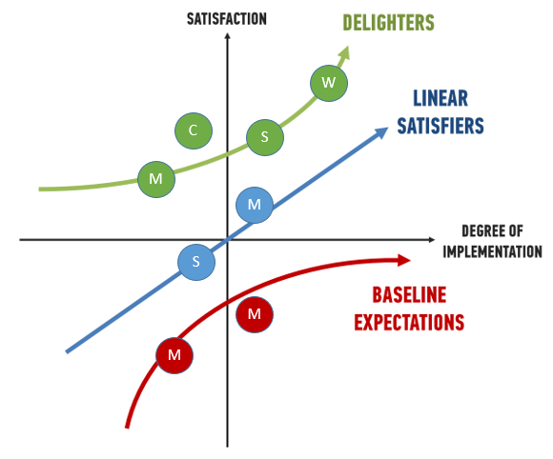

The MoSCoW prioritization stand for:

* **Must Have:** The requirement which is the most important for the system that must be involved.
* **Should Have:** Should have this requirement is high priority but not vital.
* **Could Have:** The requirement is that could be important but it doesn’t affect anything on this project.
* **Won’t Have:** The team members decided that, the requirement which delivery won’t be this time.

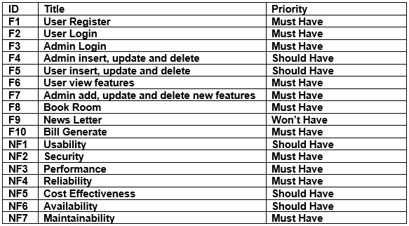

## 2.3.4 SRS (System Requirement Specification)

An SRS is system requirement specification for used in Hotel Booking Management System is web browser application-based project. It is used to gather all data, functional, behavioural requirement while developing this project. It describes the functionality of the system that need to be fulfil user requirement. Generally, it includes the system purpose, overall description and specification requirements. It aids to save time, money and increase confidentiality.

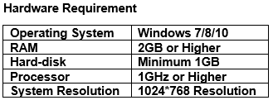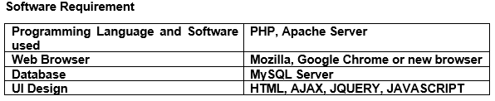

# 2.4 Use Case

A use case is the process or arranging and represent data with user requirement on diagram. It is a powerful technique of black box function requirement. It helps to identify the interaction between user and system process with clear points. Use case can aids to manage the hard and large project to divides in small points. A use case has illustrated using notation to connect to actor what roles are playing this project and showing what is happing in this system. In this hotel booking management system I have used StarUML for draw diagram. StarUML has many features that help us to draw simple and attractive diagram.

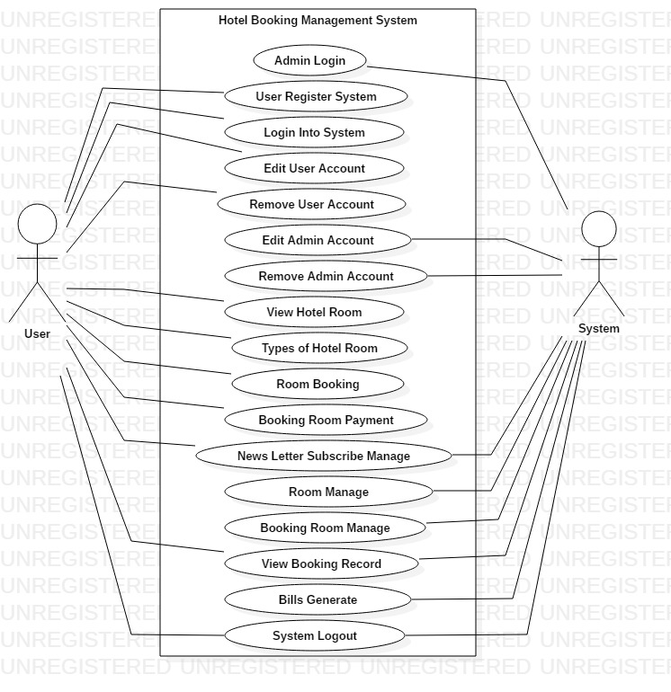

Figure 1:Hotel booking management system User case

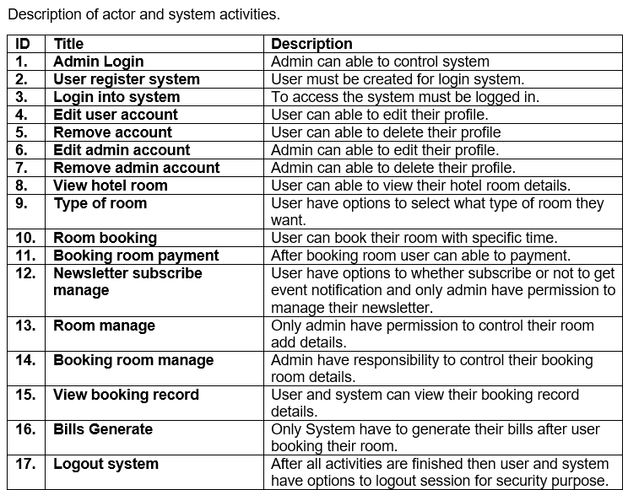

# 2.5 NLA (Natural Language Analysis)

NLA is Natural language analysis. It is the process of identify the noun, verbs and adjectives. It is the step by step analysis to gathering requirement form task. While doing the NLA process there are some step to follow the rules are:

* Find out the noun and verb,
* Removed double word form noun and verb,
* Removed synonymous noun and verb,
* Then we will get noun to candidate classes and verb to candidate operation.

**Class:** Simply, class is the blueprint of a group of objects that play the main role of the system contains with structure and behavioural features. Structure means static and behavioural means dynamic features of class.

**Attribute:** It is an object of property of class. It stores in second or below of class displayed in different line.

**Operation:** It is also called methods that store in third row or below of an attribute displayed in list format.

This project summery is:

Hotel Booking Management System is web browser-based application for user can easily booked hotel room. Firstly, to access this website user need to create account then login to the system. User can view website without login but not allowed to use the features. With login user can have allowed to add, edit and remove data as well as to view information. System have permission to used CRUD on their features like insert, update and delete their admin account.

After login user can be able to Booked room choice of what types of room they want with payment on specific price. In this hotel room have organized many events and offer on room booking system. For to get update the hotel events, user have choice to subscribe their newsletter and system should be managed it. Room manage, booking room manage and Bills generate by system. At last step user and system have options to logout from system.

# 2.6 Class Diagram

It is one of the most advance and easiest diagrams which shows the modelling relationship between class, attribute and operation with the objects. Class diagram also known as static diagram because this is not used for visualizing, describing but only used to executable code of the system.

Form above summery class, attribute and operation have allocated in below table:

|  |  |  |
| --- | --- | --- |
| **Noun (class)** | **Adjective (attribute)** | **Verbs (Operation)** |
| User, Room Booking, Contact, Admin, Payment System, Room | Browser-based, Able, Specific, Many, Last | Create, Add, Edit, Delete |

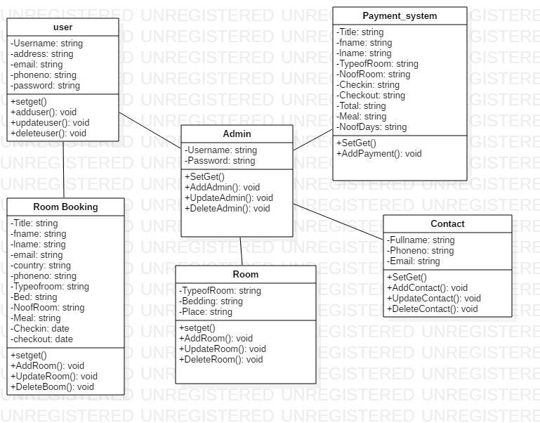

Figure 2:Hotel Booking Management System Class Diagram

# 2.7 Conclusion

Finally, at the last analysis for the Hotel Booking Management System have successfully listed out. In first step, we listed out all the activities that are involved in analysis. Then, we used CATWOY analysis for it is soft approach methodology which describe the user perspective rather than technical. Next step, we used feasibility study analysis for technical and user issues based on this project. Functional and non-Functional are prioritized based on MoSCoW prioritization method. In use case diagram represent the task between system and user. At the last, we design class diagram with their class, attribute and operations.