# Chapter-3

## 3.1 Design

In this design stage, a design is a plan or art or drawing of something before build or made. And design also known as blueprint. Generally, design provides the step by step action or function in any projects. Design is the most important phase for any application development which is directly or indirectly involved in this project. In design have three different methods and tools are structural model, behavioural model and database model.

In this hotel booking management system, we are using StarUML tools for create diagrams like use case, class diagram, activity diagram and sequence diagram. StarUML is open source application that helps to design function. It is also fast, many functionalities and feasible.

## 3.2 Structural Design

It is a tools and methods which we find out safe structure to carry the load. Structural model is also known as static structural that aids to show the relationship and properties. Example of structural design is class diagram Which is helps to describe the overview of this project.

## a) Class diagram

It is a static model which is describe the relationship between classes, attributes, objects and methods in same system class. Class diagram is easy to use, understanding the system views and clearly describe in diagram based on user requirement.

Class diagram is the most important stage in this project of design phase:

* It helps to describe the relationship between class and object,
* In hotel booking management system have describe the user and system relations,
* It describes the responsibilities of this system,
* Supportive for developer and other members too in system.

This diagram has different types of notation and components which is helps to combined the relation of each classes.

1. **Generalization**

It describes the relationship between two classes which has general and specific classes.



1. **Association**

It shows the two-class relationship with each other.



1. **Multiplicity**

The number of objects that are involved in an association

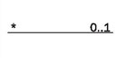

1. **Aggregation**

It controls the relationship between classes.

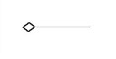

1. **Class**

Class describes the methods as well as its properties.

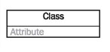

1. **Attribute**

Defined in second row in class shape displayed on separate line.

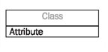

1. **Methods**

It defined in third row in class shape displayed on its own line.

This class diagram was drawn through user requirement which is collect thought analysis of this project that shown in below:

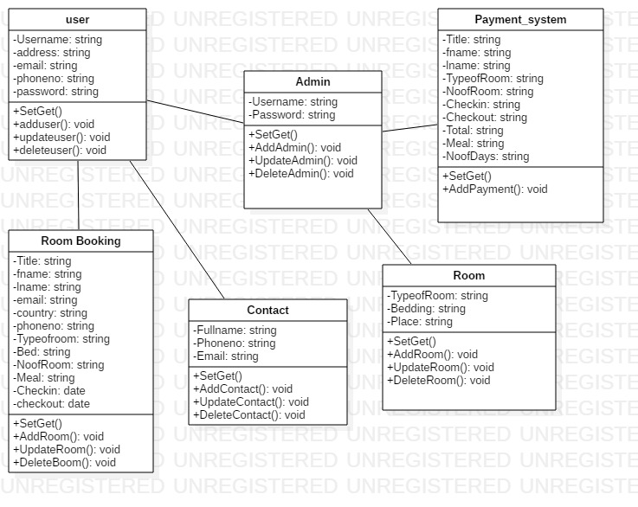

Figure 1:Hotel Booking Management System Class Diagram

From the above diagram showing hotel booking management system activities that happen between user and system admin. From above user can book hotel room and contact relations. Admin can control the cash payment system from user booking hotel room. admin can able to control room system.

## b) Data Flow Diagram

Data flow diagram is to visualize that how the data is processed or system that involves the transfer of data. It is a network representation of a system using the notation to describe the entities and their relationship.

In hotel booking management system DFD is also important in design phase are:

* DFD is the process which makes good communication between user and this system,
* It provides a graphical representation of how information flow between processes in a system,
* It is a logical information flow with clear and easily understanding of the system,
* Provide more detailed with breakout of piece of context level of diagram in system.

In Data Flow Diagram have three level which is clearly describes the system. There is some notation which is help to show relation:

1. Process

Function where the manipulation and transformation of data takes place. In process receives the input and change output in different form or content with represents in a rounded rectangle process.

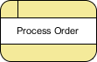

1. External Entity

It shows a human, system or subsystem data where comes from or goes to. It represents in rectangle an entity but do not process data to system.



1. Data store

A data which is used to hold information in storage and if data need for after certain time, it is easy to retrieve information. It indicates written data incoming arrow and read outgoing arrow.



1. Data Flow

A data flow indicates with the arrow with direction of the flow of information which is transfer one path of system information to another.

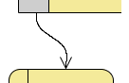

This system Diagram representation of Data Flow Diagram form level 0, level 1 and level 2 drawn in below:

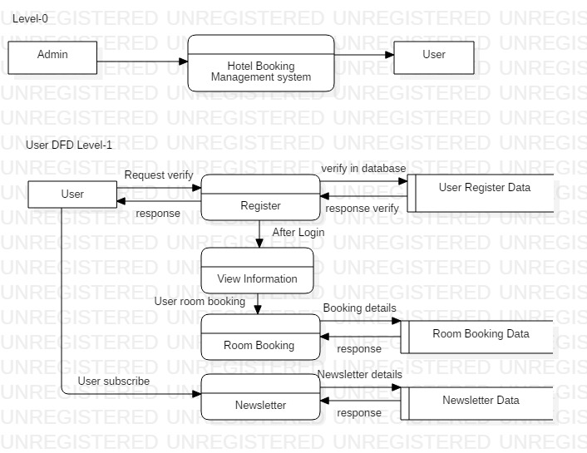

Figure 2:Data Flow Diagram of User Level-1

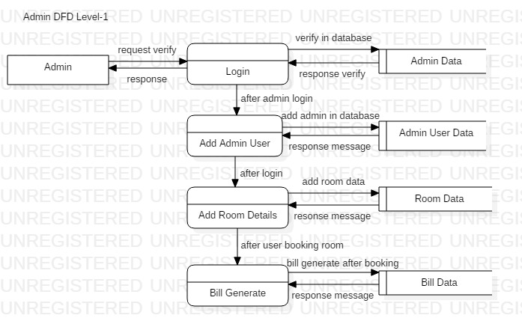

Figure 3:Data Flow Diagram of Admin Level-1

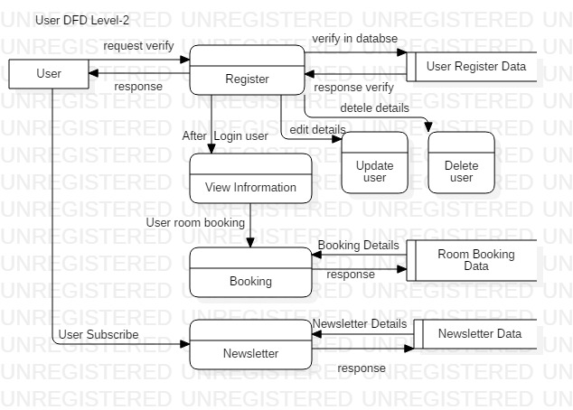

Figure 4:Data Flow Diagram of User Level-2

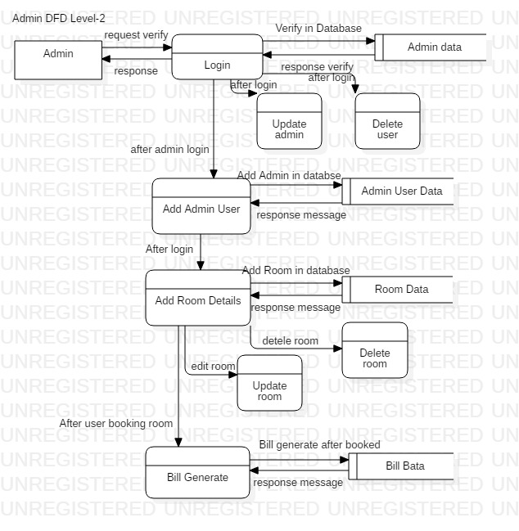

Figure 5:Data Flow Diagram of Admin Level-2

From above figure there are two actors which is interaction with the system. In DFD there are three level, which show the flow of activities in system. In level 0 there is only describe the admin and user discuss with our system. In level 1 describe the admin and user directly or indirectly process and communication with database. At last step of level 3, describe all the activity what happen from begins to ending points.

## 3.3 Behavioural Design

Behavioural design has also called dynamic design of system which is not change over the time. It deals with every type of behaviour in system. In hotel booking management system this design focus on how a structure of this system and as well as collect viewed by the user based on their user requirements. Its shows in architecture design form. Data processing and static machine mode are the two parts are included in it. Use-case, sequence diagram as well as activity diagram are involved in this hotel booking management system.

### a) Activity Diagram

It is also knowing as dynamic design which is aids to describe in graphical representation of all the system activities. Basically, an activity diagram is a flowchart which is represent the flow from one activity to another with an operation of the system. activity diagram is executable system by forward and backward technique.

The purpose of this activity diagram is:

* It aids to draw what activities are happen shows in flow of this system,
* User can easily understand and clearly describe the sequence from one to another activities,
* It aids to demonstrates the logical algorithm.

In activity diagram there are some notation is used in this system diagram are:

1. Start symbol

In activity diagram, it represents the starting points of process in system. this is a small circle with filled an arrow represent and initial state.

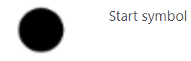

1. Join symbol

It is also known as synchronization bar that is used to combines two or more activities and flow where only one activity happens at a time.

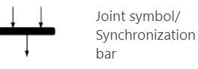

1. Fork symbol

Splits a one flow to two or more activities. Symbolize from a join to multiple arrow lines.

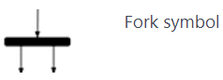

1. Decision symbol

It is a diamond shape which is used if there requires a decision to more from next activity then it use to get two activities.

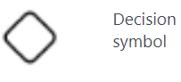

1. Note symbol

Note symbol is used for to get more information from diagram note for clearly and way to guide.

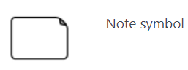

1. Option loop symbol

It is used for repeating process in system activity, also called loop symbol.

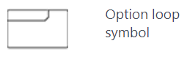

1. Action flow

It is used for communication one action to another action representation with an arrowed line.



1. Condition text

This is used in decision makes to show the message of what condition on activity flow.

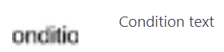

1. End symbol

In diagram at the last step of ending point activity process.

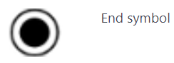

In this system have two activity user and admin. They have different action happens in activity diagram which is shown in below:

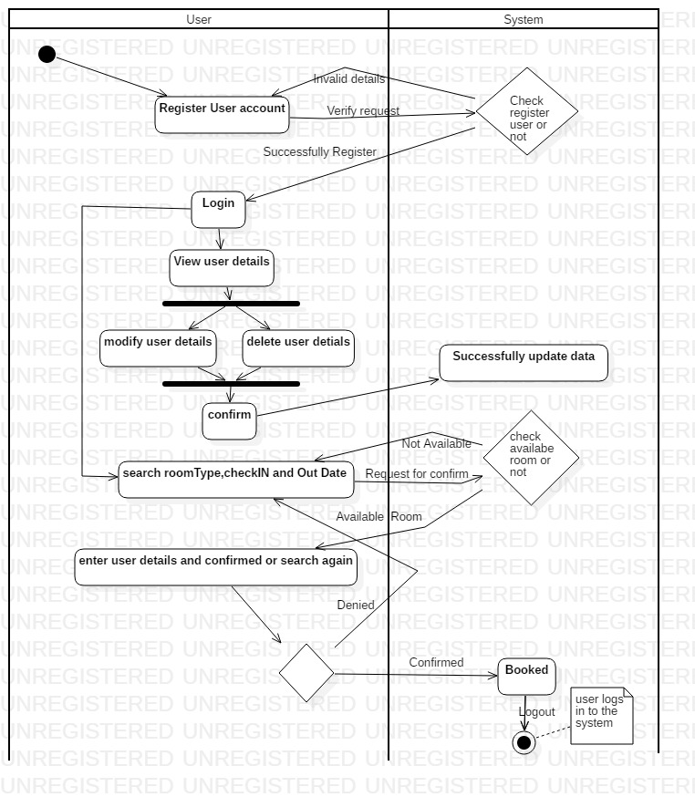

Figure 6:User Activity Diagram

In this activity diagram show that the user how to communicate with the system and database. It describes the user can register then login into system to system permission. After entering to the system user can able to do update, delete the user data and room booked with user requirement.

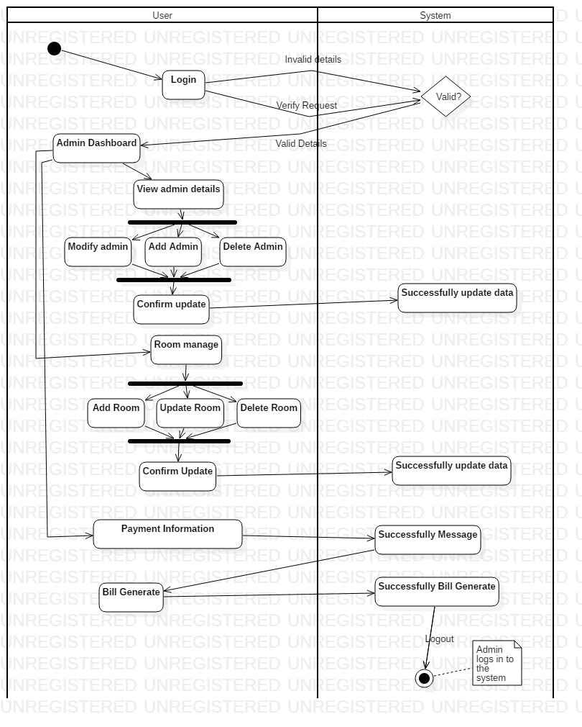

Figure 7:Admin Activity Diagram

In this activity diagram helps to decribe the admin activities. After login admin can able to entered into the system, it will be able to apply CRUD operation on admin account, room manage as well as bill generate.

### b) sequence diagram

This diagram is known as dynamic modelling in UML and event diagram that describe interaction with classes and exchange of message over time. It focusses on lifelines or the process and objects. Specially, it displays the message exchanged between the function before the lifeline ends.

The purpose of this sequence diagram in this system is:

* It aids to show the user activities,
* It shows the admin activity on this system,
* It also aids to represent the UML use case details,
* Sequence diagram describe the planning and understanding the functionality from scenario.
* It identifies how object in an existing system currently interact in it.

In sequence diagram have some notation that are used in system diagram:

1. Lifeline

Lifeline represent the time which is extends downward. The vertical line shows the events that happen to an object that processes. In sequence diagram there are several drawn lifelines but not override each other.

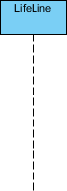

1. Activation Bars

This activation bars will represent the object what time is needed to complete this system task which is a thin rectangle shape in lifeline same place.

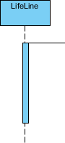

1. Actor symbol

Actor played the role of an entity that directly interact with the subject by exchanging signals data.



1. Comment

That comment also called note it gives the information which is very useful for system. It indicates the rectangle with a folding over in corner side which is linked with the object with a dashed line.



1. A Message Arrows

It indicates that the message sending and reception of a signal. The messages can flow left to right or right to left and return to the sender.

There is some symbol that helps to show the message arrows are:

1. Synchronous message

In synchronous stage for sender wait for the message from receiver message and carrying on with another message before return.



1. Asynchronous message

An asynchronous does not requires a response before sender messages.

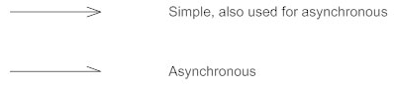

1. A return messages

A return message defines the communication between lifelines of an interaction. After the receiver were done process and return to the message caller to control overall process.

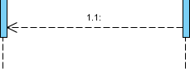

1. Found Message

It indicates some messages are send from endpoint to lifeline which is unknown.



1. Lost message

Some messages are sent to recipient arrows goes to an endpoint.



1. Sequence fragments

It represented as a box, on the top left corner there is an interaction operation which is apply a logical condition. It aids easier to create and maintain to get accurate diagram.

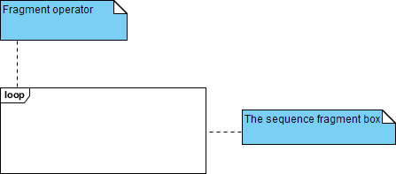

In sequence fragments have some operations which is used in their:

* Alt: Alternative multiple fragments is only the one condition is true then it will execute.
* Loop: Loop fragments must be executed in multiple times, its iteration process.

In this system have two sequence user and admin in below:

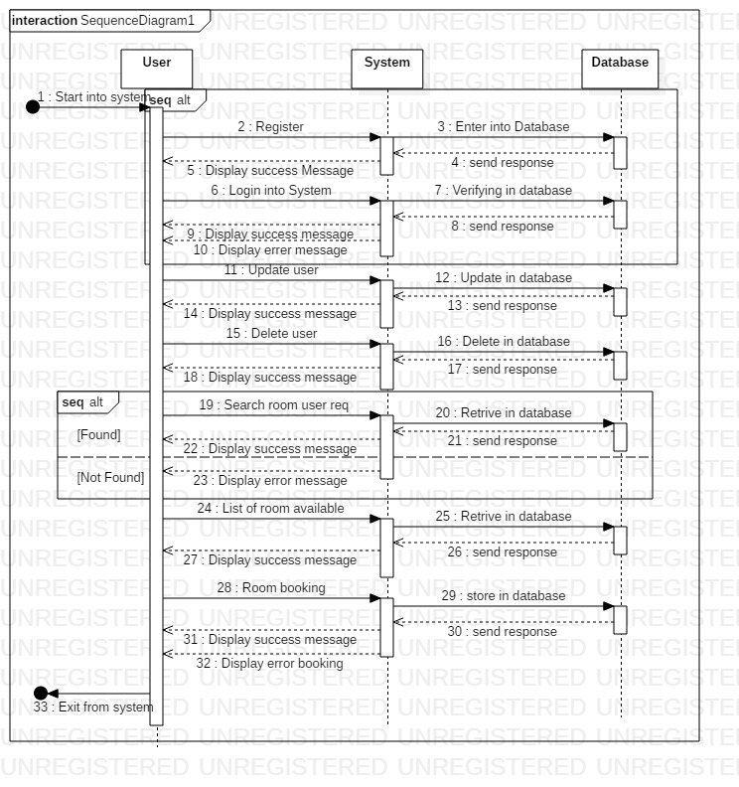

Figure 8:User Sequence Diagram

Sequence diagram is dynamic modelling showing the user activities. It will aids to clarify the user process from beginning to ending points.

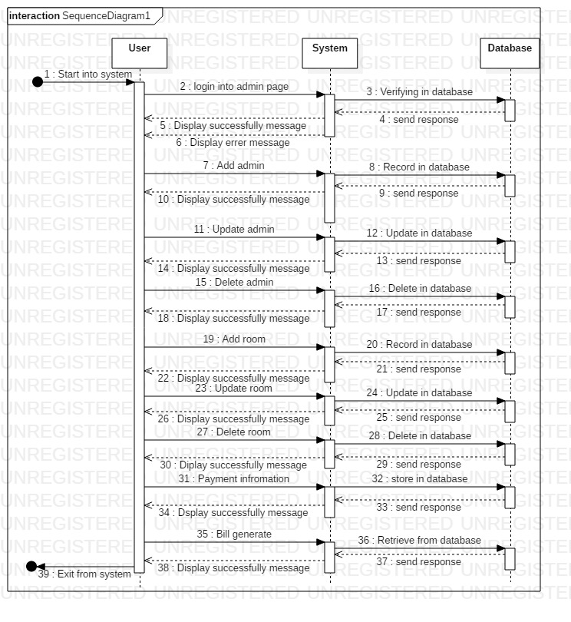

Figure 9:Admin Sequence Diagram

Admin sequence diagram helps to show the process or flow of guide to control this system. where admin can control user data and apply CRUD operation on it.

## 3.4 Database Model

A database model is khown as logical structure of database which defines the relationships and constraints. In system have also database model where we can able to store user information and accssed data. there are two entity relationship diagram data dictionary and, which is helps to clerly describe of this system.

### a) Entity Relationship Diagram

An entity relationship diagram is logical structure that show the relationship between entity and object that is used to stored data in a databse. This is a type of flowchart which is illustrates how it will relate to each other within this system.

The puropse of this diagram in system deign phase:

* ER Diagram helps to offers a visual presentation of the layout with effective design,
* In this system, it aids to increase flow of information and communication between user and system,
* ER Diagram is easy to use and understanding for non-technical client,
* It aids to analyst produce a good database structure modelling for repossess and store data in most actual manner.

This entity relationship diagram have using different notaion and relationship are:

1. Cardinality

It refers to maximum number time an example in one can related to another entity.

1. Ordinality

It refers to minimum number of time an example in one cane to associated to another entity.

1. One to One

Only one entity related to the same other entity.

1. One to Many

One entity can related to the multiple enitity.

1. Many to One

Multiple instance of an entity is related to one instance of an entity.

1. Many to Many

Multiple instance of an entity is related to the multiple instance of an entity.

In this project have ER Diagram of user, admin and system relation in below diagram:

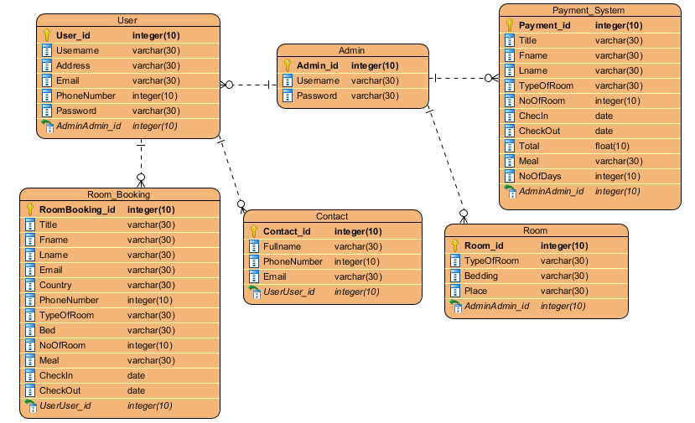

Figure 10:ER Diagram of system

This ER Diagram helps to show the relationship between user and system admin. It is easy to decribe with team members of this project. Using relationship notation help to connect one entity to another. In our system all activities are join each other with the strong relationship.

### b) Data Dictionary

A data dictionary is a collection of file or set of a data that store in database as metadata format. It is also known as blueprint as metadata that decribe what type of data is collect in database format. In this system have also database, which is help to store user data. In this system metadata is very important like:

* This is used to stored in user data for future infromation,
* In system, it helps to reduced paperwork for storing data,
* To maintain the compex and large amount of data in simple form,
* To improve the documentation and control, reduce data duplication in system information.

Metadata of this Hotel Booking Mnagament System is given below:

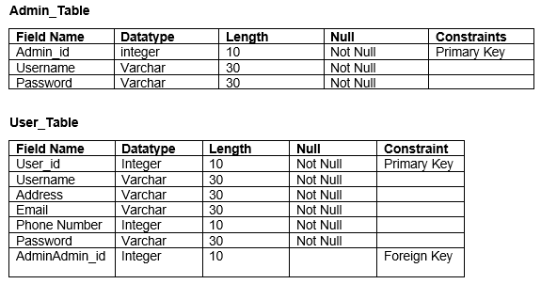

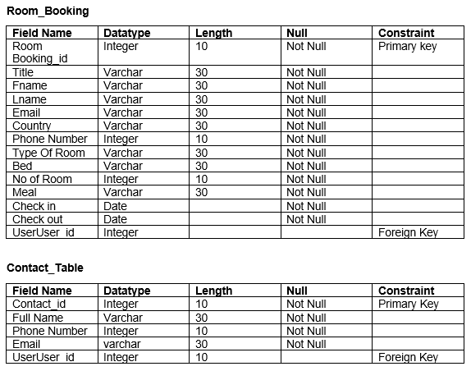

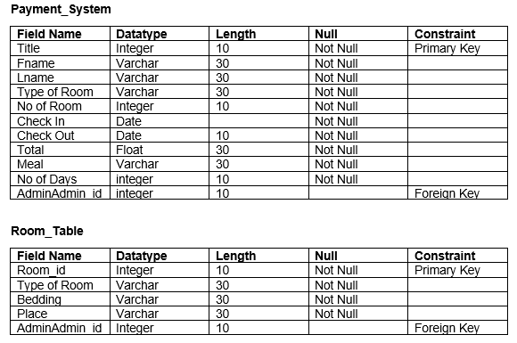

## 3.5 System Architecture

The system architectures is the process where the concepts that will be the support of the definite system are established and it helps to show the relationship between the system component.

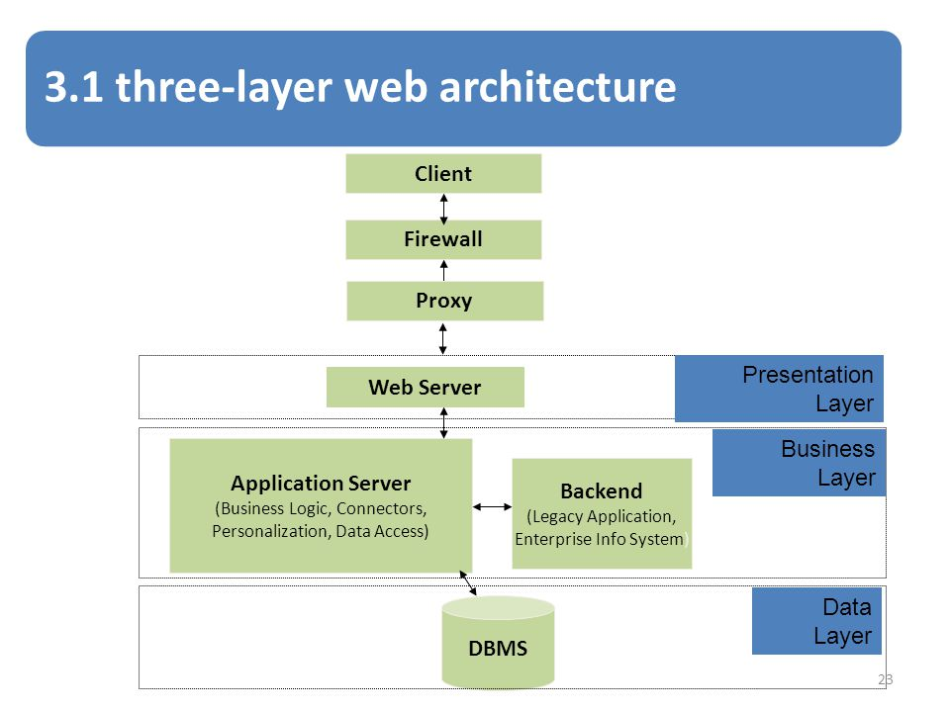

Figure 11:System Architecture

1. Presentation Layer: in this layer is user interface where user can view their system home page.
2. Business or logical layer: it describes the logical or coding part in system.
3. Data Link Layer: it describes the database where we can easily store data.

## 3.6 Prototype

Prototype is the process of creating a visual form which is known as blueprint or templates. It is the testing case after the model base design of the finished product. Prototyping is the most important phase in our hotel booking management system.

* It helps to create a project clear and fulfil user requirement,
* This is a test process so, we can get best result after developing the system,
* It helps to discuss what requirement are necessary for this system,
* It is the way of getting feedback and build a sufficiently complete product

There are some prototyping that are used to build a complete product have drawn below:

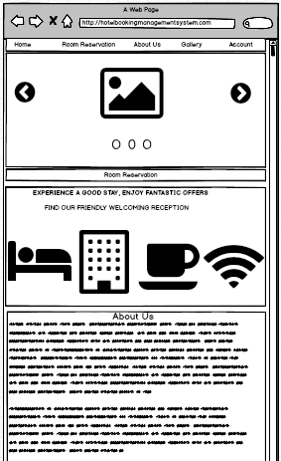

Figure 12:Prototype of Home Page

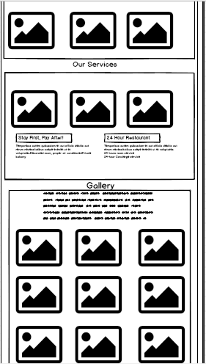

Figure 13:Prototype of Home Page

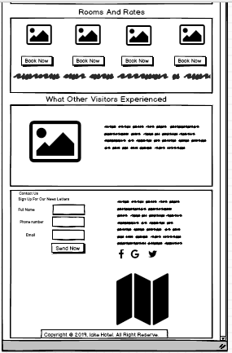

Figure 14Prototype of Home Page

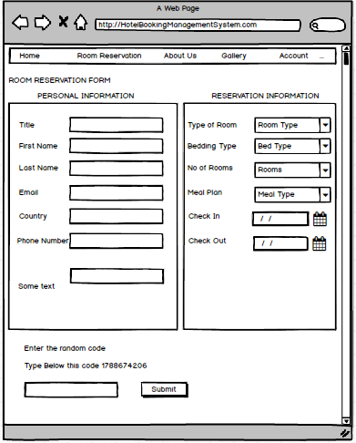

Figure 15:Prototype of Hotel Reservation

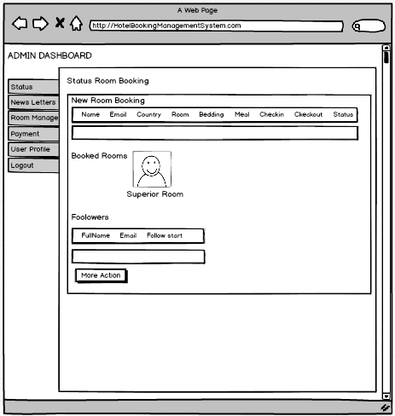

Figure 16: Admin Dashboard

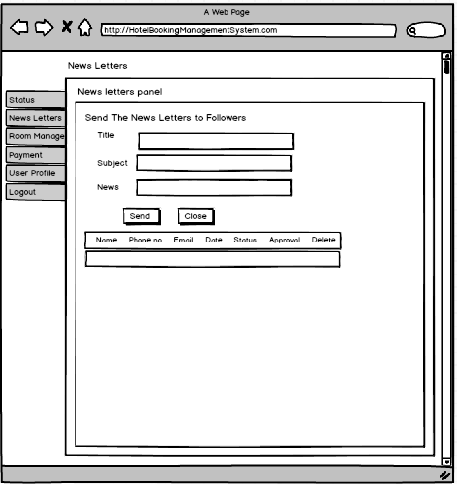

Figure 17:Admin News letters Manage

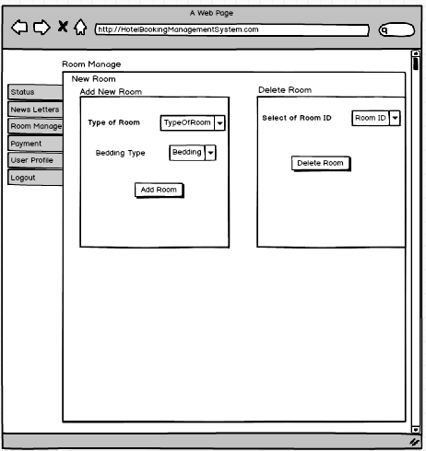

Figure 18:Admin Room Manage

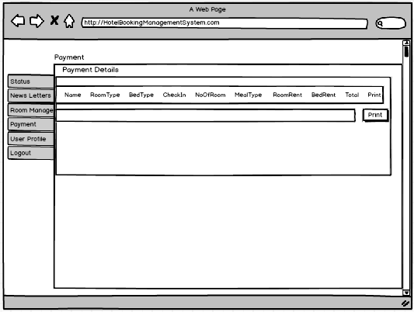

Figure 19:Admin Manage Payment Details

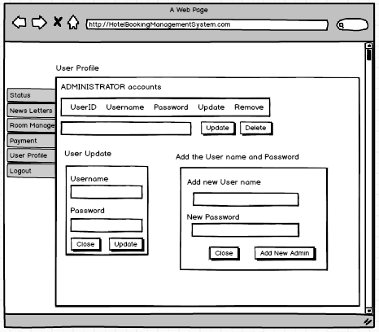

Figure 20:Admin Account CRUD Operation

## 3.7 Conclusion

At the last step of design phase, we are able to complete this phase. In first step we made class diagram and data flow diagram which is structural design. Then, next step we create behavioural diagram like activity diagram and sequence diagram. In database design we create data dictionary and Er diagram to show the relation between using StarUML and visual paradigm software. Then we create system architecture diagram. At last step, we able to create prototype of our system.