# **Automation Behaviour driven development framework**

To clone this repository use:  
git clone <https://github.com/pradipgit/auto_bdd_framework.git>

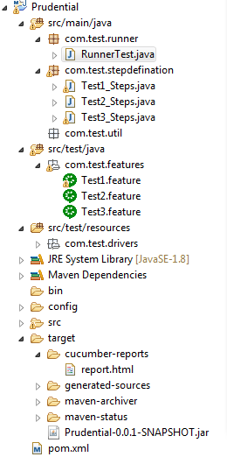

### **Features**

1.Useful for develop GUI automation  
2.Behaviour driven test automation using Cucumber/Gherkin language  
3.Maven based project  
4.JUnit is used  
5.Enabled report extending build in plugin  
6.Commandline execution

### **How to Run**

mvn clean test -Dcucumber.options="src/test/java/com/test/features"  
or  
From Eclipse:  
Run as Unit test providing below details:  
Project : Prudential  
Test class: com.test.runner.RunnerTest

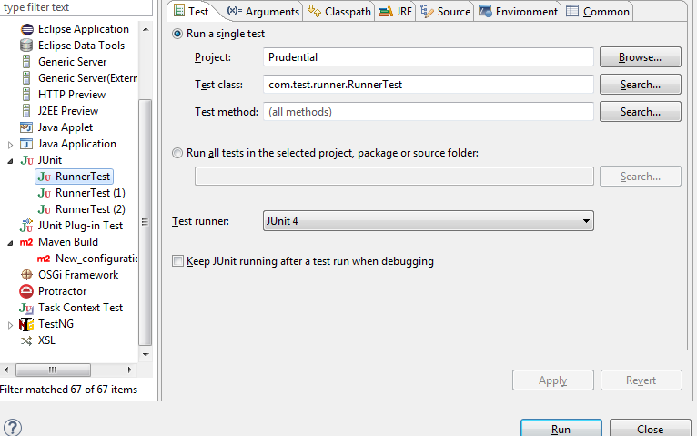

### **Examples:**

### Runner

@RunWith(Cucumber.class)  
@CucumberOptions(features = "src/test/java/com/test/features", glue = "com.test.stepdefination",  
plugin = { "com.cucumber.listener.ExtentCucumberFormatter:target/cucumber-reports/report.html" }, monochrome = true)  
public class RunnerTest {  
@AfterClass  
public static void writeExtentReport() {  
Reporter.loadXMLConfig(new File("config/report.xml"));  
}  
}

### Step defination

@Then("^I validate entity openweathermap$") public void i_validate_label_openweathermap() throws Throwable { try { Boolean actual = driver .findElement( By.xpath("//a[@class='navbar-brand']//img[@class='img-responsive']")) .isDisplayed(); Assert.assertEquals(true, actual); } catch (Exception e) { System.out.println("Error occured due to: " + e); } }

### Feature File

#Author: [pradip.blr28@gmail.com](mailto:pradip.blr28@gmail.com)

@tag  
Feature: Verify all important information in the page

@label  
Scenario Outline: Verifies that all important information is there, e.g. labels etc  
Given I open the application in the browser  
Then I validate entity   
Examples:  
| name |  
| openweathermap |  
| Support Center |  
| Sign In |  
| Sign Up |  
| Weather |  
| Maps | | Guide |  
| Search TextBox |

### **Report**

Navigate to target/cucumber-reports/reports.html

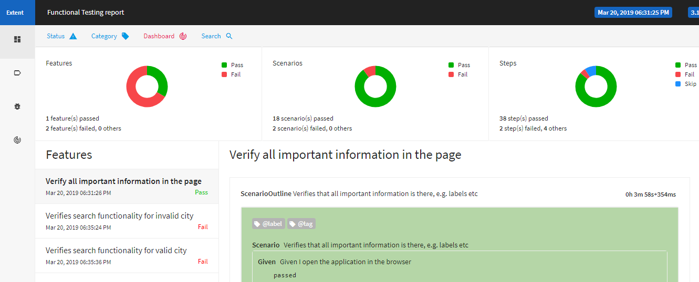

### **CI integration via Jenkin**

This is also done, but setup is in local system.

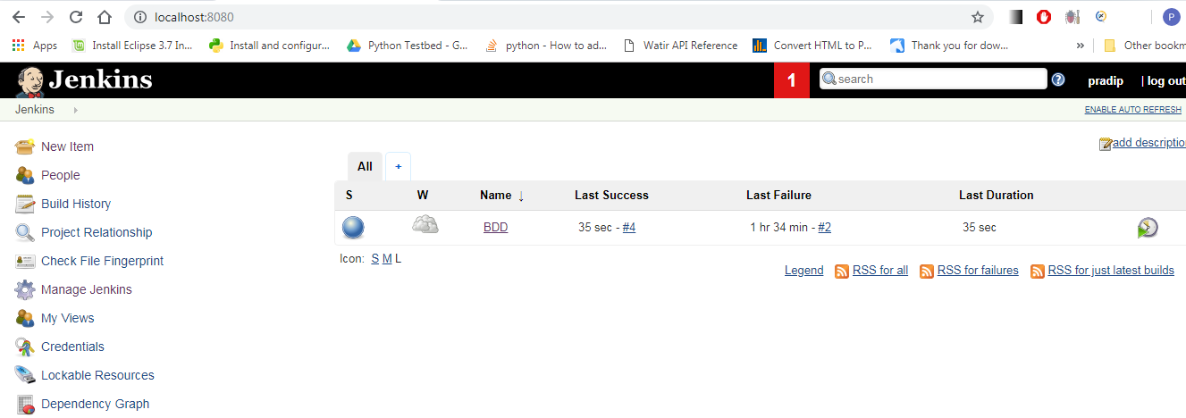

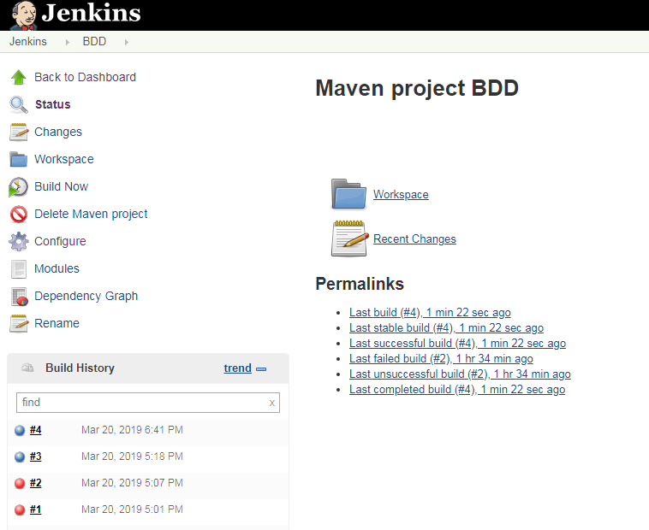

Console Output  
Started by user pradip  
Running as SYSTEM  
Building in workspace C:\Users\personal.jenkins\workspace\BDD  
Parsing POMs  
Established TCP socket on 39156  
[Prudential] $ "C:\Program Files\Java\jdk1.8.0_171/bin/java" -cp C:\Users\personal.jenkins\plugins\maven-plugin\WEB-INF\lib\maven35-agent-1.12.jar;C:\apache-maven-3.6.0\boot\plexus-classworlds-2.5.2.jar;C:\apache-maven-3.6.0/conf/logging jenkins.maven3.agent.Maven35Main C:\apache-maven-3.6.0 C:\Users\personal.jenkins\war\WEB-INF\lib\remoting-3.29.jar C:\Users\personal.jenkins\plugins\maven-plugin\WEB-INF\lib\maven35-interceptor-1.12.jar C:\Users\personal.jenkins\plugins\maven-plugin\WEB-INF\lib\maven3-interceptor-commons-1.12.jar 39156  
<===[JENKINS REMOTING CAPACITY]===>channel started  
Executing Maven: -B -f C:\selenium\Prudential\pom.xml clean install  
[INFO] Scanning for projects...  
[INFO]  
[INFO] -----------------------< Prudential:Prudential >------------------------  
[INFO] Building Prudential 0.0.1-SNAPSHOT  
[INFO] --------------------------------[ jar ]---------------------------------  
[INFO]  
[INFO] --- maven-clean-plugin:2.5:clean (default-clean) @ Prudential ---  
[INFO] Deleting C:\selenium\Prudential\target  
[INFO]  
[INFO] --- maven-resources-plugin:2.6:resources (default-resources) @ Prudential ---  
[WARNING] Using platform encoding (Cp1252 actually) to copy filtered resources, i.e. build is platform dependent!  
[INFO] skip non existing resourceDirectory C:\selenium\Prudential\src\main\resources  
[INFO]  
[INFO] --- maven-compiler-plugin:3.1:compile (default-compile) @ Prudential ---  
[INFO] Changes detected - recompiling the module!  
[WARNING] File encoding has not been set, using platform encoding Cp1252, i.e. build is platform dependent!  
[INFO] Compiling 4 source files to C:\selenium\Prudential\target\classes  
[INFO] [INFO] --- maven-resources-plugin:2.6:testResources (default-testResources) @ Prudential ---  
[WARNING] Using platform encoding (Cp1252 actually) to copy filtered resources, i.e. build is platform dependent!  
[INFO] Copying 1 resource  
[INFO] [INFO] --- maven-compiler-plugin:3.1:testCompile (default-testCompile) @ Prudential ---  
[INFO] Nothing to compile - all classes are up to date  
[INFO]  
[INFO] --- maven-surefire-plugin:2.12.4:test (default-test) @ Prudential ---  
[JENKINS] Recording test results[WARNING] Attempt to (de-)serialize anonymous class hudson.maven.reporters.BuildInfoRecorder$1; see: <https://jenkins.io/redirect/serialization-of-anonymous-classes/>

[INFO]  
[INFO] --- maven-jar-plugin:2.4:jar (default-jar) @ Prudential ---  
[INFO] Building jar: C:\selenium\Prudential\target\Prudential-0.0.1-SNAPSHOT.jar  
[INFO]  
[INFO] --- maven-install-plugin:2.4:install (default-install) @ Prudential ---  
[INFO] Installing C:\selenium\Prudential\target\Prudential-0.0.1-SNAPSHOT.jar to C:\Users\personal.m2\repository\Prudential\Prudential\0.0.1-SNAPSHOT\Prudential-0.0.1-SNAPSHOT.jar  
[INFO] Installing C:\selenium\Prudential\pom.xml to C:\Users\personal.m2\repository\Prudential\Prudential\0.0.1-SNAPSHOT\Prudential-0.0.1-SNAPSHOT.pom  
[INFO] ------------------------------------------------------------------------  
[INFO] BUILD SUCCESS  
[INFO] ------------------------------------------------------------------------  
[INFO] Total time: 6.181 s  
[INFO] Finished at: 2019-03-20T17:19:09+05:30  
[INFO] ------------------------------------------------------------------------  
Waiting for Jenkins to finish collecting data  
[JENKINS] Archiving C:\selenium\Prudential\pom.xml to Prudential/Prudential/0.0.1-SNAPSHOT/Prudential-0.0.1-SNAPSHOT.pom  
[JENKINS] Archiving C:\selenium\Prudential\target\Prudential-0.0.1-SNAPSHOT.jar to Prudential/Prudential/0.0.1-SNAPSHOT/Prudential-0.0.1-SNAPSHOT.jar  
channel stopped  
Finished: SUCCESS