New Web Designer For Solar Panel Company. Ltd.
Design Documents Developed by Solar Panel Company
For Attracting New Business Customers.

Design Brief:

Greetings, I'm glad to have you join us. We have great recommendations for you as a competent and effective web developer. I'm Pradip Pandey, the CEO of Solar panel Company, a medium-sized business that primarily supplies needs for solar energy use for Australian small businesses. Allow me to introduce myself.
In summary, we've become busier and busier. This is mostly because we make an effort to differentiate ourselves from the competition and offer excellent customer service.
Sadly, customer support has become so busy that staff members and our phone lines need backup. This is where you are needed.
Let's be honest, not everyone purchase gas tank and charcoal or anything comparable, so we need a website that assists users in purchasing the solar panels using our website which helps in booking signing up through our newsletter from our website. We might be able to attract new customers with this website.
I understand your thought process. Why don't we attempt it ourselves? I would ask my current web developers to work on the site, but they are all booked up till the end of the year with other projects!
We anticipate a top-notch website because we are a solar panel selling company directly to the customers. To maintain the "look and feel" of our primary website, we will provide you with the majority of the content and navigation. This web will have its own URL, but in order for me to thoroughly test it before publishing, I need you to upload it to a server. (I understand from the university that you have your own server there; perhaps this will be a good location for you to post it.)
The website will operate on an advertising support model, meaning that its upkeep will be financed in part by the display of adverts from our other business affiliations. Our wonderful IT girl, Cheasea, will assist you with all the prerequisites.
I am eager to see what you have to offer.
As Yours With all due respect,
Pradip Pandey

STORYBOARD EACH PAGE

Background Image
NOTES: CSS external stylesheet is used which can be reused again by editing.
Layout is using a CSS box model which can be used to edit, create, and configure the contents of the page.
Image and graphics are used.

Images:
Image is used.
Footer
ELEMENTS:
AUDIO/VIDEO:
No audio or video
TEXT: Arial, Size 20px, Link=orangered, if
active = green and visited =red

GRAPHICS:
Background Image, Color and text colors are used.
TITLE

Links to Other Pages

Content

Content

Picture

Description: | Home page.html
Content: | Contact Details, website links and buttons for other pages.
Interactions: | Navigation link to resume page and form.
Media Creation: | Image linked
Navigation: | Navigation is through the top below title to other pages using the buttons.

Background Image

Description: | Resume page html
Content: | About my professional summary, achievements, and academic qualifications.
Interactions: | Navigation link to homepage, skills page and form.
Media Creation: | Logo used.
Navigation: | Navigation is through the top below title to other pages using buttons.
NOTES: CSS external stylesheet is used which can be reused again by editing.
Layout is using a CSS box model which can be used to edit, create, and configure the contents of the page.
Image and graphics are used.

Images:
Logo is used in professional way.
Footer
ELEMENTS:
AUDIO/VIDEO:
No audio or video
TEXT: Arial, Cursive Size 20px, Link=purple, if
active = green and visited =red

GRAPHICS:
Background Color, Background image and text colors are used.
logo
TITLE

Link to New Page

Content

Content

Background Image
Description: | Web design, programming, communication and networking.html
Content: | About the skills.
Interactions: | Navigation link to my resume page and to homepage.
Media Creation: | Image is linked.
Navigation: | Navigation is through the top below title to other pages using buttons and a scroll bar is used at the bottom.
NOTES: CSS external stylesheet is used which can be reused again by editing.
CSS inline style is also used for easy purpose.
Layout is using a CSS box model which can be used to edit, create, and configure the contents of the page.
Image and graphics and logo are used.

Images:
Image is used in professional way.
Footer
Content
Content
Link to New Page
TITLE
Picture
ELEMENTS:
AUDIO/VIDEO:
No audio or video
TEXT: Arial, Cursive Size 26px, Link=purple, if
active = green and visited =red

GRAPHICS:
Background Color, Image and text colors are used.

Background Image
Description: | Javascriptpage.html
Content: | Newsletter signup Form
Interactions: | Navigation link to homepage
Media Creation: | Logo is linked
Navigation: | Navigation is through the top below title to other pages using buttons.
NOTES: CSS external stylesheet is used which can be reused again by editing.
CSS inline style is also used for easy purpose.
Layout is using a CSS box model which can be used to edit, create, and configure the contents of the page.
Image and graphics and logo are used.

Images:
Logo is used in professional way.
ELEMENTS:
AUDIO/VIDEO:
No audio or video
GRAPHICS:
Background Color, Image and text colors are used.
Link
TITLE

Footer
Form
Content
TEXT: Arial, Cursive Size 26px, Link=purple, if
active = green and visited =red

HTML FILE VALIDATION:(Screenshot)

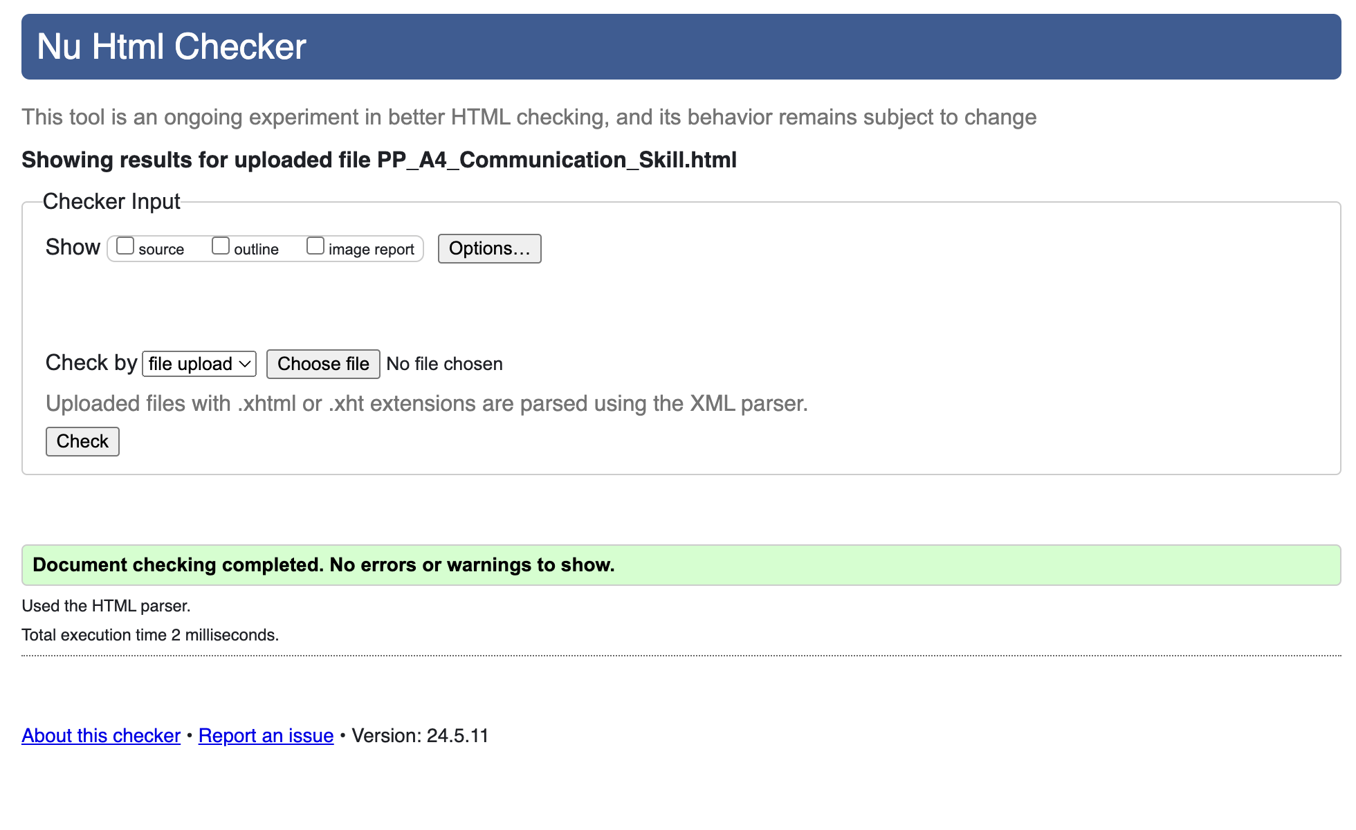

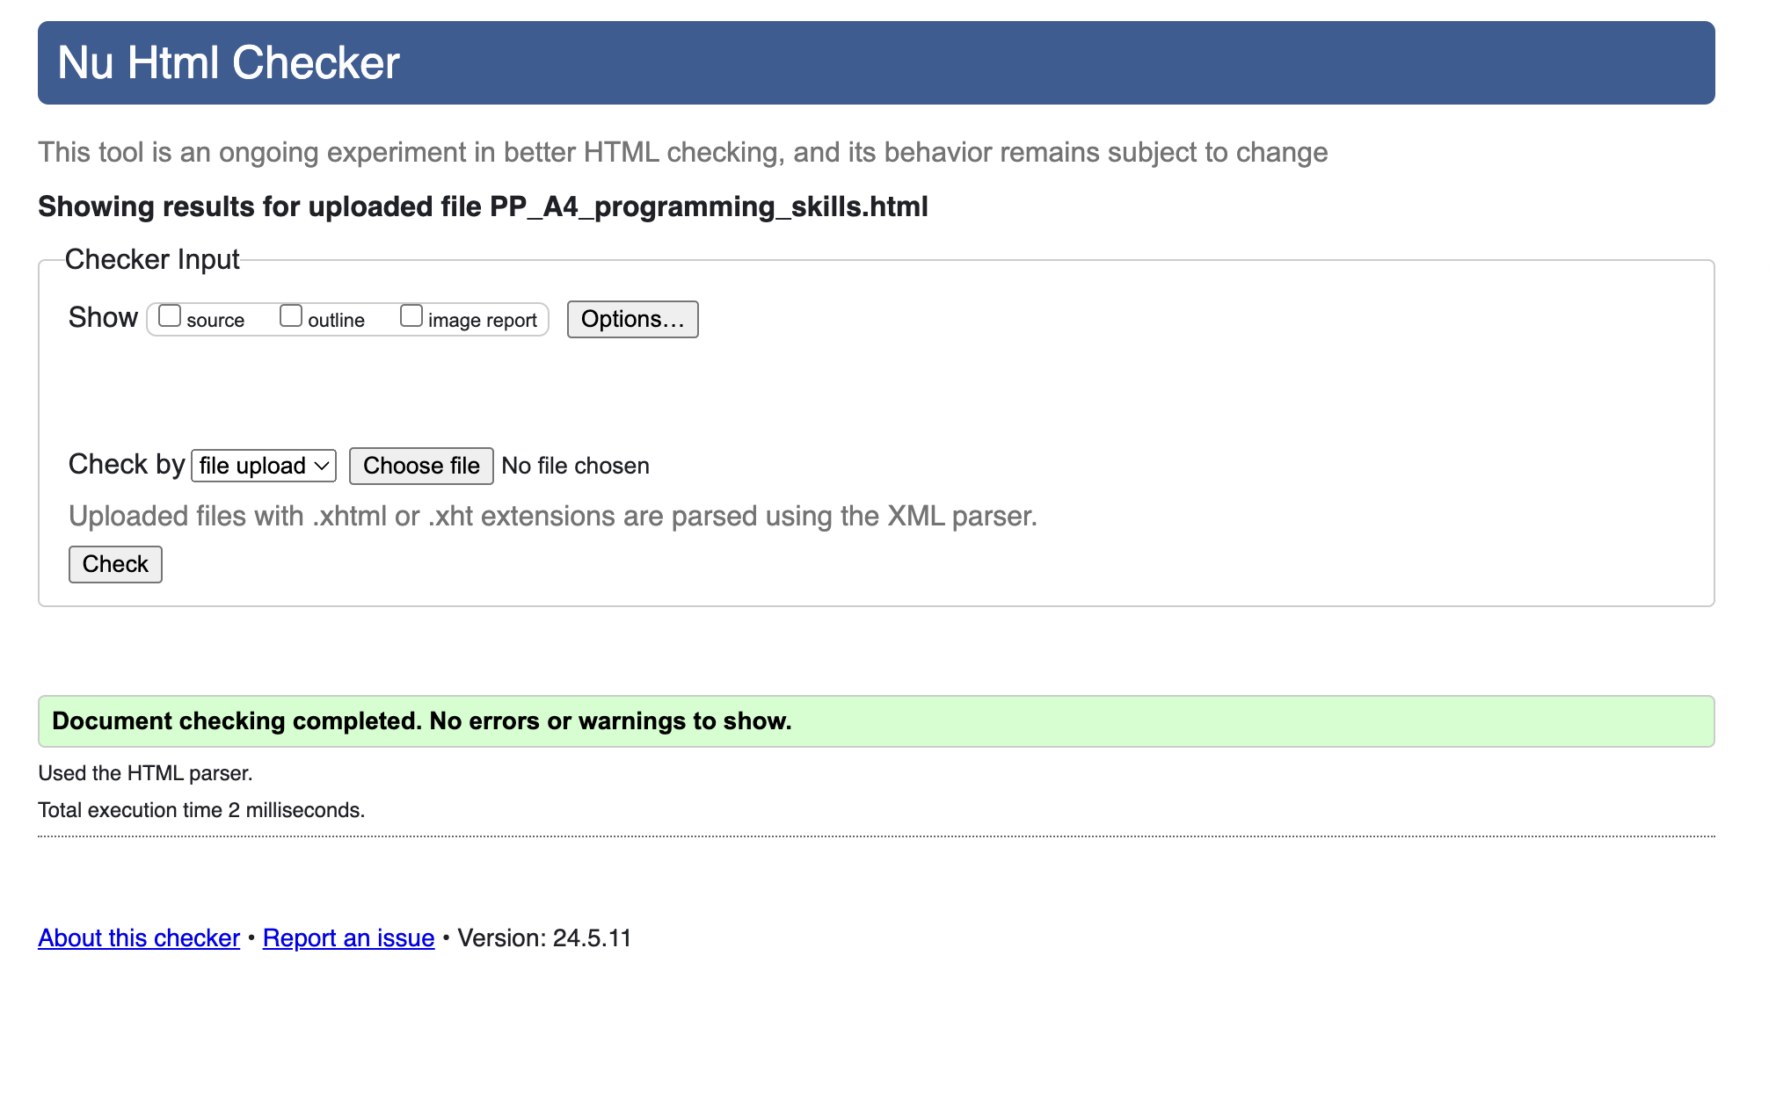

Verification Of Files:

The following is the testing protocol for this website.
• File Validation: XHTML 1.0 Transitional will be used to validate all XHTML documents.
o CSS Level 2.1 will be used to verify all CSS files.
• Check the display's "look and feel" across a range of browser widths.
• Check the "Look and Feel" of the website with several browsers:
Internet Explorer, Firefox, Chrome, and Safari.
• Verify every hyperlink on the website, including all internal and external connections (site navigation).
Examine that all of the site's media are operating properly.
Images/logo
• Verify that all JavaScript functions properly.
Form JavaScript

