Stp :

Stp stands for spanning tree protocol. Spanning Tree Protocol (STP) is a Layer 2 protocol that runs on bridges and switches.  The main purpose of STP is to ensure that you do not create loops when you have redundant paths in your network.  Redundant links are as important as backups in the case of a failover in a network. A failure of your primary activates the backup links so that users can continue to use the network. Without STP on the bridges and switches, such a failure can result in a loop.

In conclusion if one link fails it pass message through another link. It identify whether there is loop or not in the network. If it finds any loop in the network in block redundant link.

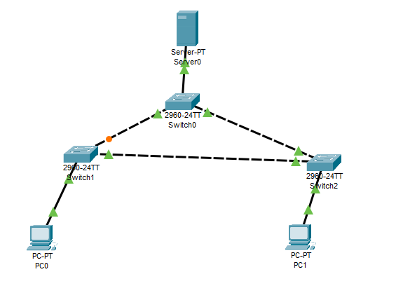

svl :

svl stands for stackwise virtual. StackWise Virtual (SV) combines two switches into a single logical network entity from the network control plane. To be the stackwise virtual both the switchs must be of same model.

Both the switch must be running of same software version. Make sure that the enough link connected for both stackwise virtual link and dual active virtual link.

In stackwise virtual link there