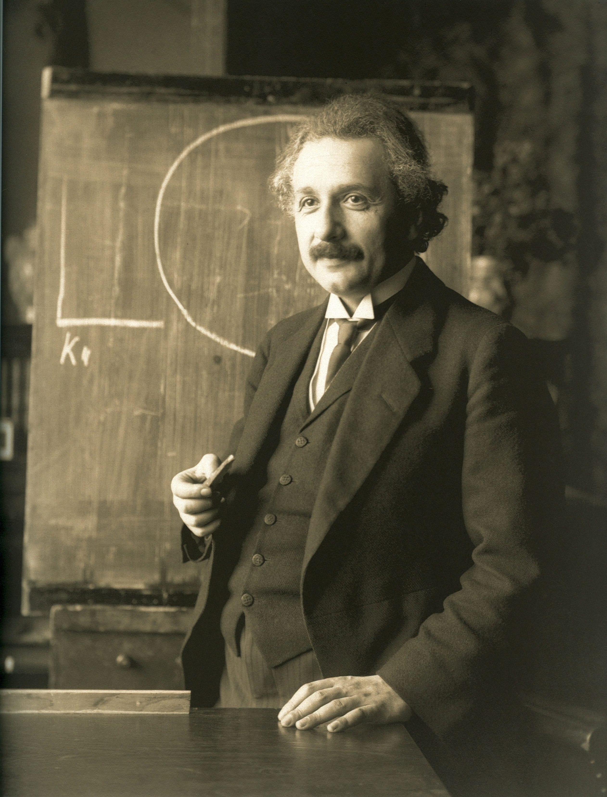

**Albert Einstein**

He is an old person.

He has got grey and black flossy hair.

He has got black mustache.

He is wearing black suits, black sub-overcoat, white shirt and black necktie.

He is a big intelligent of modern physics and the world.

He has developed mass-energy equivalence formula equation.