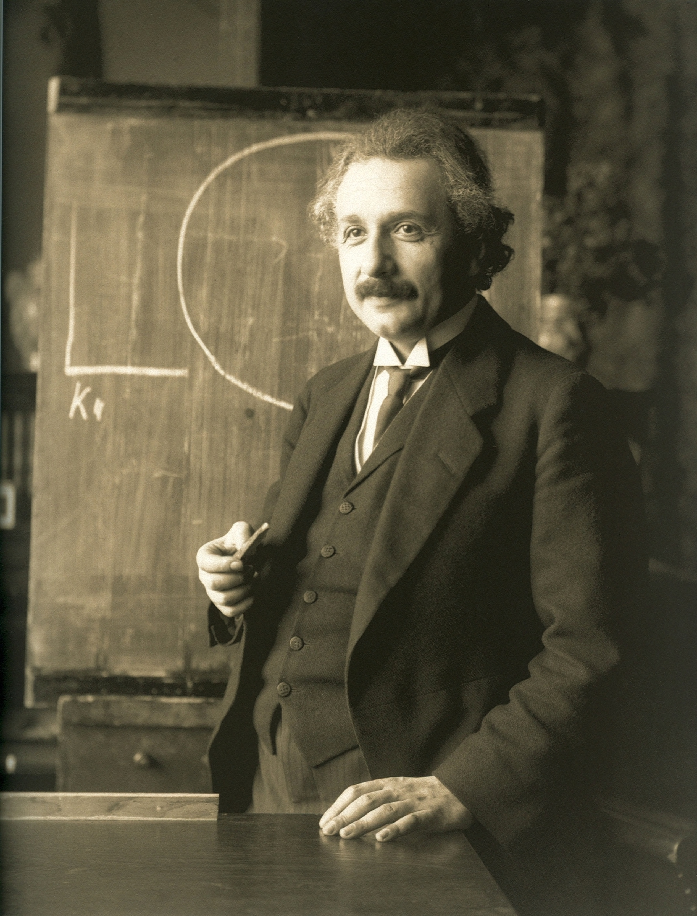

Albert Einstein

He is an old person.
He has got grey and black flossy hair.
He has got black mustache.
He is wearing black suits, black sub-overcoat, white shirt and black necktie.
He is a big intelligent of modern physics and the world.
He has developed mass-energy equivalence formula equation.

