# AN INTERNSHIP REPORT

# ELECTRICITY BILLING

# SYSTEM

***Submitted by***

|  |  |
| --- | --- |
| **BALAJI S** | **113220031021** |
| **KRISH KUMAR GUPTA** | **113220031061** |
| **PRADNESH S** | **113220031092** |

# BACHELOR OF ENGINEERING

**IN**

# COMPUTER SCIENCE AND ENGINEERING



**VELAMMAL ENGINEERING COLLEGE, CHENNAI-66.**

(An Autonomous Institution, Affiliated to Anna University, Chennai)

**2022-2023**

# VELAMMAL ENGINEERING COLLEGE, CHENNAI-66



## BONAFIDE CERTIFICATE

Certified that this internship report **“ELECTRICITY BILLING SYSTEM”** is the bonafide work of **BALAJI S** (113220031021), **KRISH KUMAR GUPTA** (113220031061), **PRADNESH S** (113220031092) carried out at “SHIASH INFO SOLUTIONS” during 10-11-2022 to 01-02-2023.

### DR. P. PRITTO PAUL, M.E, PH.D Dr. B. MURUGESHWARI

**ASSISTANT PROFESSOR - I HEAD OF THE DEPARTMENT**

Computer Science and Engineering Computer Science and Engineering

Velammal Engineering College Velammal Engineering College

Ambattur - Red Hills Road Ambattur - Red Hills Road,

Chennai – 600 066. Chennai – 600 066.

**CERTIFICATE FROM INDUSTRY:**







# CERTIFICATE OF EVALUATION

**COLLEGE NAME:** VELAMMAL ENGINEERING COLLEGE **BRANCH:** COMPUTER SCIENCE AND ENGINEERING **SEMESTER:** VI

|  |  |  |  |
| --- | --- | --- | --- |
| **S.No** | **Name of the student who has done the Internship** | **Title of the Internship** | **Name of Faculty**  **Coordinator with Designation** |
| **1** | **BALAJI S** |  |  |
| **2** | **KRISH KUMAR GUPTA** | **ELECTRICITY**  **BILLING SYSTEM** | **DR. P. PRITTO PAUL, M.E, PH.D** |
| **3** | **PRADNESH S** |  |  |

This report of internship work submitted by the above student in partial fulfillment for the award of Bachelor of Computer Science and Engineering Degree in Anna University was evaluated and confirmed to be reports of the work done by the above student and then assessed.

Submitted for Internal Evaluation held on........................

**Examiner1 Examiner2 Examiner3**

**ACKNOWLEDGEMENT**

I wish to acknowledge with thanks to the significant contribution given by the management of our college **Chairman, Dr. M. V. Muthuramalingam**, and our **Chief Executive Officer Thiru.**

**M.V.M. Velmurugan**, for their extensive support.

I would like to thank **Dr. S. SATHISHKUMAR, Principal** of Velammal Engineering College, for giving me this opportunity to do this project.

I wish to express my gratitude to our effective **Head of the Department, Dr. B. Murugeshwari**, for her moral support and for her valuable innovative suggestions, constructive interaction, constant encouragement and unending help that have enabled me to complete the project.

I wish to express my indebted humble thanks to the Company **SHIASH INFO SOLUTIONS**

and the External Guide **Mrs.DHANALAKSHMI** for their invaluable guidance in shaping this project.

I wish to express my sincere gratitude to my **Internal Guide, DR. P. PRITTO PAUL, M.E, PH.D, Assistant Professor I**, Department of Computer Science and Engineering for her guidance, without whom this project would not have been possible.

I am grateful to the entire staff members of the department of Computer Science and Engineering for providing the necessary facilities to carry out the project. I would especially like to thank my parents for providing me with the unique opportunity to work, and for their encouragement and support at all levels. Finally, my heartfelt thanks to **The Almighty** for guiding me throughout life.

### TABLE OF CONTENTS

|  |  |  |
| --- | --- | --- |
| **CHAPTER NO.** | **TITLE** | **PAGE** |
|  | ABSTRACT | IV |
|  | LIST OF FIGURES | V |
| **1** | **INTRODUCTION AND COMPANY PROFILE**  1.1 INTRODUCTION | 1 |
|  | 1.2 COMPANY PROFILE | 1 |
| **2** | **PROJECT DESCRIPTION**  2.1 AIMS AND OBJECTIVES | 2 |
|  | 2.2 SCOPE | 2 |
| **3** | **FUNCTIONAL AND NON-FUNCTIONAL REQUIREMENTS**  3.1 EXTERNAL INTERFACE | 3 |
|  | 3.1.1 HARDWARE INTERFACE | 3 |
|  | 3.1.2 SOFTWARE INTERFACE | 3 |
|  | 3.2 NON-FUNCTIONAL REQUIREMENTS | 3 |
|  | 3.3 RELIABILITY | 3 |
|  | 3.4 AVAILABILITY | 4 |
|  | 3.5 PERFORMANCE | 4 |
|  | 3.6 SOFTWARE SYSTEM ATTRIBUTES | 4 |

1. **ANALYSIS AND DESIGN**
   1. [UML DIAGRAM 5](#_TOC_250019)
      1. [USE CASE DIAGRAM 6](#_TOC_250018)
2. CONCLUSION 7

APPENDICES A CODE

[8](#_TOC_250017)

[LOGIN.JSP 9](#_TOC_250016)

[REGISTER.JSP 10](#_TOC_250015)

[ATTENDANCE.JSP 12](#_TOC_250014)

[B:OUTPUT 41](#_TOC_250001)

[REFERENCES 44](#_TOC_250000)

### ABSTRACT

Electricity consumers are often faced with the problem of inaccuracy and delay in monthly billing due to some drawbacks. Thus, it is essential to have an efficient system for such purposes via electronic platform with consideration to proximity.The proposed system automates the conventional process of paying electricity bill by visiting the Electricity Board which is tiresome and time consuming. It is also designed to automate the electricity bill calculation and payment for user convenience. The system is developed with Java swings as the base programming language which can be used to develop websites, web applications and web services. The Microsoft Structured Query Language (SQL) server is also used for creating back-end database. The system would be having two logins: the administrative and user login. The administrator can view the user's account details and can add the customer's information of consuming units of energy of the current month in their account. The Admin must feed the system with the electricity usage data into respective user’s account. The system then calculates the electricity bill for every user and updates the information into their account every month. Users can then view their electricity bill and pay before the month end.

### LIST OF FIGURES

**DIAGRAM PAGE**

* 1. UML DIAGRAM 5
  2. USE CASE DIAGRAM 6

**CHAPTER 1- INTRODUCTION AND COMPANY PROFILE**

### Introduction

Electricity Billing System is a software-based application.

i.This project aims at serving the department of electricity by computerizing the billing system.

ii.It mainly focuses on the calculation of units consumed during the specified time and the money to be charged by the electricity offices.

iii.This computerized system will make the overall billing system easy, accessible, comfortable, and effective for consumers. To design the billing system more service oriented and simple, the following features have been implemented in the project. The application has high speed of performance with accuracy and efficiency. The software provides facility of data sharing, it does not require any staff as in the conventional system. Once it is installed on the system only the meter readings are to be given by the admin where customer can view all details, it has the provision of security restriction. The electricity billing software calculates the units consumed by the customer and makes bills, it requires small storage for installation and functioning. There is provision for debugging if any problem is encountered in the system. The system excludes the need of maintaining paper electricity bill, administrator does not have to keep a manual track of the users, users can pay the amount without visiting the office. Thus, it saves human efforts and resources.

**Company profile**

Shiash Info Solutions is an IT services, Digital and Business solutions company based in Chennai (India) providing Customized Software Development, Web Application Development, Mobile Application Development and IT Consulting Services. We have earned the pride of being one of the leading desktop & web based software solution provider in India, we develop software solution that helps our customers to outperform the competition and stay ahead in today’s competitive business environment. We firmly believe that business needs can be only met when technology is in sync with business process. At Shiash Info Solution , we provide multi-dimensional IT services that caters to high-end internet strategy, software development and design solutions for corporate clients all across the globe. We have a wide and varied range of products & services that can suit the divergent needs of our large client base. We understand that for the success of any project Time, Quality and Sup port has to be top class, for this our planning & quality control team make sure that your projects are very planned & designed to be delivered on time & also the quality of the project is more than what you have expected.

## CHAPTER 2 – PROJECT DESCRIPTION

### Aims and Objective:-

We, the owners of our project, respect all customers and make them happy with our service. The main aim of our project is to satisfy customer by saving their time by payment process, maintaining records, and allowing the customer to view his/her records and permitting them to update their details The firm handles all the work manually, which is very tedious and mismatched.

The objectives of our project are as follows:

* To keep the information of consuming unit energy of current month.
* To keep the information of Customer.
* To keep the information of consuming unit energy of previous month.
* To calculate the units consumed every month regularly.
* To generate the bills adding penalty and rent.
* To save the time by implementing payment process online

### Scope:

## our project aims at business process automation, i.e. we have tried to computerize various processes of electricity billing system. in the sector of electricity board we have computerizes their department and stock maintenance. scope of any software depends upon the following things:

## 1. it satisfy the user requirement

## 2. be easy to understand by the user and operator

## 3. be easy to operate

## 4. have a good user interface

## 5. be expandable

## 6. delivered on schedule within the budget. we have tried to make such type of software, which satisfy the above given requirement.

## CHAPTER 3- FUNCTIONAL AND NON-FUNCTIONAL REQUIREMENTS

### External Interface Requirements:

**Hardware Interface**

* Hardware Specification: -Processor Intel Pentium V or higher
* Clock Speed: -1.7 GHz or more
* System Bus: -64 bits
* RAM: -16GB
* HDD: -2TB
* Monitor: -LCD Monitor
* Keyboard: -Standard keyboard
* Mouse: -Compatible mouse

### Software Interface

* Operating System: -Windows 10
* Software: -Microsoft SQL Server
* Front End: -Java core/swings (NetBeans)
* Back End: -My Sql

### Non-Functional Requirements:

### System should be able to handle multiple users.

### Login by username, password should be incorporated wherever necessary.

### Should be user friendly and display easy to understand error messages.

### Reliability

Data validation & verification need to be done at every stage of activity. Validation user input.

### Availability

* The web application should be available anywhere and anytime.
* User Session should timeout after 20 minutes of inactivity

### Performance

The system will be used by multiple users and may grow as time passes. Necessary measures need to be taken to make the system as fast as possible.

### Software System Attributes

* **Usability:** The user is facilitated to view and make entries in the forms. Validations are provided in each field to avoid inconsistent or invalid entry in the databases.
* **Security:** Application will allow only valid users to access the system. Access to any application resource will depend upon the user's designation. Security is based upon the individual username and password.
* **Maintainability:** The attendance detail will be easily available for the user.
* **Portability**: The application is developed in Netbeans. It would be portable to other operating systems provided .NET Framework is available for the OS. As the database is made in SQL Server, porting the database to another database server would require some development effort.

### Characteristics of the proposed system:

The web application has following features:

* In comparison to the present system the proposed system will be less time consuming and is more efficient.
* Analysis will be very easy in the proposed system as it is automated.
* The proposed system is very secure as no chances of loss of data as it is depends on the administrator only.

**CHAPTER-4**

**ANALYSIS AND DESIGN**

**4.1 UML DIAGRAM**

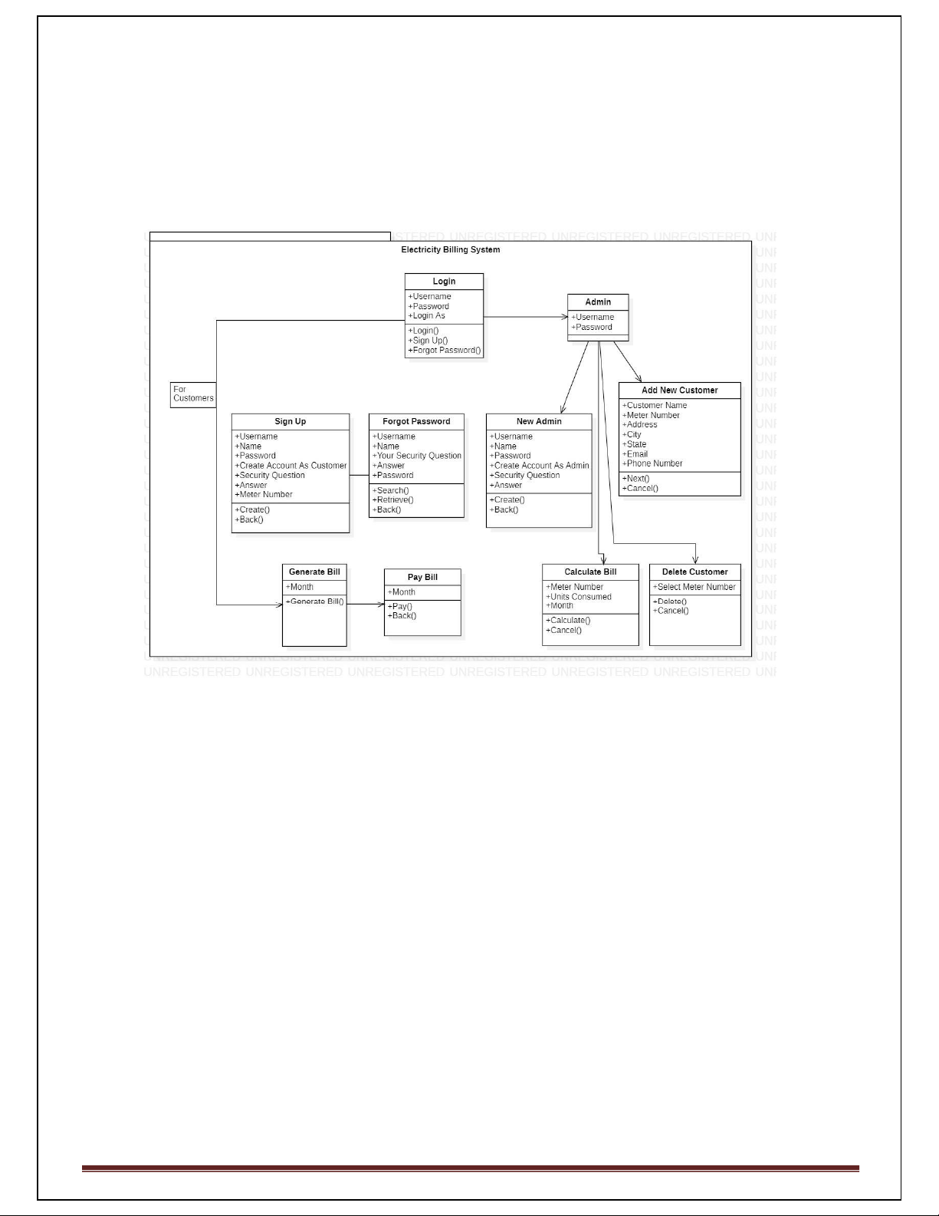

### 4.2 USE CASE DIAGRAM

### IMG_256

### CHAPTER 5 - CONCLUSION

The development of the software includes so many people like user system developer, user of the system and the management, it is important to identify the system requirements by properly collecting required data to interact with the system. Proper design builds upon this foundation and gives a blueprint, which is actually implemented by the developers. We have gained a lot of practical knowledge from this project, which we think, shall make us stand in a good state in the future.

### APPENDICES

**A: CODE**

### 

**About.java**

package Electricity;

import java.awt.\*;

import java.awt.event.\*;

import javax.swing.\*;

import java.awt.Font;

import javax.swing.JFrame;

import javax.swing.border.Border;

public class About extends JFrame implements ActionListener {

JButton b1;

JLabel l1;

Font f, f1, f2;

TextArea t1;

String s;

public About() {

setLayout(null);

JButton b1 = new JButton("Exit");

add(b1);

b1.setBounds(180, 430, 120, 20);

b1.addActionListener(this);

Font f = new Font("RALEWAY", Font.BOLD, 180);

setFont(f);

s = " About Projects \n "

+ "\nElectricity Billing System is a software-based application "

+ "developed in Java programming language. The project aims at serving"

+ "the department of electricity by computerizing the billing system. "

+ "It mainly focuses on the calculation of Units consumed during the "

+ "specified time and the money to be paid to electricity offices. "

+ "This computerized system will make the overall billing system easy, "

+ "accessible, comfortable and effective for consumers.\n\n"

;

TextArea t1 = new TextArea(s, 10, 40, Scrollbar.VERTICAL);

t1.setEditable(false);

t1.setBounds(20, 100, 450, 300);

add(t1);

Font f1 = new Font("RALEWAY", Font.BOLD, 16);

t1.setFont(f1);

Container contentPane = this.getContentPane();

t1 = new TextArea();

JLabel l1 = new JLabel("About Project");

add(l1);

l1.setBounds(170, 10, 180, 80);

l1.setForeground(Color.red);

Font f2 = new Font("RALEWAY", Font.BOLD, 20);

l1.setFont(f2);

setBounds(700, 220, 500, 550);

setLayout(null);

setVisible(true);

}

public void actionPerformed(ActionEvent e) {

dispose();

}

public static void main(String args[]) {

new About().setVisible(true);

}

}

**Billdetail.java**

package Electricity;

import javax.swing.\*;

import java.awt.\*;

import java.sql.\*;

import net.proteanit.sql.DbUtils;

public class BillDetails extends JFrame{

BillDetails(String meter) {

setSize(700, 650);

setLocation(400, 150);

getContentPane().setBackground(Color.WHITE);

JTable table = new JTable();

try {

Conn c = new Conn();

String query = "select \* from bill where meter\_no = '"+meter+"'";

ResultSet rs = c.s.executeQuery(query);

table.setModel(DbUtils.resultSetToTableModel(rs));

} catch (Exception e) {

e.printStackTrace();

}

JScrollPane sp = new JScrollPane(table);

sp.setBounds(0, 0, 700, 650);

add(sp);

setVisible(true);

}

public static void main(String[] args) {

new BillDetails("");

}

}

**Calculatebill.java**

package Electricity;

import javax.swing.\*;

import java.awt.\*;

import java.util.\*;

import java.awt.event.\*;

import java.sql.\*;

public class CalculateBill extends JFrame implements ActionListener{

JTextField tfname, tfaddress, tfstate, tfunits, tfemail, tfphone;

JButton next, cancel;

JLabel lblname, labeladdress;

Choice meternumber, cmonth;

CalculateBill() {

setSize(700, 500);

setLocation(400, 150);

JPanel p = new JPanel();

p.setLayout(null);

p.setBackground(new Color(173, 216, 230));

add(p);

JLabel heading = new JLabel("Calculate Electricity Bill");

heading.setBounds(100, 10, 400, 25);

heading.setFont(new Font("Tahoma", Font.PLAIN, 24));

p.add(heading);

JLabel lblmeternumber = new JLabel("Meter Number");

lblmeternumber.setBounds(100, 80, 100, 20);

p.add(lblmeternumber);

meternumber = new Choice();

try {

Conn c = new Conn();

ResultSet rs = c.s.executeQuery("select \* from customer");

while(rs.next()) {

meternumber.add(rs.getString("meter\_no"));

}

} catch (Exception e) {

e.printStackTrace();

}

meternumber.setBounds(240, 80, 200, 20);

p.add(meternumber);

JLabel lblmeterno = new JLabel("Name");

lblmeterno.setBounds(100, 120, 100, 20);

p.add(lblmeterno);

lblname = new JLabel("");

lblname.setBounds(240, 120, 100, 20);

p.add(lblname);

JLabel lbladdress = new JLabel("Address");

lbladdress.setBounds(100, 160, 100, 20);

p.add(lbladdress);

labeladdress = new JLabel();

labeladdress.setBounds(240, 160, 200, 20);

p.add(labeladdress);

try {

Conn c = new Conn();

ResultSet rs = c.s.executeQuery("select \* from customer where meter\_no = '"+meternumber.getSelectedItem()+"'");

while(rs.next()) {

lblname.setText(rs.getString("name"));

labeladdress.setText(rs.getString("address"));

}

} catch (Exception e) {

e.printStackTrace();

}

meternumber.addItemListener(new ItemListener() {

public void itemStateChanged(ItemEvent ie) {

try {

Conn c = new Conn();

ResultSet rs = c.s.executeQuery("select \* from customer where meter\_no = '"+meternumber.getSelectedItem()+"'");

while(rs.next()) {

lblname.setText(rs.getString("name"));

labeladdress.setText(rs.getString("address"));

}

} catch (Exception e) {

e.printStackTrace();

}

}

});

JLabel lblcity = new JLabel("Units Consumed");

lblcity.setBounds(100, 200, 100, 20);

p.add(lblcity);

tfunits = new JTextField();

tfunits.setBounds(240, 200, 200, 20);

p.add(tfunits);

JLabel lblstate = new JLabel("Month");

lblstate.setBounds(100, 240, 100, 20);

p.add(lblstate);

cmonth = new Choice();

cmonth.setBounds(240, 240, 200, 20);

cmonth.add("January");

cmonth.add("February");

cmonth.add("March");

cmonth.add("April");

cmonth.add("May");

cmonth.add("June");

cmonth.add("July");

cmonth.add("August");

cmonth.add("September");

cmonth.add("October");

cmonth.add("November");

cmonth.add("December");

p.add(cmonth);

next = new JButton("Submit");

next.setBounds(120, 350, 100,25);

next.setBackground(Color.BLACK);

next.setForeground(Color.WHITE);

next.addActionListener(this);

p.add(next);

cancel = new JButton("Cancel");

cancel.setBounds(250, 350, 100,25);

cancel.setBackground(Color.BLACK);

cancel.setForeground(Color.WHITE);

cancel.addActionListener(this);

p.add(cancel);

setLayout(new BorderLayout());

add(p, "Center");

ImageIcon i1 = new ImageIcon(ClassLoader.getSystemResource("icon/hicon2.jpg"));

Image i2 = i1.getImage().getScaledInstance(150, 300, Image.SCALE\_DEFAULT);

ImageIcon i3 = new ImageIcon(i2);

JLabel image = new JLabel(i3);

add(image, "West");

getContentPane().setBackground(Color.WHITE);

setVisible(true);

}

public void actionPerformed(ActionEvent ae) {

if (ae.getSource() == next) {

String meter = meternumber.getSelectedItem();

String units = tfunits.getText();

String month = cmonth.getSelectedItem();

int totalbill = 0;

int unit\_consumed = Integer.parseInt(units);

String query = "select \* from tax";

try {

Conn c = new Conn();

ResultSet rs = c.s.executeQuery(query);

while(rs.next()) {

totalbill += unit\_consumed \* Integer.parseInt(rs.getString("cost\_per\_unit"));

totalbill += Integer.parseInt(rs.getString("meter\_rent"));

totalbill += Integer.parseInt(rs.getString("service\_charge"));

totalbill += Integer.parseInt(rs.getString("service\_tax"));

totalbill += Integer.parseInt(rs.getString("swacch\_bharat\_cess"));

totalbill += Integer.parseInt(rs.getString("fixed\_tax"));

}

} catch (Exception e) {

e.printStackTrace();

}

String query2 = "insert into bill values('"+meter+"', '"+month+"', '"+units+"', '"+totalbill+"', 'Not Paid')";

try {

Conn c = new Conn();

c.s.executeUpdate(query2);

JOptionPane.showMessageDialog(null, "Customer Bill Updated Successfully");

setVisible(false);

} catch (Exception e) {

e.printStackTrace();

}

} else {

setVisible(false);

}

}

public static void main(String[] args) {

new CalculateBill();

}

}

**Con.java**

package Electricity;

import java.sql.\*;

public class Conn {

Connection c;

Statement s;

Conn() {

try {

c = DriverManager.getConnection("jdbc:mysql:///project2", "root", "Admin");

s = c.createStatement();

} catch (Exception e) {

e.printStackTrace();

}

}

}

**Customerdetails.java**

package Electricity;

import java.awt.\*;

import javax.swing.\*;

import java.sql.\*;

import net.proteanit.sql.DbUtils;

import java.awt.event.\*;

public class CustomerDetails extends JFrame implements ActionListener{

Choice meternumber, cmonth;

JTable table;

JButton search, print;

CustomerDetails(){

super("Customer Details");

setSize(1200, 650);

setLocation(200, 150);

table = new JTable();

try {

Conn c = new Conn();

ResultSet rs = c.s.executeQuery("select \* from customer");

table.setModel(DbUtils.resultSetToTableModel(rs));

} catch (Exception e) {

e.printStackTrace();

}

JScrollPane sp = new JScrollPane(table);

add(sp);

print = new JButton("Print");

print.addActionListener(this);

add(print, "South");

setVisible(true);

}

public void actionPerformed(ActionEvent ae) {

try {

table.print();

} catch (Exception e) {

e.printStackTrace();

}

}

public static void main(String[] args) {

new CustomerDetails();

}

}

**Depositdetails.java**

package Electricity;

import java.awt.\*;

import javax.swing.\*;

import java.sql.\*;

import net.proteanit.sql.DbUtils;

import java.awt.event.\*;

public class DepositDetails extends JFrame implements ActionListener{

Choice meternumber, cmonth;

JTable table;

JButton search, print;

DepositDetails(){

super("Deposit Details");

setSize(700, 700);

setLocation(400, 100);

setLayout(null);

getContentPane().setBackground(Color.WHITE);

JLabel lblmeternumber = new JLabel("Search By Meter Number");

lblmeternumber.setBounds(20, 20, 150, 20);

add(lblmeternumber);

meternumber = new Choice();

meternumber.setBounds(180, 20, 150, 20);

add(meternumber);

try {

Conn c = new Conn();

ResultSet rs = c.s.executeQuery("select \* from customer");

while(rs.next()) {

meternumber.add(rs.getString("meter\_no"));

}

} catch (Exception e) {

e.printStackTrace();

}

JLabel lblmonth = new JLabel("Search By Month");

lblmonth.setBounds(400, 20, 100, 20);

add(lblmonth);

cmonth = new Choice();

cmonth.setBounds(520, 20, 150, 20);

cmonth.add("January");

cmonth.add("February");

cmonth.add("March");

cmonth.add("April");

cmonth.add("May");

cmonth.add("June");

cmonth.add("July");

cmonth.add("August");

cmonth.add("September");

cmonth.add("October");

cmonth.add("November");

cmonth.add("December");

add(cmonth);

table = new JTable();

try {

Conn c = new Conn();

ResultSet rs = c.s.executeQuery("select \* from bill");

table.setModel(DbUtils.resultSetToTableModel(rs));

} catch (Exception e) {

e.printStackTrace();

}

JScrollPane sp = new JScrollPane(table);

sp.setBounds(0, 100, 700, 600);

add(sp);

search = new JButton("Search");

search.setBounds(20, 70, 80, 20);

search.addActionListener(this);

add(search);

print = new JButton("Print");

print.setBounds(120, 70, 80, 20);

print.addActionListener(this);

add(print);

setVisible(true);

}

public void actionPerformed(ActionEvent ae) {

if (ae.getSource() == search) {

String query = "select \* from bill where meter\_no = '"+meternumber.getSelectedItem()+"' and month = '"+cmonth.getSelectedItem()+"'";

try {

Conn c = new Conn();

ResultSet rs = c.s.executeQuery(query);

table.setModel(DbUtils.resultSetToTableModel(rs));

} catch (Exception e) {

}

} else {

try {

table.print();

} catch (Exception e) {

e.printStackTrace();

}

}

}

public static void main(String[] args) {

new DepositDetails();

}

}

**Generatebill.java**

package Electricity;

import javax.swing.\*;

import java.awt.\*;

import java.awt.event.\*;

import java.sql.\*;

public class GenerateBill extends JFrame implements ActionListener{

String meter;

JButton bill;

Choice cmonth;

JTextArea area;

GenerateBill(String meter) {

this.meter = meter;

setSize(500, 800);

setLocation(550, 30);

setLayout(new BorderLayout());

JPanel panel = new JPanel();

JLabel heading = new JLabel("Generate Bill");

JLabel meternumber = new JLabel(meter);

cmonth = new Choice();

cmonth.add("January");

cmonth.add("February");

cmonth.add("March");

cmonth.add("April");

cmonth.add("May");

cmonth.add("June");

cmonth.add("July");

cmonth.add("August");

cmonth.add("September");

cmonth.add("October");

cmonth.add("November");

cmonth.add("December");

area = new JTextArea(50, 15);

area.setText("\n\n\t--------Click on the---------\n\t Generate Bill Button to get\n\tthe bill of the Selected Month");

area.setFont(new Font("Senserif", Font.ITALIC, 18));

JScrollPane pane = new JScrollPane(area);

bill = new JButton("Generate Bill");

bill.addActionListener(this);

panel.add(heading);

panel.add(meternumber);

panel.add(cmonth);

add(panel, "North");

add(pane, "Center");

add(bill, "South");

setVisible(true);

}

public void actionPerformed(ActionEvent ae) {

try {

Conn c = new Conn();

String month = cmonth.getSelectedItem();

area.setText("\tReliance Power Limited\nELECTRICITY BILL GENERATED FOR THE MONTH\n\tOF "+month+", 2022\n\n\n");

ResultSet rs = c.s.executeQuery("select \* from customer where meter\_no = '"+meter+"'");

if(rs.next()) {

area.append("\n Customer Name: " + rs.getString("name"));

area.append("\n Meter Number : " + rs.getString("meter\_no"));

area.append("\n Address : " + rs.getString("address"));

area.append("\n City : " + rs.getString("city"));

area.append("\n State : " + rs.getString("state"));

area.append("\n Email : " + rs.getString("email"));

area.append("\n Phone : " + rs.getString("phone"));

area.append("\n---------------------------------------------------");

area.append("\n");

}

rs = c.s.executeQuery("select \* from meter\_info where meter\_no = '"+meter+"'");

if(rs.next()) {

area.append("\n Meter Location: " + rs.getString("meter\_location"));

area.append("\n Meter Type: " + rs.getString("meter\_type"));

area.append("\n Phase Code: " + rs.getString("phase\_code"));

area.append("\n Bill Type: " + rs.getString("bill\_type"));

area.append("\n Days: " + rs.getString("days"));

area.append("\n---------------------------------------------------");

area.append("\n");

}

rs = c.s.executeQuery("select \* from tax");

if(rs.next()) {

area.append("\n");

area.append("\n Cost Per Unit: " + rs.getString("cost\_per\_unit"));

area.append("\n Meter Rent: " + rs.getString("cost\_per\_unit"));

area.append("\n Service Charge: " + rs.getString("service\_charge"));

area.append("\n Service Tax: " + rs.getString("service\_charge"));

area.append("\n Swacch Bharat Cess: " + rs.getString("swacch\_bharat\_cess"));

area.append("\n Fixed Tax: " + rs.getString("fixed\_tax"));

area.append("\n");

}

rs = c.s.executeQuery("select \* from bill where meter\_no = '"+meter+"' and month='"+month+"'");

if(rs.next()) {

area.append("\n");

area.append("\n Current Month: " + rs.getString("month"));

area.append("\n Units Consumed: " + rs.getString("units"));

area.append("\n Total Charges: " + rs.getString("totalbill"));

area.append("\n-------------------------------------------------------");

area.append("\n Total Payable: " + rs.getString("totalbill"));

area.append("\n");

}

} catch (Exception e) {

e.printStackTrace();

}

}

public static void main(String[] args) {

new GenerateBill("");

}

}

**Lastbill.java**

package Electricity;

import java.awt.\*;

import java.awt.event.\*;

import javax.swing.\*;

import java.sql.\*;

public class LastBill extends JFrame implements ActionListener{

JLabel l1;

JTextArea t1;

JButton b1;

Choice c1;

JPanel p1;

LastBill(){

setSize(500,900);

setLayout(new BorderLayout());

p1 = new JPanel();

l1 = new JLabel("Generate Bill");

c1 = new Choice();

c1.add("1001");

c1.add("1002");

c1.add("1003");

c1.add("1004");

c1.add("1005");

c1.add("1006");

c1.add("1007");

c1.add("1008");

c1.add("1009");

c1.add("1010");

t1 = new JTextArea(50,15);

JScrollPane jsp = new JScrollPane(t1);

t1.setFont(new Font("Senserif",Font.ITALIC,18));

b1 = new JButton("Generate Bill");

p1.add(l1);

p1.add(c1);

add(p1,"North");

add(jsp,"Center");

add(b1,"South");

b1.addActionListener(this);

setLocation(350,40);

}

public void actionPerformed(ActionEvent ae){

try{

Conn c = new Conn();

ResultSet rs = c.s.executeQuery("select \* from emp where meter\_number="+c1.getSelectedItem());

if(rs.next()){

t1.append("\n Customer Name:"+rs.getString("name"));

t1.append("\n Meter Number: "+rs.getString("meter\_number"));

t1.append("\n Address: "+rs.getString("address"));

t1.append("\n State: "+rs.getString("state"));

t1.append("\n City: "+rs.getString("city"));

t1.append("\n Email: "+rs.getString("email"));

t1.append("\n Phone Number "+rs.getString("phone"));

t1.append("\n-------------------------------------------------------------");

t1.append("\n");

}

t1.append("Details of the Last Bills\n\n\n");

rs = c.s.executeQuery("select \* from bill where meter\_number="+c1.getSelectedItem());

while(rs.next()){

t1.append(" "+ rs.getString("month") + " " +rs.getString("amount") + "\n");

}

}catch(Exception e){

e.printStackTrace();

}

}

public static void main(String[] args){

new LastBill().setVisible(true);

}

}

**Login.java**

package Electricity;

import javax.swing.\*;

import java.awt.\*;

import java.awt.event.\*;

import java.sql.\*;

public class Login extends JFrame implements ActionListener{

JButton login, cancel, signup;

JTextField username, password;

Choice logginin;

Login() {

super("Login Page");

getContentPane().setBackground(Color.WHITE);

setLayout(null);

JLabel lblusername = new JLabel("Username");

lblusername.setBounds(300, 20, 100, 20);

add(lblusername);

username = new JTextField();

username.setBounds(400, 20, 150, 20);

add(username);

JLabel lblpassword = new JLabel("Password");

lblpassword.setBounds(300, 60, 100, 20);

add(lblpassword);

password = new JTextField();

password.setBounds(400, 60, 150, 20);

add(password);

JLabel loggininas = new JLabel("Loggin in as");

loggininas.setBounds(300, 100, 100, 20);

add(loggininas);

logginin = new Choice();

logginin.add("Admin");

logginin.add("Customer");

logginin.setBounds(400, 100, 150, 20);

add(logginin);

ImageIcon i1 = new ImageIcon(ClassLoader.getSystemResource("icon/login.png"));

Image i2 = i1.getImage().getScaledInstance(16, 16, Image.SCALE\_DEFAULT);

login = new JButton("Login", new ImageIcon(i2));

login.setBounds(330, 160, 100, 20);

login.addActionListener(this);

add(login);

ImageIcon i3 = new ImageIcon(ClassLoader.getSystemResource("icon/cancel.jpg"));

Image i4 = i3.getImage().getScaledInstance(16, 16, Image.SCALE\_DEFAULT);

cancel = new JButton("Cancel", new ImageIcon(i4));

cancel.setBounds(450, 160, 100, 20);

cancel.addActionListener(this);

add(cancel);

ImageIcon i5 = new ImageIcon(ClassLoader.getSystemResource("icon/signup.png"));

Image i6 = i5.getImage().getScaledInstance(16, 16, Image.SCALE\_DEFAULT);

signup = new JButton("Signup", new ImageIcon(i6));

signup.setBounds(380, 200, 100, 20);

signup.addActionListener(this);

add(signup);

ImageIcon i7 = new ImageIcon(ClassLoader.getSystemResource("icon/second.jpg"));

Image i8 = i7.getImage().getScaledInstance(250, 250, Image.SCALE\_DEFAULT);

ImageIcon i9 = new ImageIcon(i8);

JLabel image = new JLabel(i9);

image.setBounds(0, 0, 250, 250);

add(image);

setSize(640, 300);

setLocation(400, 200);

setVisible(true);

}

public void actionPerformed(ActionEvent ae) {

if (ae.getSource() == login) {

String susername = username.getText();

String spassword = password.getText();

String user = logginin.getSelectedItem();

try {

Conn c = new Conn();

String query = "select \* from login where username = '"+susername+"' and password = '"+spassword+"' and user = '"+user+"'";

ResultSet rs = c.s.executeQuery(query);

if (rs.next()) {

String meter = rs.getString("meter\_no");

setVisible(false);

new Project(user, meter);

} else {

JOptionPane.showMessageDialog(null, "Invalid Login");

username.setText("");

password.setText("");

}

} catch (Exception e) {

e.printStackTrace();

}

} else if (ae.getSource() == cancel) {

setVisible(false);

} else if (ae.getSource() == signup) {

setVisible(false);

new Signup();

}

}

public static void main(String[] args) {

new Login();

}

}

**Meterinfo.java**

package Electricity;

import javax.swing.\*;

import java.awt.\*;

import java.util.\*;

import java.awt.event.\*;

public class MeterInfo extends JFrame implements ActionListener{

JTextField tfname, tfaddress, tfstate, tfcity, tfemail, tfphone;

JButton next, cancel;

JLabel lblmeter;

Choice meterlocation, metertype, phasecode, billtype;

String meternumber;

MeterInfo(String meternumber) {

this.meternumber = meternumber;

setSize(700, 500);

setLocation(400, 200);

JPanel p = new JPanel();

p.setLayout(null);

p.setBackground(new Color(173, 216, 230));

add(p);

JLabel heading = new JLabel("Meter Information");

heading.setBounds(180, 10, 200, 25);

heading.setFont(new Font("Tahoma", Font.PLAIN, 24));

p.add(heading);

JLabel lblname = new JLabel("Meter Number");

lblname.setBounds(100, 80, 100, 20);

p.add(lblname);

JLabel lblmeternumber = new JLabel(meternumber);

lblmeternumber.setBounds(240, 80, 100, 20);

p.add(lblmeternumber);

JLabel lblmeterno = new JLabel("Meter Location");

lblmeterno.setBounds(100, 120, 100, 20);

p.add(lblmeterno);

meterlocation = new Choice();

meterlocation.add("Outside");

meterlocation.add("Inside");

meterlocation.setBounds(240, 120, 200, 20);

p.add(meterlocation);

JLabel lbladdress = new JLabel("Meter Type");

lbladdress.setBounds(100, 160, 100, 20);

p.add(lbladdress);

metertype = new Choice();

metertype.add("Electric Meter");

metertype.add("Solar Meter");

metertype.add("Smart Meter");

metertype.setBounds(240, 160, 200, 20);

p.add(metertype);

JLabel lblcity = new JLabel("Phase Code");

lblcity.setBounds(100, 200, 100, 20);

p.add(lblcity);

phasecode = new Choice();

phasecode.add("011");

phasecode.add("022");

phasecode.add("033");

phasecode.add("044");

phasecode.add("055");

phasecode.add("066");

phasecode.add("077");

phasecode.add("088");

phasecode.add("099");

phasecode.setBounds(240, 200, 200, 20);

p.add(phasecode);

JLabel lblstate = new JLabel("Bill Type");

lblstate.setBounds(100, 240, 100, 20);

p.add(lblstate);

billtype = new Choice();

billtype.add("Normal");

billtype.add("Industial");

billtype.setBounds(240, 240, 200, 20);

p.add(billtype);

JLabel lblemail = new JLabel("Days");

lblemail.setBounds(100, 280, 100, 20);

p.add(lblemail);

JLabel lblemails = new JLabel("30 Days");

lblemails.setBounds(240, 280, 100, 20);

p.add(lblemails);

JLabel lblphone = new JLabel("Note");

lblphone.setBounds(100, 320, 100, 20);

p.add(lblphone);

JLabel lblphones = new JLabel("By Default Bill is calculated for 30 days only");

lblphones.setBounds(240, 320, 500, 20);

p.add(lblphones);

next = new JButton("Submit");

next.setBounds(220, 390, 100,25);

next.setBackground(Color.BLACK);

next.setForeground(Color.WHITE);

next.addActionListener(this);

p.add(next);

setLayout(new BorderLayout());

add(p, "Center");

ImageIcon i1 = new ImageIcon(ClassLoader.getSystemResource("icon/hicon1.jpg"));

Image i2 = i1.getImage().getScaledInstance(150, 300, Image.SCALE\_DEFAULT);

ImageIcon i3 = new ImageIcon(i2);

JLabel image = new JLabel(i3);

add(image, "West");

getContentPane().setBackground(Color.WHITE);

setVisible(true);

}

public void actionPerformed(ActionEvent ae) {

if (ae.getSource() == next) {

String meter = meternumber;

String location = meterlocation.getSelectedItem();

String type = metertype.getSelectedItem();

String code = phasecode.getSelectedItem();

String typebill = billtype.getSelectedItem();

String days = "30";

String query = "insert into meter\_info values('"+meter+"', '"+location+"', '"+type+"', '"+code+"', '"+typebill+"', '"+days+"')";

try {

Conn c = new Conn();

c.s.executeUpdate(query);

JOptionPane.showMessageDialog(null, "Meter Information Added Successfully");

setVisible(false);

} catch (Exception e) {

e.printStackTrace();

}

} else {

setVisible(false);

}

}

public static void main(String[] args) {

new MeterInfo("");

}

}

**Newcustomer.java**

package Electricity;

import javax.swing.\*;

import java.awt.\*;

import java.util.\*;

import java.awt.event.\*;

public class NewCustomer extends JFrame implements ActionListener{

JTextField tfname, tfaddress, tfstate, tfcity, tfemail, tfphone;

JButton next, cancel;

JLabel lblmeter;

NewCustomer() {

setSize(700, 500);

setLocation(400, 200);

JPanel p = new JPanel();

p.setLayout(null);

p.setBackground(new Color(173, 216, 230));

add(p);

JLabel heading = new JLabel("New Customer");

heading.setBounds(180, 10, 200, 25);

heading.setFont(new Font("Tahoma", Font.PLAIN, 24));

p.add(heading);

JLabel lblname = new JLabel("Customer Name");

lblname.setBounds(100, 80, 100, 20);

p.add(lblname);

tfname = new JTextField();

tfname.setBounds(240, 80, 200, 20);

p.add(tfname);

JLabel lblmeterno = new JLabel("Meter Number");

lblmeterno.setBounds(100, 120, 100, 20);

p.add(lblmeterno);

lblmeter = new JLabel("");

lblmeter.setBounds(240, 120, 100, 20);

p.add(lblmeter);

Random ran = new Random();

long number = ran.nextLong() % 1000000;

lblmeter.setText("" + Math.abs(number));

JLabel lbladdress = new JLabel("Address");

lbladdress.setBounds(100, 160, 100, 20);

p.add(lbladdress);

tfaddress = new JTextField();

tfaddress.setBounds(240, 160, 200, 20);

p.add(tfaddress);

JLabel lblcity = new JLabel("City");

lblcity.setBounds(100, 200, 100, 20);

p.add(lblcity);

tfcity = new JTextField();

tfcity.setBounds(240, 200, 200, 20);

p.add(tfcity);

JLabel lblstate = new JLabel("State");

lblstate.setBounds(100, 240, 100, 20);

p.add(lblstate);

tfstate = new JTextField();

tfstate.setBounds(240, 240, 200, 20);

p.add(tfstate);

JLabel lblemail = new JLabel("Email");

lblemail.setBounds(100, 280, 100, 20);

p.add(lblemail);

tfemail = new JTextField();

tfemail.setBounds(240, 280, 200, 20);

p.add(tfemail);

JLabel lblphone = new JLabel("Phone Number");

lblphone.setBounds(100, 320, 100, 20);

p.add(lblphone);

tfphone = new JTextField();

tfphone.setBounds(240, 320, 200, 20);

p.add(tfphone);

next = new JButton("Next");

next.setBounds(120, 390, 100,25);

next.setBackground(Color.BLACK);

next.setForeground(Color.WHITE);

next.addActionListener(this);

p.add(next);

cancel = new JButton("Cancel");

cancel.setBounds(250, 390, 100,25);

cancel.setBackground(Color.BLACK);

cancel.setForeground(Color.WHITE);

cancel.addActionListener(this);

p.add(cancel);

setLayout(new BorderLayout());

add(p, "Center");

ImageIcon i1 = new ImageIcon(ClassLoader.getSystemResource("icon/hicon1.jpg"));

Image i2 = i1.getImage().getScaledInstance(150, 300, Image.SCALE\_DEFAULT);

ImageIcon i3 = new ImageIcon(i2);

JLabel image = new JLabel(i3);

add(image, "West");

getContentPane().setBackground(Color.WHITE);

setVisible(true);

}

public void actionPerformed(ActionEvent ae) {

if (ae.getSource() == next) {

String name = tfname.getText();

String meter = lblmeter.getText();

String address = tfaddress.getText();

String city = tfcity.getText();

String state = tfstate.getText();

String email = tfemail.getText();

String phone = tfphone.getText();

String query1 = "insert into customer values('"+name+"', '"+meter+"', '"+address+"', '"+city+"', '"+state+"', '"+email+"', '"+phone+"')";

String query2 = "insert into login values('"+meter+"', '', '"+name+"', '', '')";

try {

Conn c = new Conn();

c.s.executeUpdate(query1);

c.s.executeUpdate(query2);

JOptionPane.showMessageDialog(null, "Customer Details Added Successfully");

setVisible(false);

// new frame

new MeterInfo(meter);

} catch (Exception e) {

e.printStackTrace();

}

} else {

setVisible(false);

}

}

public static void main(String[] args) {

new NewCustomer();

}

}

**Paybill.java**

package Electricity;

import javax.swing.\*;

import java.awt.\*;

import java.sql.\*;

import java.awt.event.\*;

public class PayBill extends JFrame implements ActionListener{

Choice cmonth;

JButton pay, back;

String meter;

PayBill(String meter) {

this.meter = meter;

setLayout(null);

setBounds(300, 150, 900, 600);

JLabel heading = new JLabel("Electicity Bill");

heading.setFont(new Font("Tahoma", Font.BOLD, 24));

heading.setBounds(120, 5, 400, 30);

add(heading);

JLabel lblmeternumber = new JLabel("Meter Number");

lblmeternumber.setBounds(35, 80, 200, 20);

add(lblmeternumber);

JLabel meternumber = new JLabel("");

meternumber.setBounds(300, 80, 200, 20);

add(meternumber);

JLabel lblname = new JLabel("Name");

lblname.setBounds(35, 140, 200, 20);

add(lblname);

JLabel labelname = new JLabel("");

labelname.setBounds(300, 140, 200, 20);

add(labelname);

JLabel lblmonth = new JLabel("Month");

lblmonth.setBounds(35, 200, 200, 20);

add(lblmonth);

cmonth = new Choice();

cmonth.setBounds(300, 200, 200, 20);

cmonth.add("January");

cmonth.add("February");

cmonth.add("March");

cmonth.add("April");

cmonth.add("May");

cmonth.add("June");

cmonth.add("July");

cmonth.add("August");

cmonth.add("September");

cmonth.add("October");

cmonth.add("November");

cmonth.add("December");

add(cmonth);

JLabel lblunits = new JLabel("Units");

lblunits.setBounds(35, 260, 200, 20);

add(lblunits);

JLabel labelunits = new JLabel("");

labelunits.setBounds(300, 260, 200, 20);

add(labelunits);

JLabel lbltotalbill = new JLabel("Total Bill");

lbltotalbill.setBounds(35, 320, 200, 20);

add(lbltotalbill);

JLabel labeltotalbill = new JLabel("");

labeltotalbill.setBounds(300, 320, 200, 20);

add(labeltotalbill);

JLabel lblstatus = new JLabel("Status");

lblstatus.setBounds(35, 380, 200, 20);

add(lblstatus);

JLabel labelstatus = new JLabel("");

labelstatus.setBounds(300, 380, 200, 20);

labelstatus.setForeground(Color.RED);

add(labelstatus);

try {

Conn c = new Conn();

ResultSet rs = c.s.executeQuery("select \* from customer where meter\_no = '"+meter+"'");

while(rs.next()) {

meternumber.setText(meter);

labelname.setText(rs.getString("name"));

}

rs = c.s.executeQuery("select \* from bill where meter\_no = '"+meter+"' AND month = 'January'");

while(rs.next()) {

labelunits.setText(rs.getString("units"));

labeltotalbill.setText(rs.getString("totalbill"));

labelstatus.setText(rs.getString("status"));

}

} catch (Exception e) {

e.printStackTrace();

}

cmonth.addItemListener(new ItemListener(){

@Override

public void itemStateChanged(ItemEvent ae) {

try {

Conn c = new Conn();

ResultSet rs = c.s.executeQuery("select \* from bill where meter\_no = '"+meter+"' AND month = '"+cmonth.getSelectedItem()+"'");

while(rs.next()) {

labelunits.setText(rs.getString("units"));

labeltotalbill.setText(rs.getString("totalbill"));

labelstatus.setText(rs.getString("status"));

}

} catch (Exception e) {

e.printStackTrace();

}

}

});

pay = new JButton("Pay");

pay.setBackground(Color.BLACK);

pay.setForeground(Color.WHITE);

pay.setBounds(100, 460, 100, 25);

pay.addActionListener(this);

add(pay);

back = new JButton("Back");

back.setBackground(Color.BLACK);

back.setForeground(Color.WHITE);

back.setBounds(230, 460, 100, 25);

back.addActionListener(this);

add(back);

getContentPane().setBackground(Color.WHITE);

ImageIcon i1 = new ImageIcon(ClassLoader.getSystemResource("icon/bill.png"));

Image i2 = i1.getImage().getScaledInstance(600, 300, Image.SCALE\_DEFAULT);

ImageIcon i3 = new ImageIcon(i2);

JLabel image = new JLabel(i3);

image.setBounds(400, 120, 600, 300);

add(image);

setVisible(true);

}

public void actionPerformed(ActionEvent ae) {

if (ae.getSource() == pay) {

try {

Conn c = new Conn();

c.s.executeUpdate("update bill set status = 'Paid' where meter\_no = '"+meter+"' AND month='"+cmonth.getSelectedItem()+"'");

} catch (Exception e) {

e.printStackTrace();

}

setVisible(false);

new Paytm(meter);

} else {

setVisible(false);

}

}

public static void main(String[] args){

new PayBill("");

}

}

**Paytm.java**

package Electricity;

import javax.swing.\*;

import java.awt.\*;

import java.awt.event.\*;

public class Paytm extends JFrame implements ActionListener{

String meter;

JButton back;

Paytm(String meter) {

this.meter = meter;

JEditorPane j = new JEditorPane();

j.setEditable(false);

try {

j.setPage("https://paytm.com/online-payments");

} catch (Exception e) {

j.setContentType("text/html");

j.setText("<html>Could not load<html>");

}

JScrollPane pane = new JScrollPane(j);

add(pane);

back = new JButton("Back");

back.setBounds(640, 20, 80, 30);

back.addActionListener(this);

j.add(back);

setSize(800, 600);

setLocation(400, 150);

setVisible(true);

}

public void actionPerformed(ActionEvent ae) {

setVisible(false);

new PayBill(meter);

}

public static void main(String[] args) {

new Paytm("");

}

}

**Project.java**

package Electricity;

import javax.swing.\*;

import java.awt.\*;

import java.awt.event.\*;

public class Project extends JFrame implements ActionListener{

String atype, meter;

Project(String atype, String meter) {

this.atype = atype;

this.meter = meter;

setExtendedState(JFrame.MAXIMIZED\_BOTH);

ImageIcon i1 = new ImageIcon(ClassLoader.getSystemResource("icon/elect1.jpg"));

Image i2 = i1.getImage().getScaledInstance(1550, 850, Image.SCALE\_DEFAULT);

ImageIcon i3 = new ImageIcon(i2);

JLabel image = new JLabel(i3);

add(image);

JMenuBar mb = new JMenuBar();

setJMenuBar(mb);

JMenu master = new JMenu("Master");

master.setForeground(Color.BLUE);

JMenuItem newcustomer = new JMenuItem("New Customer");

newcustomer.setFont(new Font("monospaced", Font.PLAIN, 12));

newcustomer.setBackground(Color.WHITE);

ImageIcon icon1 = new ImageIcon(ClassLoader.getSystemResource("icon/icon1.png"));

Image image1 = icon1.getImage().getScaledInstance(20, 20, Image.SCALE\_DEFAULT);

newcustomer.setIcon(new ImageIcon(image1));

newcustomer.setMnemonic('D');

newcustomer.addActionListener(this);

newcustomer.setAccelerator(KeyStroke.getKeyStroke(KeyEvent.VK\_D, ActionEvent.CTRL\_MASK));

master.add(newcustomer);

JMenuItem customerdetails = new JMenuItem("Customer Details");

customerdetails.setFont(new Font("monospaced", Font.PLAIN, 12));

customerdetails.setBackground(Color.WHITE);

ImageIcon icon2 = new ImageIcon(ClassLoader.getSystemResource("icon/icon2.png"));

Image image2 = icon2.getImage().getScaledInstance(20, 20, Image.SCALE\_DEFAULT);

customerdetails.setIcon(new ImageIcon(image2));

customerdetails.setMnemonic('M');

customerdetails.addActionListener(this);

customerdetails.setAccelerator(KeyStroke.getKeyStroke(KeyEvent.VK\_M, ActionEvent.CTRL\_MASK));

master.add(customerdetails);

JMenuItem depositdetails = new JMenuItem("Deposit Details");

depositdetails.setFont(new Font("monospaced", Font.PLAIN, 12));

depositdetails.setBackground(Color.WHITE);

ImageIcon icon3 = new ImageIcon(ClassLoader.getSystemResource("icon/icon3.png"));

Image image3 = icon3.getImage().getScaledInstance(20, 20, Image.SCALE\_DEFAULT);

depositdetails.setIcon(new ImageIcon(image3));

depositdetails.setMnemonic('N');

depositdetails.addActionListener(this);

depositdetails.setAccelerator(KeyStroke.getKeyStroke(KeyEvent.VK\_N, ActionEvent.CTRL\_MASK));

master.add(depositdetails);

JMenuItem calculatebill = new JMenuItem("Calculate Bill");

calculatebill.setFont(new Font("monospaced", Font.PLAIN, 12));

calculatebill.setBackground(Color.WHITE);

ImageIcon icon4 = new ImageIcon(ClassLoader.getSystemResource("icon/icon5.png"));

Image image4 = icon4.getImage().getScaledInstance(20, 20, Image.SCALE\_DEFAULT);

calculatebill.setIcon(new ImageIcon(image4));

calculatebill.setMnemonic('B');

calculatebill.addActionListener(this);

calculatebill.setAccelerator(KeyStroke.getKeyStroke(KeyEvent.VK\_B, ActionEvent.CTRL\_MASK));

master.add(calculatebill);

JMenu info = new JMenu("Information");

info.setForeground(Color.RED);

JMenuItem updateinformation = new JMenuItem("Update Information");

updateinformation.setFont(new Font("monospaced", Font.PLAIN, 12));

updateinformation.setBackground(Color.WHITE);

ImageIcon icon5 = new ImageIcon(ClassLoader.getSystemResource("icon/icon4.png"));

Image image5 = icon5.getImage().getScaledInstance(20, 20, Image.SCALE\_DEFAULT);

updateinformation.setIcon(new ImageIcon(image5));

updateinformation.setMnemonic('P');

updateinformation.addActionListener(this);

updateinformation.setAccelerator(KeyStroke.getKeyStroke(KeyEvent.VK\_P, ActionEvent.CTRL\_MASK));

info.add(updateinformation);

JMenuItem viewinformation = new JMenuItem("View Information");

viewinformation.setFont(new Font("monospaced", Font.PLAIN, 12));

viewinformation.setBackground(Color.WHITE);

ImageIcon icon6 = new ImageIcon(ClassLoader.getSystemResource("icon/icon6.png"));

Image image6 = icon6.getImage().getScaledInstance(20, 20, Image.SCALE\_DEFAULT);

viewinformation.setIcon(new ImageIcon(image6));

viewinformation.setMnemonic('L');

viewinformation.addActionListener(this);

viewinformation.setAccelerator(KeyStroke.getKeyStroke(KeyEvent.VK\_L, ActionEvent.CTRL\_MASK));

info.add(viewinformation);

JMenu user = new JMenu("User");

user.setForeground(Color.BLUE);

JMenuItem paybill = new JMenuItem("Pay Bill");

paybill.setFont(new Font("monospaced", Font.PLAIN, 12));

paybill.setBackground(Color.WHITE);

ImageIcon icon7 = new ImageIcon(ClassLoader.getSystemResource("icon/icon4.png"));

Image image7 = icon7.getImage().getScaledInstance(20, 20, Image.SCALE\_DEFAULT);

paybill.setIcon(new ImageIcon(image7));

paybill.setMnemonic('R');

paybill.addActionListener(this);

paybill.setAccelerator(KeyStroke.getKeyStroke(KeyEvent.VK\_R, ActionEvent.CTRL\_MASK));

user.add(paybill);

JMenuItem billdetails = new JMenuItem("Bill Details");

billdetails.setFont(new Font("monospaced", Font.PLAIN, 12));

billdetails.setBackground(Color.WHITE);

ImageIcon icon8 = new ImageIcon(ClassLoader.getSystemResource("icon/icon6.png"));

Image image8 = icon8.getImage().getScaledInstance(20, 20, Image.SCALE\_DEFAULT);

billdetails.setIcon(new ImageIcon(image8));

billdetails.setMnemonic('B');

billdetails.addActionListener(this);

billdetails.setAccelerator(KeyStroke.getKeyStroke(KeyEvent.VK\_B, ActionEvent.CTRL\_MASK));

user.add(billdetails);

JMenu report = new JMenu("Report");

report.setForeground(Color.RED);

JMenuItem generatebill = new JMenuItem("Generate Bill");

generatebill.setFont(new Font("monospaced", Font.PLAIN, 12));

generatebill.setBackground(Color.WHITE);

ImageIcon icon9 = new ImageIcon(ClassLoader.getSystemResource("icon/icon7.png"));

Image image9 = icon9.getImage().getScaledInstance(20, 20, Image.SCALE\_DEFAULT);

generatebill.setIcon(new ImageIcon(image9));

generatebill.setMnemonic('G');

generatebill.addActionListener(this);

generatebill.setAccelerator(KeyStroke.getKeyStroke(KeyEvent.VK\_G, ActionEvent.CTRL\_MASK));

report.add(generatebill);

JMenu utility = new JMenu("Utility");

utility.setForeground(Color.BLUE);

JMenuItem notepad = new JMenuItem("Notepad");

notepad.setFont(new Font("monospaced", Font.PLAIN, 12));

notepad.setBackground(Color.WHITE);

ImageIcon icon10 = new ImageIcon(ClassLoader.getSystemResource("icon/icon12.png"));

Image image10 = icon10.getImage().getScaledInstance(20, 20, Image.SCALE\_DEFAULT);

notepad.setIcon(new ImageIcon(image10));

notepad.setMnemonic('N');

notepad.addActionListener(this);

notepad.setAccelerator(KeyStroke.getKeyStroke(KeyEvent.VK\_N, ActionEvent.CTRL\_MASK));

utility.add(notepad);

JMenuItem calculator = new JMenuItem("Calculator");

calculator.setFont(new Font("monospaced", Font.PLAIN, 12));

calculator.setBackground(Color.WHITE);

ImageIcon icon11 = new ImageIcon(ClassLoader.getSystemResource("icon/icon9.png"));

Image image11 = icon11.getImage().getScaledInstance(20, 20, Image.SCALE\_DEFAULT);

calculator.setIcon(new ImageIcon(image10));

calculator.setMnemonic('C');

calculator.addActionListener(this);

calculator.setAccelerator(KeyStroke.getKeyStroke(KeyEvent.VK\_C, ActionEvent.CTRL\_MASK));

utility.add(calculator);

JMenu mexit = new JMenu("Exit");

mexit.setForeground(Color.RED);

JMenuItem exit = new JMenuItem("Exit");

exit.setFont(new Font("monospaced", Font.PLAIN, 12));

exit.setBackground(Color.WHITE);

ImageIcon icon12 = new ImageIcon(ClassLoader.getSystemResource("icon/icon11.png"));

Image image12 = icon12.getImage().getScaledInstance(20, 20, Image.SCALE\_DEFAULT);

exit.setIcon(new ImageIcon(image12));

exit.setMnemonic('W');

exit.addActionListener(this);

exit.setAccelerator(KeyStroke.getKeyStroke(KeyEvent.VK\_W, ActionEvent.CTRL\_MASK));

mexit.add(exit);

if (atype.equals("Admin")) {

mb.add(master);

} else {

mb.add(info);

mb.add(user);

mb.add(report);

}

mb.add(utility);

mb.add(mexit);

setLayout(new FlowLayout());

setVisible(true);

}

public void actionPerformed(ActionEvent ae) {

String msg = ae.getActionCommand();

if (msg.equals("New Customer")) {

new NewCustomer();

} else if (msg.equals("Customer Details")) {

new CustomerDetails();

} else if (msg.equals("Deposit Details")) {

new DepositDetails();

} else if (msg.equals("Calculate Bill")) {

new CalculateBill();

} else if (msg.equals("View Information")) {

new ViewInformation(meter);

} else if (msg.equals("Update Information")) {

new UpdateInformation(meter);

} else if (msg.equals("Bill Details")) {

new BillDetails(meter);

} else if (msg.equals("Notepad")) {

try {

Runtime.getRuntime().exec("notepad.exe");

} catch (Exception e) {

e.printStackTrace();

}

} else if (msg.equals("Calculator")) {

try {

Runtime.getRuntime().exec("calc.exe");

} catch (Exception e) {

e.printStackTrace();

}

} else if (msg.equals("Exit")) {

setVisible(false);

new Login();

} else if (msg.equals("Pay Bill")) {

new PayBill(meter);

} else if (msg.equals("Generate Bill")) {

new GenerateBill(meter);

}

}

public static void main(String[] args) {

new Project("", "");

}

}

**Signup.java**

package Electricity;

import javax.swing.\*;

import javax.swing.border.\*;

import java.awt.\*;

import java.awt.event.\*;

import java.sql.\*;

public class Signup extends JFrame implements ActionListener{

JButton create, back;

Choice accountType;

JTextField meter, username, name, password;

Signup(){

setBounds(450, 150, 700, 400);

getContentPane().setBackground(Color.WHITE);

setLayout(null);

JPanel panel = new JPanel();

panel.setBounds(30, 30, 650, 300);

panel.setBorder(new TitledBorder(new LineBorder(new Color(173, 216, 230), 2), "Create-Account", TitledBorder.LEADING, TitledBorder.TOP, null, new Color(172, 216, 230)));

panel.setBackground(Color.WHITE);

panel.setLayout(null);

panel.setForeground(new Color(34, 139, 34));

add(panel);

JLabel heading = new JLabel("Create Account As");

heading.setBounds(100, 50, 140, 20);

heading.setForeground(Color.GRAY);

heading.setFont(new Font("Tahoma", Font.BOLD, 14));

panel.add(heading);

accountType = new Choice();

accountType.add("Admin");

accountType.add("Customer");

accountType.setBounds(260, 50, 150, 20);

panel.add(accountType);

JLabel lblmeter = new JLabel("Meter Number");

lblmeter.setBounds(100, 90, 140, 20);

lblmeter.setForeground(Color.GRAY);

lblmeter.setFont(new Font("Tahoma", Font.BOLD, 14));

lblmeter.setVisible(false);

panel.add(lblmeter);

meter = new JTextField();

meter.setBounds(260, 90, 150, 20);

meter.setVisible(false);

panel.add(meter);

JLabel lblusername = new JLabel("Username");

lblusername.setBounds(100, 130, 140, 20);

lblusername.setForeground(Color.GRAY);

lblusername.setFont(new Font("Tahoma", Font.BOLD, 14));

panel.add(lblusername);

username = new JTextField();

username.setBounds(260, 130, 150, 20);

panel.add(username);

JLabel lblname = new JLabel("Name");

lblname.setBounds(100, 170, 140, 20);

lblname.setForeground(Color.GRAY);

lblname.setFont(new Font("Tahoma", Font.BOLD, 14));

panel.add(lblname);

name = new JTextField();

name.setBounds(260, 170, 150, 20);

panel.add(name);

meter.addFocusListener(new FocusListener() {

@Override

public void focusGained(FocusEvent fe) {}

@Override

public void focusLost(FocusEvent fe) {

try {

Conn c = new Conn();

ResultSet rs = c.s.executeQuery("select \* from login where meter\_no = '"+meter.getText()+"'");

while(rs.next()) {

name.setText(rs.getString("name"));

}

} catch (Exception e) {

e.printStackTrace();

}

}

});

JLabel lblpassword = new JLabel("Password");

lblpassword.setBounds(100, 210, 140, 20);

lblpassword.setForeground(Color.GRAY);

lblpassword.setFont(new Font("Tahoma", Font.BOLD, 14));

panel.add(lblpassword);

password = new JTextField();

password.setBounds(260, 210, 150, 20);

panel.add(password);

accountType.addItemListener(new ItemListener() {

public void itemStateChanged(ItemEvent ae) {

String user = accountType.getSelectedItem();

if (user.equals("Customer")) {

lblmeter.setVisible(true);

meter.setVisible(true);

name.setEditable(false);

} else {

lblmeter.setVisible(false);

meter.setVisible(false);

name.setEditable(true);

}

}

});

create = new JButton("Create");

create.setBackground(Color.BLACK);

create.setForeground(Color.WHITE);

create.setBounds(140, 260, 120, 25);

create.addActionListener(this);

panel.add(create);

back = new JButton("Back");

back.setBackground(Color.BLACK);

back.setForeground(Color.WHITE);

back.setBounds(300, 260, 120, 25);

back.addActionListener(this);

panel.add(back);

ImageIcon i1 = new ImageIcon(ClassLoader.getSystemResource("icon/signupImage.png"));

Image i2 = i1.getImage().getScaledInstance(250, 250, Image.SCALE\_DEFAULT);

ImageIcon i3 = new ImageIcon(i2);

JLabel image = new JLabel(i3);

image.setBounds(415, 30, 250, 250);

panel.add(image);

setVisible(true);

}

public void actionPerformed(ActionEvent ae) {

if (ae.getSource() == create) {

String atype = accountType.getSelectedItem();

String susername = username.getText();

String sname = name.getText();

String spassword = password.getText();

String smeter = meter.getText();

try {

Conn c = new Conn();

String query = null;

if (atype.equals("Admin")) {

query = "insert into login values('"+smeter+"', '"+susername+"', '"+sname+"', '"+spassword+"', '"+atype+"')";

} else {

query = "update login set username = '"+susername+"', password = '"+spassword+"', user =

“”+atype+"' where meter\_no = '"+smeter+"'";

}

c.s.executeUpdate(query);

JOptionPane.showMessageDialog(null, "Account Created Successfully");

setVisible(false);

new Login();

} catch (Exception e) {

e.printStackTrace();

}

} else if (ae.getSource() == back) {

setVisible(false);

new Login();

}

}

public static void main(String[] args) {

new Signup();

}

}

**Splash.java**

package Electricity;

import javax.swing.\*;

import java.awt.\*;

public class Splash extends JFrame implements Runnable {

Thread t;

Splash() {

ImageIcon i1 = new ImageIcon(ClassLoader.getSystemResource("icon/elect.jpg"));

Image i2 = i1.getImage().getScaledInstance(730, 550, Image.SCALE\_DEFAULT);

ImageIcon i3 = new ImageIcon(i2);

JLabel image = new JLabel(i3);

add(image);

setVisible(true);

int x = 1;

for (int i = 2; i < 600; i+=4, x+=1) {

setSize(i + x, i);

setLocation(700 - ((i + x)/2), 400 - (i/2));

try {

Thread.sleep(5);

} catch (Exception e) {

e.printStackTrace();

}

}

t = new Thread(this);

t.start();

setVisible(true);

}

public void run() {

try {

Thread.sleep(7000);

setVisible(false);

// login frame

new Login();

} catch (Exception e) {

e.printStackTrace();

}

}

public static void main(String[] args) {

new Splash();

}

}

**Updateinformation.java**

package Electricity;

import javax.swing.\*;

import java.awt.\*;

import java.sql.\*;

import java.awt.event.\*;

public class UpdateInformation extends JFrame implements ActionListener{

JTextField tfaddress, tfstate, tfcity, tfemail, tfphone;

JButton update, cancel;

String meter;

JLabel name;

UpdateInformation(String meter) {

this.meter = meter;

setBounds(300, 150, 1050, 450);

getContentPane().setBackground(Color.WHITE);

setLayout(null);

JLabel heading = new JLabel("UPDATE CUSTOMER INFORMATION");

heading.setBounds(110, 0, 400, 30);

heading.setFont(new Font("Tahoma", Font.PLAIN, 20));

add(heading);

JLabel lblname = new JLabel("Name");

lblname.setBounds(30, 70, 100, 20);

add(lblname);

name = new JLabel("");

name.setBounds(230, 70, 200, 20);

add(name);

JLabel lblmeternumber = new JLabel("Meter Number");

lblmeternumber.setBounds(30, 110, 100, 20);

add(lblmeternumber);

JLabel meternumber = new JLabel("");

meternumber.setBounds(230, 110, 200, 20);

add(meternumber);

JLabel lbladdress = new JLabel("Address");

lbladdress.setBounds(30, 150, 100, 20);

add(lbladdress);

tfaddress = new JTextField();

tfaddress.setBounds(230, 150, 200, 20);

add(tfaddress);

JLabel lblcity = new JLabel("City");

lblcity.setBounds(30, 190, 100, 20);

add(lblcity);

tfcity = new JTextField();

tfcity.setBounds(230, 190, 200, 20);

add(tfcity);

JLabel lblstate = new JLabel("State");

lblstate.setBounds(30, 230, 100, 20);

add(lblstate);

tfstate = new JTextField();

tfstate.setBounds(230, 230, 200, 20);

add(tfstate);

JLabel lblemail = new JLabel("Email");

lblemail.setBounds(30, 270, 100, 20);

add(lblemail);

tfemail = new JTextField();

tfemail.setBounds(230, 270, 200, 20);

add(tfemail);

JLabel lblphone = new JLabel("Phone");

lblphone.setBounds(30, 310, 100, 20);

add(lblphone);

tfphone = new JTextField();

tfphone.setBounds(230, 310, 200, 20);

add(tfphone);

try {

Conn c = new Conn();

ResultSet rs = c.s.executeQuery("select \* from customer where meter\_no = '"+meter+"'");

while(rs.next()) {

name.setText(rs.getString("name"));

tfaddress.setText(rs.getString("address"));

tfcity.setText(rs.getString("city"));

tfstate.setText(rs.getString("state"));

tfemail.setText(rs.getString("email"));

tfphone.setText(rs.getString("phone"));

meternumber.setText(rs.getString("meter\_no"));

}

} catch (Exception e) {

e.printStackTrace();

}

update = new JButton("Update");

update.setBackground(Color.BLACK);

update.setForeground(Color.WHITE);

update.setBounds(70, 360, 100, 25);

add(update);

update.addActionListener(this);

cancel = new JButton("Cancel");

cancel.setBackground(Color.BLACK);

cancel.setForeground(Color.WHITE);

cancel.setBounds(230, 360, 100, 25);

add(cancel);

cancel.addActionListener(this);

ImageIcon i1 = new ImageIcon(ClassLoader.getSystemResource("icon/update.jpg"));

Image i2 = i1.getImage().getScaledInstance(400, 300, Image.SCALE\_DEFAULT);

ImageIcon i3 = new ImageIcon(i2);

JLabel image = new JLabel(i3);

image.setBounds(550, 50, 400, 300);

add(image);

setVisible(true);

}

public void actionPerformed(ActionEvent ae) {

if (ae.getSource() == update) {

String address = tfaddress.getText();

String city = tfcity.getText();

String state = tfstate.getText();

String email = tfemail.getText();

String phone = tfphone.getText();

try {

Conn c = new Conn();

c.s.executeUpdate("update customer set address = '"+address+"', city = '"+city+"', state = '"+state+"', email = '"+email+"', phone = '"+phone+"' where meter\_no = '"+meter+"'");

JOptionPane.showMessageDialog(null, "User Information Updated Successfully");

setVisible(false);

} catch (Exception e) {

e.printStackTrace();

}

} else {

setVisible(false);

}

}

public static void main(String[] args) {

new UpdateInformation("");

}

}

**Viewinformation.java**

package Electricity;

import javax.swing.\*;

import java.awt.\*;

import java.sql.\*;

import java.awt.event.\*;

public class ViewInformation extends JFrame implements ActionListener{

JButton b1;

ViewInformation(String meter){

setBounds(600,250, 850, 650);

getContentPane().setBackground(Color.WHITE);

setLayout(null);

JLabel title = new JLabel("VIEW CUSTOMER INFORMATION");

title.setBounds(250, 0, 500, 40);

title.setFont(new Font("Tahoma", Font.PLAIN, 20));

add(title);

JLabel l1 = new JLabel("Name");

l1.setBounds(70, 80, 100, 20);

add(l1);

JLabel l11 = new JLabel();

l11.setBounds(250, 80, 100, 20);

add(l11);

JLabel l2 = new JLabel("Meter Number");

l2.setBounds(70, 140, 100, 20);

add(l2);

JLabel l12 = new JLabel();

l12.setBounds(250, 140, 100, 20);

add(l12);

JLabel l3 = new JLabel("Address");

l3.setBounds(70, 200, 100, 20);

add(l3);

JLabel l13 = new JLabel();

l13.setBounds(250, 200, 100, 20);

add(l13);

JLabel l4 = new JLabel("City");

l4.setBounds(70, 260, 100, 20);

add(l4);

JLabel l14 = new JLabel();

l14.setBounds(250, 260, 100, 20);

add(l14);

JLabel l5 = new JLabel("State");

l5.setBounds(500, 80, 100, 20);

add(l5);

JLabel l15 = new JLabel();

l15.setBounds(650, 80, 100, 20);

add(l15);

JLabel l6 = new JLabel("Email");

l6.setBounds(500, 140, 100, 20);

add(l6);

JLabel l16 = new JLabel();

l16.setBounds(650, 140, 150, 20);

add(l16);

JLabel l7 = new JLabel("Phone");

l7.setBounds(500, 200, 100, 20);

add(l7);

JLabel l17 = new JLabel();

l17.setBounds(650, 200, 100, 20);

add(l17);

try{

Conn c = new Conn();

ResultSet rs = c.s.executeQuery("select \* from customer where meter = '"+meter+"'");

while(rs.next()){

l11.setText(rs.getString(1));

l12.setText(rs.getString(2));

l13.setText(rs.getString(3));

l14.setText(rs.getString(4));

l15.setText(rs.getString(5));

l16.setText(rs.getString(6));

l17.setText(rs.getString(7));

}

}catch(Exception e){}

b1 = new JButton("Back");

b1.setBackground(Color.BLACK);

b1.setForeground(Color.WHITE);

b1.setBounds(350, 340, 100, 25);

b1.addActionListener(this);

add(b1);

ImageIcon i1 = new ImageIcon(ClassLoader.getSystemResource("icon/viewcustomer.jpg"));

Image i2 = i1.getImage().getScaledInstance(600, 300, Image.SCALE\_DEFAULT);

ImageIcon i3 = new ImageIcon(i2);

JLabel l8 = new JLabel(i3);

l8.setBounds(20, 350, 600, 300);

add(l8);

}

public void actionPerformed(ActionEvent ae){

this.setVisible(false);

}

public static void main(String[] args){

new ViewInformation("").setVisible(true);

}

}

### B: OUTPUT

1.Home screen

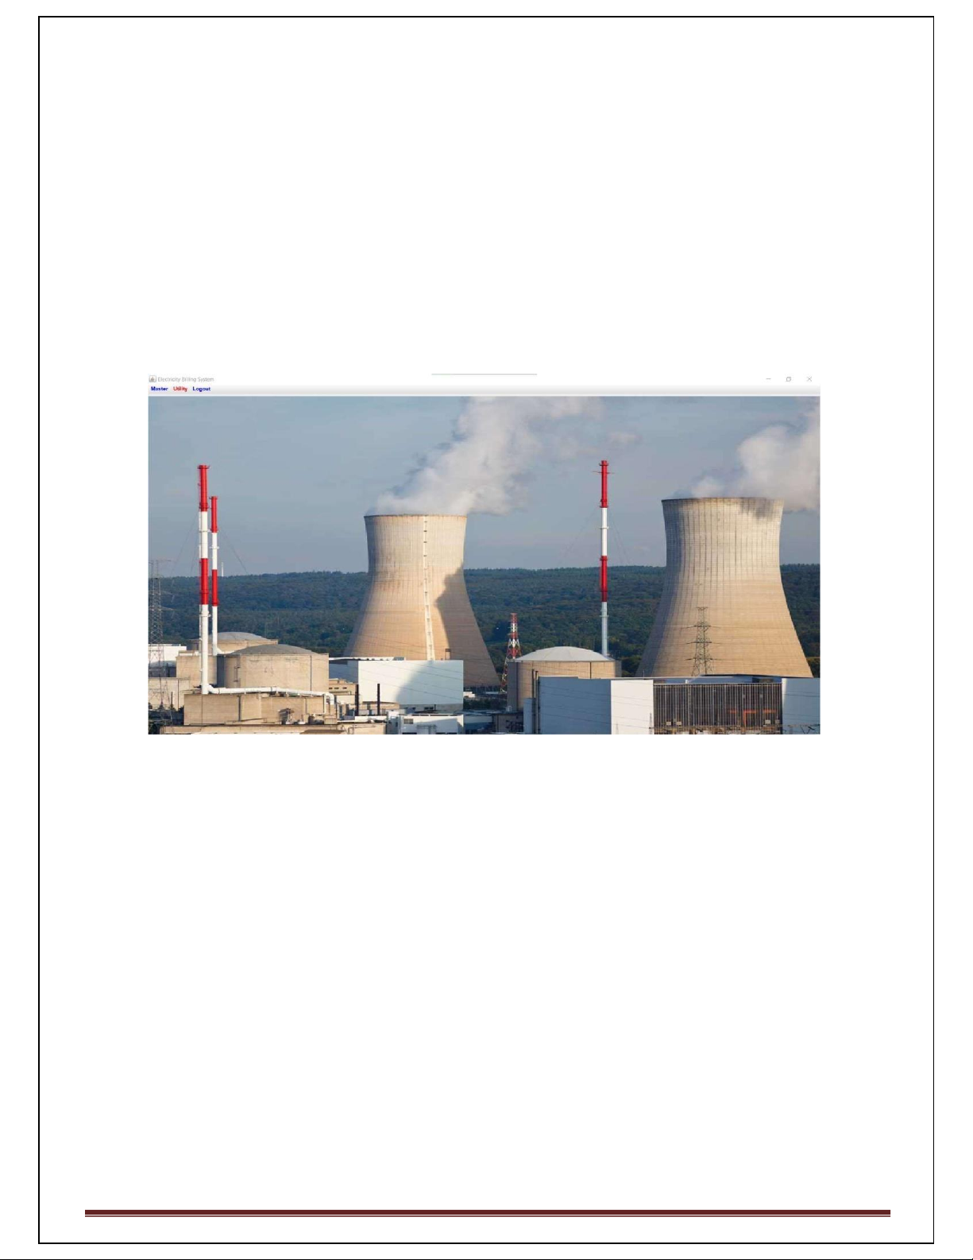

1. New customer screen

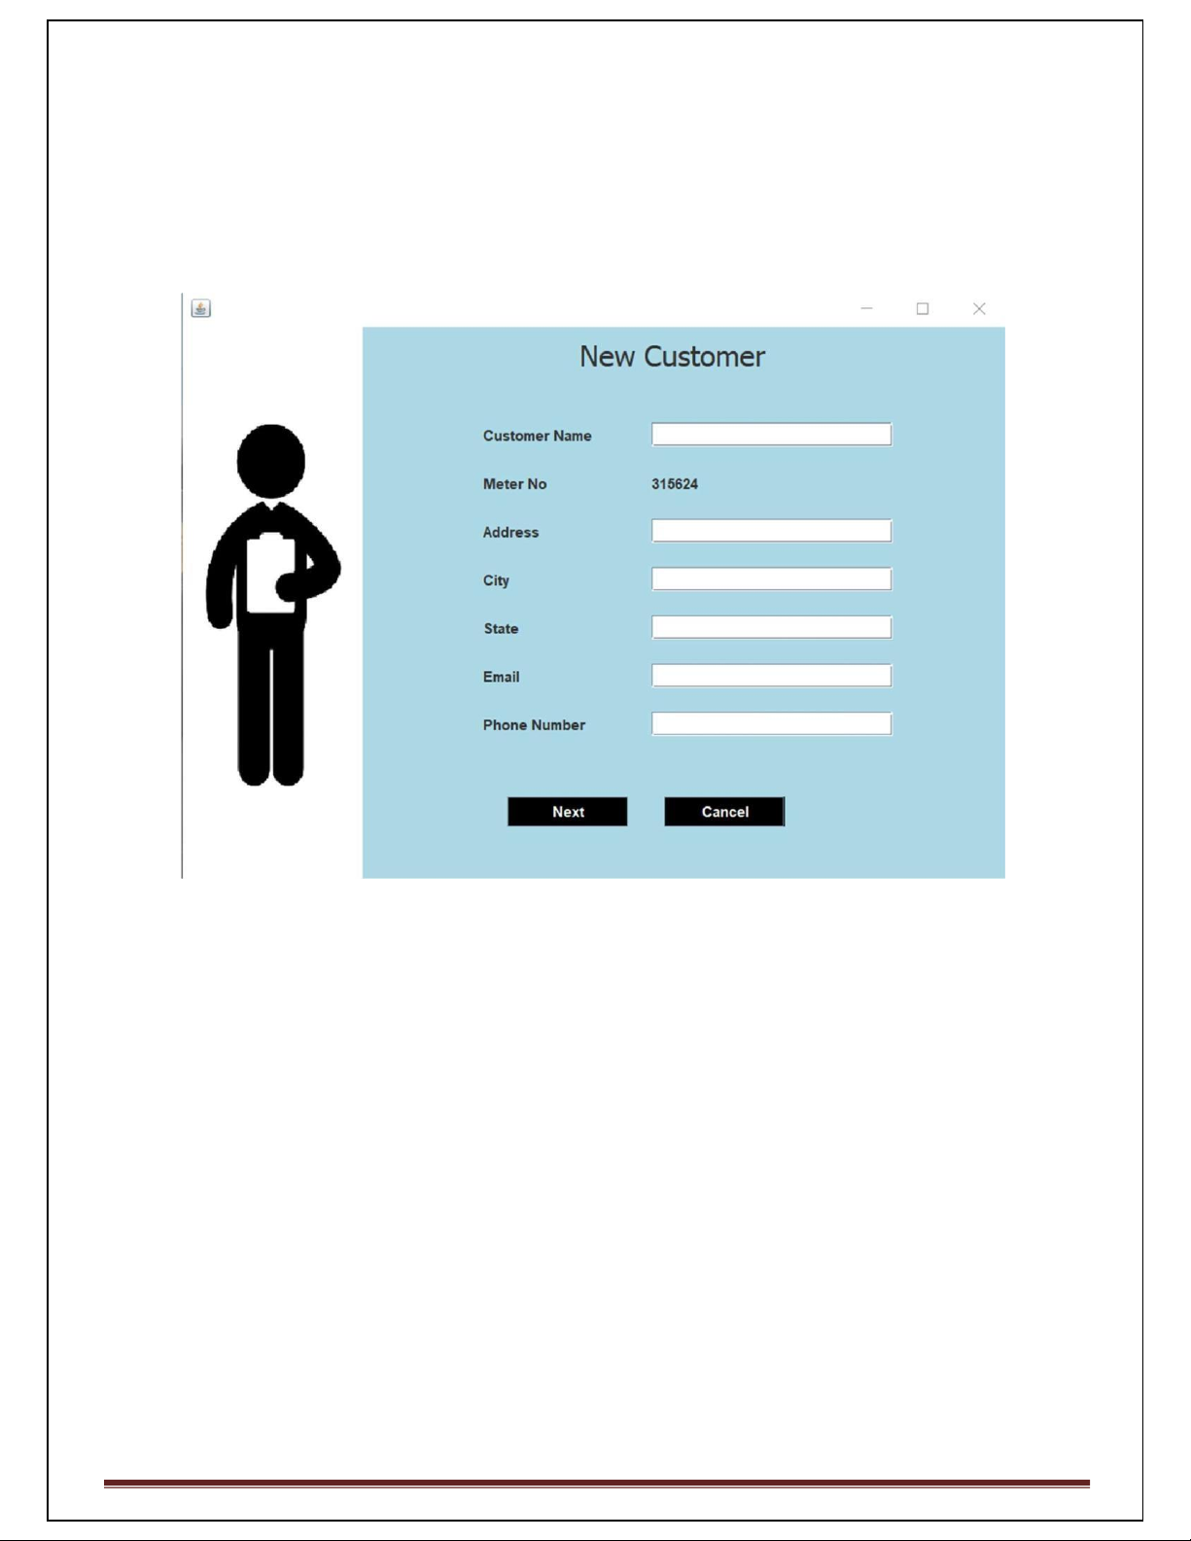

1. Meter info Screen

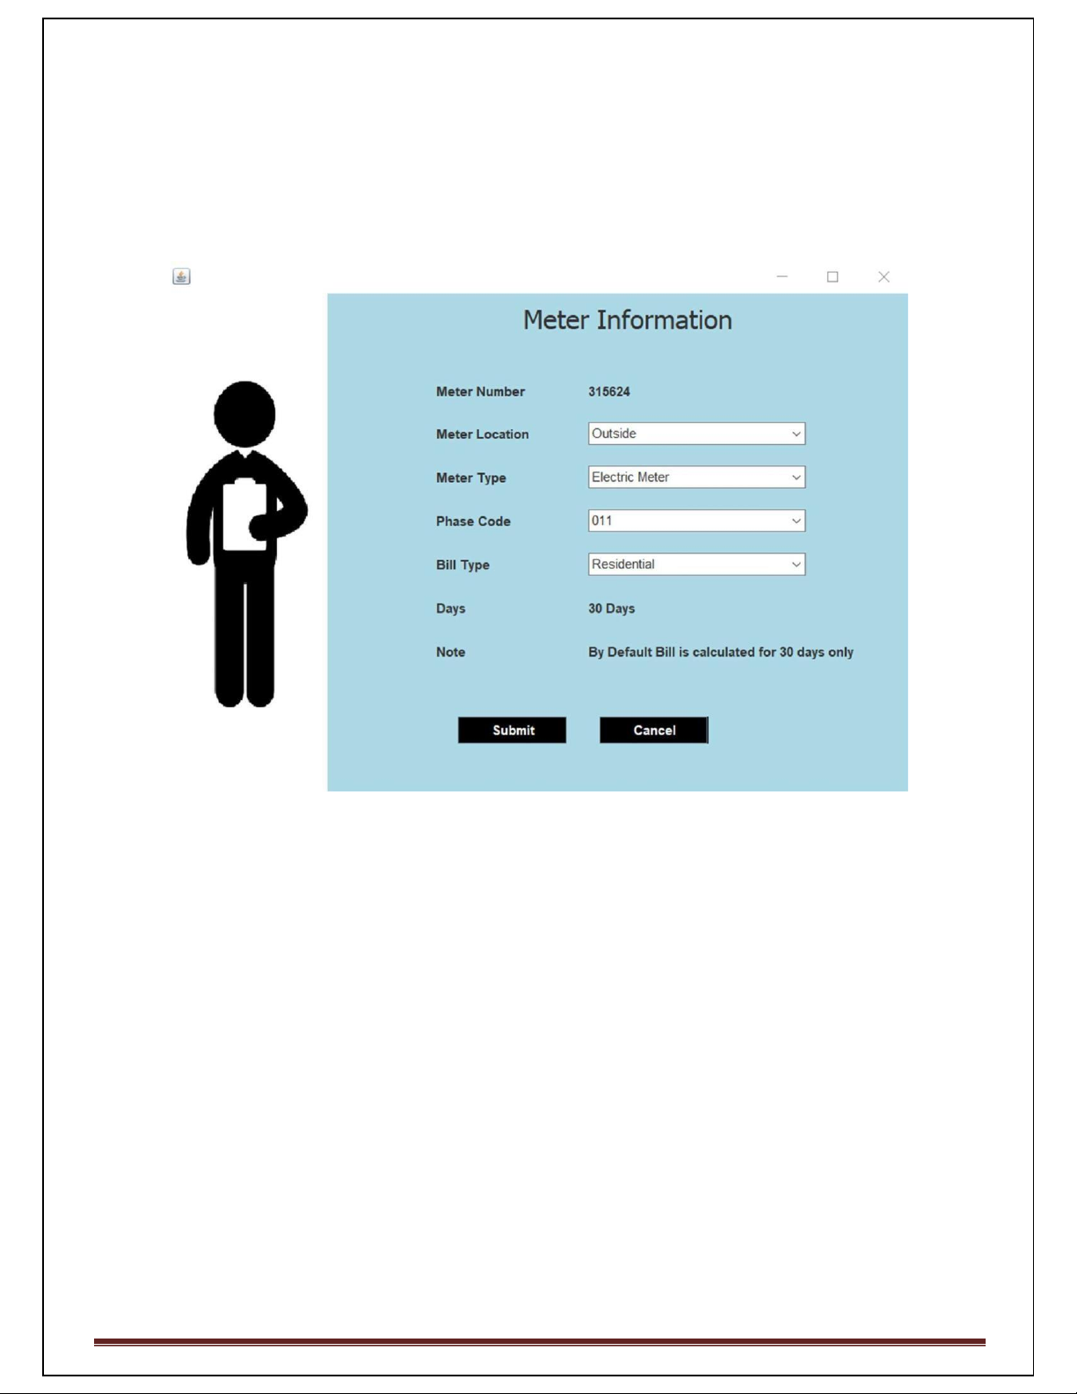

1. Add New Admin Screen

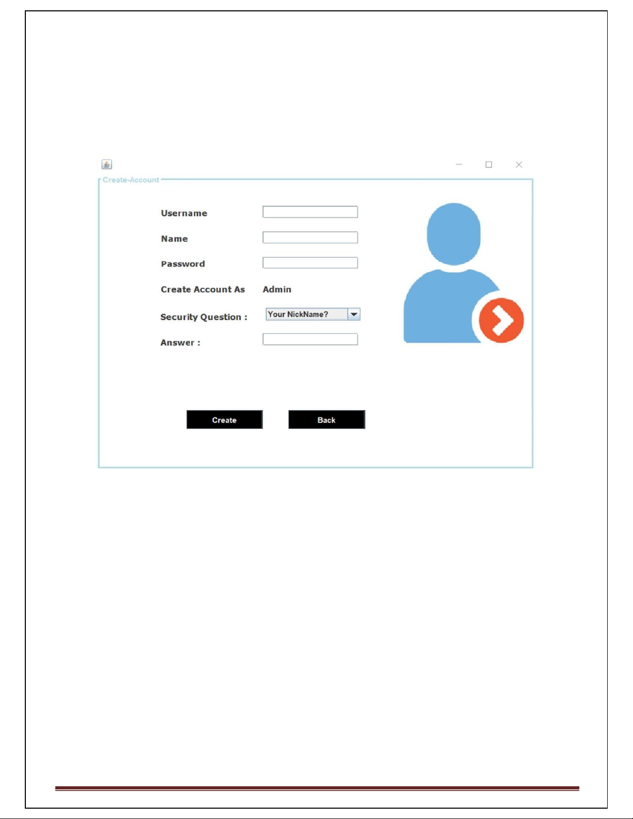

1. Customer Details Screen

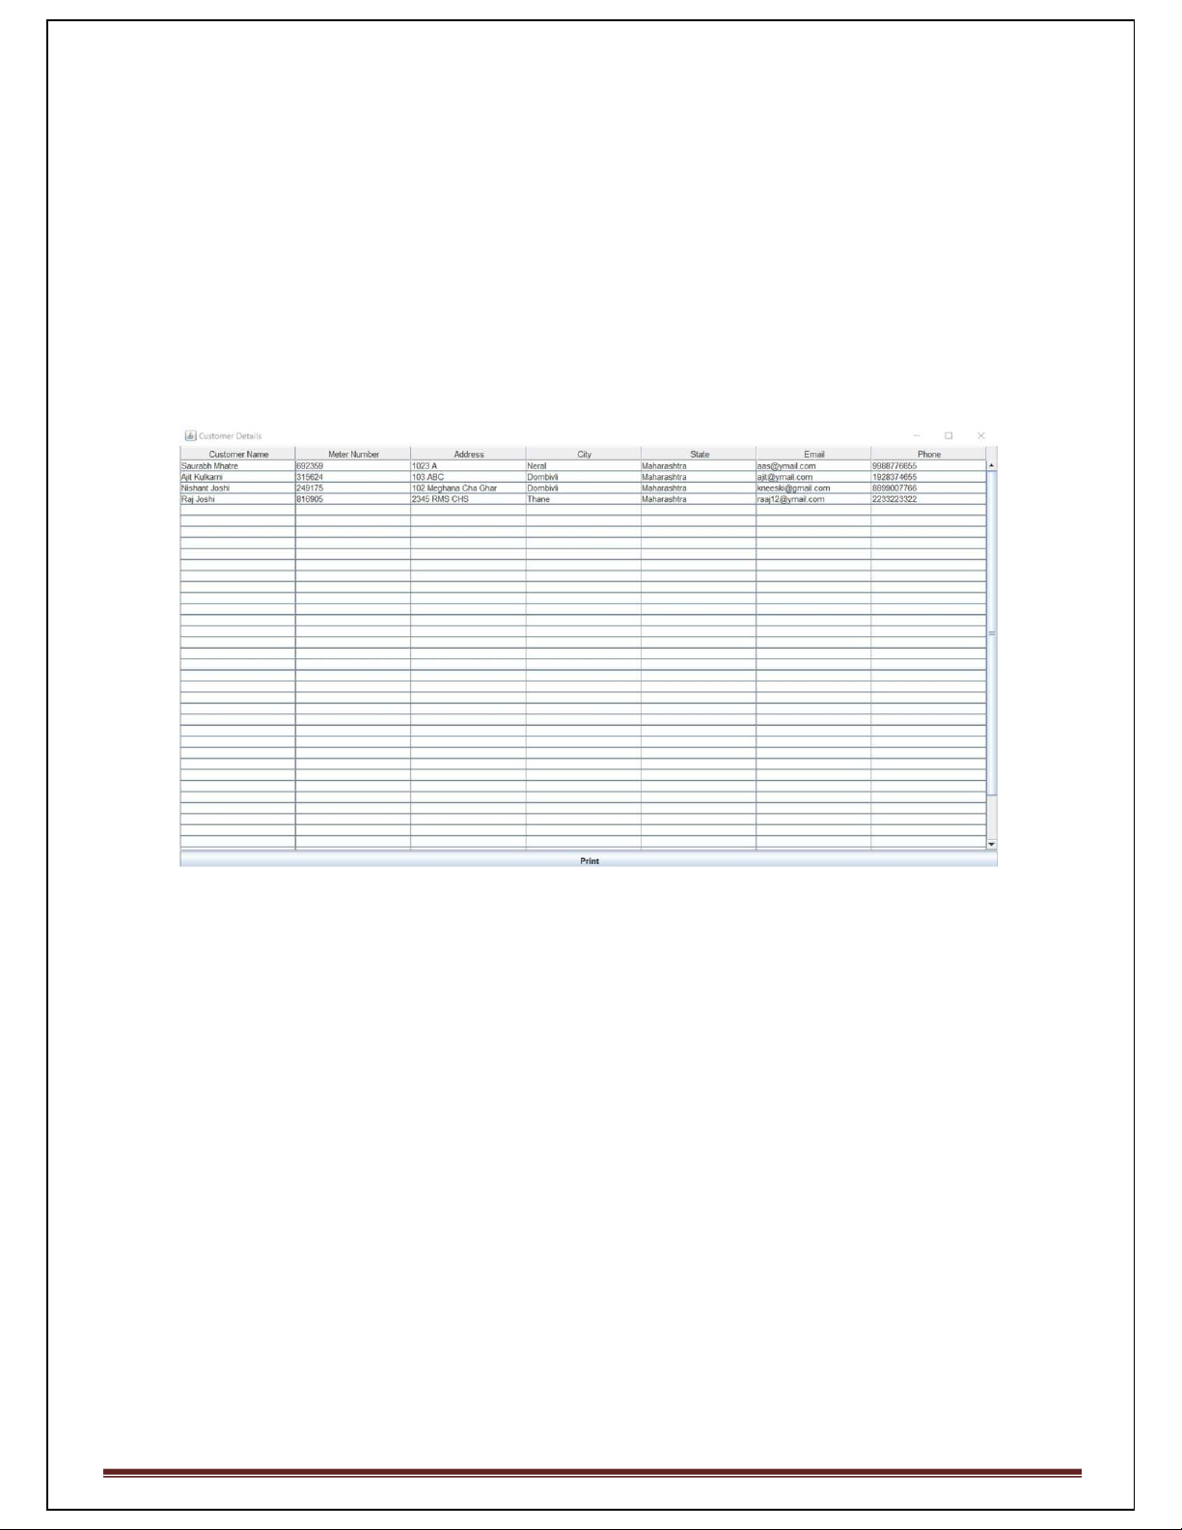

1. Deposit Details Screen

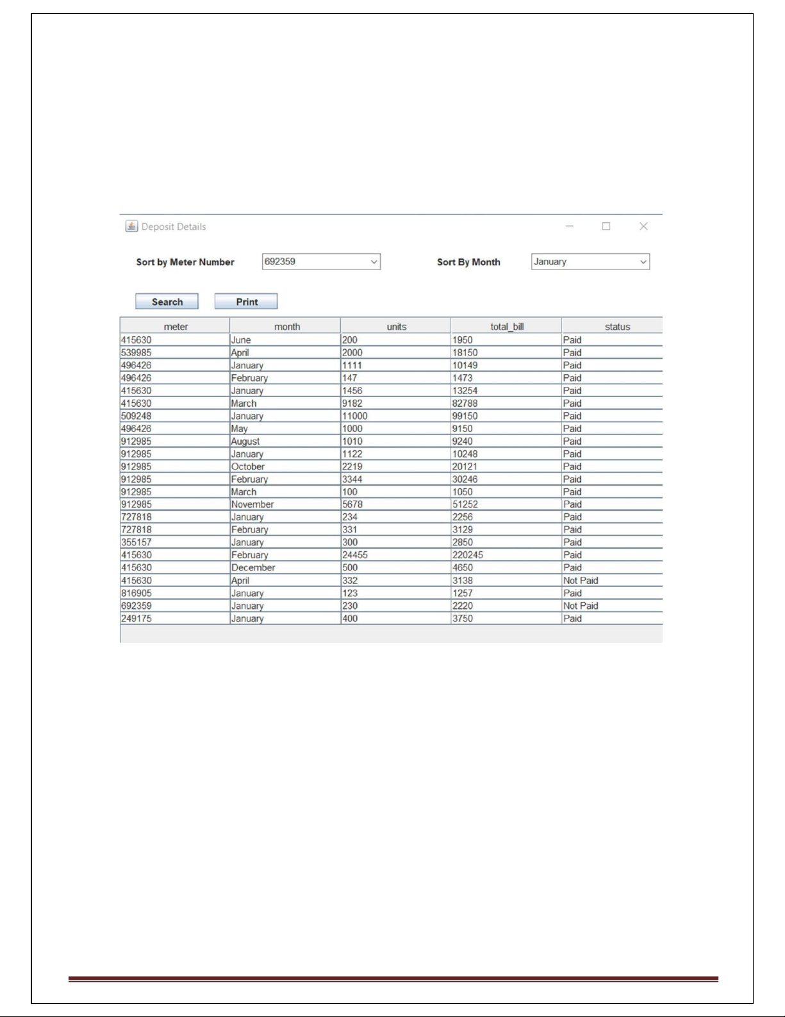

1. Calculate Bill Screen

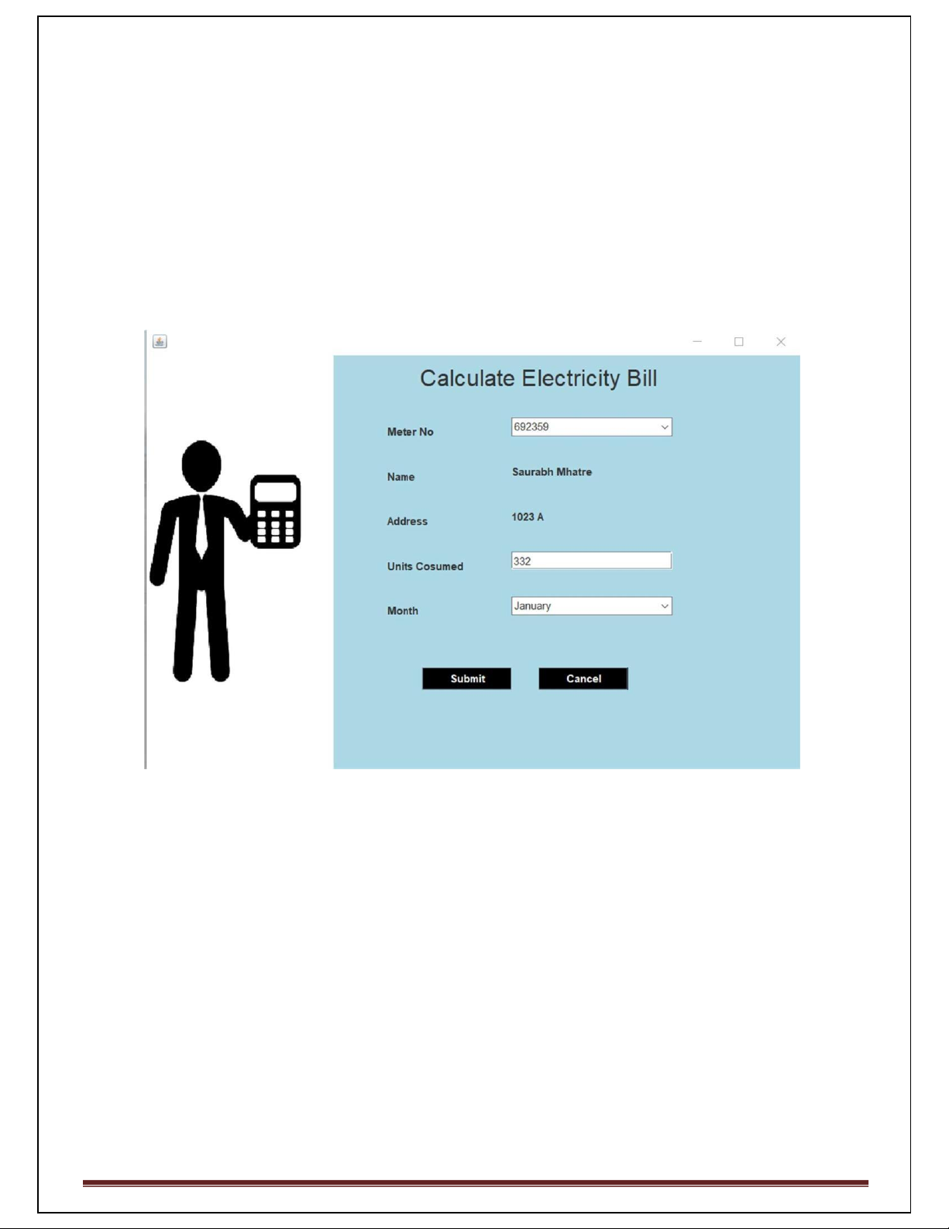

1. View Customer Info Screen

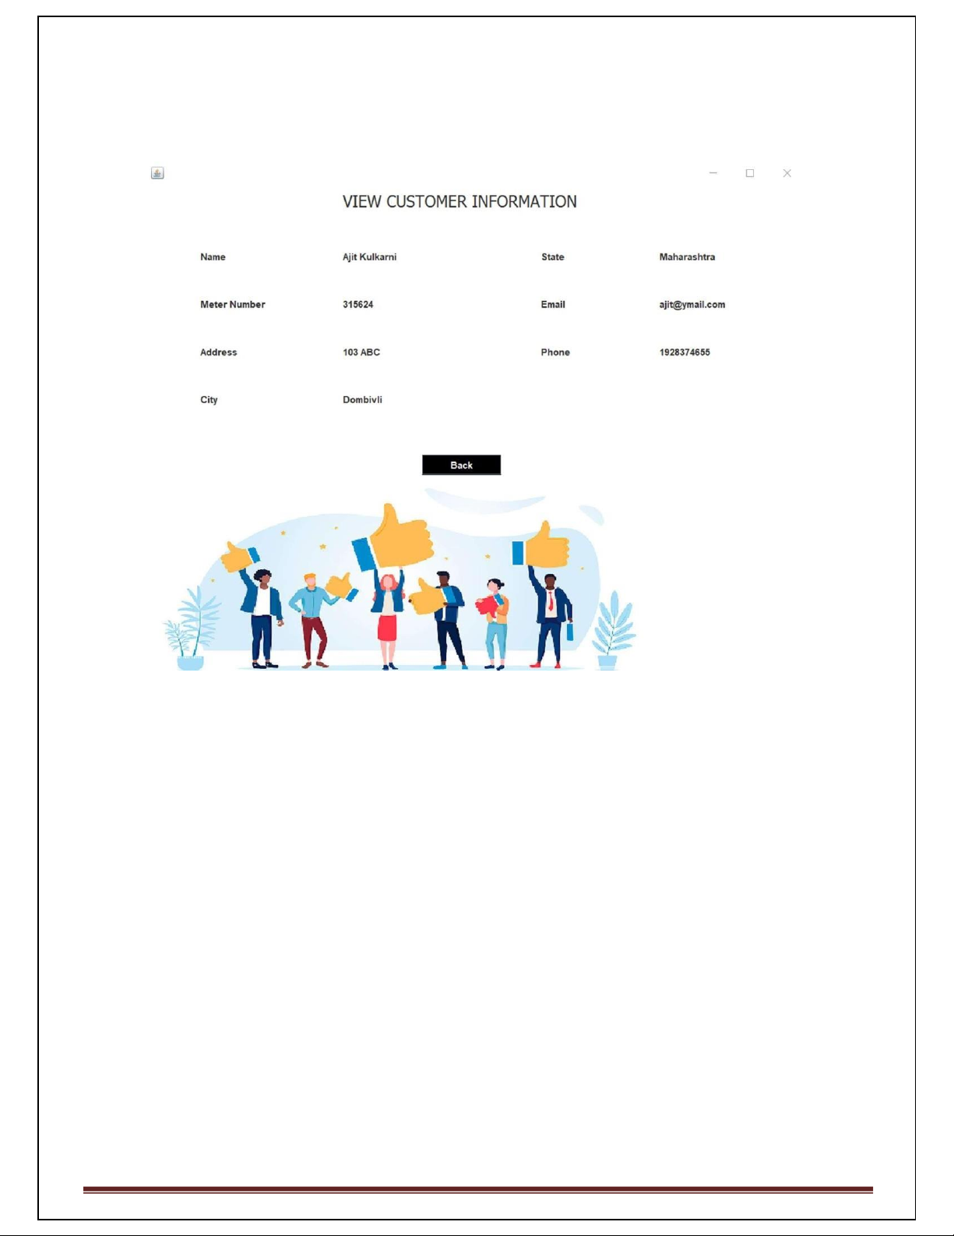

1. Update Customer Info Screen

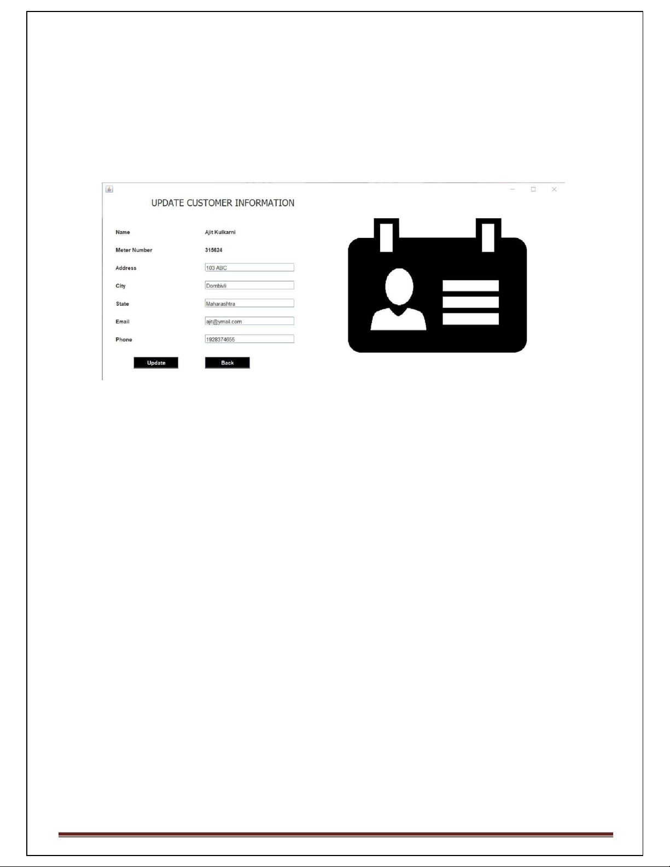

1. Bill Details Screen for Customers

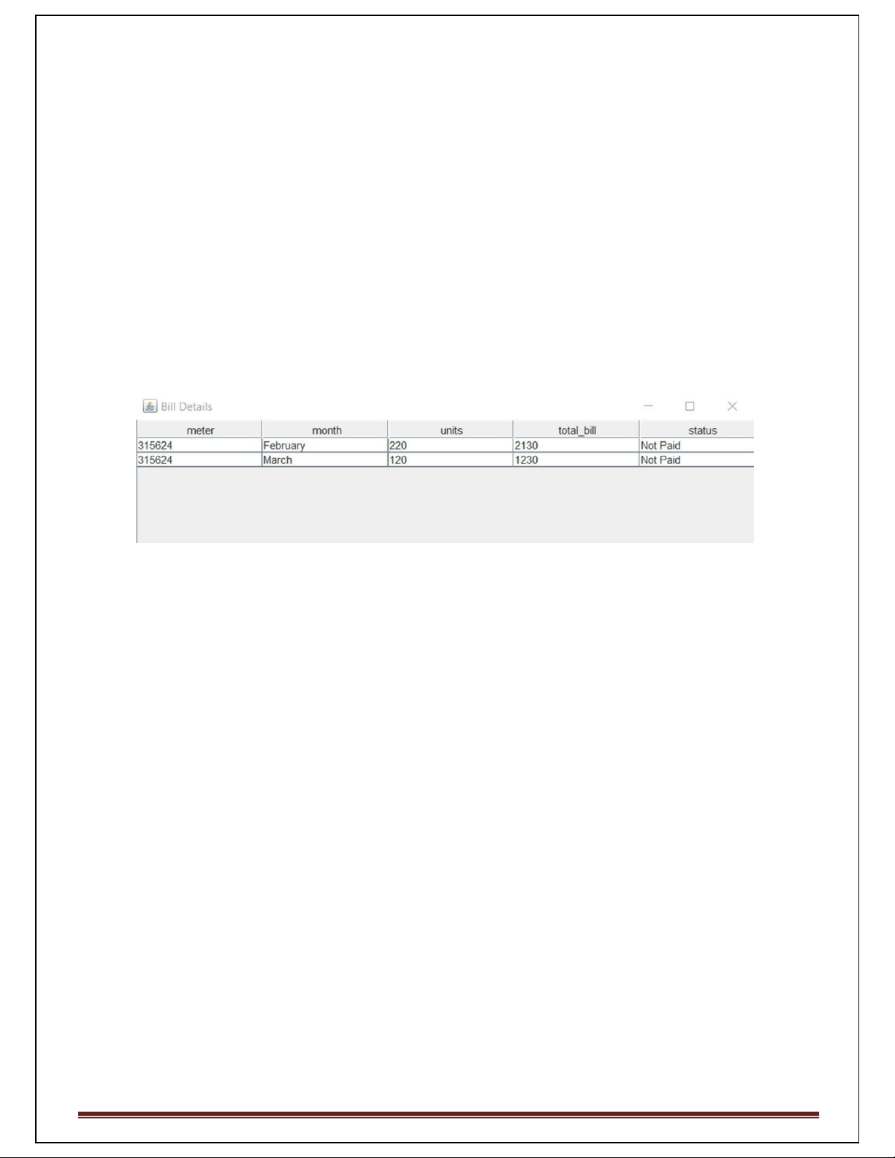

11. Pay Bill Screen

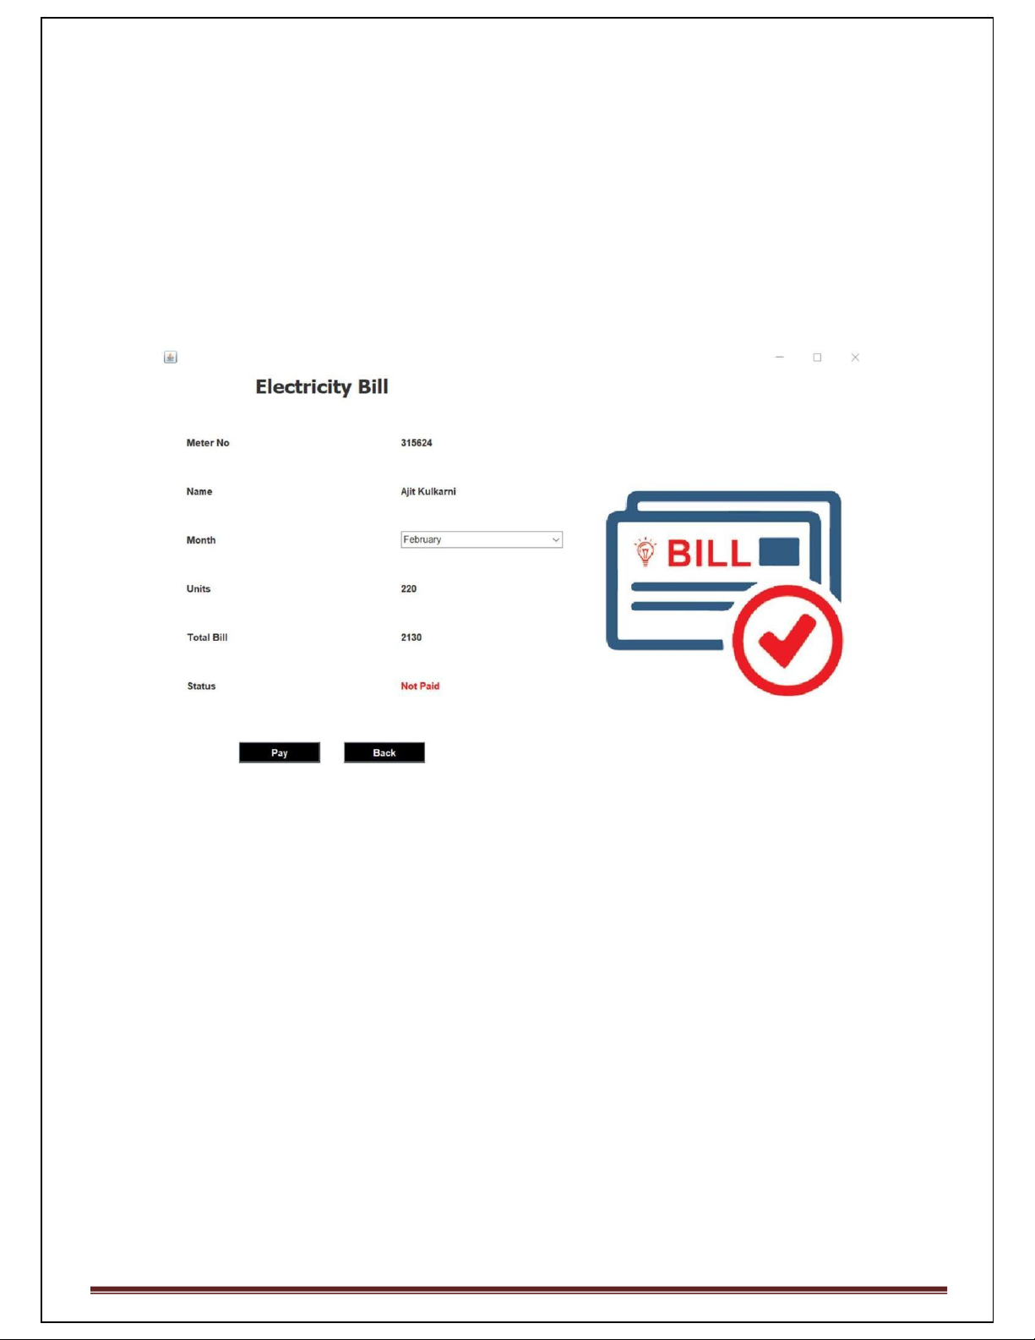

12. Paytm Gateway Screen

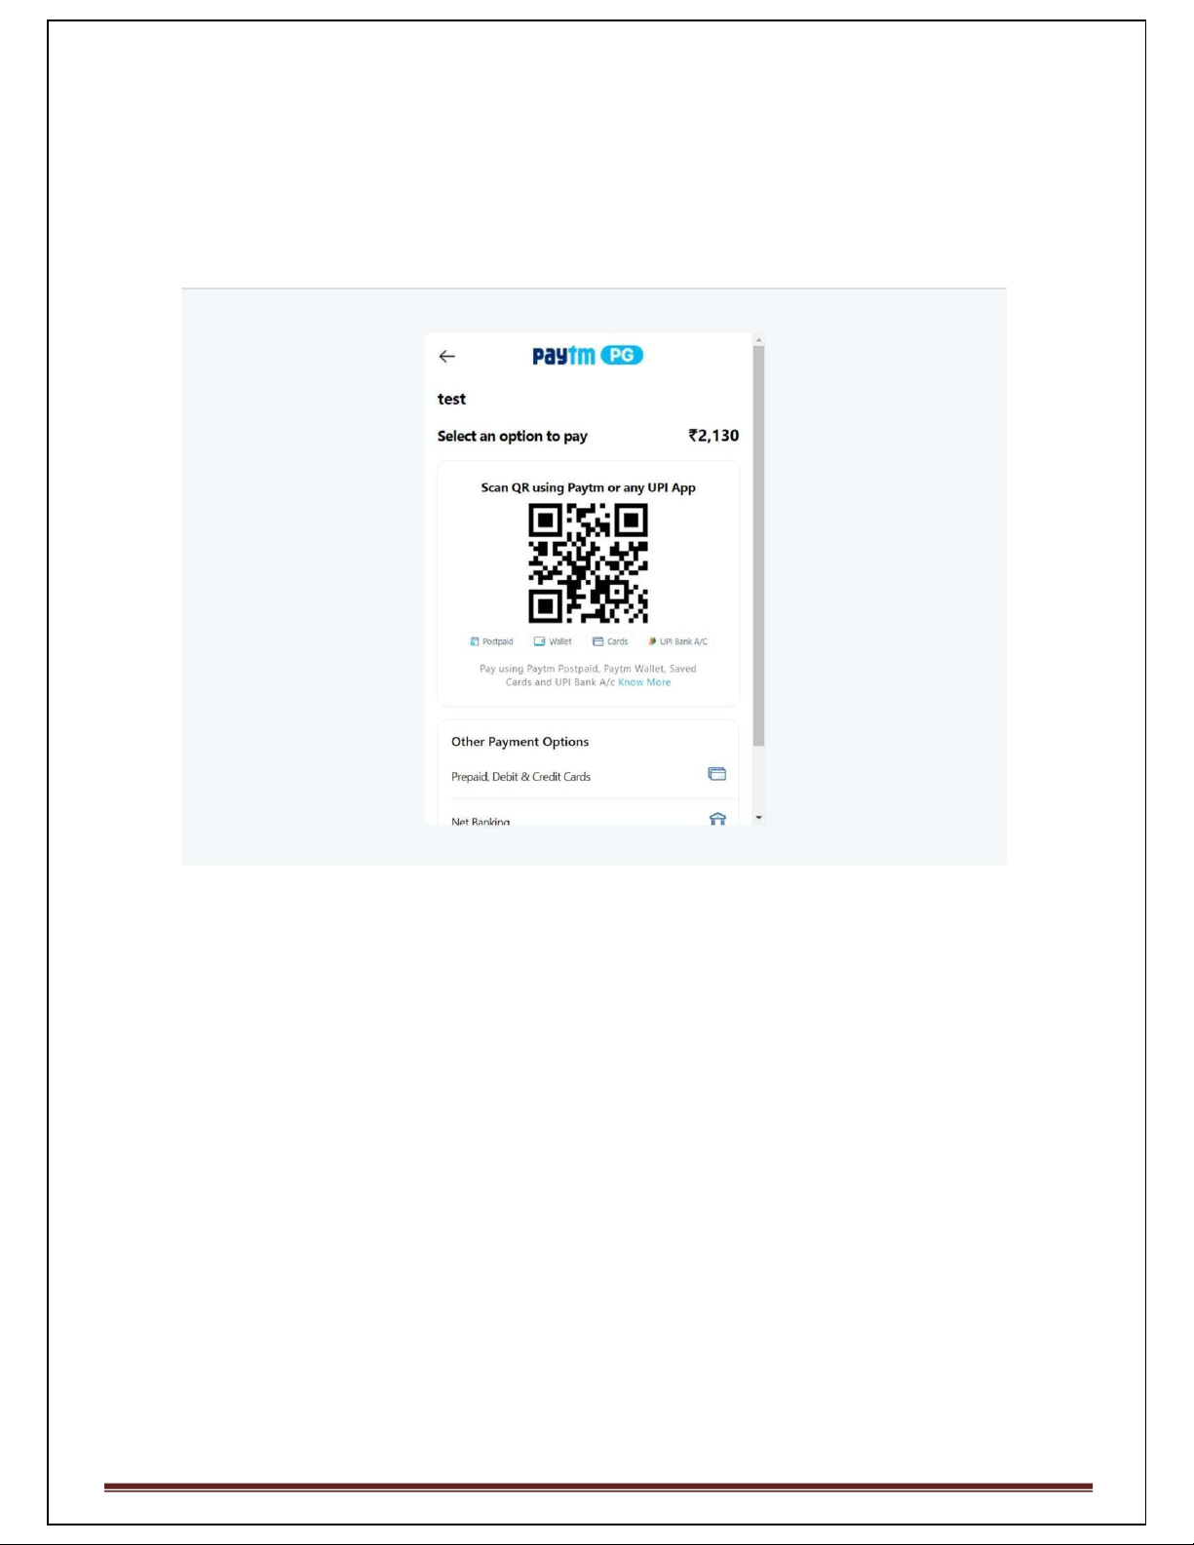

13. Generate/ Show Bill Screen

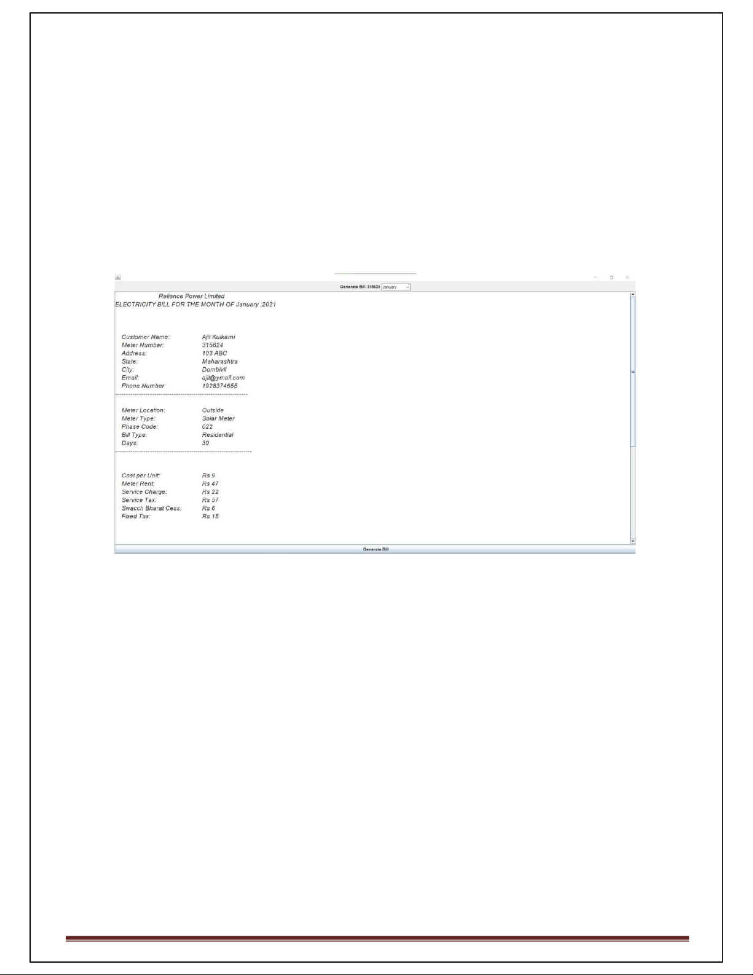

**REFERENCES:**

Book Reference

Database Management Systems 3rd Edition by Raghu

Ramakrishnan (TEXTBOOK).

Websites

* https://www.youtube.com/watch?v=iWitVuW2D1o&t=4s
* www.stackoverflow.com
* [www.google.com](http://www.google.com)
* http://www.javatpoint.com/