Requirement Linter
Architecture, Implementation Roadmap & Scope Document
AIFD Hackathon | Claritev — Healthcare IT, Payer Domain | v1.0

1. Executive Summary
Requirement Linter reads Jira stories ahead of sprint planning and scores them against an 8-dimension Definition of Ready (DoR) rubric — surfacing gaps, generating clarifying questions, and drafting Gherkin acceptance criteria before the team ever sits down to refine or plan the story.
The tool is designed to reduce sprint churn caused by underspecified stories — a cost that rarely appears as a line item but consistently erodes velocity through mid-sprint clarification loops, re-estimation, and carryover. It is scoped deliberately narrow: read-only by default, human-confirmed before any write-back, and explicit about what it cannot reliably judge (see Section 4, Out of Scope).
This document consolidates the architecture, phased rollout plan, and scope boundaries into a single reference — including the revised approach to dependency detection following technical review feedback.

2. Architecture

2.1 Pipeline overview
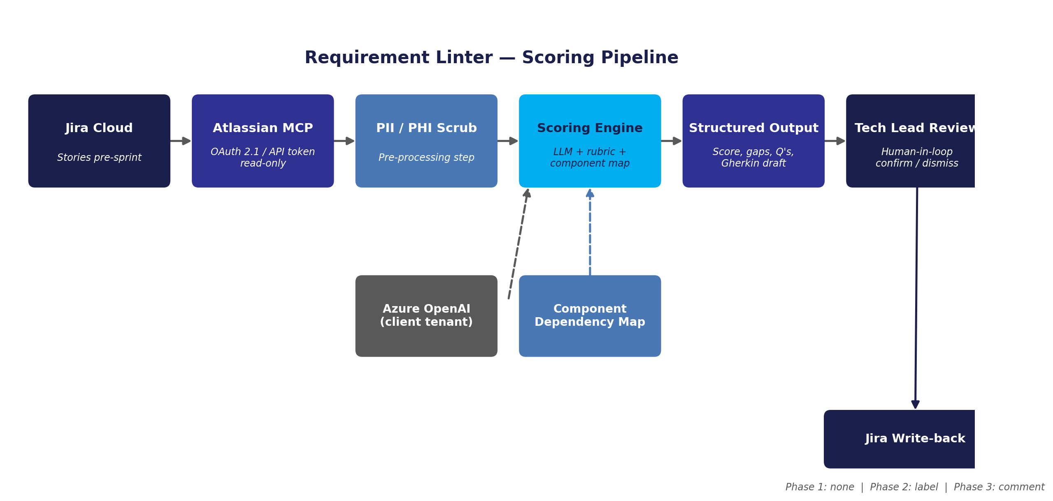

2.2 Component responsibilities
Component | Responsibility
Jira Cloud | System of record for stories, epics, comments, and issue links. No schema changes required.
Atlassian MCP Connector | Read-only access to story fields via OAuth 2.1 (preferred) or API token (if admin-enabled). Client-side admin must enable Rovo + Remote MCP server toggles.
PII / PHI Scrub | Pre-processing pass on description/comment text before anything leaves Jira. Strips or masks patient/member-identifying content.
Component Dependency Map | Static, tech-lead-maintained reference of which of the 5 applications depend on which others. Feeds the scoring engine's dependency check — no code/repo access involved.
Scoring Engine | LLM call (Azure OpenAI, client tenant) combining story payload + rubric + dependency map lookup. Returns structured JSON: score, dimension breakdown, gaps, clarifying questions, draft Gherkin.
Tech Lead Review | Human-in-loop confirmation step. Dependency flags and any write-back candidates are confirmed or dismissed by a tech lead before reaching Jira.
Jira Write-back | Gated by rollout phase — see Section 3. Nothing is written to Jira without prior client sign-off on the relevant phase.

2.3 Data handling notes
- Attachment content is never sent — only a boolean presence flag — unless the client's approved Azure OpenAI endpoint is explicitly cleared for that content type.
- All inference runs inside the client's Azure OpenAI tenant, not a shared/public endpoint — required given PHI-adjacent content.
- The component dependency map is a plain reference document (see prior spec appendix), not a live system query — it introduces no new access surface.

3. Implementation Roadmap
The rollout is phased and gated on client sign-off at each stage — no phase begins until the prior one is approved. This mirrors the read-only → labels → comments sequence already agreed for the broader AIFD rollout.
Phase | Duration | Scope | Exit criteria
0 — Setup & Access | Weeks 1–2 | MCP OAuth/API token enablement with client admin; component map first draft from tech leads; PII scrub rules defined; Azure OpenAI endpoint confirmed for PHI-adjacent use. | MCP connection live in a test project; endpoint approval on record.
1 — Read-only Pilot | Weeks 3–5 | Score stories from 1 application (recommend BenInsights — existing VSM baseline). No Jira write-back; scores reviewed offline with tech leads and PO. | Score-vs-human-judgment correlation reviewed at 2 sprint retros; false-positive rate on dependency flag acceptable to tech leads.
2 — Label Write-back | Weeks 6–8 | With client sign-off, readiness label (e.g., Ready / Needs-Info) written directly to story. Still no comments. Expand to 2nd application. | Client sign-off obtained in writing; label accuracy validated for 2+ sprints.
3 — Comment Write-back | Weeks 9–11 | Gaps, clarifying questions, and draft Gherkin posted as Jira comments (tech-lead-approved) rather than just a label. Full 5-application rollout begins. | Comment acceptance/edit rate tracked; adoption confirmed by tech leads across all 5 apps.
4 — Steady State | Week 12+ | Rubric version-locked; component map on a quarterly review cadence; success metrics (Section 6) reported alongside existing portfolio reviews. | Ongoing — folded into standard delivery governance, not a special initiative.

4. Scope

4.1 In scope
- DoR scoring across all 8 rubric dimensions for Story-type issues.
- Dependency detection limited to: (a) Jira link-graph check, and (b) component-map lookup with tech-lead confirmation — not source-code or repo-based inference.
- Structured output: readiness score, dimension breakdown, gap list, clarifying questions, draft Gherkin.
- Read-only Jira access via MCP; phased write-back gated on explicit client sign-off.
- PII/PHI scrub on all text leaving Jira prior to LLM inference.
- Coverage across the 5 Claritev applications: PlanOptix, BenInsights, CompleteVue, Colossus, EDM.

4.2 Out of scope
- Source code / repository access of any kind — dependency detection is metadata- and map-based only, per technical review feedback.
- Automatic Jira write-back without a human (tech lead) confirmation step at any phase.
- Non-Story issue types (Bugs, Epics, Tasks) — may be considered as a future extension, not in this scope.
- Multi-Jira-site support (dependency/story data spanning more than one Atlassian Cloud site) — a known platform limitation, not a Requirement Linter gap.
- Financial, contractual, or SOW-level dependency tracking — this tool addresses technical/delivery dependencies only.
- Attachment-content analysis (mockups, data samples) unless a separately approved endpoint/data-handling agreement is in place.

4.3 Assumptions
- Client admin enables Rovo + Remote MCP server for the Atlassian Cloud site (or approves API token auth as fallback).
- Tech leads own and maintain the component dependency map on an agreed cadence (recommend quarterly).
- Scrum Master and PO remain the decision-owners of the backlog — the tool is advisory input, not an autonomous gatekeeper.
- Azure OpenAI endpoint used for inference sits within the client's own tenant and has been cleared for PHI-adjacent content.

5. Risks & Mitigations
Risk | Mitigation
Client admin delays enabling MCP/API token access | Raise as a Phase 0 dependency in the 30-60-90 plan; escalate through existing VP/COO channel if blocking timeline.
LLM flags false-positive dependencies without repo context | Scoped to map-based suggestion + mandatory tech-lead confirmation before any Jira write — no autonomous claims.
Rubric perceived as a black box by client stakeholders | Rubric is version-controlled and documented (see companion Scoring Spec doc); every score is traceable to a rubric version.
PHI/PII leakage via story text | Mandatory scrub step before any text reaches the LLM; attachment content excluded by default.
Component dependency map goes stale | Quarterly review owned by tech leads; flagged as an explicit open item, not assumed self-maintaining.
Tech lead adoption resistance (extra review step) | Frame as replacing ad hoc DoR checking, not adding to it; track time saved vs. manual review as an adoption metric.

6. Success Metrics
- Reduction in mid-sprint clarification questions/comments on stories scored “Ready” vs. historical baseline.
- Cycle time from refinement to sprint start, before vs. after rollout.
- Tech lead time spent on manual DoR review, before vs. after (proxy metric, consistent with existing VSM methodology).
- Score-to-actual-readiness correlation, reviewed at sprint retro — the score's practical trustworthiness over time, not just its existence.
- Dependency-flag acceptance rate by tech leads (confirmed vs. dismissed) — tracks whether the component map is adding real signal.

7. Open Items
- Confirm Azure OpenAI tenant endpoint approval for PHI-adjacent inference (Phase 0 blocker).
- Assign a named owner for the component dependency map's quarterly refresh.
- Decide retention policy for scored payloads — discard post-response, or retain for audit.
- Evaluate, post-Phase 1, whether epic_summary context is worth the added token cost.
- Revisit non-Story issue types (Bugs/Epics) as a possible Phase 5 extension once Story coverage is stable.

Companion document: Requirement Linter — Story Scoring: LLM Input/Output Specification (v1.0)

