AI DELIVERY FIRST · HACKATHON
Implementation Approach & Detailed Architecture
The Requirement Linter — a story-readiness agent over MCP-connected Jira

Stated assumptions (swappable): in-boundary LLM = Azure OpenAI (GPT-4 class) · agent glue = Python · Jira reached via an MCP server with read scopes · 2-day build. Replace the LLM with the client’s sanctioned endpoint if different.

1. Solution Overview
The Requirement Linter is an agent — not a chatbot. On trigger, it pulls a batch of in-flight user stories from Jira over MCP, assembles each into a normalised bundle, scores it against a Definition-of-Ready rubric using an in-boundary LLM, and returns a structured verdict: a readiness score, a specific gap list, pre-written clarifying questions, and draft Given-When-Then acceptance criteria. The verdict is rendered to an internal surface; write-back to Jira is governed and off by default.
Design principle: the rubric and domain context are the intelligence; MCP is plumbing; the LLM is a swappable engine. Keep all three loosely coupled so any one can change without a rewrite.

2. Logical Architecture
Eleven components across four layers: Ingest (pull from Jira), Reason (score against the rubric), Serve (render the verdict), and a governed Write-back path that stays dormant until client sign-off.
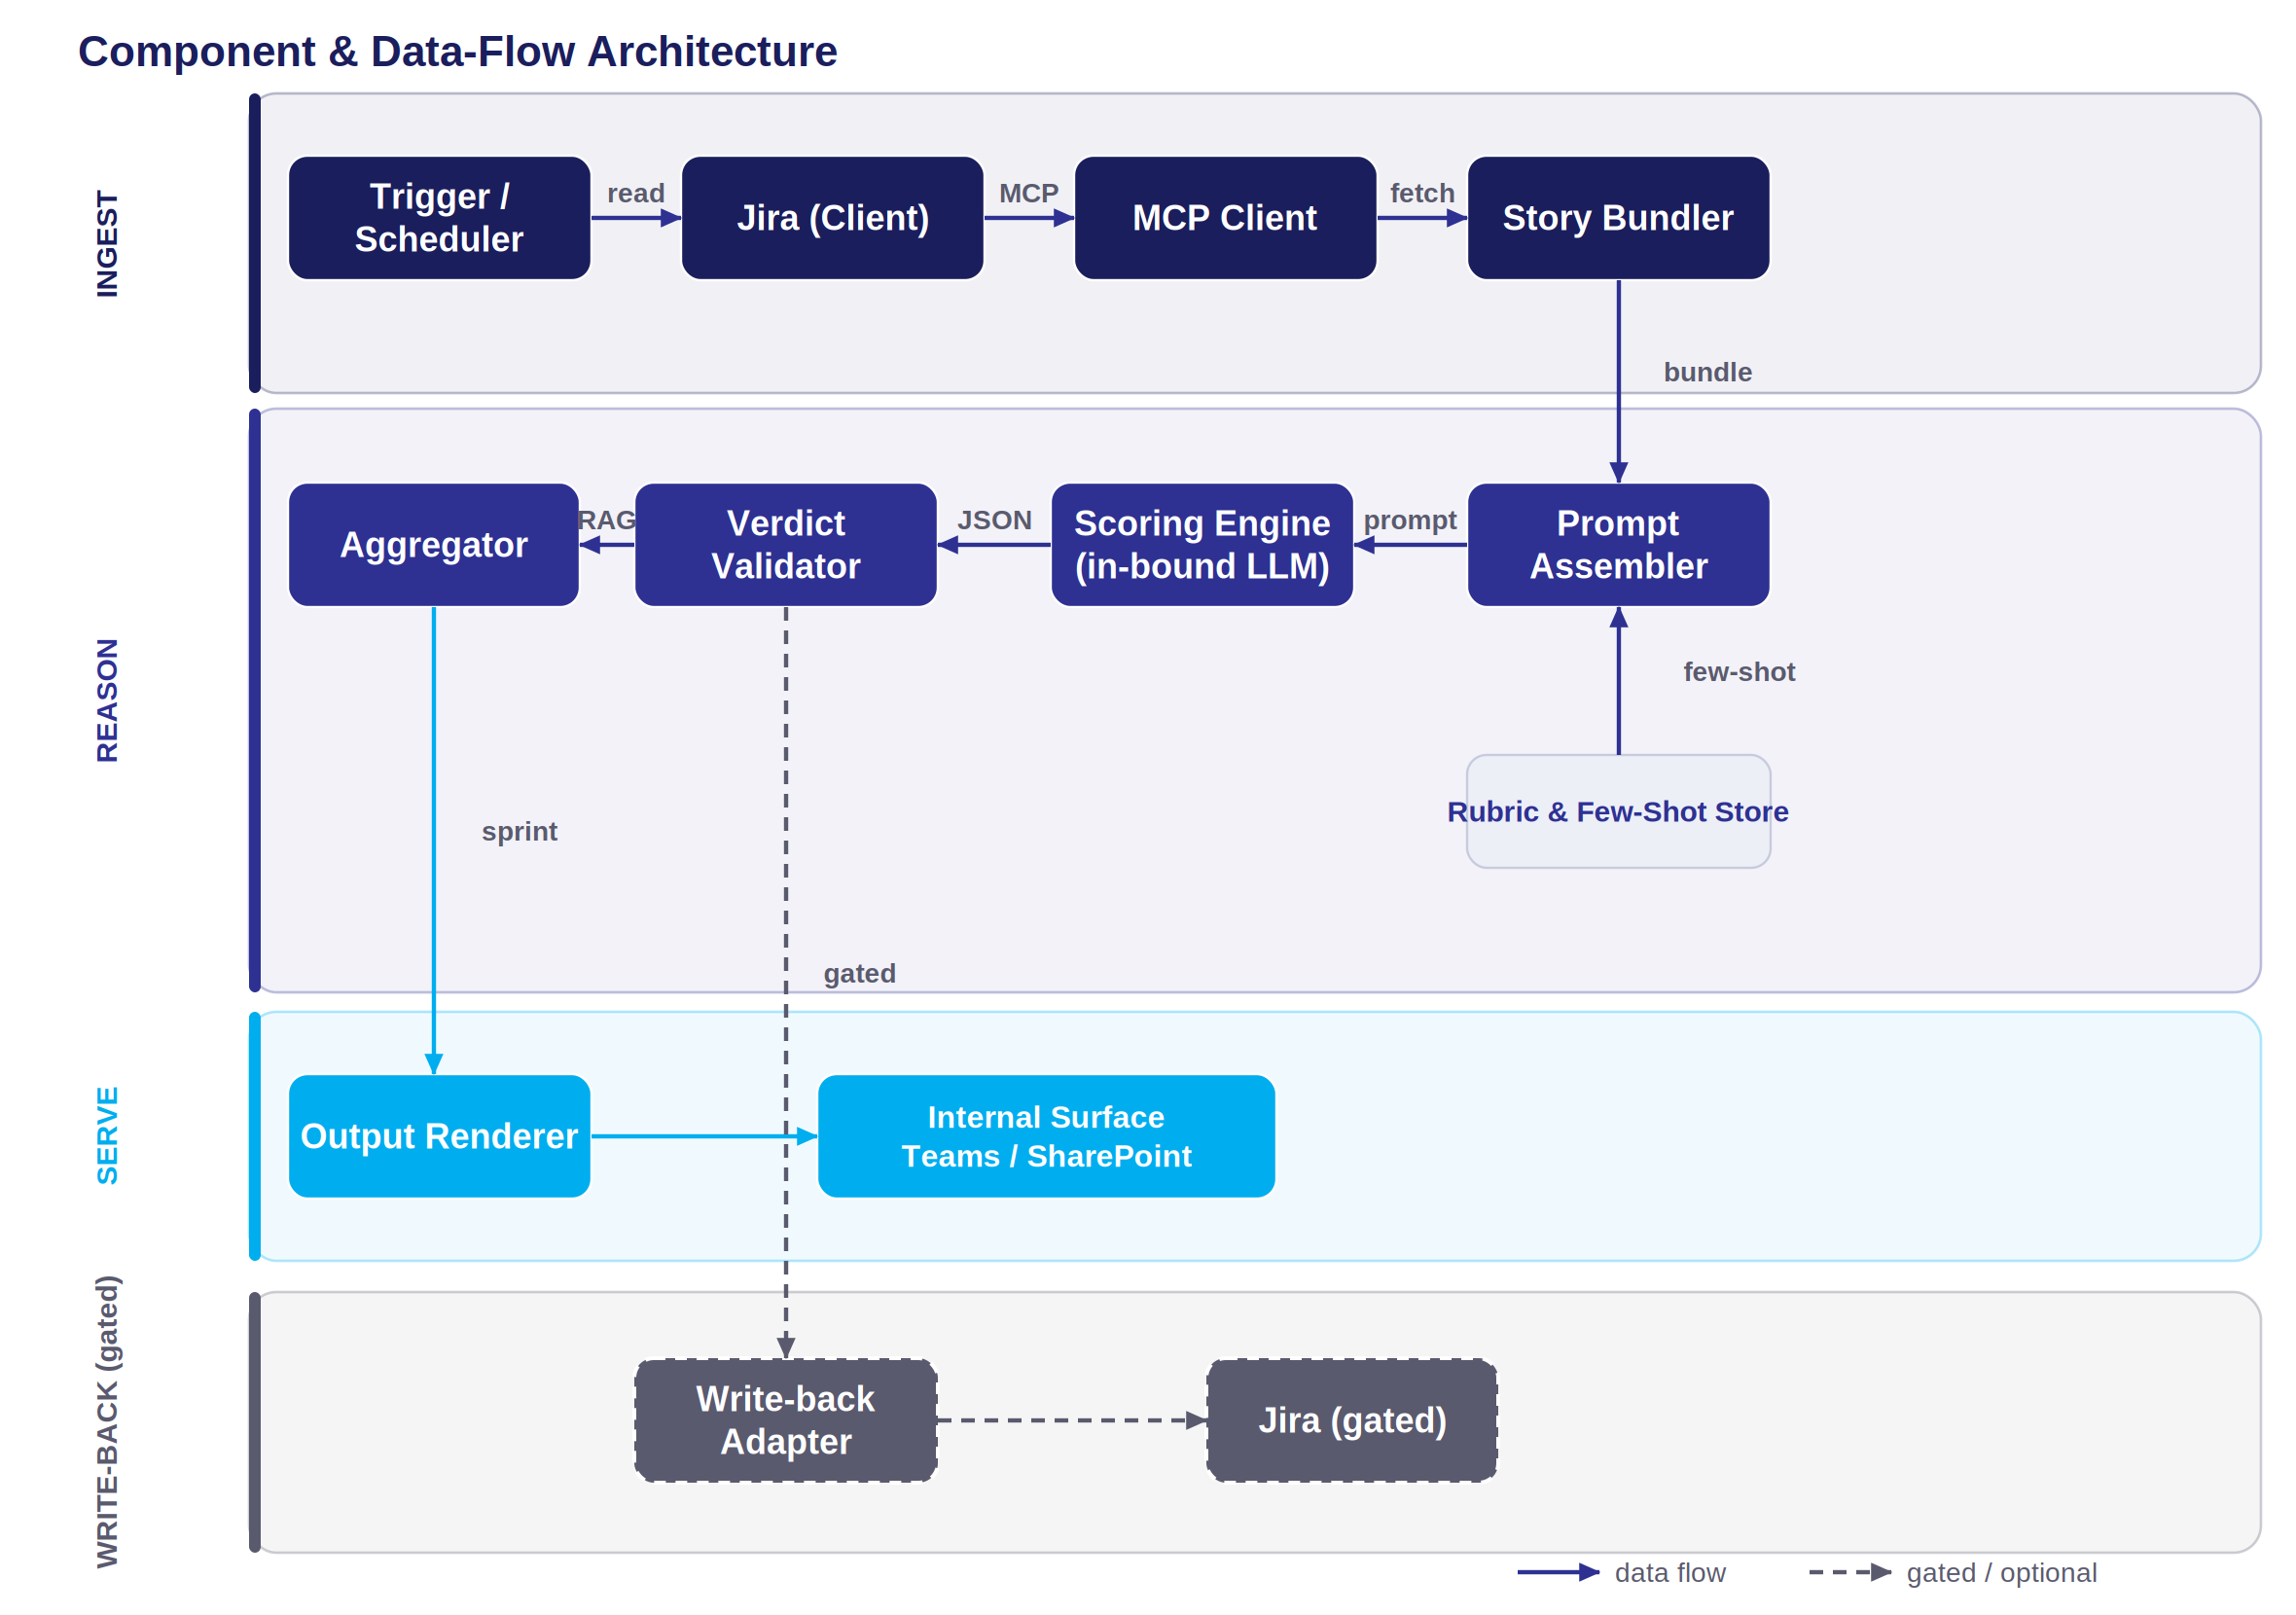
Figure 1 — Component & data-flow architecture. Read path is solid; gated write-back is dashed. LLM inference stays inside the client tenant.
INGEST | REASON | SERVE | WRITE-BACK (gated)

# | Component | Responsibility | Hackathon tech
1 | Trigger / Scheduler | Starts a run — manual button for the demo; cron poll on a status-entry query for v2. | Python CLI / cron
2 | Jira MCP Client | Wraps MCP tools; issues JQL search and per-issue fetch; holds read scopes. | MCP client SDK
3 | Story Bundler | Normalises issue fields + description + ACs + comments + linked issues into one StoryBundle. | Python
4 | Rubric & Few-Shot Store | DoR rubric, domain DoR template, golden good/bad examples for the prompt. | YAML / JSON
5 | Prompt Assembler | Merges bundle + rubric + few-shot into the scoring prompt; enforces JSON-only output. | Python / Jinja
6 | Scoring Engine (LLM) | In-boundary LLM; returns the structured verdict per story. Low temperature, schema-forced. | Azure OpenAI
7 | Verdict Validator | Schema-validates JSON, one repair retry on malformed output, computes RAG from score + thresholds. | pydantic
8 | Aggregator | Sprint-level rollup: RAG spread, top risks, count ready vs blocked. | Python
9 | Output Renderer | Builds the internal view — Teams Adaptive Card or a Streamlit table for stage. | Teams / Streamlit
10 | Write-Back Adapter | GATED. add_label / update_field / add_comment. Dormant until sign-off. | MCP write tools
11 | Feedback Store | Logs each flag and whether it led to a story edit — the precision signal (v2). | SQLite / SP list

3. Data Flow — The Agent Loop
One run, end to end. Steps 3–7 repeat per story; steps 8–10 run once per batch.
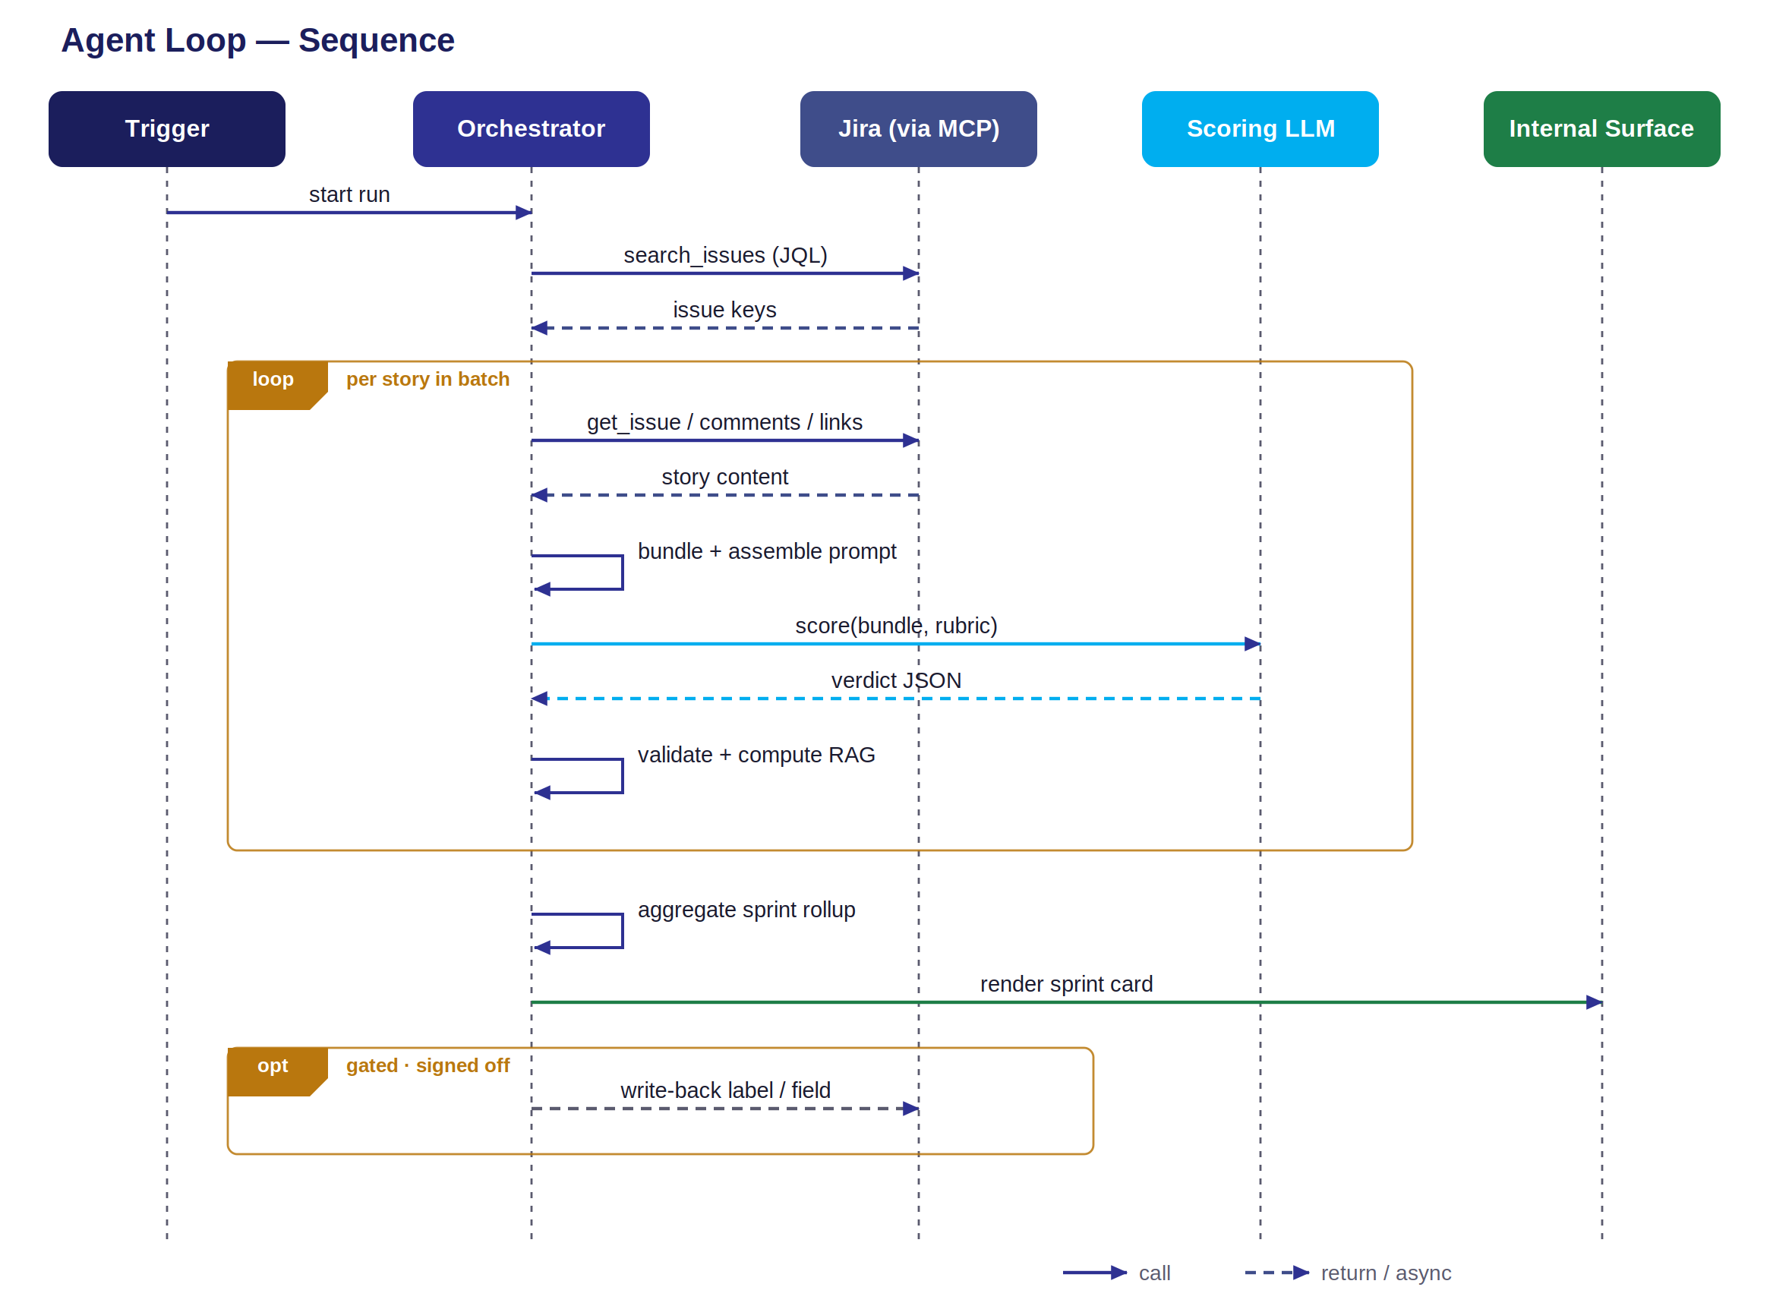
Figure 2 — Sequence of one run. The per-story loop covers fetch → bundle → score → validate; aggregation, render, and gated write-back run once per batch.
- Step 1 — Trigger fires: Orchestrator starts a run with a target query (e.g. the next sprint).
- Step 2 — Select stories: MCP search_issues with JQL — sprint = next AND status = “Ready for Refinement” — returns issue keys.
- Step 3 — Fetch content: Per key: get_issue (fields, description, ACs) + get_comments + get_linked_issues.
- Step 4 — Bundle: Bundler normalises into a StoryBundle: title, narrative, current ACs, fields, comment thread, links.
- Step 5 — Assemble prompt: Prompt Assembler injects the bundle into the rubric + few-shot template; forces JSON-only output.
- Step 6 — Score: LLM call (temp ≈ 0.2, schema-forced). Returns the verdict object.
- Step 7 — Validate: Parser schema-checks; one repair retry if malformed; computes RAG from score + thresholds.
- Step 8 — Aggregate: Batch rollup: RAG spread, top recurring gaps, ready vs blocked counts.
- Step 9 — Render: Renderer posts the sprint card / dashboard to the internal surface.
- Step 10 — Write-back (gated): If enabled and signed off: apply Readiness label / field; comments only at Stage 3.
Latency note: scoring is per-story and parallelisable. Run the batch with a small async pool (e.g. 5 concurrent LLM calls) so a 14-story sprint scores in seconds, not a minute. Cap concurrency to the endpoint’s rate limit.

4. The Scoring Engine

4.1 Prompt structure
A system prompt carries the fixed intelligence (role, rubric, output contract, few-shot). The user message carries only the StoryBundle. Keeping the story out of the system prompt makes the rubric cacheable and the boundary clean.
SYSTEM:
You are a story-readiness reviewer for a SAFe Agile team.
Score the story against the Definition-of-Ready rubric below.
Rubric dimensions: Testable ACs, Edge cases, Negative paths,
Data/field rules, Dependencies, Non-functional, Out-of-scope,
DoD alignment. (+ domain DoR notes for the payer context)
For every gap, give a specific finding and a 'why'.
Propose draft acceptance criteria in Given-When-Then.
Few-shot: <one GOOD story+verdict> <one POOR story+verdict>
Output JSON ONLY, matching the schema. No prose, no markdown.

USER:
{ StoryBundle: title, narrative, current_ACs, fields,
comments[], linked_issues[] }

4.2 Output schema (the verdict)
Strict, machine-parseable. This contract is what makes the agent demo-able and lets the verdict drive a UI, a label, or a metric without re-prompting.
{
"issueKey": "BEN-1234",
"readinessScore": 42, // 0-100
"rag": "RED", // RED | AMBER | GREEN
"invest": { "testable": false, "small": true, ... },
"gaps": [
{ "dimension": "Negative paths",
"finding": "No behaviour defined for empty-form submit",
"severity": "high" }
],
"clarifyingQuestions": [
"What is shown when the user submits an empty form?"
],
"draftAcceptanceCriteria": [
{ "scenario": "Empty submit",
"gherkin": "Given the form is empty / When the user
submits / Then an inline error is shown" }
],
"crossStoryFlags": [
"Contradicts AC on linked parent BEN-1180"
],
"confidence": 0.82
}
RAG is computed, not asked: the LLM returns a score and findings; the Validator derives RAG from your thresholds (e.g. <50 RED, 50–74 AMBER, ≥75 GREEN). This keeps the band tunable without re-prompting and stops the model from drifting its own cut-offs.

5. MCP Integration Layer
The agent talks to Jira only through MCP tools — never raw REST. Scopes are least-privilege: read-only for the hackathon, write tools registered but unbound until Stage 2/3 sign-off.
MCP tool | Access | Use
search_issues | read | JQL query to select the batch (sprint / status / label).
get_issue | read | Full fields, description, acceptance-criteria field.
get_comments | read | Comment thread — powers the “unanswered question” flag.
get_linked_issues | read | Parent/child + links — powers cross-story consistency checks.
add_label | WRITE · gated | Stage 2: apply Readiness:Amber/Red. Non-intrusive.
update_field | WRITE · gated | Stage 2: write a custom Readiness Score field.
add_comment | WRITE · gated | Stage 3 only: post clarifying questions. Sign-off required.

Trigger options, in order of hackathon safety: manual run (demo default) → scheduled poll on a status-entry JQL → Jira automation webhook on transition into “Ready for Refinement” (v2). Build the manual path; show the webhook on the roadmap.

6. Data Boundary & Security
This is the section that clears or kills the project in a payer environment. Treat it as a first-class requirement, not a footnote.
- In-boundary inference only. Story content — potentially PHI-adjacent — is scored only by a client-approved LLM inside the tenant. No story text egresses to any external API. Confirm the sanctioned endpoint before committing to a live demo.
- Read-only by default. Stage 1 writes nothing to the client backlog; the verdict lands on our surface. Zero footprint.
- Least-privilege MCP scopes. Only the four read tools are bound for the hackathon. Write tools stay unregistered until sign-off.
- Synthetic data on stage. Demo against a sandbox project with seeded stories — never the live client board, so nothing real is exposed in the room.
- Secrets in vault, not code. Endpoint keys and Jira tokens in a key vault / environment, never in the repo or the prompt.
- No data compiled across sources. The agent reads the backlog to score it; it does not aggregate personal data or act on instructions found inside ticket text.

7. Implementation Plan — 2-Day Build
Sequenced so a working end-to-end thread exists by end of Day 1, leaving Day 2 for output polish and demo. The differentiator is rubric + Gherkin quality, so the plan front-loads the brains and time-boxes the plumbing.
Phase | Block | Tasks | Output
Day 0 | Prep | Confirm sanctioned LLM + MCP access; stand up sandbox Jira project; seed 5–6 stories (good→terrible); draft rubric + 2 golden examples. | Env + rubric ready
Day 1 AM | Ingest | Wire MCP client; search_issues + get_issue/comments/links; build StoryBundler + normaliser. | Bundles printing
Day 1 PM | Reason | Prompt Assembler; first LLM call; output schema; Validator + RAG thresholds. End-to-end one story. | Verdict JSON
Day 2 AM | Serve | Batch loop + async pool; Aggregator (sprint rollup); Renderer (Teams card / Streamlit). | Sprint view
Day 2 PM | Polish + demo | Tune thresholds on seeded set; rehearse the money-shot; roadmap + governance slide. | Demo-ready

De-scope rule: if the MCP write scope or the sanctioned LLM isn’t available in time, fall back to read-only + a mock-LLM stub and present as a proposal. Say so openly — a clean fallback beats a broken live call on stage.

8. Demo Plan
- Open on the backlog: “Here’s the next sprint — 14 stories, none reviewed yet.”
- Run the agent live: one command → the batch scores in seconds, RAG spread fills the screen.
- Drill into a RED story: show the specific gaps, the pre-written questions, and the draft Gherkin it generated.
- Show the cross-story flag: “this contradicts its linked parent” — the thing a human reviewer never has time to catch.
- Close on governance: read-only today, write-back gated — the delivery-maturity beat that wins the room.

9. Production Roadmap
Horizon | Increment
Post-hackathon | Webhook trigger on status transition; persist runs; harden the schema + repair path.
30–60 days | Stage-2 write-back (label/field) under client sign-off; feedback store live; threshold tuning from real acted-on rate.
60–90 days | Domain DoR library across BenInsights / PlanOptix / Claims; per-account rubric variants; trend dashboard on readiness over time.
Scale | Stage-3 comment write-back where signed off; integrate the readiness score into refinement entry as a soft gate.

10. Build Risks & Mitigations
Build risk | Mitigation
Sanctioned LLM not approved in time | Read-only + mock-LLM stub; present as proposal. Confirm the endpoint Day 0, not Day 2.
MCP write scope unavailable | Fine — Stage 1 is read-only by design. Write-back was always a roadmap item.
LLM returns malformed JSON | Schema-force the call; one repair retry; pydantic validation; reject and flag on second failure.
False positives erode trust | Tune thresholds on the seeded set; require a “why” per flag; pilot one squad before scaling.
Batch latency on large sprints | Async pool capped at the endpoint rate limit; cache the rubric/system prompt.
Hallucinated payer edge cases | Domain DoR template + golden examples ground the model; low temperature.

Loosely coupled by design: swap the LLM, swap the surface, keep the rubric.

