SPORTS COUCIL
🧱 Website Architecture & Visualization
1. Page One: Home Page
The landing area. This needs to be high-impact to show the scale of the council.
Hero Section (Top Fold):
Main Title: Large typography displaying "SRM Sports Council".
Stats Bar: Immediately below the title, a clean display of dynamic numbers:
- Total Teams
- Total Members
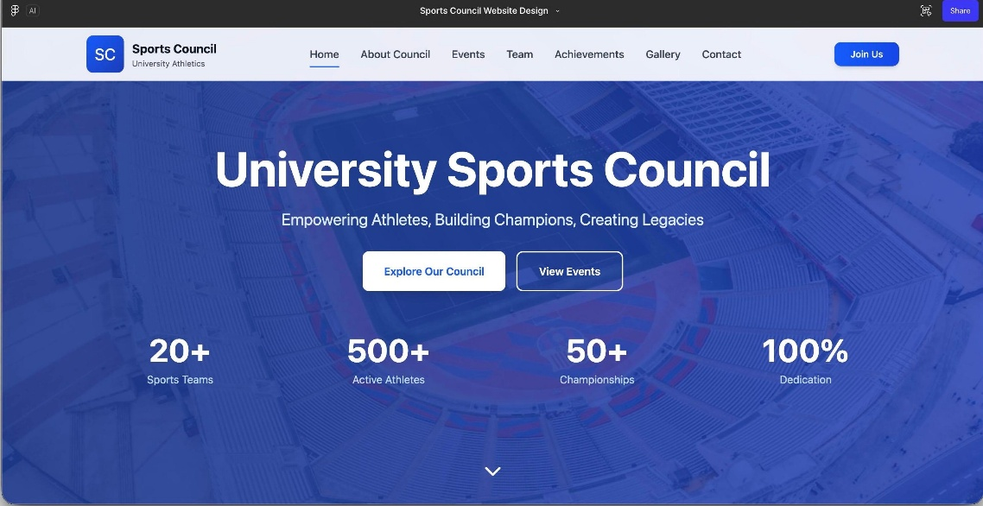
<referenceimg>
* News Ticker / Slider:
* A visually engaging “Image Carousel” showing high-quality action shots from recent games.
* Overlaid text for "Latest News" headlines.
* Section: About Council & Core Values:
* A dedicated section explaining the mission.
* The Council Hierarchy displayed clearly with names and titles:
- Directors
- Convenors
- ⁠ Coaches
- ⁠Student body
---
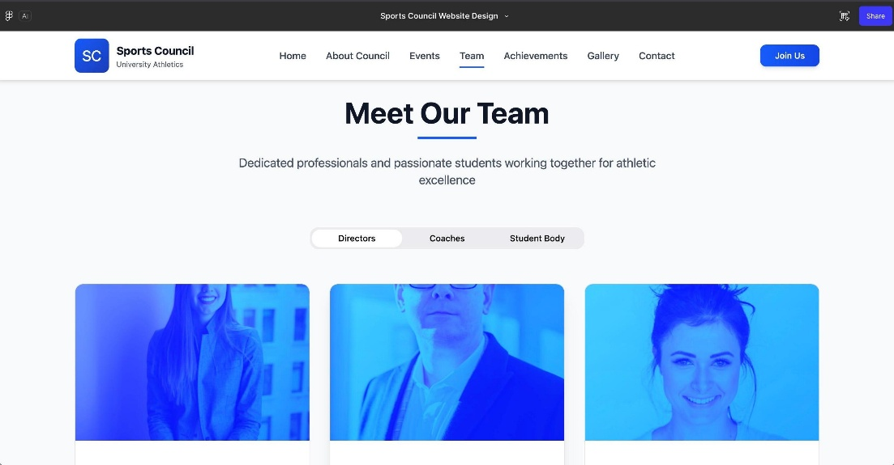
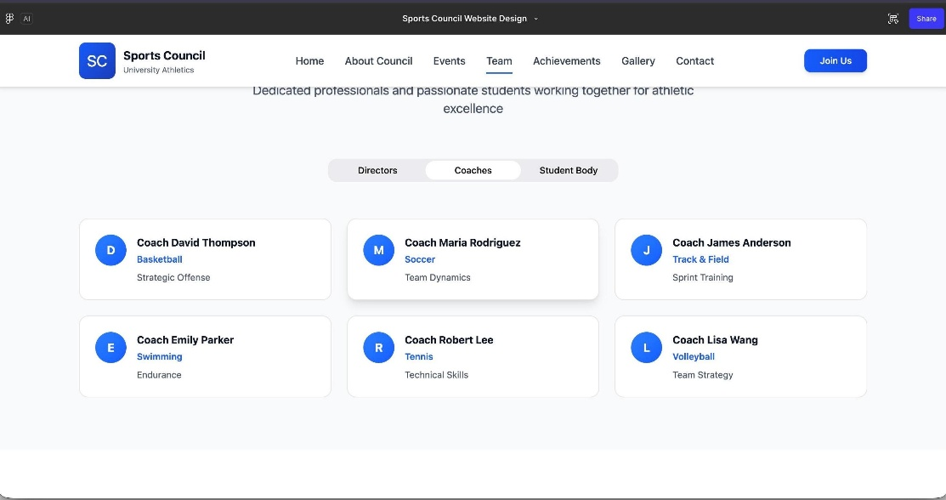
2. Page Two: Clubs
This will act as a directory for all sporting disciplines. Based on your sketch, a "Grid Layout" is best here.
* The Grid Display: Clickable cards/tiles for each sport. As per your notes, the grid includes:
- Cricket | Badminton | Tennis | Gym | Carroms | Chess | [Slot for Expansion] | [Slot for Expansion]**

*Individual Club Popup/Page (When a card is clicked):
- Leadership: Display Convenors & Co-convenors names/photos.
- Roster: "Team if any" — A list or table displaying current team members.
- Visuals: A dedicated Gallery section specific to that sport (e.g., photos of the Cricket team playing).
---
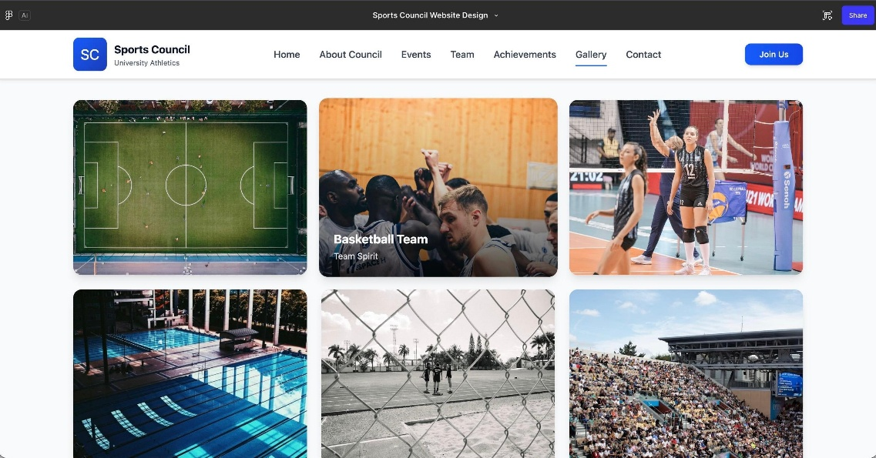
3. Page Three: Events
This page needs to be chronological to help users navigate time.
- ** Sub-Section A: Present Events (Live)
  - Highlighted section showing what is happening *right now* (Live scores or ongoing tournament banners).

- **Sub-Section B: Future Events (Upcoming)**
  - A calendar view or list view of upcoming fixtures and registration links.

- **Sub-Section C: Past Events (Archive)**
  - A database of previous tournaments.
  - Result Cards: As per your requirement, specific details for each past event:
  - Game Details
  - Winners (Gold/1st)
  - Runners-up (Silver/2nd)
  - Etc..
---
<img>
4. Page Four: Achievements
The "Trophy Cabinet" of the website.
Masonry Wall or a Timeline of Glory .
Content:
- Photos of trophies won by SRMAP teams.
- Inter-university accolades.
- Individual student-athlete record
