Visualize BigQuery Public Data (New York CitiBike) with Tableau.

Bar Char (entire view):

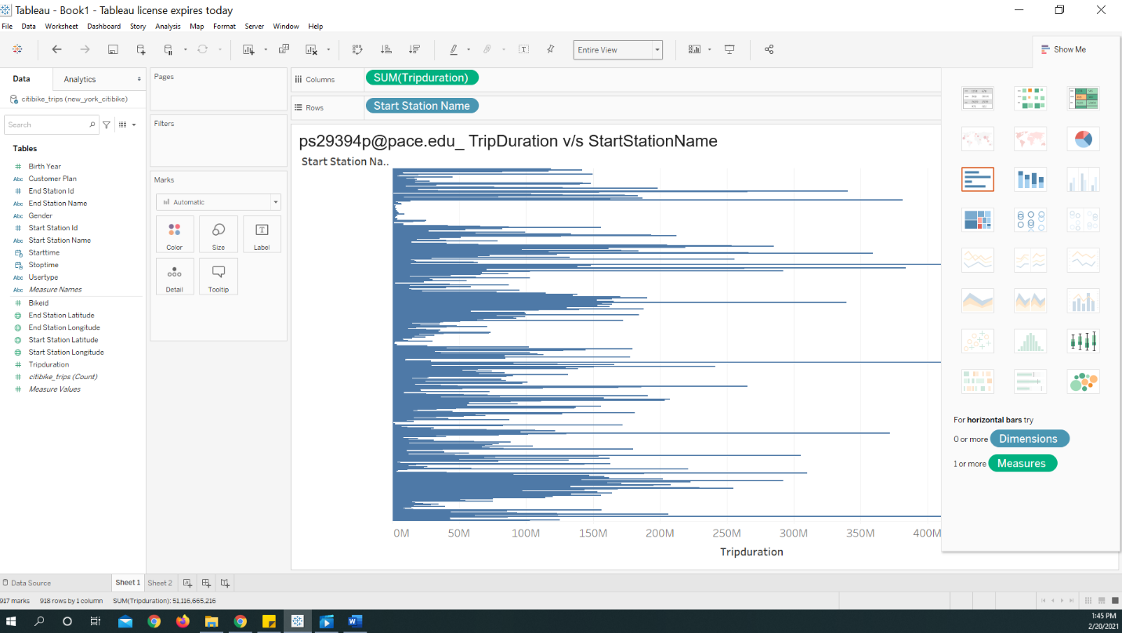

Map chart(Geographical distribution):

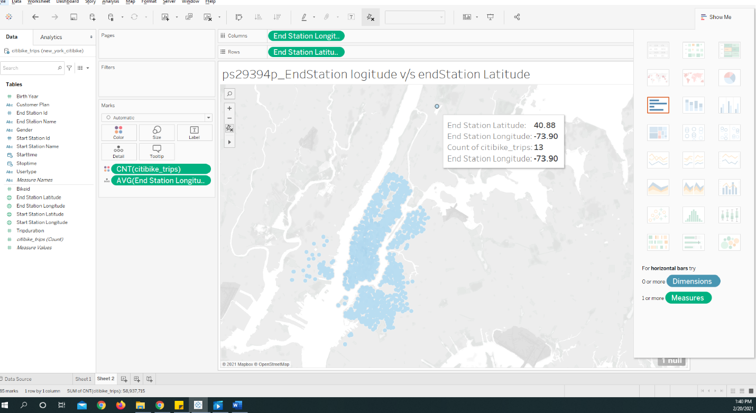

Line Chart: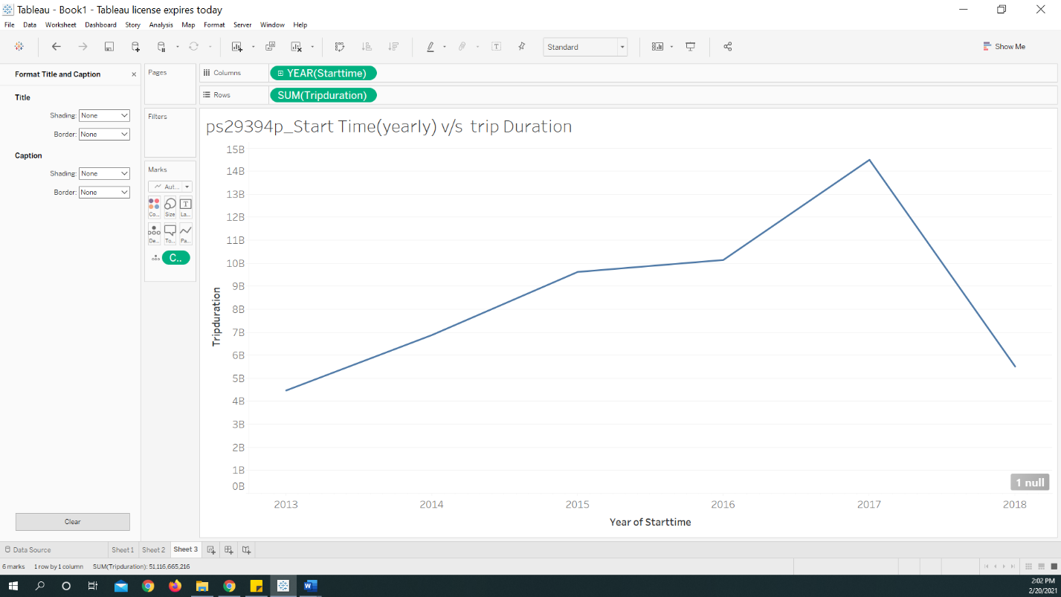

Dashboard:

