LLPIN-7876

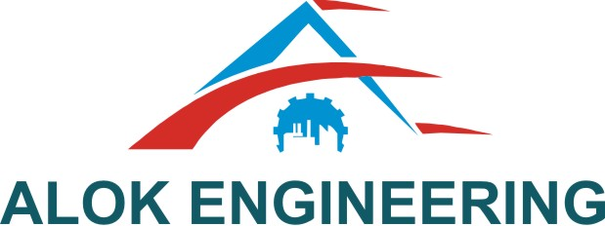

**Alok Engineering LLP**

D-155, Five Star M.I.D.C. Shendra Aurangabad-431005

Phone: 0240-2984019, Cell: +91-7066044464, e-mail: [sales@alokeng.com](mailto:sales@alokeng.com), [www.alokeng.com](http://www.alokeng.com)

No. AELLP/Shendra/Qtn./31/2018-2019 Date: 24

/03/2019

To,

Mr. Ajit Naduvinamani

RUCHA ENGINEERS PVT. LIM. unit -4

Shendra MIDC, Aurangabad,

**Sub: Quotation for Plate .**

Resp. Sir,

We are pleased to offer our best Quotation for plate .

|  |  |  |  |  |  |  |
| --- | --- | --- | --- | --- | --- | --- |
| **Sr.no** | **Description** | | **PLATE SIZE** | **PER UNIT** | **QTY** | **Final Cost** |
| **01** | **PI009/ ASM4/SA1/P4** | | **155X135X16** | **508** | **8** | **4064** |
| **02** | **PI001/ASM4/SA2/P2** | | **155X155X12** | **543** | **8** | **4344** |
|  | |  | | | | |

We look forward doing business with you.

Note: If concept revised additional charges applied according to changes in concept.

Thanks & Regards,

**Ajinath Sonwane**

**7972673104**

**Terms & Conditions:**

Prices Basis : The Prices are exclusive of GST 18 % ,HSN Code 9017

Delivery : 1 week from the date of receipt of your PO.

Validity : 15 days from date of this offer

Payment Terms : 50 % Advanced remaining proforma invoice against the delivery .