LLPIN-7876

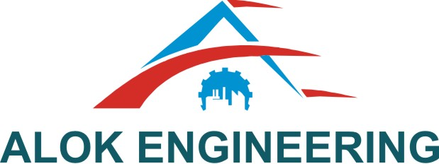

**Alok Engineering LLP**

D-155, Five Star M.I.D.C. Shendra Aurangabad-431005

Phone: 0240-2984019, Cell: +91-7066044464, e-mail: [sales@alokeng.com](mailto:sales@alokeng.com), [www.alokeng.com](http://www.alokeng.com)

No. AELLP/Shendra/Qtn./50/2018-2019 Date: 03-05-2019

To,

Mr. Ajit Naduvinamani

Rucha Engineers Pvt. Ltd. LIM. Unit 4

Shendra MIDC Area , Aurangabad.

**Sub: Quotation for IP001 Mechanical Assembly ASM6/SA1. ASM7/ SA1, ASM4/P9 & ASM4/ P10**

Resp. Sir,

We are pleased to offer our best Quotation for Manufacturing material with material as per below details.

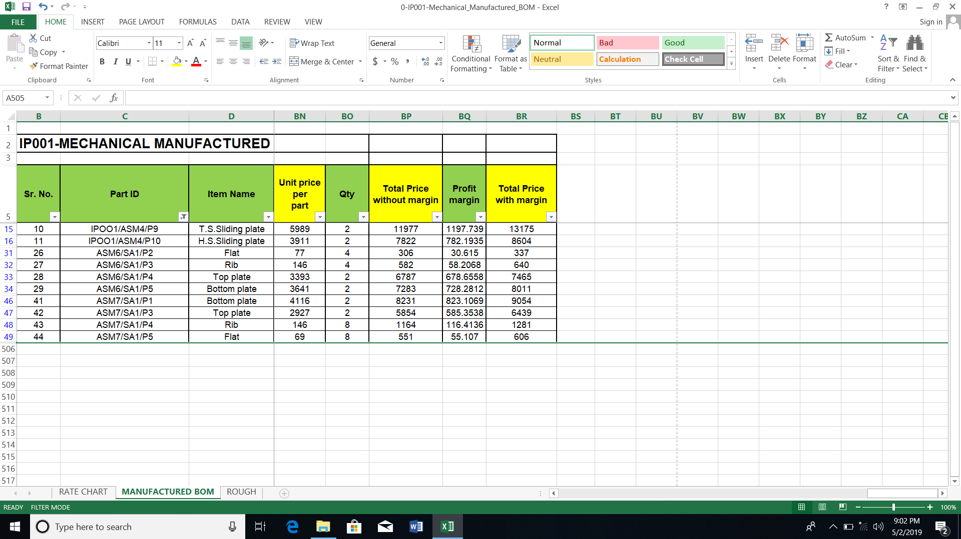

Any addition of the manufacturing process the extra charges are applicable.

We look forward doing business with you.

Thanks & Regards,

**Ajinath Sonwane**

**7972673104**

**Terms & Conditions:**

Prices Basis : The Prices are exclusive of GST 18 % ,HSN Code 9017

Delivery : 2 week from the date of receipt of your PO.

Validity : 15 days from date of this offer

Payment Terms : 50 % Advanced remaining against the material GRN .