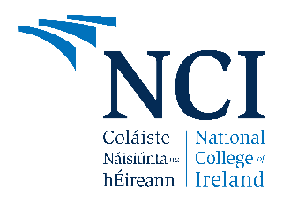
National College of Ireland
M.Sc. in Cloud Computing — Year 1
Cloud Machine Learning
Professor : Dr. Alejandro Flores Lamas
Team Members :
Anurag Aman ( 25143654 )
Aditya Nath Singh ( 25122282 )
Pradnyesh Bhushan Patil ( 25143174 )

Topic name : Predicting Risk of Fatal Coastal Incidents
Datasets that share common environmental and location-based features:
- Shark attacks or wildlife incidents
- Rip current incidents
- Surfing accidents
Common features:
- Date/season
- Beach/coastal location
- Water temperature
- Wave height
- Weather conditions
- Human activity (swimming, surfing, diving)
- Time of day
- Fatal / non-fatal outcome

ML Task for the topic
- Fatal vs Non-fatal Incident (Classification)
Predict whether an incident will result in a fatal or non-fatal outcome based on environmental and activity-related factors.
- High-risk vs Low-risk Conditions (Classification)
Identify whether the combination of weather, wave, temperature, location, and activity conditions represents a high-risk or low-risk situation.
- Incident Type Prediction (Multi-class Classification)
Predict the most likely type of coastal incident (e.g., shark attack, rip current incident, surfing accident, or other surface hazard incident) based on environmental conditions and human activity.

Shared features :
Feature | Shark | Surfing | Rip Current
Location | ✓ | ✓ | ✓
Date/Season | ✓ | ✓ | ✓
Weather | ✓ | ✓ | ✓
Wave Conditions | ✓ | ✓ | ✓
Water Activity | ✓ | ✓ | ✓
Fatality | ✓ | ✓ | ✓
This creates a integrated dataset suitable for:
- Classification
- Risk prediction
- Accident severity prediction
- Hotspot analysis

