Store file into AWS S3 Bucket and access it

IAM User Manu
Bucket name – my-fileprocessor-bucket

Empty bucket before uploading the files.
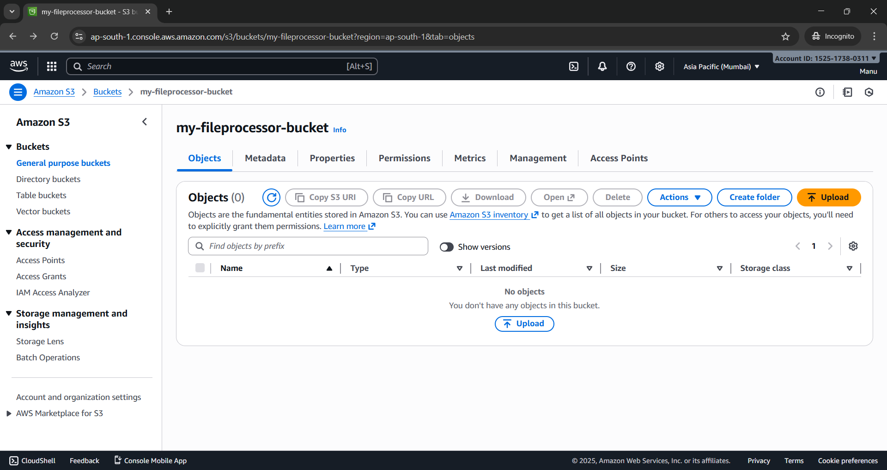

Get File Names –
url – GET -http://localhost:8080/S3/v1/files

204 as no data found
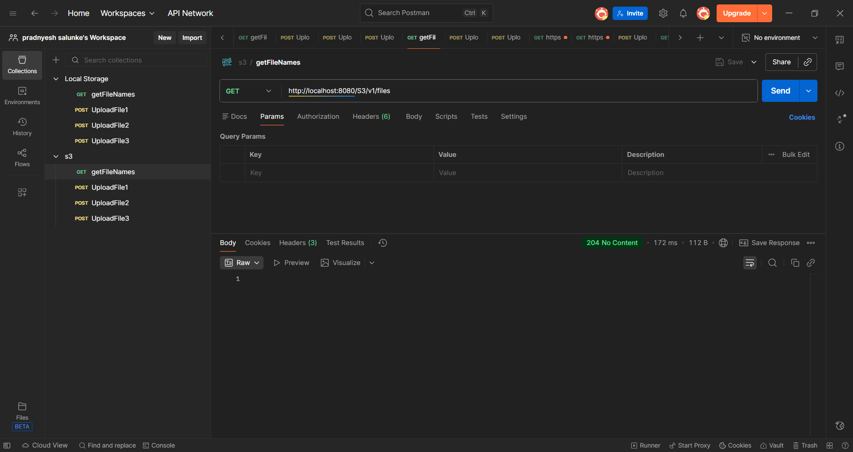

Now upload the file –
Post - http://localhost:8080/S3/v1/upload
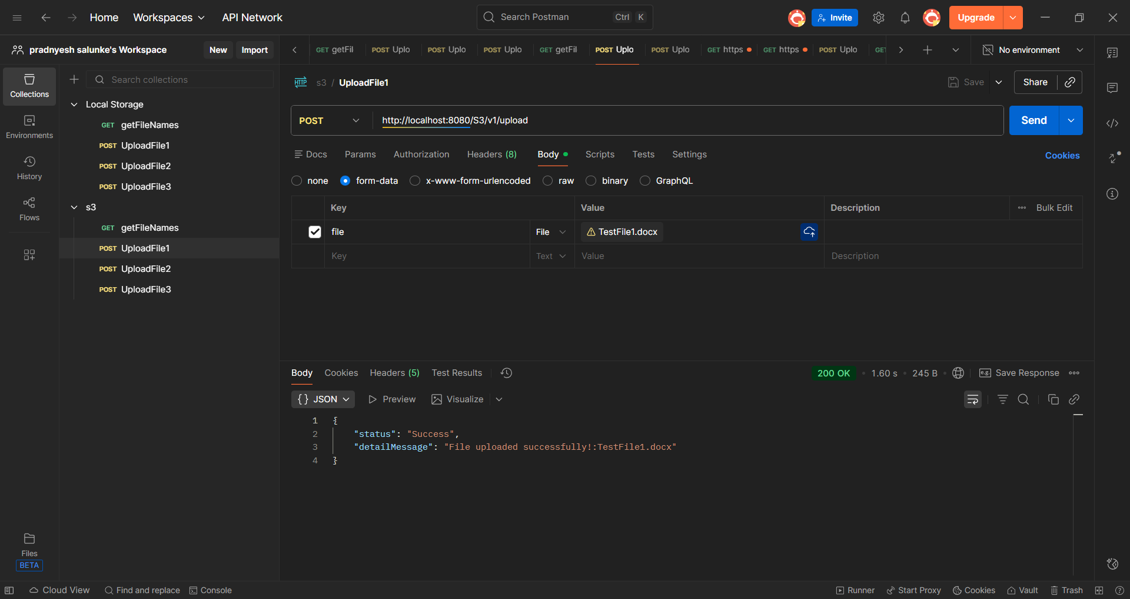

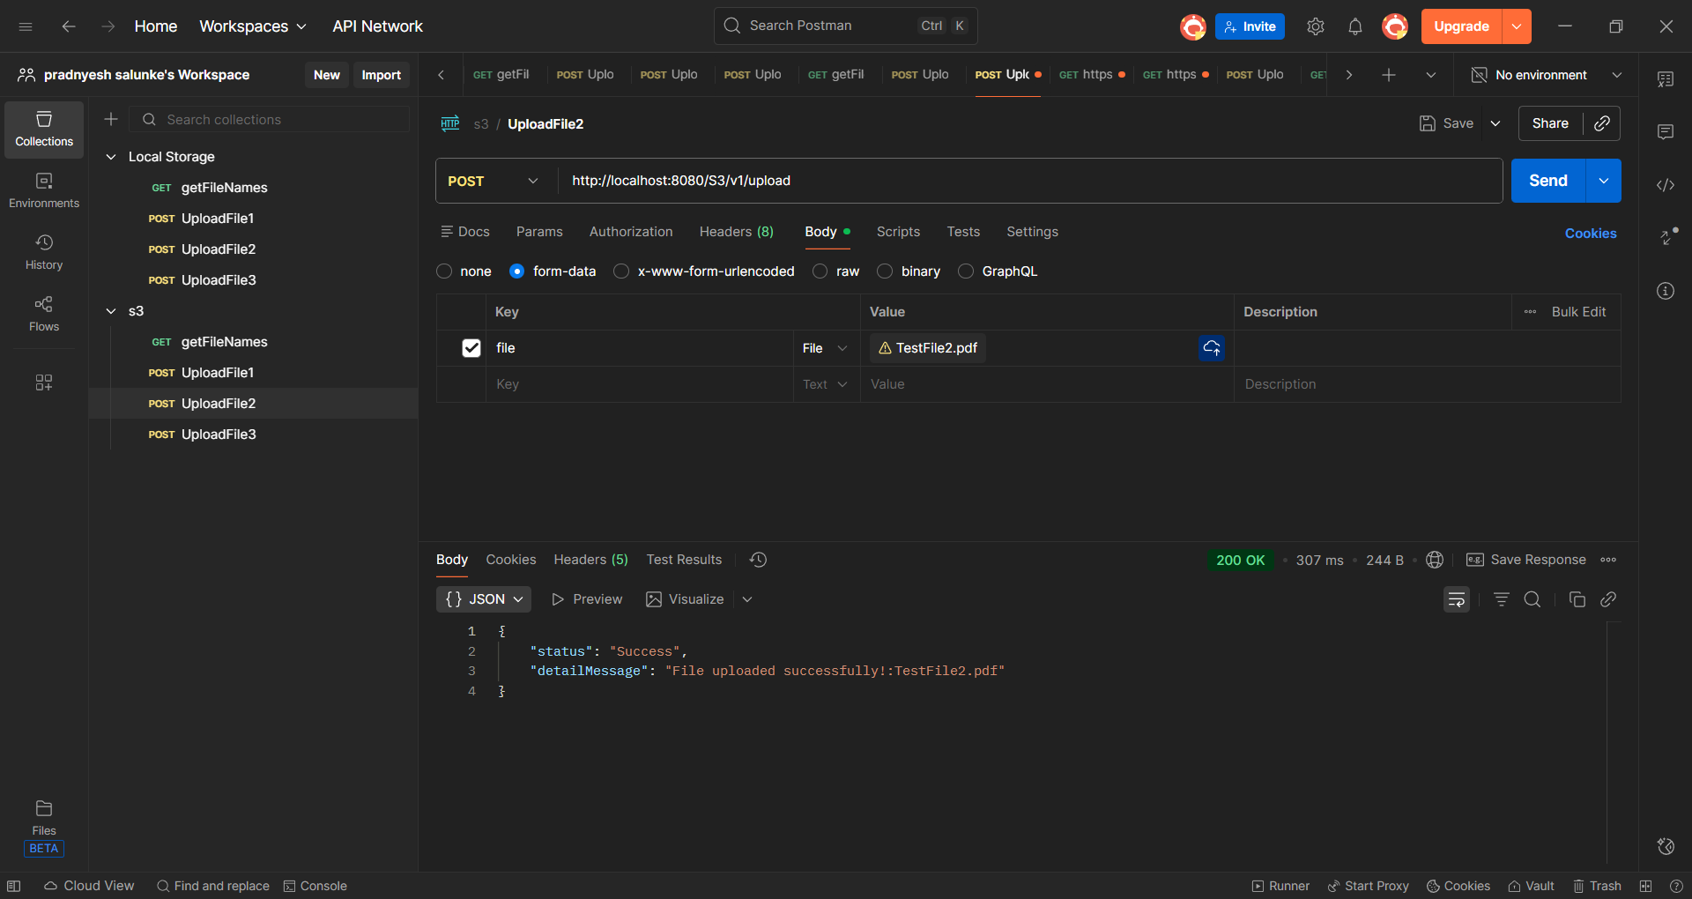

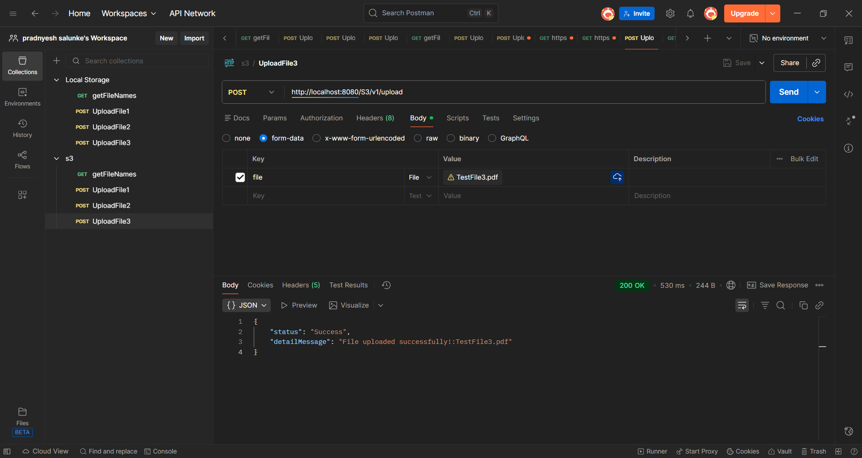

After uploading 3 files to s3 bucket

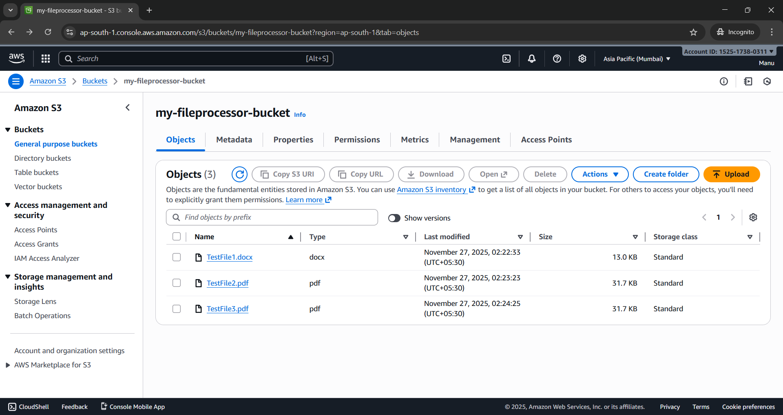

- Get file with URL – bucket is private but configure pre-signed so that URLs can be access and file download

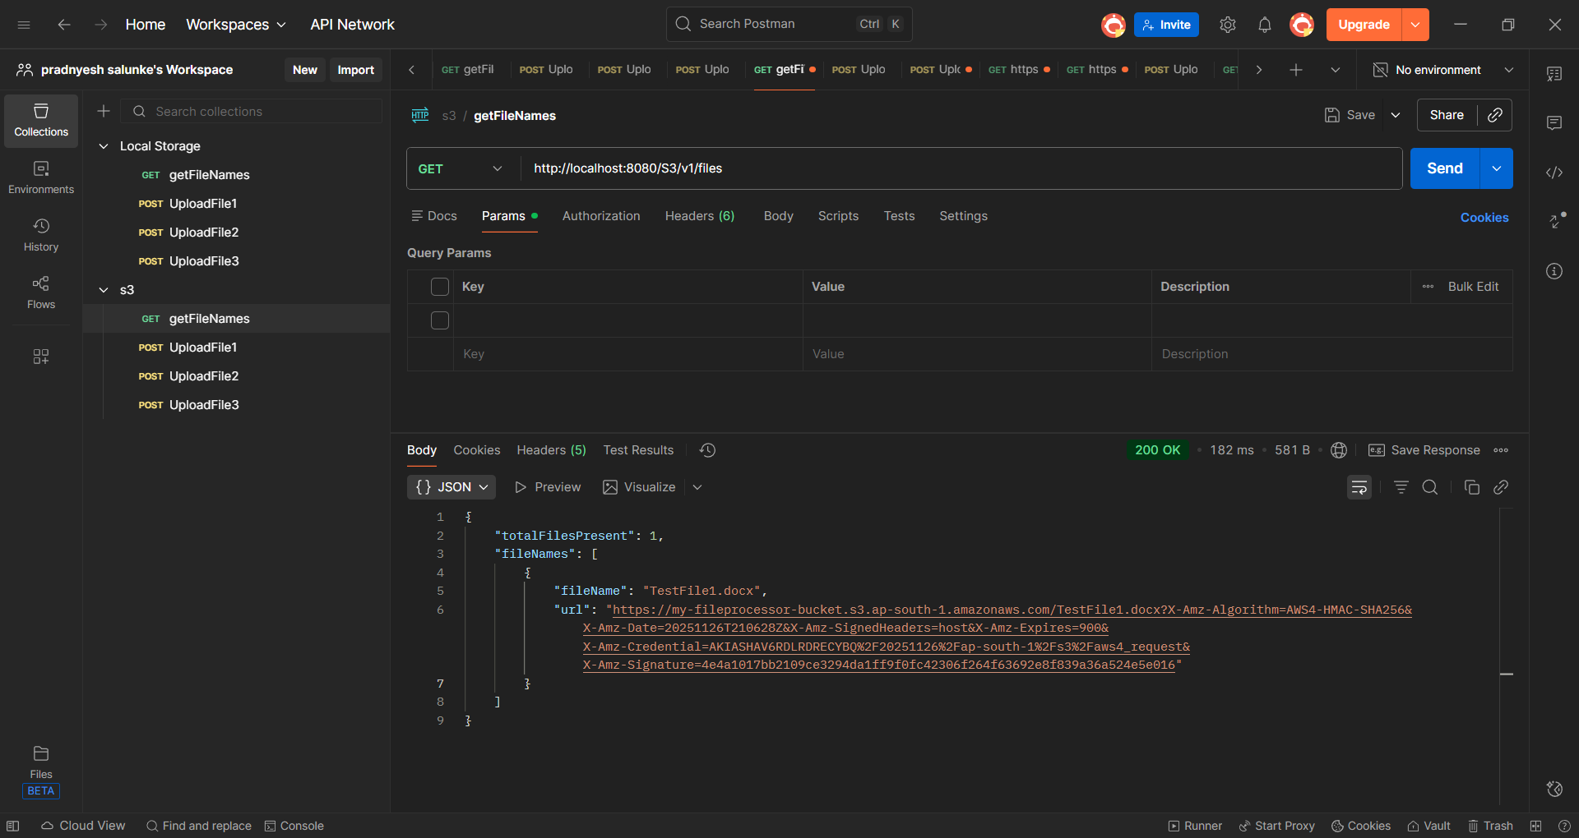

If File is not send then throwing 400 bad request -with message provide correct file

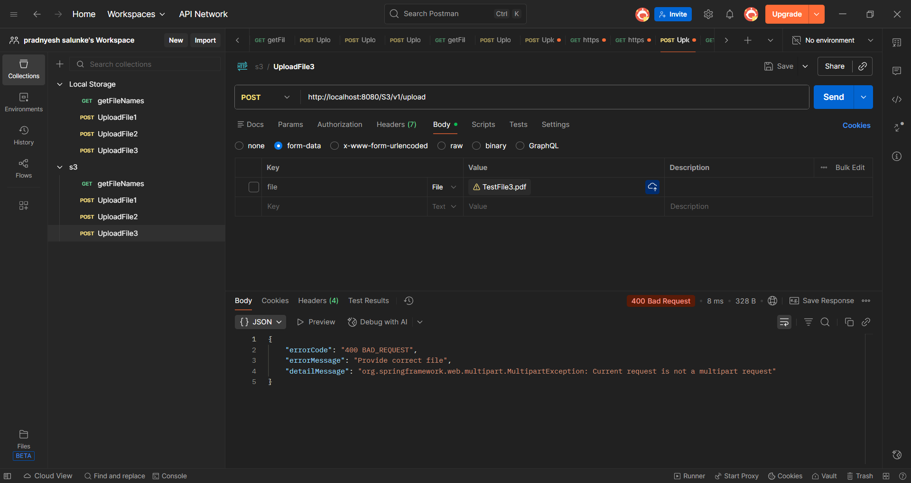

Local Storage Endpoints -
Before local storage endpoint hit-
there is no folder name files

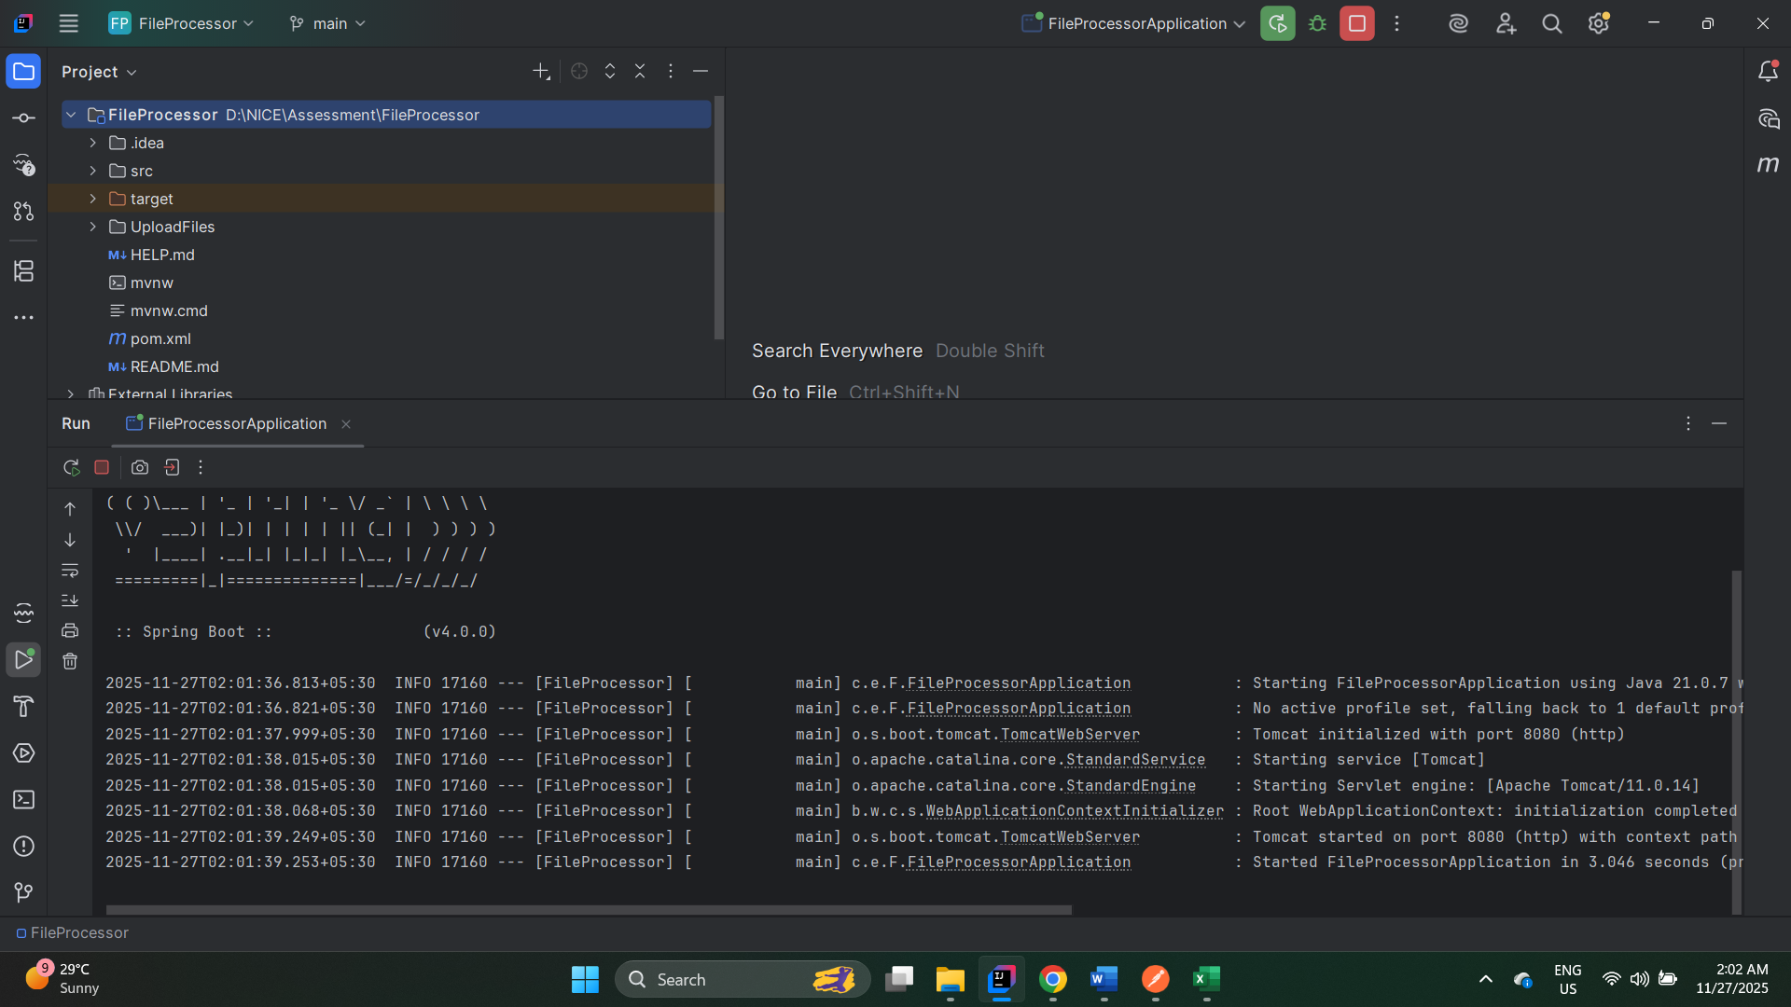

Testing get file for local – and as expected throw exception
url -GET - http://localhost:8080/local/v1/files
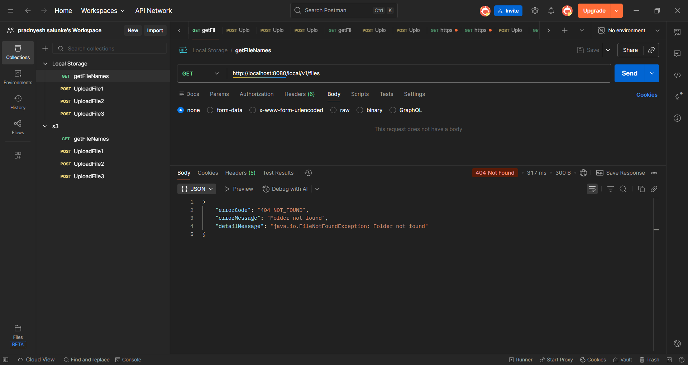

Post – upload -
copied the file into local storage by creating new folder name as files
http://localhost:8080/local/v1/file/upload
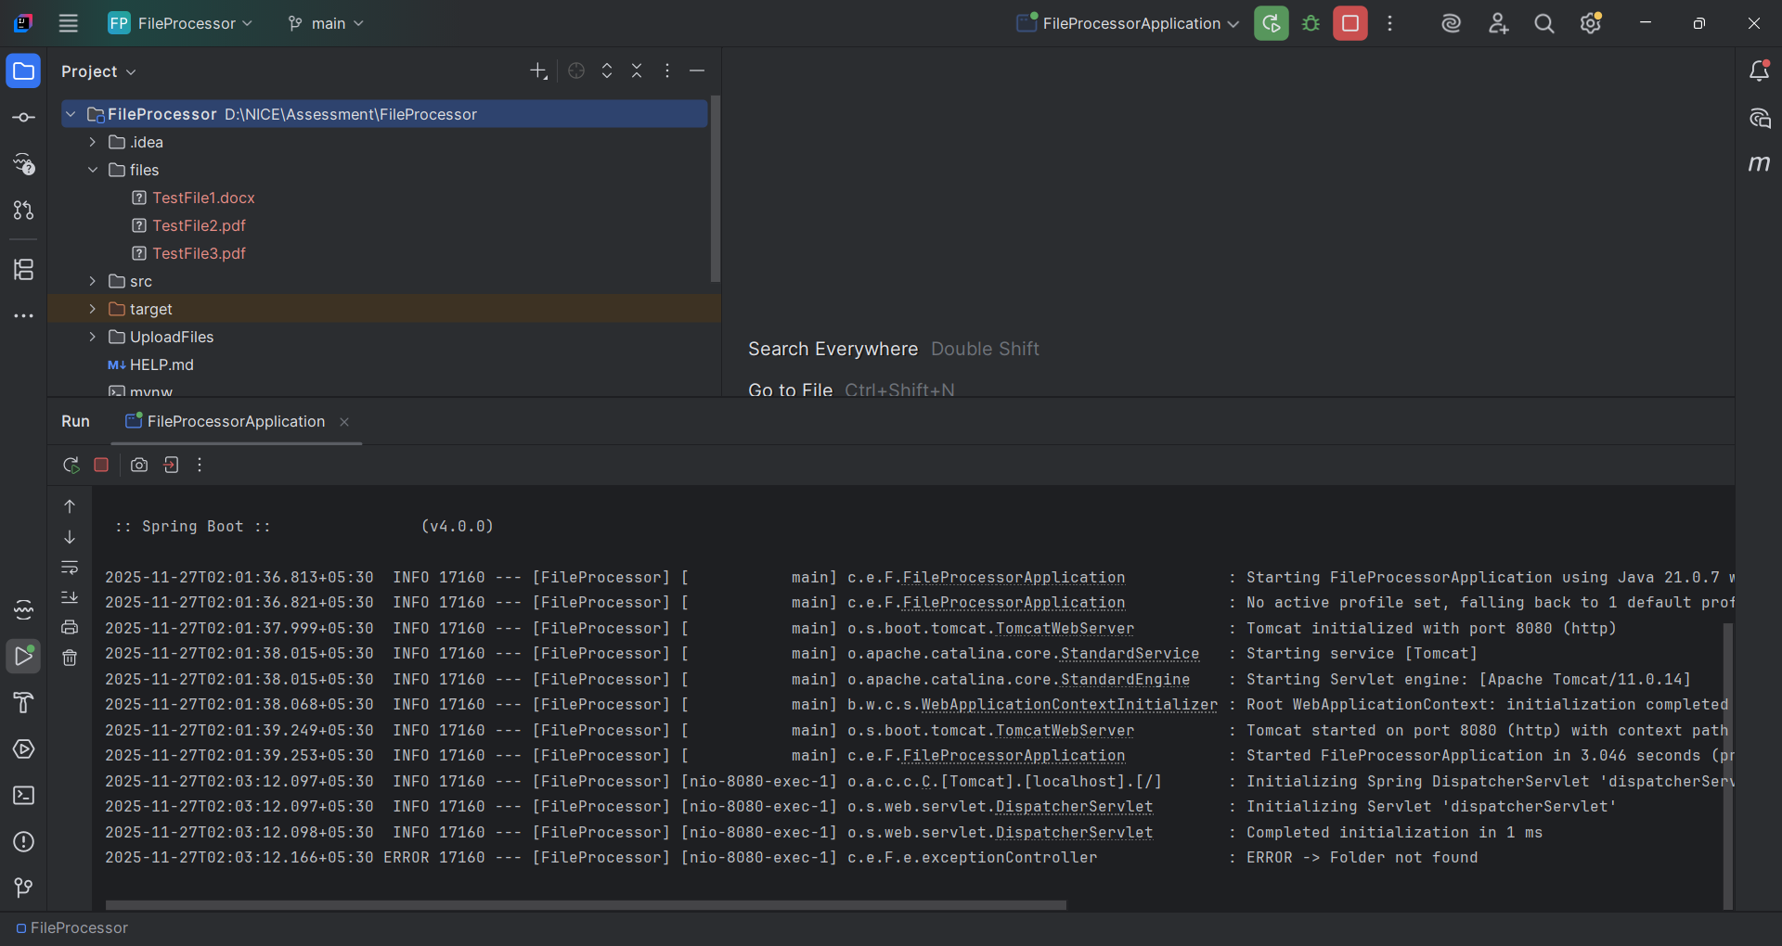

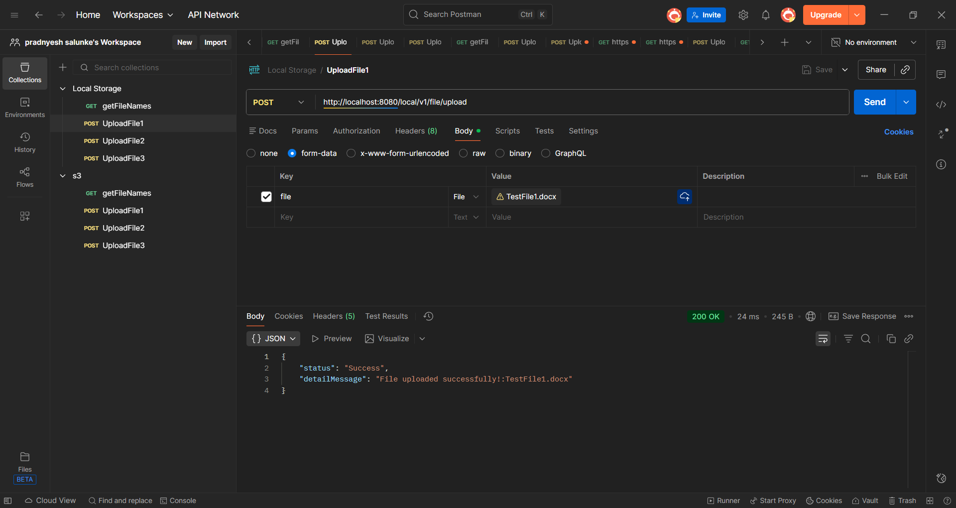

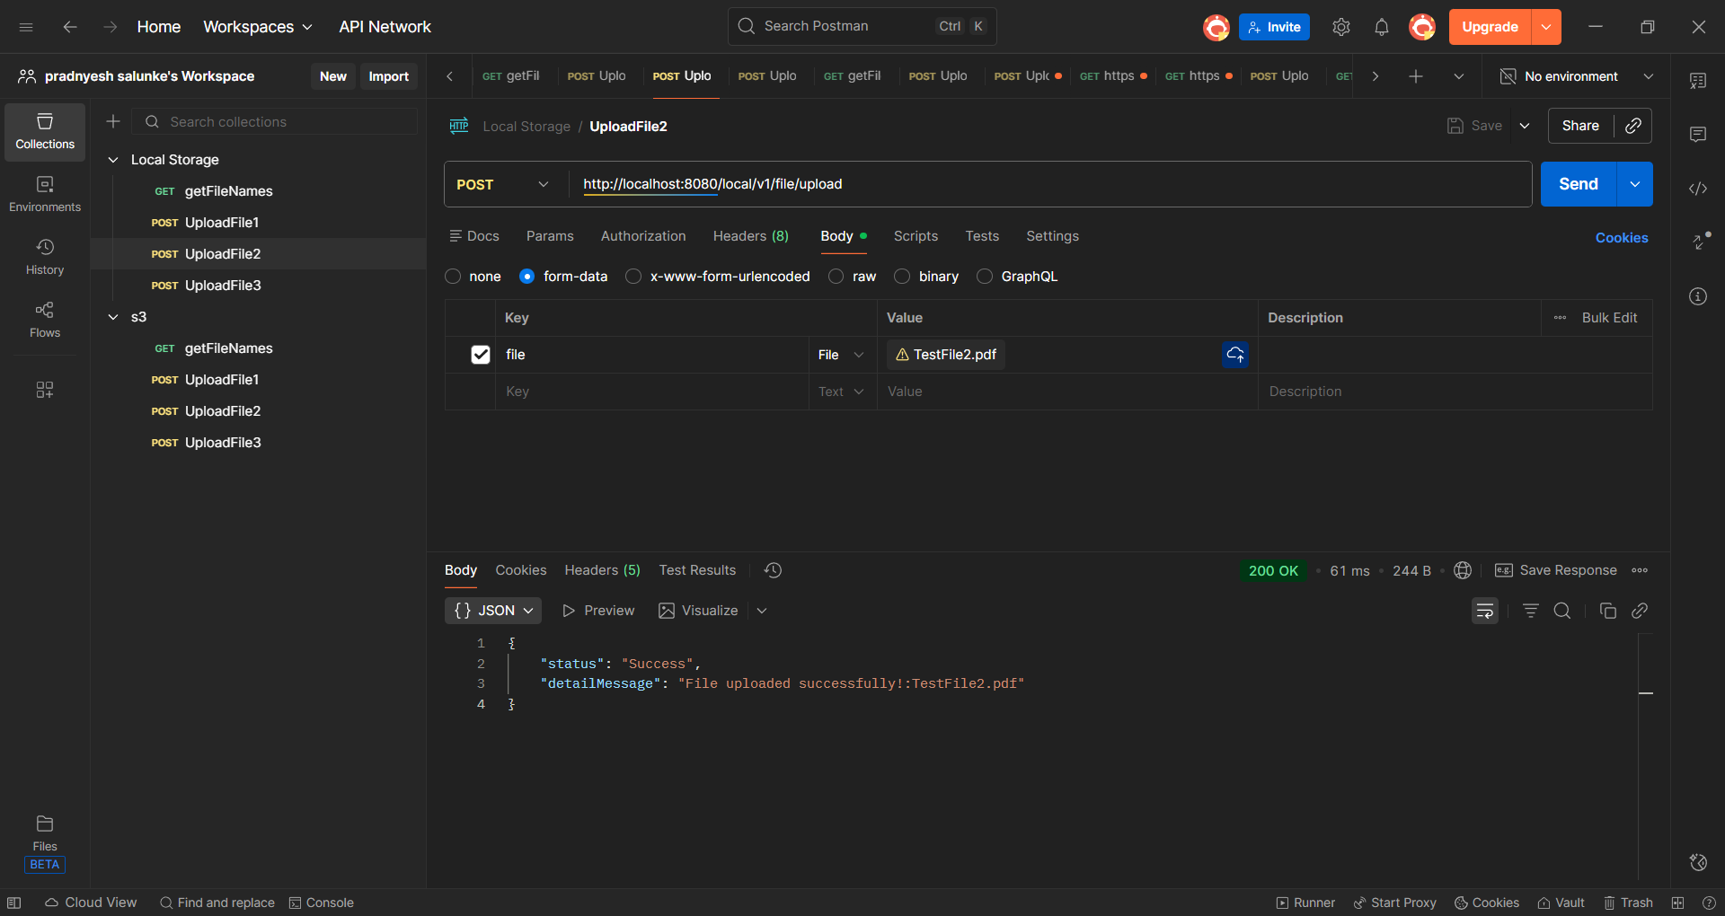

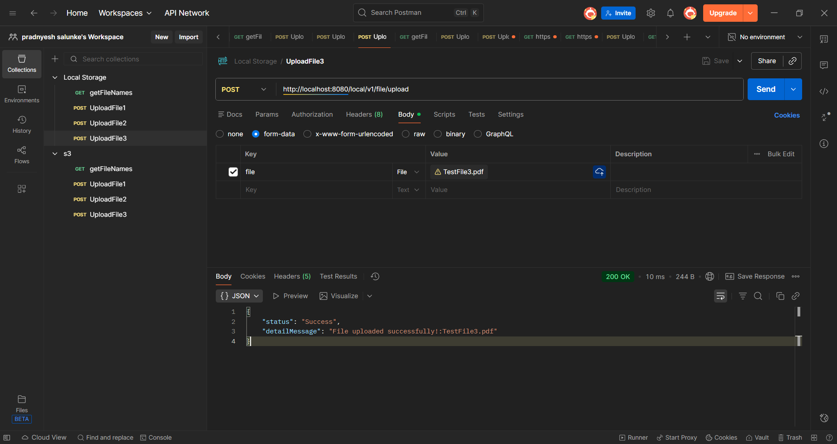

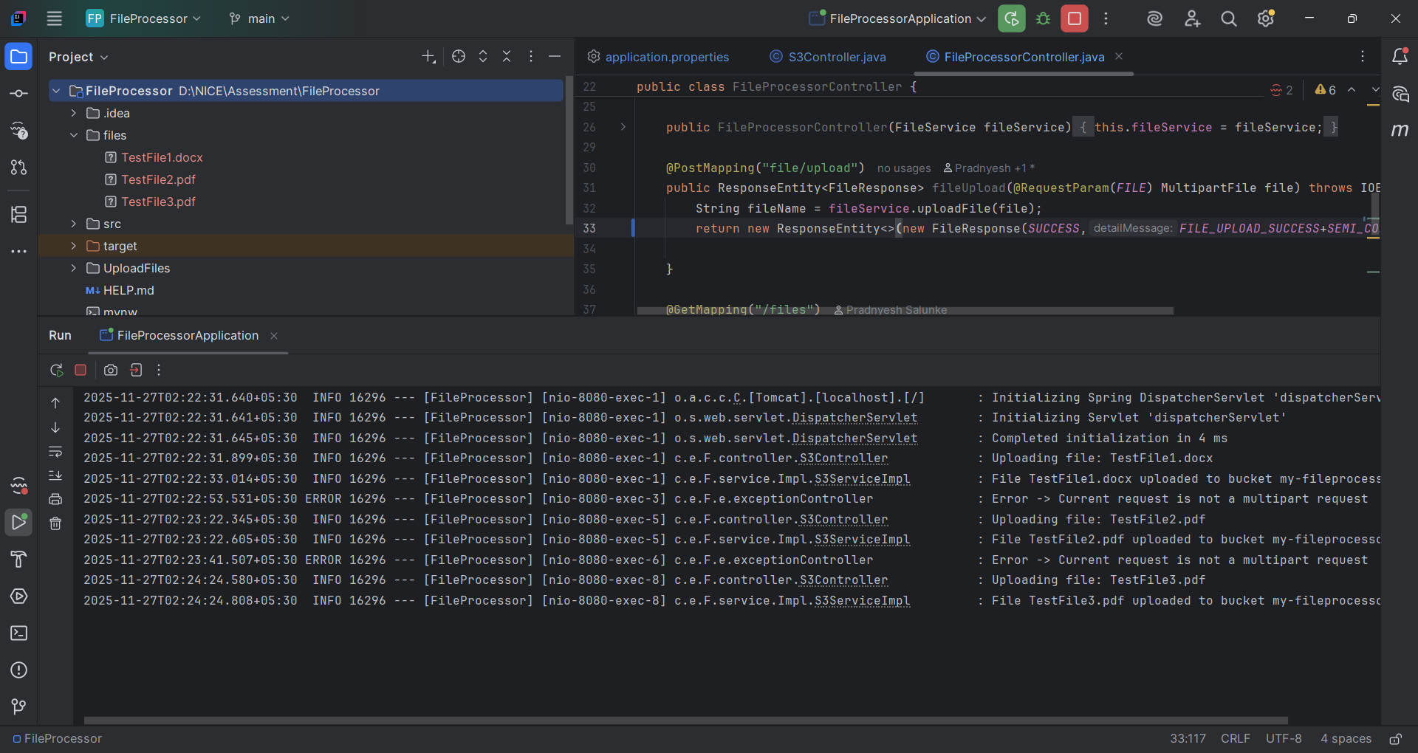

If same file tried to upload again ,will throw file already exist error.
