# Data Feeds

|  |  |  |  |  |  |
| --- | --- | --- | --- | --- | --- |
| Subject Area | Source | Database Name | Source | Foundation | Mart |
| Master Data | RMS/FMW | na | item | plus_item | Dim_item |
| Transaction | TeraData EDW | EDWP_XX_DATA | merch_class | plus_merch_class | NA |
| Transaction | TeraData EDW | EDWP_XX_DATA | merch_department | plus_merch_department | NA |
| Customer Transaction | TeraData CRM | EDWP_XX_DATA | sales_customer | plus_sales_customer | included into fact transaction tables |
| Transaction | TeraData EDW | EDWP_XX_DATA | sales_transaction_detail | plus_sales_transaction_detail | fact_transaction_detail |
| Transaction | TeraData EDW | EDWP_XX_DATA | sales_transaction_header | plus_sales_transaction_header | fact_transaction |
| Master Data | RMS/FMW | na | store | plus_store | dim_store |
| Customer Email | TeraData CRM | DMMCIPI04 | store_address | plus_store_address | NA |
| Customer Card | TeraData CRM | DVZEKE | tmci997_esp_outbound | plus_tmci997_esp_outbound | plus_brand_customer_email_outbound |
| Customer Card | TeraData CRM | DVZEKE | vmci015_cust_ccard | plus_vmci015_cust_ccard | plus_brand_customer_account |
| Customer | TeraData CRM | DVZEKE | vmci016_ccard_type | plus_vmci016_ccard_type | Included in plus_brand_customer_account |
| Customer | TeraData CRM | DMMCIPI04 | vmci019_customer | plus_vmci019_customer | plus_brand_customer |
| Campaign Contact | TeraData CRM | DVZEKE | vmci019_custonly | plus_vmci019_custonly | Included in plus_brand_customer |
| Campaign Contact | TeraData CRM | DVZEKE | vmci024_dir_mkt_cl | plus_vmci024_dir_mkt_cl | plus_brand_customer_direct_marketing_cell |
| Campaign Contact | TeraData CRM | DVZEKE | vmci025_mailing | plus_vmci025_mailing | plus_brand_customer_mailing |
| Customer | TeraData CRM | DMMCIPI04 | vmci051_clcst_gp_h | plus_vmci051_clcst_gp_h | plus_brand_customer_clcst_gp |
| Customer | TeraData CRM | DVZEKE | vmci079_club_memb | plus_vmci079_club_memb | plus_brand_customer_perks_membership |
| Customer Email | TeraData CRM | DMMCIPI04 | vmci105_chain_cust | plus_vmci105_chain_cust | Included in plus_brand_customer |
| Customer Email | TeraData CRM | DMMCIPI04 | vmci172_chain_cust_email | plus_vmci172_chain_cust_email | plus_brand_customer_email |
| Customer Email | TeraData CRM | DMMCIPI04 | vmci173_full_email_addr_status | plus_vmci173_full_email_addr_status | Include in plus_brand_customer_email |
| Customer | TeraData CRM | DMMCIPI04 | vmci173_full_email_address | plus_vmci173_full_email_address | Included in plus_brand_customer_email |
| Customer | TeraData CRM | DMMCIPI04 | vmci180_cust_demog | plus_vmci180_cust_demog | plus_brand_customer_demographics |
| Customer | TeraData CRM | DMMCIPI04 | vmci198_opt_in_out_type | plus_vmci198_opt_in_out_type | Included in plus_brand_customer_opt_in_out |
| Customer | TeraData CRM | DMMCIPI04 | vmci396_curr_opt_in_out_full | plus_vmci396_curr_opt_in_out_full | plus_brand_customer_opt_in_out |
| Customer Email | TeraData CRM | DMMCIPI04 | vmci972_chain_cust_fullemail | plus_vmci972_chain_cust_fullemail | Included in plus_brand_customer_email |

Data Model

**Foundation layer**



**Mart Layer**



**S3 – Simple Storage Service**

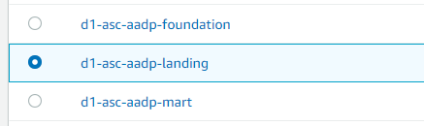

1. Landing – This has all the raw data coming from Source systems.

All the data feeds mentioned above are stored in this layer within the appropriate folder structure in BZIP format.

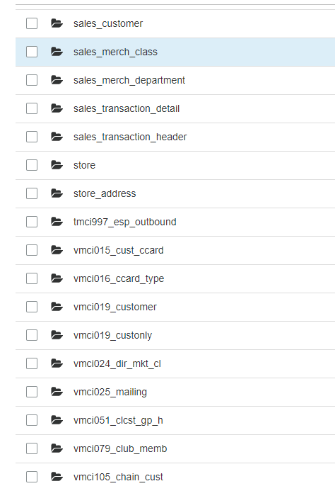

1. Foundation – This layer has few transformation w.r.t hashing of keys and partition. Foundation layer holds the same datatypes and table structure as source data. This layer is available to view in Athena.

All the Objects are stored in parquet format.

Refer annexure for Data model for Foundation

1. Mart – Data Mart is on top of foundation layer to avoid all the data anomalies from source systems. Data Mart follows the best practices of Data Architecture with required naming standards, table structure with more transformations, and give us one common model for all the three different sources.

Refer annexure for Foundation-Mart mapping document and Data Model for Mart Layer.

Athena

Foundation –

Database – plus_foundation

Mart –

Database – plus_mart

Testing Documentation –

<https://ascenaretail.sharepoint.com/:x:/s/SP-ASC-AA_DataArchitecture/EauMwTRHRN9Cqq_uS4oJu_sB5PHVX7OYFU6ON0PQpWu3FQ?e=KI323X>

Key mapping document -

<https://ascenaretail.sharepoint.com/:x:/s/SP-ASC-AA_DataArchitecture/EauMwTRHRN9Cqq_uS4oJu_sB5PHVX7OYFU6ON0PQpWu3FQ?e=KI323X>