**First load**

"plus_mart_stg"."plus_direct_marketing_cell" **loaded**

**View created**

CREATE OR REPLACE VIEW plus_mart_dev.plus_direct_marketing_cell AS

SELECT * FROM

(SELECT *,

ROW_NUMBER()

        OVER (partition by direct_marketing_cell_key

    ORDER BY  mart_insert_tms desc) AS row_num

    FROM plus_mart_stg.plus_direct_marketing_cell ) as dmc

    where dmc.row_num=1

;

**Count Check**

SELECT count(*) FROM "plus_mart_dev"."plus_direct_marketing_cell" limit 10;

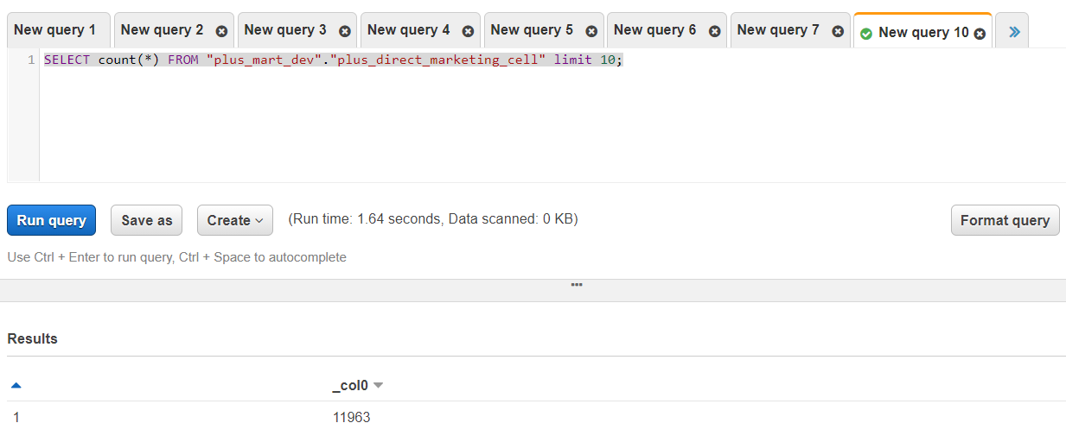

**Primary Key check**

SELECT direct_marketing_cell_key

FROM "plus_mart_dev"."plus_direct_marketing_cell"

GROUP BY direct_marketing_cell_key

HAVING count(*)>1;

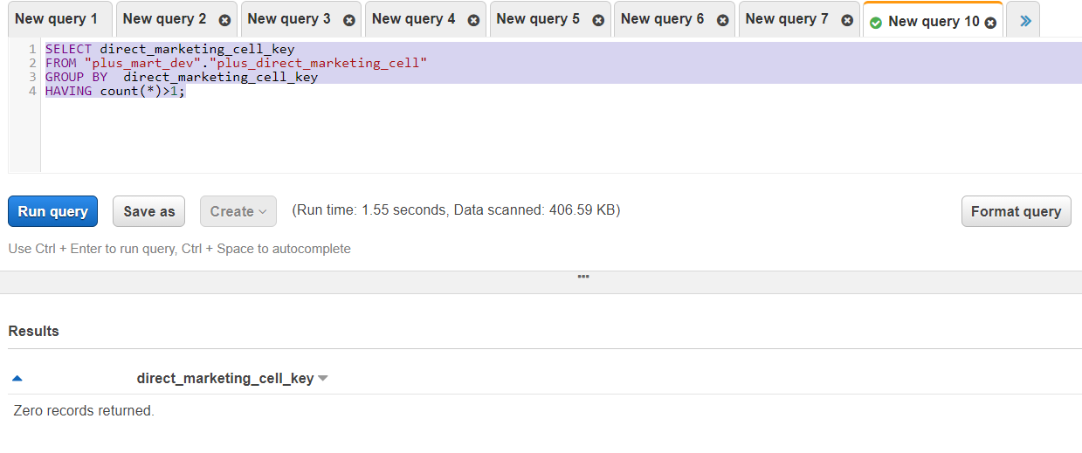

**Incremental load**

**Count check**

SELECT count(*) FROM "plus_mart_stg"."plus_direct_marketing_cell" limit 10;

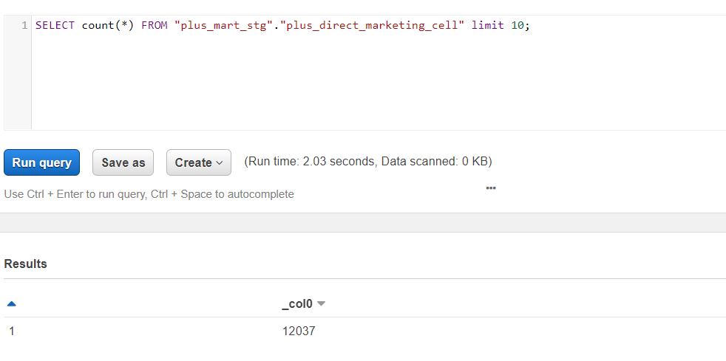

**Number of changed record ( additional check for understanding)**

SELECT count(*)

FROM "plus_mart_stg"."plus_direct_marketing_cell"

WHERE direct_marketing_cell_key IN

(SELECT direct_marketing_cell_key

FROM "plus_mart_stg"."plus_direct_marketing_cell"

GROUP BY direct_marketing_cell_key

HAVING count(*)>1)

**18**

**In final view**

The record count should be 11963 ( first load view count) + 65 ( new record ) =12028

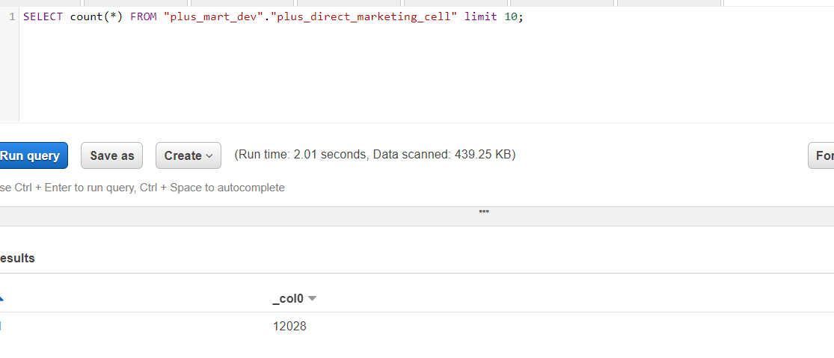

**Primary Key Check**

SELECT direct_marketing_cell_key,

count(*)

FROM "plus_mart_dev"."plus_direct_marketing_cell"

GROUP BY direct_marketing_cell_key

HAVING count(*)>1

