**Steps to run glue job in Production environment.**

Prerequisite – Access to start/stop Glue Job in Prod Environment

Step1: Click in AWS glue icon in AWS management Console, please refer below screenshot.

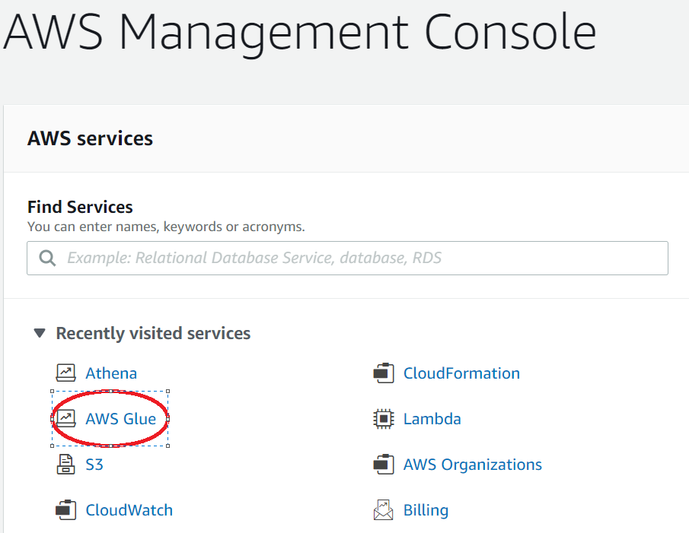

Step2: Once AWS glue console is opened, you have to click on “Jobs” under ETL category.

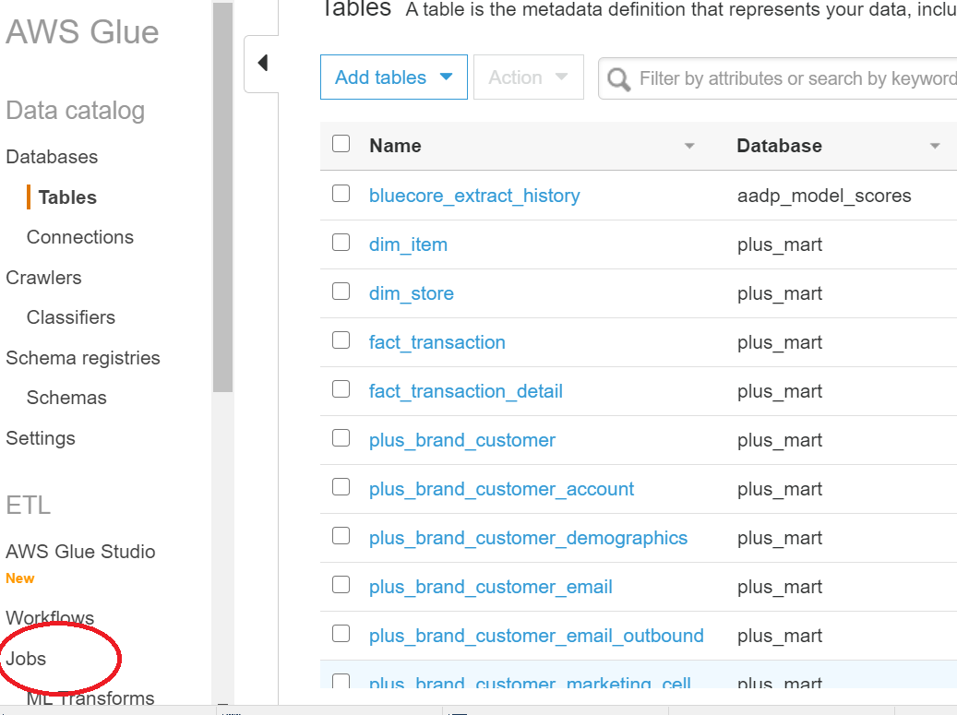

Step3: Once you clicked on “ jobs” you will see list of jobs like below .

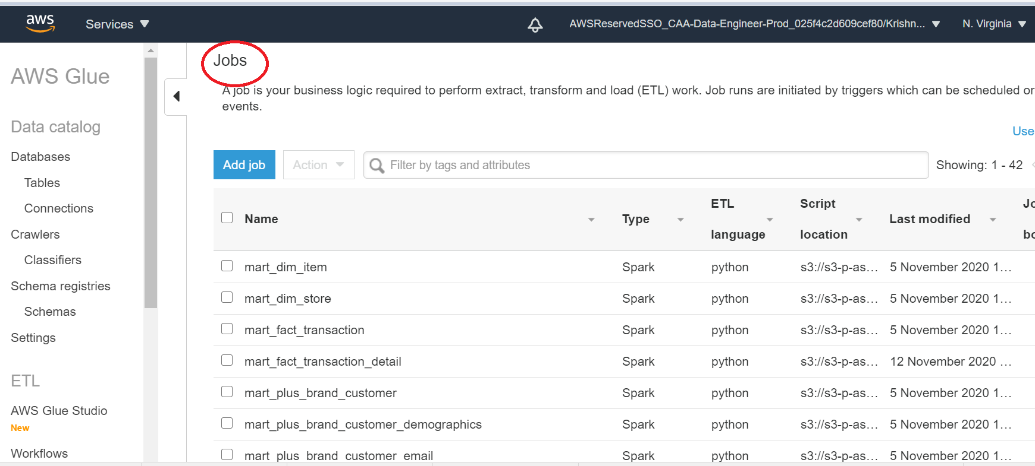

Step 4: Click on required job that need to be run and go to actions in drop box then select “Run job”.

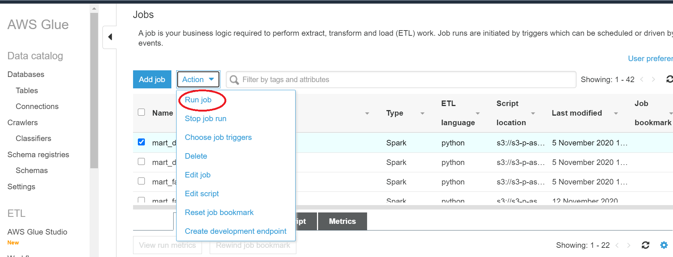

**Steps to merge code in Prod**

Prerequisite – AWS Codecommit

1. Access to merge, and push code in Prod branch of Repo – “cc-d-aadp-dsu-caa”

A separate user is created for Prod control team to access codecommit repo.

* Rittika to share ID
* Cloud Team to reset the password and share with Prod control team only

1. Github client installation
2. Initial setup - Github repo cloned to Prod Branch

**Steps –**

1. Open Command line prompt
2. cd to github folder

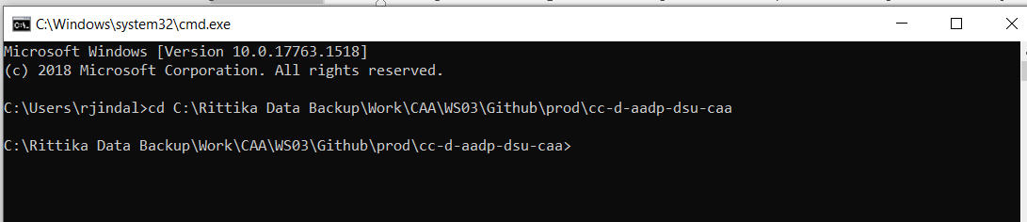

1. Type ‘git branch’ and it should always be pointing to Prod Branch
2. Type ‘git merge master’ to get latest updates from Master branch

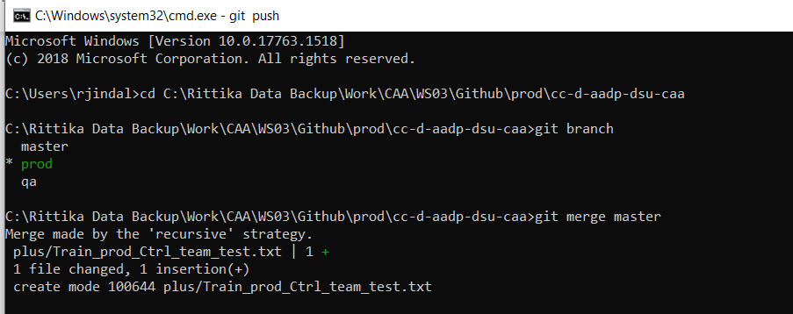

1. ** The file name should be in sync with CR created for this change
2. Type ‘git push’ to push the code to Prod

