Update on CAA Premium – Epsilon data load.

** Right now, Epsilon System is accessed using Rittika’s credentials, until we get a common account from epsilon

1. Glue Databases created

* Stack ‘pre-Database’ created pre_foundation and pre_mart

1. Glue Connection to Epsilon

* Connection created by UI to Epsilon DB

1. Glue job created

* Epsilon-connect-tst-RJ

1. Foundation loaded for table

* DM_OWNER.lu_product_vw

1. Athena table

* SELECT count(*) FROM "pre_foundation"."lu_product_vw" limit 10;

Connection and Port has been opened for Epsilon Database and we can connect to Epsilon over our VPN, without citrix. Refer the below screenshot

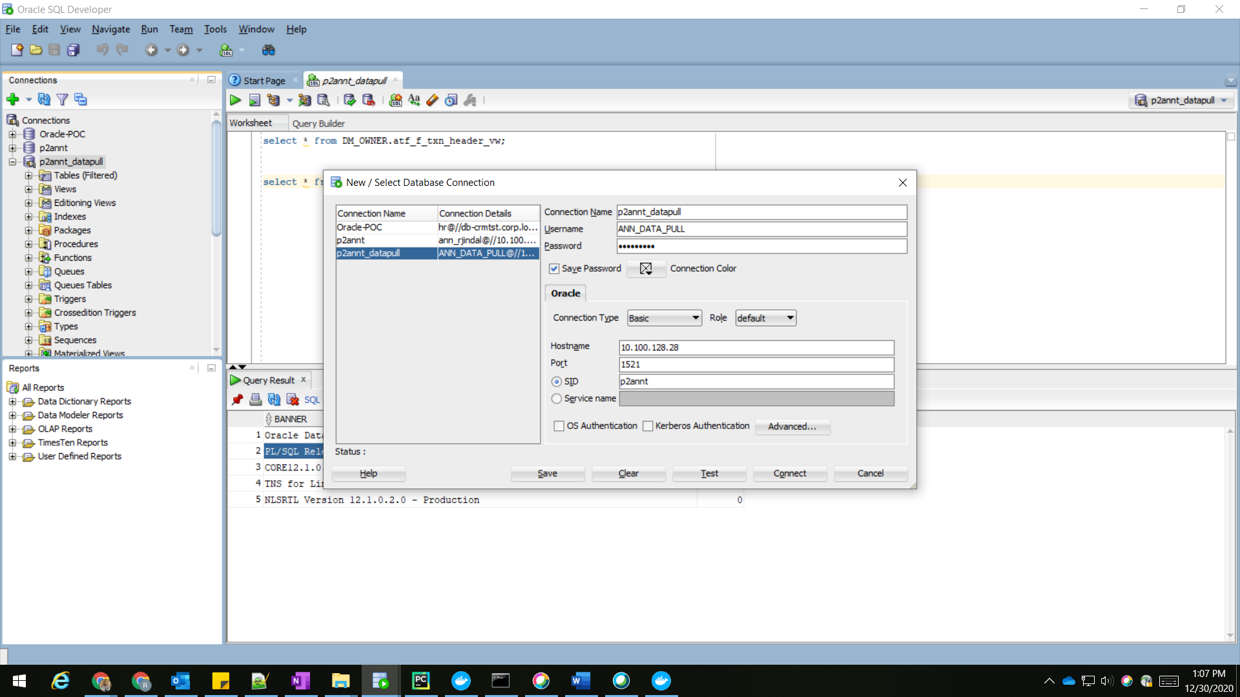

ID – ANN_DATA_PULL

Pwd - bw9h0CUS!

Next Steps –

* Created secretid using Secret manager.
* SR raised with Cloud team to give our Glue role access to Secret Manager.
* Secret-manager-test-RJ is created to test secret manager, which would help us in rotating the password before it expires(90 days) as per Epsilon Policy
* Cloudformation Template for Creating connection and Secret I

12/29

1. Connection created with id and password in secret manager

Refer Stack name - [pre-Glue-connection](https://console.aws.amazon.com/cloudformation/home?region=us-east-1#/stacks/stackinfo?filteringText=&filteringStatus=active&viewNested=false&hideStacks=false&stackId=arn%3Aaws%3Acloudformation%3Aus-east-1%3A479484306740%3Astack%2Fpre-Glue-connection%2F37a206c0-4514-11eb-903f-0aeefef9077b)

Secret Manager

