- Student Name: Pradnya Parab
- Repository URL: https://github.com/prads31-pixel/multienv-deployment-pradnya.git
- Deployment Status: Working
- Access URLs:
- - Development: http://localhost:3000/dev
- - Production: http://localhost:3000/prod
- - Frontend: http://localhost:3000
- Date of Submission: 18-10-2026
- Submit the submission-info.txt file through the designated submission link provided by instructor
- Ensure repository is public and accessible for evaluation

Dev Environment Application Setup:
Command to resolve DnsName Cmd:
Resolve-DnsName production.cloudfront.docker.com
Test-NetConnection production.cloudfront.docker.com -Port 443

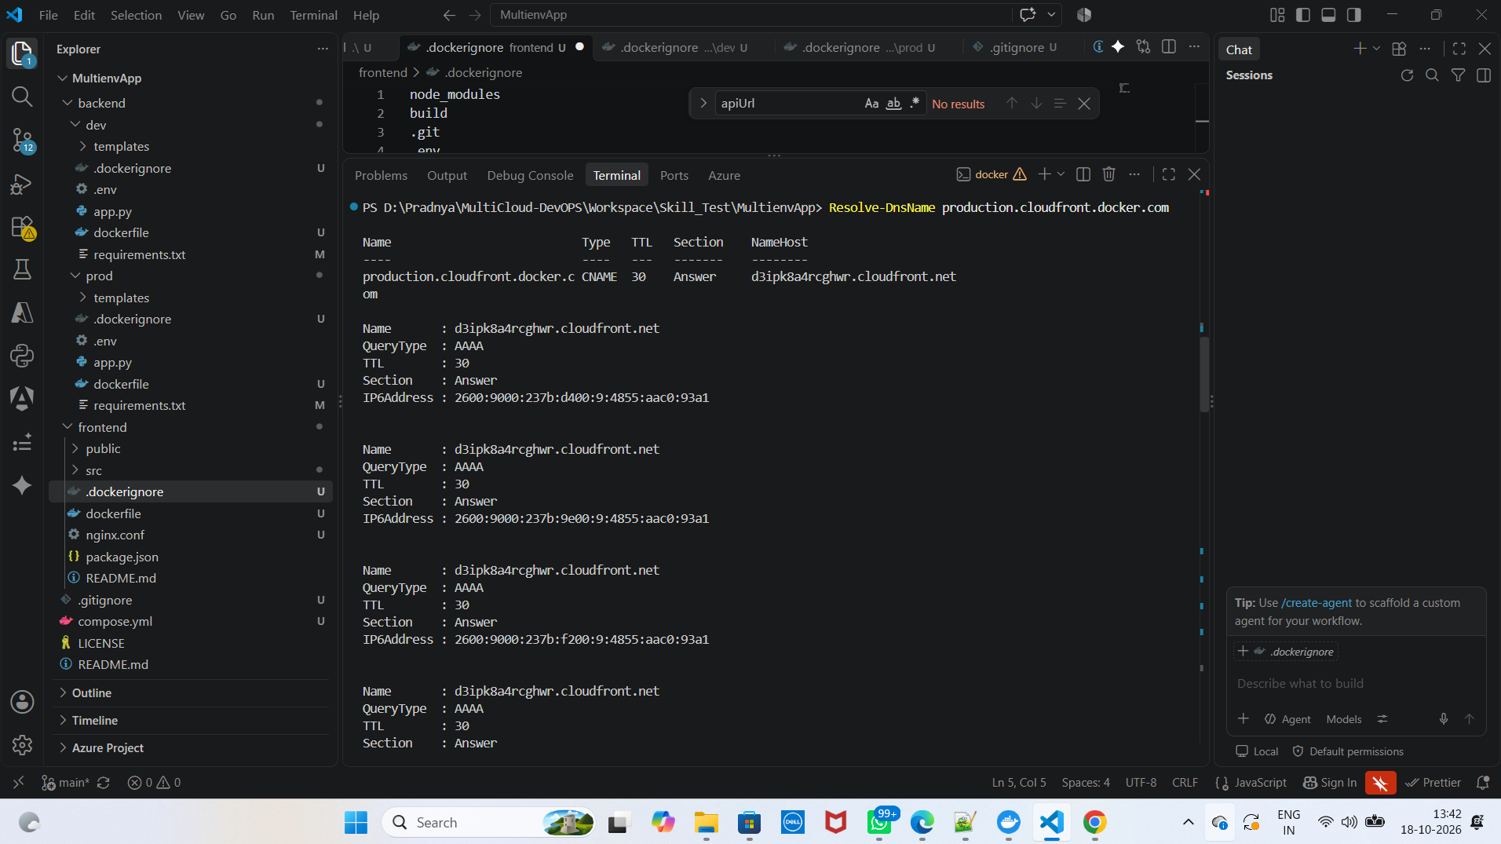
(local setup with times stamp)
Commands run locally to install missing dependencies :
docker pull python:3.11-slim
docker pull node:22-bookworm-slim
docker pull nginx:stable-alpine
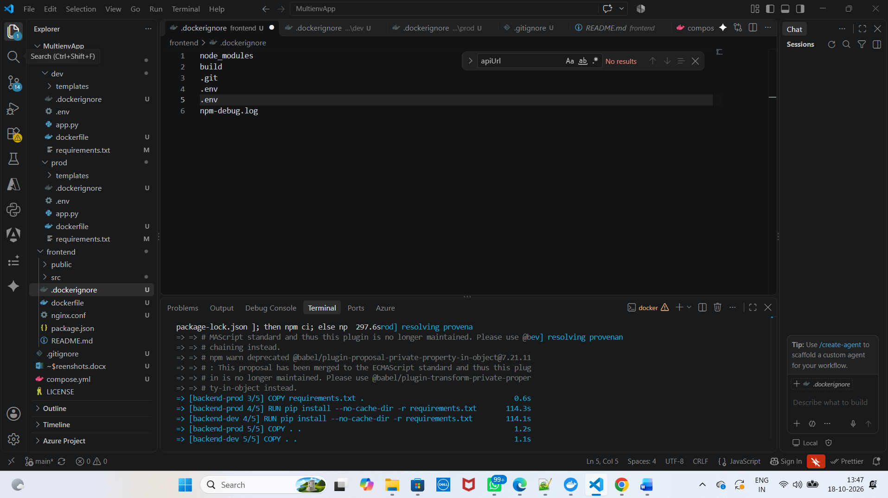

Docker services running locally
Docker services running locally - VSCode
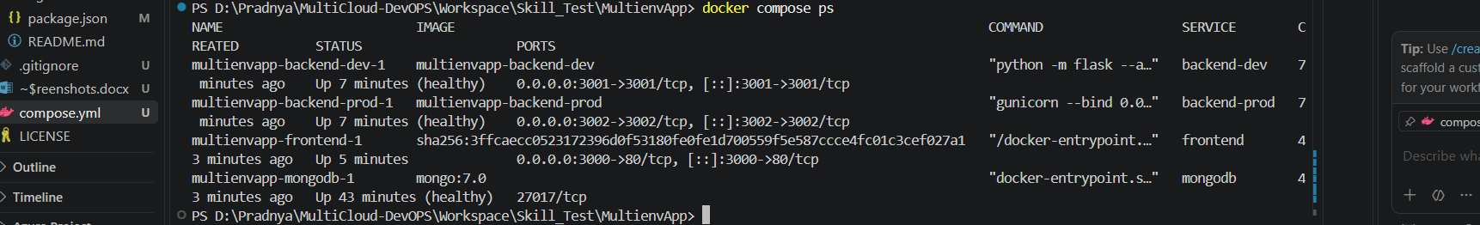
Docker services running locally - Docker
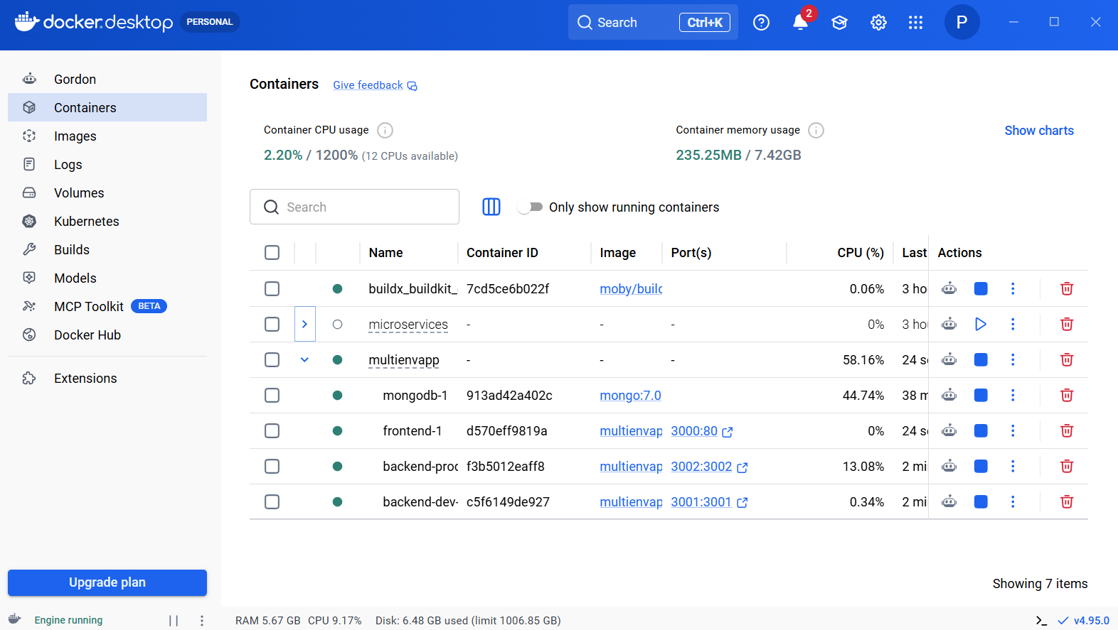

Application working locally.
