PRADUMN KUMAR PATHAK
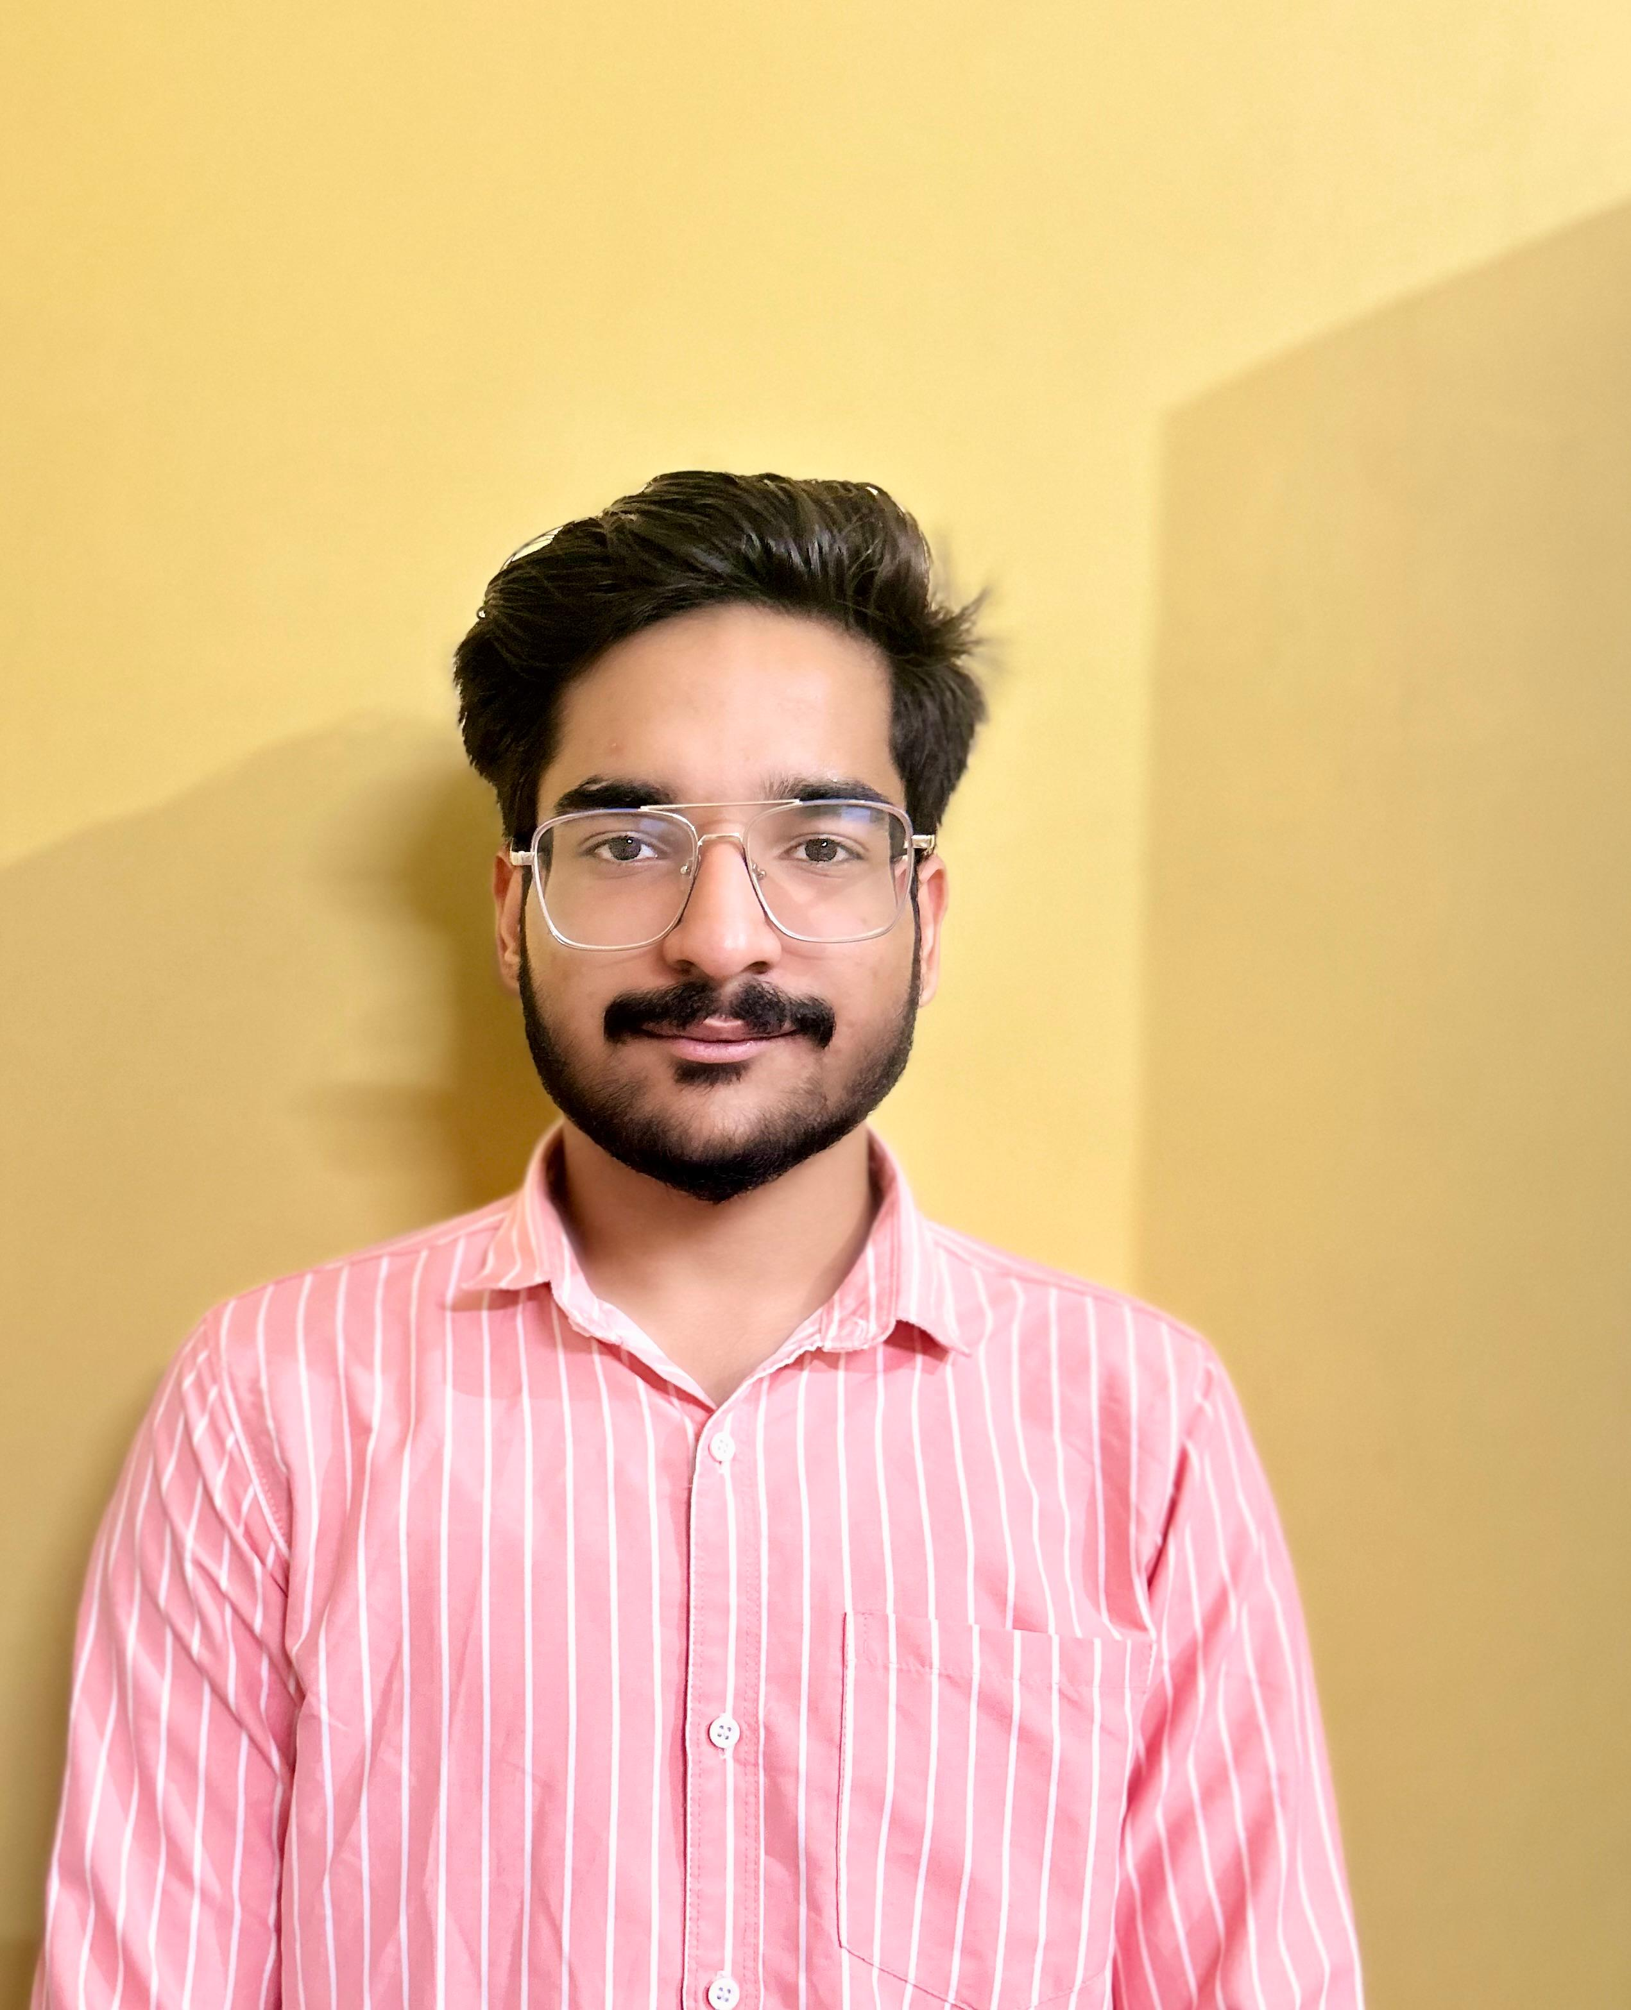
GURUGRAM, +91 8368490261, pradumn.pathak_cs23@gla.ac.in

EDUCATION
Bachelor of Technology in Computer Science, GLA University, Mathura,7.75 June 2027
Intermediate, Colonel's Central Academy, Gurugram, 90% May 2023
High School, Our Lady of Fatima Convent Secondary School, Gurugram, 95% May 2021

INTERNSHIP/ TRAINING EXPERIENCE __________________________________________________________________

Maruti Suzuki India Limited, Gurugram June 2025 – July 2025
Database administrator Intern
- Monitored Oracle Enterprise Manager (OEM) dashboards to track database health, performance, and alert notifications.
- Analysed key database parameters (CPU usage, memory (SGA/PGA), tablespace, archive logs, sessions) and documented warning/critical thresholds.
- Prepared OEM Alert Threshold Tables for proactive monitoring of database performance.

Job Oriented Value-Added Course, GLA University, Mathura June 2025 – July 2025
Trainee
- Learnt basics of ML, Gen AI
- Post completing the training, creating a Project AI notes generator.

PROJECTS
Mood Lifter website April 2024

- Built an AI-powered Mood Detection web app integrating camera input and real-time recommendations to enhance user well-being.
- Tools and Technologies used include Typescript, React.
Personal Portfolio June 2025

Designed and deployed a modern, responsive developer portfolio to showcase projects, skills, and experience.

Integrated contact form with EmailJS, GitHub, LinkedIn, and live project links.

Deployed using Vite + React + Tailwind CSS for performance optimization.

Technologies: React, Vite, Tailwind CSS, JavaScript

AI Notes Generator July 2025
- Built an AI-powered notes generation tool that converts long-form content into concise, structured notes.
- Implemented content summarization logic to improve learning efficiency and productivity.
- Integrated modern UI with responsive design for better usability.
- Technologies: React, JavaScript, AI APIs, HTML, CSS

SKILLS
Technical Professional
Java, Python Effective Communication Skills
HTML, CSS, JavaScript Adaptability
React Interpersonal Skills

CO-CURRICULAR ACTIVITIES

- Volunteered in the Mphasis placement drive, providing management support and assisting students in the smooth functioning of the drive
- Participated in Hack and Viz 2.0, a hackathon of 30hrs conducted by GLA University.
- Participated in Spectra 3.0, a hackathon conducted by Codebusters Club.

