PARAMASIVAM Pradeep

Pradeep.p@msn.com

Deliverables

* Code
* Documentation
* URL of the running service

Agenda

- Service deployed to public cloud: AWS, Azure or Google Cloud Platform  
- Service responds to HTTP GET request with “hello world” string wrapped in JSON  
- Response contains instance ID as a header value  
- Requests load balanced across three instances of the service  
- Infrastructure build in a manner that is auditable, consistent and repeatable  
- List of TODO items on what it would take to operate the infrastructure as a production service with financially backed SLAs

Devops Task documentation

Proof of concept

Contents

Architecture 2

Modules 2

Parameter 3

Auto Scaling 3

Load Balancer 3

Listener 3

Stickiness 3

Security Group 3

Ec2 Instance 3

CloudFomation Script 4

Output 4

# Architecture

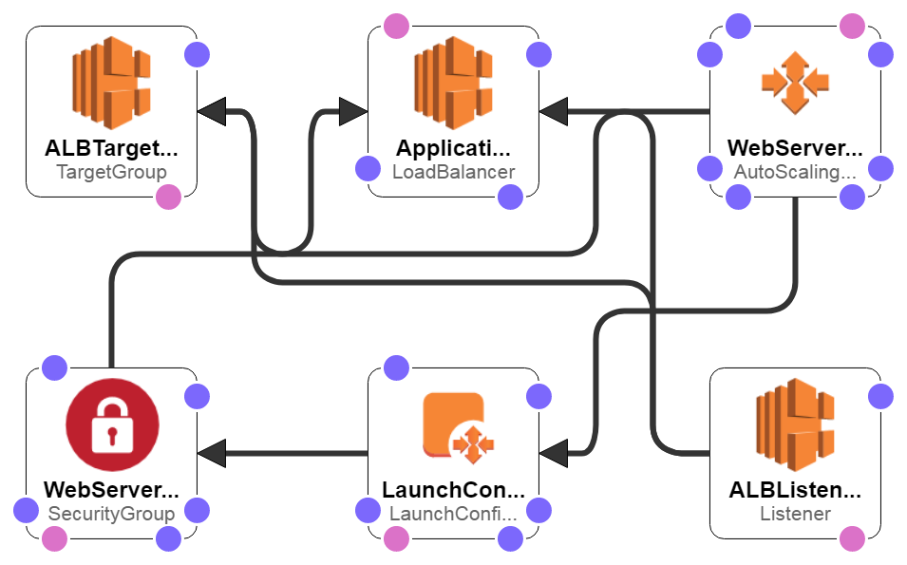

Modules

1. Webserver – Ec2 instance
2. Load balancer – Application load Balancer V2
3. Server Scaling - Auto Scaling
4. Framework – php 5.3
5. Stack Management Tool: CloudFomation
6. Script: Yaml

Parameter

## Auto Scaling

* 1. Initial No of Instance
  2. Max and Minimum no of nodes.
  3. Scale UP rules
  4. Scale Down Rules
  5. Schedule Action is as of now.

## Load Balancer

### Listener

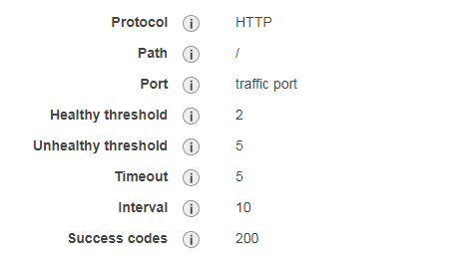

Stickiness: Disabled (Since to show the LB distribution)

Key: stickiness.enabled

Value: 'false'

- Key: stickiness.type

Value: lb_cookie

- Key: stickiness.lb_cookie.duration_seconds

Value: '30'

## Security Group

Port Rules: 22 and 80 (TCP)

SSH connected via Key Pair (Defined during Stack Creation)

## Ec2 Instance

User Defined Mapping

* + 1. Instance Type
    2. AMI
    3. Region
    4. Subnet
    5. Bootstrap Script to deploy the HTTP Service and create Index page.

## CloudFomation Script



Below is the parameter need to be provided during Stack Creation

## Output

**WebsiteURL:**

Description: Load Balancer A Record will be published as URL for newly created LAMP stack

Value: !Join

- ''

- - 'http://'

- !GetAtt

- ApplicationLoadBalancer

- DNSName