**EECS: 332 Intro to Computer Vision, MP #1**

**Connected Component Labeling, Due on 10/06/2016**

**Pradyoth Hegde, Student Id: 2997017**

**Introduction**

Connected Component Labeling is a Labeling technique where subsets of connected components are labelled uniquely based on a given heuristic. It is an algorithmic approach of Graph Theory. We develop an algorithm which traverses through the image, labeling pixels based on connectivity and relative values of their neighbors.

**Algorithm to perform CCL**

**ccl(inp_image) = [label_img, num]**

**inp_image** is the input binary image  
**label_img** is the output labelled image  
**num** is the number of labels in the labelled image

1. Iterate over every pixel of the image. There are **two passes** to the procedure
2. Check only the **foreground pixels** and ignore the background pixels
3. While checking one particular pixel, check if the pixels to its **Upper** and **Left** side are both zero, if so, then assign a new value to this pixel in the Output Image, say “**L**” and **increment** the value of “L”
4. While checking a pixel, if either its Upper or Left Pixel is zero, while the other is not zero, set the non-zero value to the value of the pixel in the Output Image.
5. While checking a pixel, if its Upper and Left Pixel are not equal to zero, but equal to each other, then set the value of the Label Image Pixel to be the value of One of them.
6. But, in the previous step, if the Upper and Left pixels are not equal to each other, then we need to create a Mapping Table. Where we map the maximum value between the Upper and Left neighbor to the minimum value between them.
7. Thus repeating this process to create a mapping table which has maps from one pixel to another.
8. Now, in the second pass, we go over each pixel and recursively check if there are any other mappings to that particular pixel. Eg: If “5” is mapped to “4”, but “4” is mapped to “2”. We ensure that “5” is mapped to “2”
9. When the pixel values are updated, then the procedure is complete.
10. To display the number of distinct labels, the number of unique values in the lookup table can be returned and displayed. In MATLAB, we can use the function **(size (unique (label_img))**
11. For images which have a lot of background noise, then we can use a size filter. The size filter removes small objects whose size is less than a certain number of pixels
12. This Size Filter must be used while running the code on gun.bmp

**Result Analysis**

As you can see in Fig 1, The function mat2gray has been used, which converts a matrix to a grayscale image. Therefore, we can see the slight differences in Color between the various grayscale values. The different regions have been marked with the red regions. Here, the background (Pixels with value 0) are labelled as well. Therefore, there are 7 different labels in this particular image.

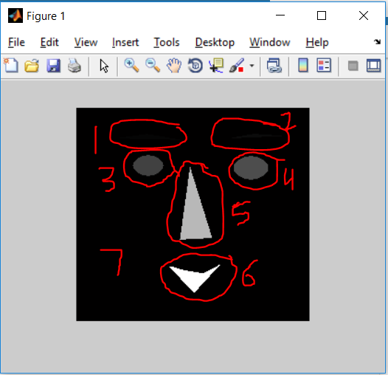

Fig 1. Output of Running CCL on Face.bmp

Also, the second return statement “num” is also shown. Which is returning the value of “7”. Thereby proving that there are 7 Labels in the particular image.

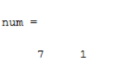

Fig 2. Number of Labels in the Image

**MP#1 Results for test images**

1. Gun

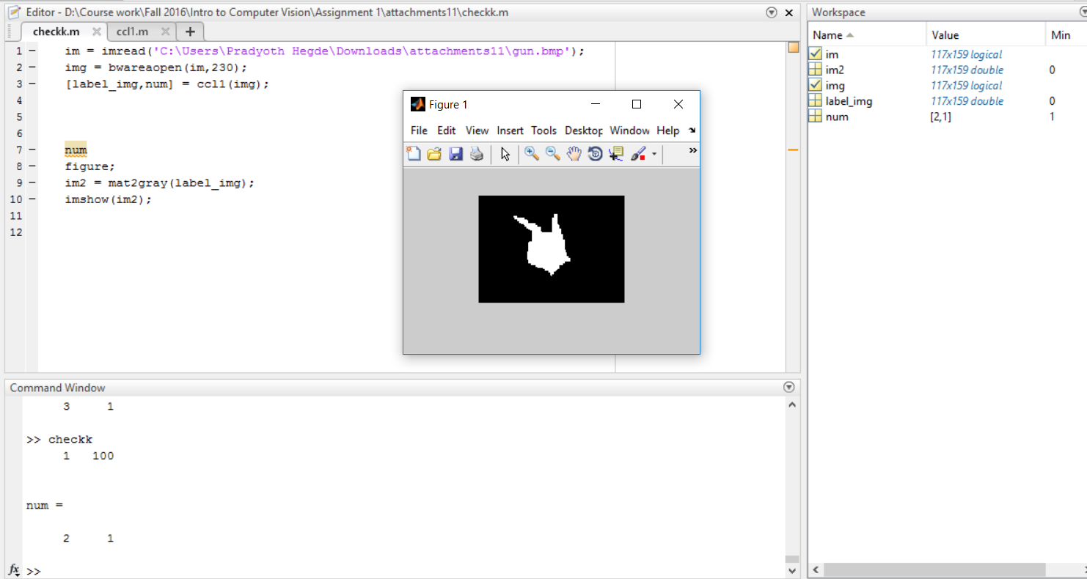

1. Face

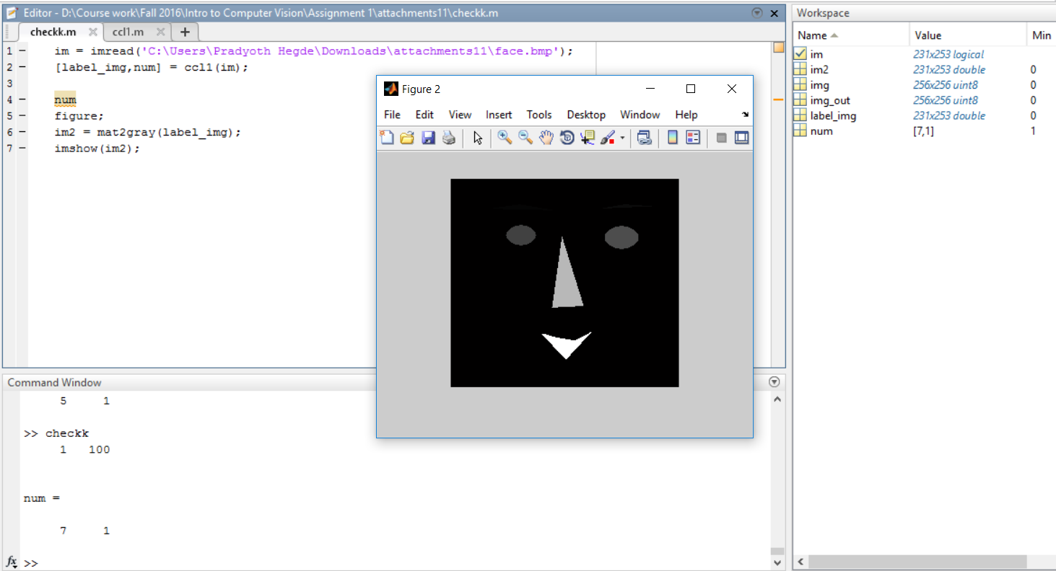

1. Test

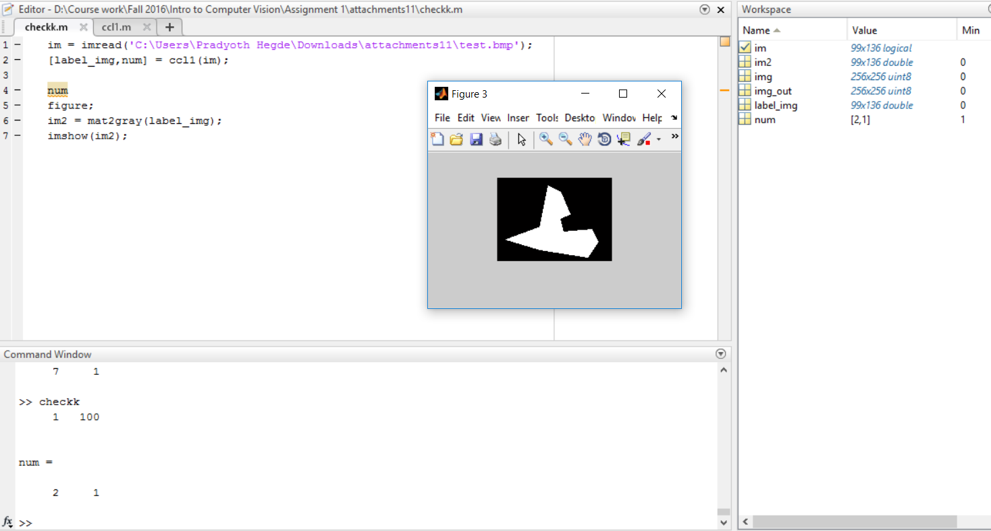

1. Test Image -4

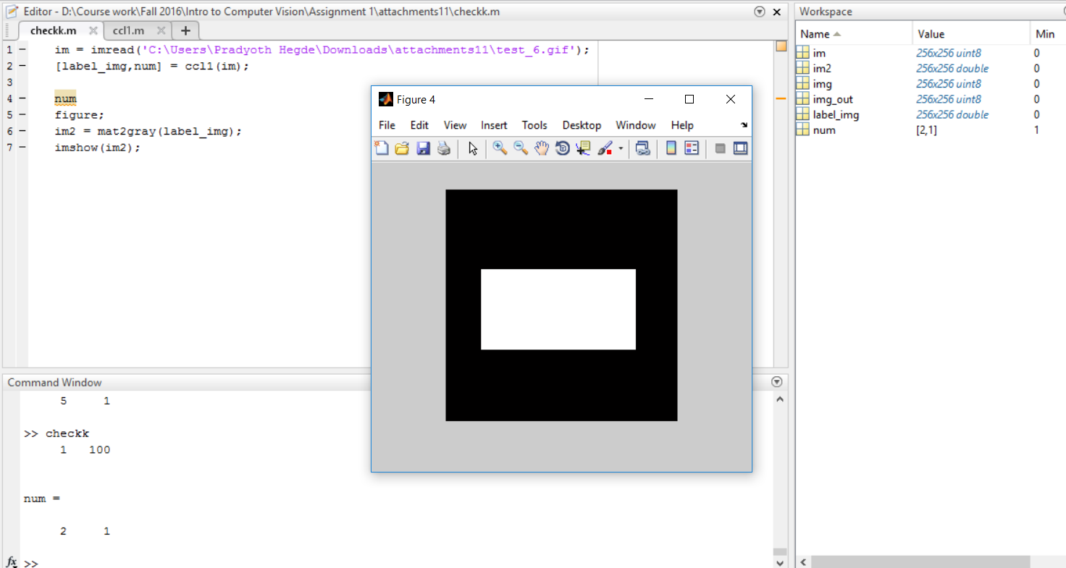

1. Test Image -5

