Project by : Vaibhav Bhosale(Roll No.-130050007) &
Pradyot Prakash(Roll No.-130050008)
Project Title: Electromagnetic Simulator

OBJECTIVE:
The objective of this tool is to simulate the trajectory of charged particles under the influence of their electric and magnetic field.

INPUT:
There are two modes through which input can be given:
A. INPUT THROUGH A FILE (For accuracy):
Make a text file named 'data' through which input would be taken. A sample view of the input file is:

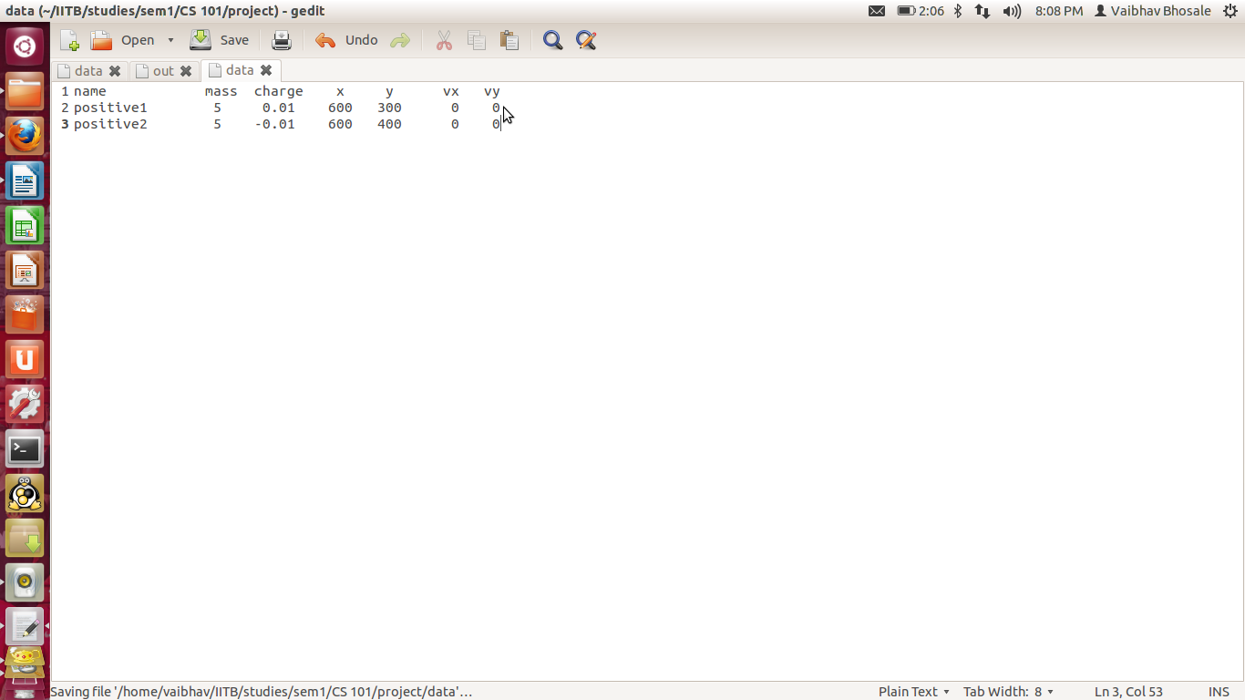
But while giving the input one needs to take care about the magnitude of the charge. Since we have used C++ variables for the attributes of a particle like acceleration, velocity, co-ordinates and also the electric and magnetic field at a given point, so if the value increases above a certain value, since data-types are put up in circular loops, so the actual field values are not calculated values are taken by the compiler.
One of the limitation, thus, can be that our tool cannot simulate properly for charges having magnitude greater 0.01 C.

Some of the sample inputs are:
(a) Two oppositely charged particles having opposite charges but same magnitude and zero velocity. The values are the same as in the image in the earlier page.

(b)Two oppositely charged particles having opposite charges but same magnitude and projected at a certain velocity so that trace a circle around their common center of mass.
The input values for this are:
Particle 1 :
name:p1 mass=5 charge=0.01 vx=30 vy=0 x=200 y=300
Particle 2 :
name:p2 mass=5 charge=-0.01 vx=-30 vy=0 x=200 y=200

(c)Some other inputs can be like all the vertices of a regular polygon occupied by similarly charged particles(having same charge) and a particle at the center having a specific value of charge so that all the charges are in equilibrium.
The input values for this are:
Particle 1 :
name:p1 mass:5 charge=0.01 x=100 y=300 vx=0 vy=0
Particle 2 :
name:p2 mass=5 charge=0.01 x=300 y=300 vx=0 vy=0
Particle 3 :
name:p3 mass=5 charge=0.01 x=200 y=126.794919243 vx=0 vy=0
Particle 4 :
name:n mass=5 charge=0.005773503 x=200 y=242.264973081 vx=0 vy=0

B. INPUT THROUGH A WINDOW (For ease):
This is probably an easier method of giving the input. One can give the co-ordinates of his/her choice by clicking at the position corresponding to that point.
A single click at any point will show the co-ordinates of the point and a double click will assign that position to the particle.
Once the co-ordinates are given then you need to give the other parameters(name, mass velocities in x and y directions) through the terminal.
Sample input for this mode would be similar as for the above mode.

Once this input is given, you can also give external electric and magnetic field.

OUTPUT:
The output would be shown on a canvas in the form of a circle representing a particle and moving accordingly along with its label(name).

Output to Sample input:
(a)Herein the particles would collide and finally both would be at rest (merging to form a new particle).

(b)Both the particles would continue moving in a circle for as long as the program is being executed.

(c)All the four particles remain at rest all the time th program is being executed.

ALGORITHM:
We have made a few approximations to relate this to the actual simulation. We have assumed that the force remains constant for a small time interval 'dt'.

To simulate the particles we have used the equations of motion to calculate the values of the co-ordinates of the particles and the velocities and acceleration in both x and y direction.

Through a loop the coordinates of the center of the circle representing the particle have been reset after a small time 'dt' and thus it moves. Also we have used the imprint feature of 'simplecpp' due to which the the path of the particle gets imprinted on the canvas. while moving through which we can examine the trajectory.

For colliding particles we have used standard mechanics which states that the total momentum should be conserved and have also used conservation of charge and mass when two particles merge.

MAJOR CLASSES:
The following classes have been used:
A. body : This class includes the attributes of a particle like name, mass, etc. as its objects.
B. operations : This class contains many functions used in our program.
The functions are:
(a) itos : This function is to convert an 'int' variable to 'string' variable.
(b) displayAndInput : This function is for the user interface of the program and also to take input for the program. This function can take input via both file and window.

C. data : This class includes overloading of operator '&' to find the dot product of two vectors. Also there are two functions:
(a) electricField : This function is to calculate the electric field at any point due to all the charges present.
(b) magneticField : This function is to calculate the magnetic field at the position of one of the particles due to the others.

HOW TO RUN THE CODE :
- Compile the code and then execute it.
- A window pops up where in it asks if the user wants to give input through a file or window. On clicking at the appropriate button, the input can be given as mentioned earlier.
- Later provide the values of the external electric and magnetic fields if desirable.
- Now the simulation begins.
- Once it is done, it show s a message to click on the window to close it.

SPECIAL FEATURE OF CODE :
It can be easily extended to many other forces which have 1/r^2 dependence like gravitational force. Also this can be used to simulate the motion of solar system and of satellites sent in space. There can be broader extensions wherein one can simulate the motion of sub-atomic particles as well.

