Visible Light Communication using PHY 1

Choppa Aravind Reddy – EE16BTECH11004

Karlapati Raja Pradyumna – EE16BTECH11017

# Introduction

Visible light communication (VLC) refers to short-range optical wireless communication using the visible light spectrum from 380 to 780 nm. VLC transmits data by intensity modulating optical sources, such as light emitting diodes (LEDs) and laser diodes, faster than the persistence

of the human eye. Traditional radio frequency (RF) communication below 6 GHz is rapidly running out of spectrum bandwidth for high data- rate communication. With ~300 THz of bandwidth available for VLC, multi-gigabit-per second data rates could be provided over short distances, for example, using arrays of LEDs in a multiple-input multiple-output (MIMO) fashion.

The two main challenges for communication using visible light spectrum are flicker mitigation and dimming support. Flicker refers to the fluctuation of the brightness of light. Any potential flicker resulting from modulating the light sources for communication must be mitigated because flicker can cause noticeable, negative/harmful physiological changes in humans. To avoid flicker, the changes in brightness must fall within the maximum flickering time period (MFTP). The MFTP is defined as the maximum time period over which the light intensity can change without the human eye perceiving it. While there is no widely accepted optimal flicker frequency number, a frequency greater than 200 Hz (MFTP < 5 ms) is generally considered safe. Therefore, the modulation process in VLC must not introduce any noticeable flicker either during the data frame or between data frames. Dimming support is another important consideration for VLC for power savings and energy efficiency. It is desirable to maintain communication while a user arbitrarily dims the light source. The human eye responds to low light levels by enlarging the pupil, which

allows more light to enter the eye. This response results in a difference between perceived and measured levels of light. Hence, communication support needs to be provided when the light source is dimmed over a large range, typically between 0.1–100 percent.

# Modulation methods in PHY 1

PHY 1 operates from 11.67 to 266.6 kb/s, and is defined for a single light source supporting on-off keying(OOK). PHY 1 mode contains mechanisms for modulating the light source, run length limited (RLL) line coding, and channel coding for forward error correction (FEC). RLL line codes are used to avoid long runs of 1s and 0s that could potentially cause flicker and clock and data recovery (CDR) detection problems. RLL line codes take in random data symbols at input and guarantee DC balance with equal 1s and 0s at the output for every symbol. The RLL code used in PHY 1 is Manchester coding. The channel codes support both long and short data frames for high-data rate indoor and low-data-rate outdoor applications. For outdoor applications, stronger codes using concatenated RS and CC codes are developed to overcome the additional path loss due

to longer distance and potential interference introduced by optical noise sources such as daylight and fluorescent lighting. Reed-Solomon (RS) and convolutional codes (CC) are preferred over advanced coding schemes such as

low density parity check(LDPC) codes in order to support short data frames, hard decision decoding, low complexity, and their ability to interface well with RLL line codes. For indoor applications, where the coding requirements are less stringent for short distances, RS codes are used for FEC since they are better suited to high-data-rate implementations. RS codes also interface well in conjunction with the RLL line codes, where the errors detected from the RLL line code at the receiver could be marked as erasures to the RS decoder, providing performance improvements of around 1 dB. For PHY I, an inter leaver between the RS code and the CC code provides an additional 1 dB of performance improvement.

# Transmission via labview

First we generate 7 random numbers which are sent to the RS (7,15) encoder.

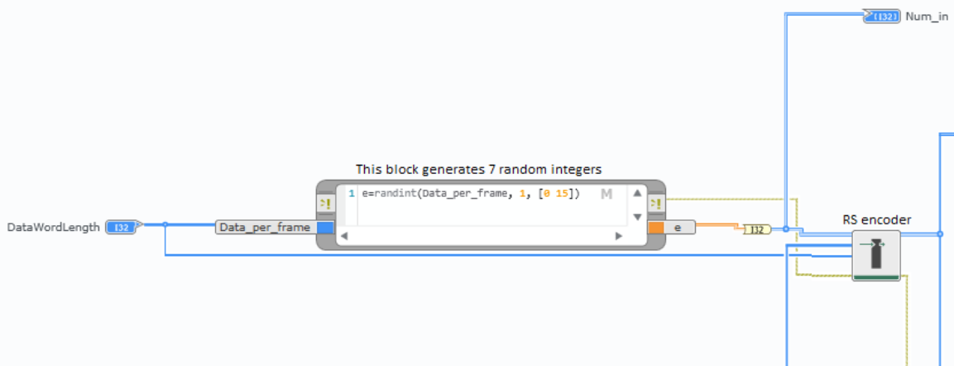

The output from the RS encoder is converted into bits and then sent to CC encoder.

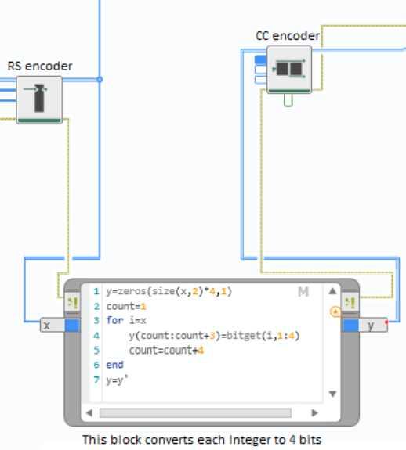

The output from the CC encoder is encoded with the help of Manchester coding and then the addition of frames is done. The then output is stored into a file.

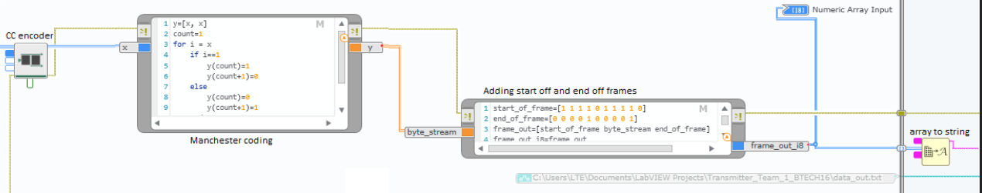

Using LPC1768s, the text file generated is transmitted using an LED and an LDR. The data recieved is again written into another LPC and is saved.

The received file from the LPC 1768 is decoded in labview by the following method.

Initially the data in the received file form LPC 1768 is converted into an array and is sent through Manchester decoder and then to CC encoder.

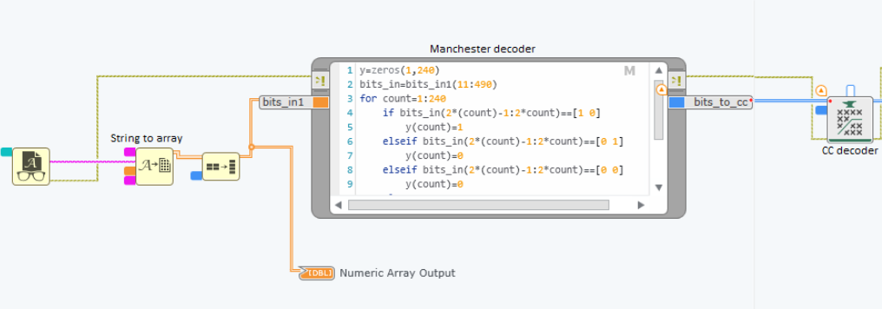

The output from the CC encoder is converted into numbers and then is sent through RS encoder.

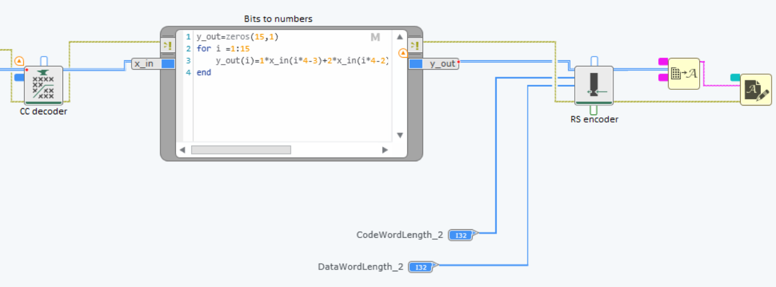

The data decoded from the RS encoder is compared with the initital random data generated by the transmitter LabVIEW diagram. It is found that most of the times, the transmitted and recieved frames are the same.