To: Teresa Wall, Vice President of Research, Power-by-Nano Technologies

From: Team 18 - DMBP

Subject: Procedures for determining the cheapest and least toxic nanomaterial combinations

Date: February 24, 2015

**I. Introduction/Re-Usability:**

The direct user (the QD-PV fabrication team) needs a mathematical model that can determine the best configuration of particles to produce (a user specified amount of) energy in the least toxic and/or the cheapest way. This model must not only output a solution based on varied inputs, but must also be easy to use or modify incase the fabrication team needs to make any changes. An algorithm with the ability to minimize toxicity while keeping the costs as low as possible will be considered successful, this should be paired with the fact that the model is easy to follow and make changes to. This algorithm should be able to accept inputs such as what materials will be mixed and the desired effective band gap energy and output the cheapest/least toxic material combinations (3 total: min cost, min tox, and min both) as well as the costs/toxicities associated with that combination. This combination will be used by the fabrication team to create materials for customers’ diverse solar cell needs. This problem is quite complex as the algorithm must optimize cost and/or toxicity, both of which are in terms of many other variables.

There are several constraints for this algorithm. The first is that it must be able to mix 5 of 12 materials at a time. It must be able to use any of those 12 at a given time, but only 5 at once. Any 12 materials could be tested but the materials we used were QD1-10 as given and QD11 and 12 which were made for testing extreme inputs for our algorithm. Another constraint is that while optimizing, the material combination must maintain an effective energy level of exactly the user specified amount. The algorithm assumes a total weight of 100g being tested and a minimum weight of any one of the 5 tested materials to be 2g. Another constraint is that the material must use the two given equations for calculating effective band gap energy and QD band gap energy (see following page). Additionally, the model is based off of inputs of a certain unit (ie. Desired energy is in eV – see matlab script comments for details on other inputs). If values of the incorrect unit are placed, results will be invalid.

The algorithm’s procedure work’s generally as follows. The procedure eventually will arrive at 3 combinations of 5 materials that will have minimum cost, toxicity, and both. This is done by first calculating effective band gap energies of each of the 5 materials. Then, every possible combination of 2 materials are mixed so that they meet the desired effective energy level (which is user defined). There are 10 possible combinations, and the ones that yield the minimum cost, toxicity, etc. are chosen as best. This will then give the fabrication team the best mixtures (depending on what they are optimizing) to select for the customers’ needs.

There are a few limitations as well. The algorithm assumes that 5 materials will be mixed at once (as this was the suggested amount in the given memo). If this value is to change in the future, the script/algorithm must be altered. Possible number of materials being tested is unlimited, however. For example, the user could input 5,000 different materials. If they do this though, they still may only mix 5 at a time.

The assumptions are that the quantum dots that are made will be produced without manufacturing errors and will be used in ideal situations without any random errors. We will ignore factors that would affect all materials equally such as interference from the environment like weather conditions that may reduce the efficiency of these QD cells. The limitations of our procedure are that it is still conceptual and theoretical. This means that the model is quite ideal and requires future real-world testing.

**II. Procedure/Mathematical Model:**

Our mathematical model is in the form of a matlab .m file as attached. The steps that this program follows are:

**Inputs:** Bulk energy (eV), radius (nm), dielectric constant, cost ($/g), toxicity (impact/g), decimal accuracy (0.01 recommended -2 decimal places), desired effective band gap energy (eV), and which five (of likely 12, could be more or less though) of the materials are being used (ie. [1, 2, 3, 4, 5] if QD1-5 are used).

**Pre-Iteration Calculations:**

Calculate the effective band gap energy of each of the 5 materials using this equation:

http://puu.sh/ganaq/20a79eabb5.png (1)

Units in the above calculation are the same as specified in the inputs section.

**Error Message:**

Before starting, calculate the maximum possible effective energy level by using the following equation:

http://latex.codecogs.com/gif.latex?E_%7Bmax%7D%20%3D%20%5Cfrac%7B%2892*a%29%20&plus;%202%20*%20b%7D%7B100%7D

Where ‘a’ is the band gap energy of the highest energy material and ‘b’ is the sum of the band gap energies of the 4 other materials.

Calculate the minimum by using the same equation except that ‘a’ is the band gap energy of the lowest energy material.

If the desired energy is above the maximum possible energy or below the minimum, the energy level is impossible and print an error statement.

**Main Procedure (Iteration):**

Repeat the following steps for a total of 10 times so that each material combination ((1, 2), (1,3), (1,4), (1,5), (2,3), (2,4), (2,5), (3,4), (3,5),(4,5)) are used.:

1. Set the mass of the first material (of the 2) to 92g and the other 4 to 2g.

2. Calculate the effective band gap energy of the combination using the following equation:

http://puu.sh/gaojJ/cdd6ba8929.png

3. If that value is not equal to the desired energy, decrease the mass of the first material by 0.01 (or whatever other decimal accuracy wanted) and increase the mass of the second material by 0.01.

4. Calculate the effective band gap energy once more using the same equation.

Repeat steps 3-4 until either the band gap energy is equal to the desired or until the mass of the first material is down to 2g.

5. Save the above mass combination for later use.

6. Iterate all of the above steps 10 times so that all combinations (as listed above) are completed.

**Procedure for determining min cost (Post-Iteration):**

1. Calculate the cost of 100g of each of the 10 combinations.

2. Find the combination of the cheapest cost and select it.

3. Print the cost ($/g) and combination (% of each of the 5 materials).

**Procedure for determining min toxicity (Post-Iteration):**

1. Using the same 10 combinations, calculate the toxicity (in impact) of 100g of each of the combinations.

2. Find the lowest toxicity combination and select it.

3. Print the combination (% of ea. material) of the least toxic combination along with the toxicity (impact/g)

**Procedure for minimizing cost and toxicity**

1. Calculate the “toxicity/cost combination” for each of the 5 materials being mixed

http://latex.codecogs.com/gif.latex?combination%20%3D%20%5Cfrac%7Bcost%7D%7Bcost_%7Bavrg%7D%7D%20&plus;%20%5Cfrac%7Btoxicity%7D%7Btoxicity_%7Bavrg%7D%7D

Where cost is the cost of the individual material ($/g) and cost_avrg is the average cost for the 5 materials being tested. Likewise, toxicity is the toxicity of the individual material (impact/g) and the avrg is the avrg for the 5 materials being tested.

2. Calculate the total “combination” by multiplying the adding the product of the combination of each material with its mass percentage to give the total “combination” for 100g.

3. Find and select the set of mass percentages of the lowest “combination”

4. Calculate and print the cost($/g) and toxicity(impact/g) of the lowest “combination material” and the mass percentage of each component of that material.

**Example Steps of Procedure:**

For step 3 of the iterations, 92g goes to 91.99g and 2g goes to 2.01 g for materials 1 and 2 respectively.

For step 1 of min cost and toxicity: “combination” for material 1 (using materials 1-5) = 2/ 2.4 + 45/ 35 = 2.1190

For step 2 of min cost and toxicity: total combination for combination 1 = (2.1190 2.2500 2.3810 1.5595 1.6905) . * (58.8800 35.1200 2.0000 2.0000 2.0000) = 215.05(unitless)

**Rationale for the algorithm’s design:**

In our algorithm, only 2 materials are optimized at a time. This is because any optimal combination will use only 2 materials (the other three at 2%). This is because if a material is “good” in that it balances out the negative attributes of the cheapest option, it should be used. The second best material, although good, is not best and should not be used. No matter what the situation is, the optimal combination will only include 2 materials. Our equation for “cost/toxicity combination” was chosen because it balances both cost and toxicity in a way that if both are high, that value is high and if both are low, that value is low. There is no one perfect way to minimize 2 variables, but this does so with relatively equal weighting (by factoring out the averages). It is also easily noticed that the algorithm has many, many iterations (up to 10s of thousands). This may seem inefficient but it is quite helpful. Even with the large number of iterations, the program runs nearly instantaneously. Also, with the large number of iterations instead of few if statements in the algorithm/code, the complexity is significantly decreased and the possibility for errors is decreased.

**Complexicity of the Problem:**

This problem involves optimizing a function that is in terms of several different variables and as such, is quite complex. Our algorithm addresses all possible combinations and then selects the best material combination of those. It can receive many different inputs and produces multiple different outputs. Additionally, it has error statements as outputs if inputs outside of its scope are given. If there is a solution, this algorithm should find it and if there isn’t, then it will state that there is no solution.

**III. Results (Share-ability):**

On the following pages are a few demonstrations of the results of our algorithm. They have been tested for a variety of desired energies and possible mixable materials.

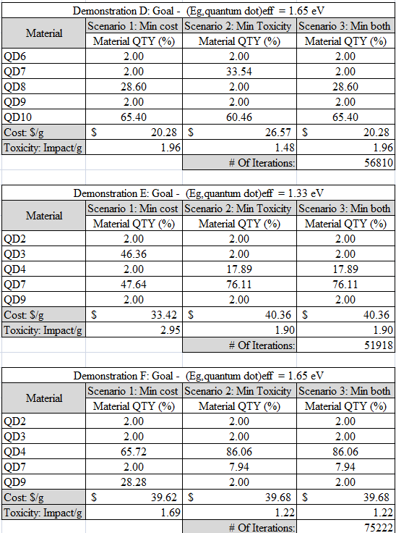

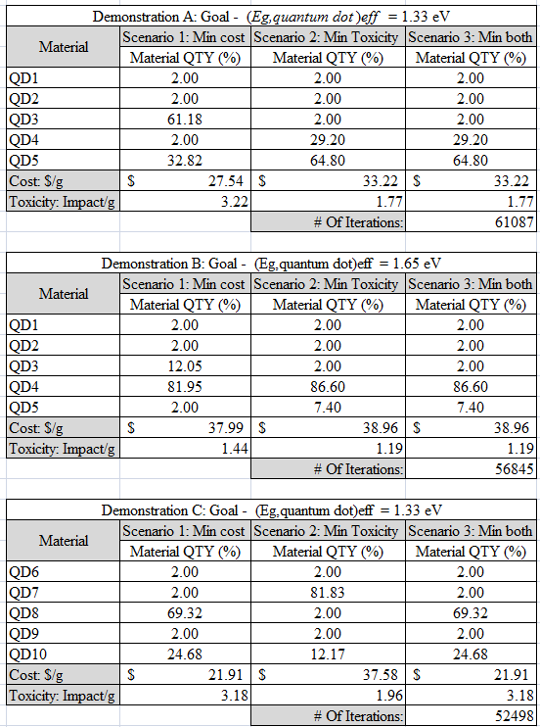

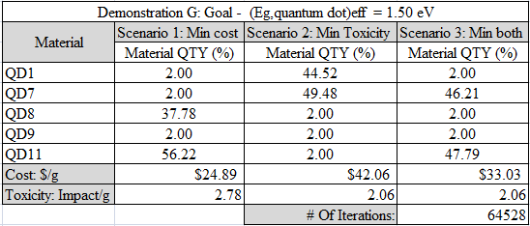

**Demonstration H: Energy of 1.00eV**

Materials QD1-4, QD12

QD12 Properties: Bulk energy: 12.0eV, dielectric constant: 5.9, radius:3.7nm, cost: $0/g, toxicity 0impact/g

These properties and energy levels were chosen so that there is no possible 5 material combination that yields such a desired energy level, regardless of cost or toxicity. Our matlab script thus produced the following error message:

“Error: energy not possible.”

**Demonstration G**

QD11 Properties: Bulk energy: 1.95eV, dielectric constant: 3.2, radius: 2.8nm, cost: 25$/g, toxicity: 2impact/g

These properties were chosen, along with the demonstration’s desired energy, to make a mass combination with equivalent toxicity to another optimized combination. In this instance, there are 2 combinations that meet all requirements and both have an average toxicity of 2.06impact/g. Previously, such values would create errors for our matlab script. We have since adjusted it and made the script print out one and alert the user that there are multiple combinations where both are optimized.

Thank you for the opportunity to help you optimize this new technology that can potentially change the world of energy production and consumption. We hope these procedures help the fabrication team to reduce both toxicity and costs of your products.

Sincerely,

Team 18