**What is a public cloud?**

Public clouds are the most common way of deploying cloud computing. The cloud resources (like servers and storage) are owned and operated by a third-party [cloud service provider](https://azure.microsoft.com/en-us/overview/what-is-cloud-computing/) and delivered over the Internet. [Microsoft Azure](https://azure.microsoft.com/en-us/) is an example of a public cloud. With a public cloud, all hardware, software, and other supporting infrastructure is owned and managed by the cloud provider. In a public cloud, you share the same hardware, storage, and network devices with other organizations or cloud “tenants.” You access services and manage your account using a web browser. Public cloud deployments are frequently used to provide web-based email, online office applications, storage, and testing and development environments.

**Advantages of public clouds:**

* Lower costs—no need to purchase hardware or software, and you pay only for the service you use.
* No maintenance—your service provider provides the maintenance.
* Near-unlimited scalability—on-demand resources are available to meet your business needs.
* High reliability—a vast network of servers ensures against failure.

**What is a private cloud?**

A private cloud consists of computing resources used exclusively by one business or organization. The private cloud can be physically located at your organization’s on-site datacenter, or it can be hosted by a third-party service provider. But in a private cloud, the services and infrastructure are always maintained on a private network and the hardware and software are dedicated solely to your organization. In this way, a private cloud can make it easier for an organization to customize its resources to meet specific IT requirements. Private clouds are often used by government agencies, financial institutions, any other mid- to large-size organizations with business-critical operations seeking enhanced control over their environment.

**Advantages of a private clouds:**

* More flexibility—your organization can customize its cloud environment to meet specific business needs.
* Improved security—resources are not shared with others, so higher levels of control and security are possible.
* High scalability—private clouds still afford the scalability and efficiency of a public cloud.

**What is a hybrid cloud?**

Often called “the best of both worlds,” hybrid clouds combine on-premises infrastructure, or private clouds, with public clouds so organizations can reap the advantages of both. In a hybrid cloud, data and applications can move between private and public clouds for greater flexibility and more deployment options. For instance, you can use the public cloud for high-volume, lower-security needs such as web-based email, and the private cloud (or other on-premises infrastructure) for sensitive, business-critical operations like financial reporting. In a hybrid cloud, “cloud bursting” is also an option. This is when an application or resource runs in the private cloud until there is a spike in demand (such as seasonal event like online shopping or tax filing), at which point the organization can “burst through” to the public cloud to tap into additional computing resources.

**Advantages of hybrid clouds:**

* Control—your organization can maintain a private infrastructure for sensitive assets.
* Flexibility—you can take advantage of additional resources in the public cloud when you need them.
* Cost-effectiveness—with the ability to scale to the public cloud, you pay for extra computing power only when needed.
* Ease—transitioning to the cloud doesn’t have to be overwhelming because you can migrate gradually—phasing in workloads over time.

# What is cloud computing?

A beginner’s guide

Simply put, cloud computing is the delivery of computing services—including servers, storage, databases, networking, software, analytics, and intelligence—over the Internet (“the cloud”) to offer faster innovation, flexible resources, and economies of scale. You typically pay only for cloud services you use, helping you lower your operating costs, run your infrastructure more efficiently, and scale as your business needs change.

**Top benefits of cloud computing**

Cloud computing is a big shift from the traditional way businesses think about IT resources. Here are seven common reasons organizations are turning to cloud computing services:

**Cost**

Cloud computing eliminates the capital expense of buying hardware and software and setting up and running on-site datacenters—the racks of servers, the round-the-clock electricity for power and cooling, and the IT experts for managing the infrastructure. It adds up fast.

**Speed**

Most cloud computing services are provided self service and on demand, so even vast amounts of computing resources can be provisioned in minutes, typically with just a few mouse clicks, giving businesses a lot of flexibility and taking the pressure off capacity planning.

**Global scale**

The benefits of cloud computing services include the ability to scale elastically. In cloud speak, that means delivering the right amount of IT resources—for example, more or less computing power, storage, bandwidth—right when they’re needed, and from the right geographic location.

**Productivity**

On-site datacenters typically require a lot of “racking and stacking”—hardware setup, software patching, and other time-consuming IT management chores. Cloud computing removes the need for many of these tasks, so IT teams can spend time on achieving more important business goals.

**Performance**

The biggest cloud computing services run on a worldwide network of secure datacenters, which are regularly upgraded to the latest generation of fast and efficient computing hardware. This offers several benefits over a single corporate datacenter, including reduced network latency for applications and greater economies of scale.

**Reliability**

Cloud computing makes data backup, disaster recovery, and business continuity easier and less expensive because data can be mirrored at multiple redundant sites on the cloud provider’s network.

**Security**

Many cloud providers offer a broad set of policies, technologies, and controls that strengthen your security posture overall, helping protect your data, apps, and infrastructure from potential threats.

**Types of cloud computing**

Not all clouds are the same and not one type of cloud computing is right for everyone. Several different models, types, and services have evolved to help offer the right solution for your needs.

First, you need to determine the type of cloud deployment, or cloud computing architecture, that your cloud services will be implemented on. There are three different ways to deploy cloud services: on a public cloud, private cloud, or hybrid cloud.

**Public cloud**

Public clouds are owned and operated by a third-party [cloud service providers](https://azure.microsoft.com/en-us/overview/choosing-a-cloud-service-provider/), which deliver their computing resources, like servers and storage, over the Internet. Microsoft Azure is an example of a public cloud. With a public cloud, all hardware, software, and other supporting infrastructure is owned and managed by the cloud provider. You access these services and manage your account using a web browser.

**Private cloud**

A private cloud refers to cloud computing resources used exclusively by a single business or organization. A private cloud can be physically located on the company’s on-site datacenter. Some companies also pay third-party service providers to host their private cloud. A private cloud is one in which the services and infrastructure are maintained on a private network.

**Hybrid cloud**

Hybrid clouds combine public and private clouds, bound together by technology that allows data and applications to be shared between them. By allowing data and applications to move between private and public clouds, a hybrid cloud gives your business greater flexibility, more deployment options, and helps optimize your existing infrastructure, security, and compliance.

**Types of cloud services: IaaS, PaaS, serverless, and SaaS**

Most cloud computing services fall into four broad categories: infrastructure as a service (IaaS), platform as a service (PaaS), serverless, and software as a service (SaaS). These are sometimes called the cloud computing "stack" because they build on top of one another. Knowing what they are and how they’re different makes it easier to accomplish your business goals.

* **Infrastructure as a service (IaaS)**

The most basic category of cloud computing services. With IaaS, you rent IT infrastructure—servers and virtual machines (VMs), storage, networks, operating systems—from a cloud provider on a pay-as-you-go basis

[**Learn more about IaaS**](https://azure.microsoft.com/en-us/overview/what-is-iaas/)

* **Platform as a service (PaaS)**

Platform as a service refers to cloud computing services that supply an on-demand environment for developing, testing, delivering, and managing software applications. PaaS is designed to make it easier for developers to quickly create web or mobile apps, without worrying about setting up or managing the underlying infrastructure of servers, storage, network, and databases needed for development.

[**Learn more about PaaS**](https://azure.microsoft.com/en-us/overview/what-is-paas/)

* **Serverless computing**

Overlapping with PaaS, serverless computing focuses on building app functionality without spending time continually managing the servers and infrastructure required to do so. The cloud provider handles the setup, capacity planning, and server management for you. Serverless architectures are highly scalable and event-driven, only using resources when a specific function or trigger occurs.

[**Learn more about serverless computing**](https://azure.microsoft.com/en-us/overview/serverless-computing/)

* **Software as a service (SaaS)**

Software as a service is a method for delivering software applications over the Internet, on demand and typically on a subscription basis. With SaaS, cloud providers host and manage the software application and underlying infrastructure, and handle any maintenance, like software upgrades and security patching. Users connect to the application over the Internet, usually with a web browser on their phone, tablet, or PC.

[**Learn more about SaaS**](https://azure.microsoft.com/en-us/overview/what-is-saas/)

**How consumers use cloud computing**

In simple terms, [cloud computing](https://azure.microsoft.com/en-us/overview/what-is-cloud-computing/) is the delivery of computing services over the Internet. Many of the things you do every day are made possible through the cloud—like email, online banking, file storage and backup, social media, and even online shopping. The cloud has become popular because it provides benefits to consumers and businesses alike including lower costs, easier access, and higher reliability.

**What's so good about the cloud?**

For consumers, convenience is one of the biggest benefits of using the cloud. The commonality of the scenarios above is that your applications and data are stored in the cloud, not on your computer or mobile device. This gives you the freedom to access your apps and data from different Internet-connected devices. And because maintenance is automatic, there’s less to manage on your end. You don’t have to worry about installing software updates—it all happens in the cloud.

**How businesses use cloud computing**

You’re probably using cloud computing at work, too. Just like your personal email, your business email may also be cloud-based. Other business uses of the cloud include collaboration and communication; productivity; file backup; data analysis; tools for developing software; and more. Many organizations use cloud-based apps through a subscription model. It’s cost-effective because the organization only pays for what it uses. And, it’s convenient and keeps people productive because they can access their apps and data from any Internet-connected device. Cloud computing also makes many business processes more reliable because data can be mirrored at multiple redundant sites on the cloud provider’s network.

Here are some examples of how businesses use cloud computing:

**Communication**

The cloud gives users easy, web-based access to communication and collaboration tools like email and calendaring. Messaging, and voice and video calling apps like Skype also take advantage of the cloud. Your messages and information are located on the service provider’s network rather than on your personal device.

**Productivity**

Office tools (like Microsoft Office 365) can be cloud-based, allowing you to connect to your most-used apps over the Internet. You can work in your document, presentation, or spreadsheet software from nearly anywhere. With your information stored in the cloud, you don’t have to worry about losing your data if your device fails. Many apps can be run directly from your web browser without needing to download or install special software.



**Business processes**

Many sophisticated business applications such as customer relationship management, enterprise resource planning, and document management can also be rented from a cloud service provider. This ensures the availability and security of your organization’s business-critical resources—and lets you access these tools conveniently, through the web browser.

**File storage**

The cloud can be used for file storage. The advantage for you is easy backup—many cloud services automatically sync your files from your desktop. Also, if you switch to a different computer or mobile device, you can still retrieve your files. Organizations pay only for the storage used, and don’t have to maintain the infrastructure—the cloud service provider does this.

**Backup and recovery**

When your organization relies on cloud services for backup and recovery, it can avoid capital outlay for infrastructure and management. Instead, the cloud services provider is responsible for managing data and meeting legal and compliance requirements. The cloud also provides higher flexibility in that it can accommodate unpredictable storage and backup demands. Your cloud services provider can also make recovery faster because your organization’s assets are located over a network of physical locations rather than at one on-site data center.

**Application development**

If you’re developing web, mobile, or gaming apps, the cloud can help you quickly create cross-platform experiences that scale as your user base grows. Many cloud services include pre-coded tools—such as directory services, search, and security—that can speed and simplify your development.

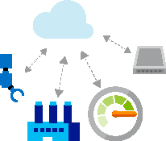

**Test and development**

The cloud can provide an environment to help save costs and bring your apps to market faster. Rather than securing budgets and spending valuable project time and resources setting up physical environments, your teams can quickly set up and dismantle test and development environments in the cloud. You can scale these dev-test environments up or down depending on need.

**Big data analytics**

With cloud computing, you can tap into your organization’s data to analyze it for patterns and insights, make predictions, improve forecasting, and make other business decisions. Cloud services can provide your organization with higher processing power and sophisticated tools for mining massive amounts of data, as well as the ability to quickly scale your environment as your data grows.

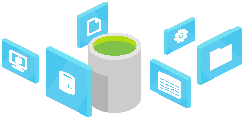

# What is SaaS?

## Software as a service

Software as a service (SaaS) allows users to connect to and use cloud-based apps over the Internet. Common examples are email, calendaring, and office tools (such as Microsoft Office 365).

SaaS provides a complete software solution that you purchase on a pay-as-you-go basis from a [cloud service provider](https://azure.microsoft.com/en-us/overview/choosing-a-cloud-service-provider/). You rent the use of an app for your organization, and your users connect to it over the Internet, usually with a web browser. All of the underlying infrastructure, middleware, app software, and app data are located in the service provider’s data center. The service provider manages the hardware and software, and with the appropriate service agreement, will ensure the availability and the security of the app and your data as well. SaaS allows your organization to get quickly up and running with an app at minimal upfront cost.

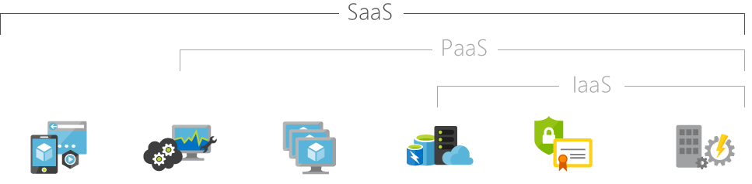

|  |  |  |  |  |  |
| --- | --- | --- | --- | --- | --- |
| Hosted applications/apps | Development tools, database management, business analytics | Operating systems | Servers and storage | Networking firewalls/security | Data center physical plant/building |

## Common SaaS scenarios

If you’ve used a web-based email service such as Outlook, Hotmail, or Yahoo! Mail, then you’ve already used a form of SaaS. With these services, you log into your account over the Internet, often from a web browser. The email software is located on the service provider’s network, and your messages are stored there as well. You can access your email and stored messages from a web browser on any computer or Internet-connected device.

The previous examples are free services for personal use. For organizational use, you can rent productivity apps, such as email, collaboration, and calendaring; and sophisticated business applications such as customer relationship management (CRM), enterprise resource planning (ERP), and document management. You pay for the use of these apps by subscription or according to the level of use.

## Advantages of SaaS

**Gain access to sophisticated applications.** To provide SaaS apps to users, you don’t need to purchase, install, update, or maintain any hardware, middleware, or software. SaaS makes even sophisticated enterprise applications, such as ERP and CRM, affordable for organizations that lack the resources to buy, deploy, and manage the required infrastructure and software themselves.

**Pay only for what you use.** You also save money because the SaaS service automatically scales up and down according to the level of usage.

**Use free client software.** Users can run most SaaS apps directly from their web browser without needing to download and install any software, although some apps require plugins. This means that you don’t need to purchase and install special software for your users.

**Mobilize your workforce easily.** SaaS makes it easy to “mobilize” your workforce because users can access SaaS apps and data from any Internet-connected computer or mobile device. You don’t need to worry about developing apps to run on different types of computers and devices because the service provider has already done so. In addition, you don’t need to bring special expertise onboard to manage the security issues inherent in mobile computing. A carefully chosen service provider will ensure the security of your data, regardless of the type of device consuming it.

**Access app data from anywhere.** With data stored in the cloud, users can access their information from any Internet-connected computer or mobile device. And when app data is stored in the cloud, no data is lost if a user’s computer or device fails.

# What is IaaS?

## Infrastructure as a service

Infrastructure as a service (IaaS) is an instant computing infrastructure, provisioned and managed over the internet. It’s one of the four types of cloud services, along with software as a service ([SaaS](https://azure.microsoft.com/en-us/overview/what-is-saas/)), platform as a service ([PaaS](https://azure.microsoft.com/en-us/overview/what-is-paas/)), and [serverless](https://azure.microsoft.com/en-us/overview/serverless-computing/).

IaaS quickly scales up and down with demand, letting you pay only for what you use. It helps you avoid the expense and complexity of buying and managing your own physical servers and other datacenter infrastructure. Each resource is offered as a separate service component, and you only need to rent a particular one for as long as you need it. A [cloud computing service provider](https://azure.microsoft.com/en-us/overview/choosing-a-cloud-service-provider/), such as [Azure](https://azure.microsoft.com/en-us/overview/what-is-azure/iaas/), manages the infrastructure, while you purchase, install, configure, and manage your own software—operating systems, middleware, and applications.

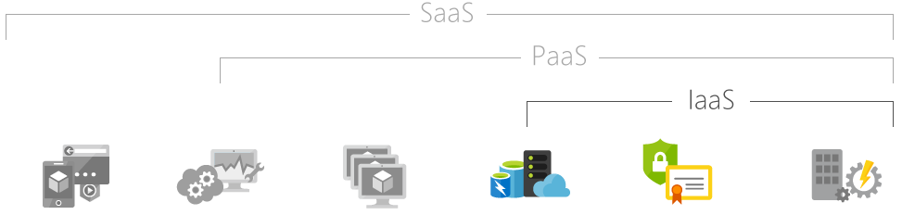

|  |  |  |  |  |  |
| --- | --- | --- | --- | --- | --- |
| Hosted applications/apps | Development tools, database management, business analytics | Operating systems | Servers and storage | Networking firewalls/security | Data center physical plant/building |

## Common IaaS business scenarios

Typical things businesses do with IaaS include:

**Test and development.** Teams can quickly set up and dismantle test and development environments, bringing new applications to market faster. IaaS makes it quick and economical to scale up dev-test environments up and down.

**Website hosting.** Running websites using IaaS can be less expensive than traditional web hosting.

**Storage, backup, and recovery.** Organizations avoid the capital outlay for storage and complexity of storage management, which typically requires a skilled staff to manage data and meet legal and compliance requirements. IaaS is useful for handling unpredictable demand and steadily growing storage needs. It can also simplify planning and management of backup and recovery systems.

**Web apps.** IaaS provides all the infrastructure to support web apps, including storage, web and application servers, and networking resources. Organizations can quickly deploy web apps on IaaS and easily scale infrastructure up and down when demand for the apps is unpredictable.

**High-performance computing.** High-performance computing (HPC) on supercomputers, computer grids, or computer clusters helps solve complex problems involving millions of variables or calculations. Examples include earthquake and protein folding simulations, climate and weather predictions, financial modeling, and evaluating product designs.

**Big data analysis.** Big data is a popular term for massive data sets that contain potentially valuable patterns, trends, and associations. Mining data sets to locate or tease out these hidden patterns requires a huge amount of processing power, which IaaS economically provides.

## Advantages of IaaS

**Eliminates capital expense and reduces ongoing cost.** IaaS sidesteps the upfront expense of setting up and managing an onsite datacenter, making it an economical option for start-ups and businesses testing new ideas.

**Improves business continuity and disaster recovery.** Achieving high availability, business continuity, and disaster recovery is expensive, since it requires a significant amount of technology and staff. But with the right service level agreement (SLA) in place, IaaS can reduce this cost and access applications and data as usual during a disaster or outage.

**Innovate rapidly.** As soon as you’ve decided to launch a new product or initiative, the necessary computing infrastructure can be ready in minutes or hours, rather than the days or weeks—and sometimes months—it could take to set up internally.

**Respond quicker to shifting business conditions.** IaaS enables you to quickly scale up resources to accommodate spikes in demand for your application— during the holidays, for example—then scale resources back down again when activity decreases to save money.

**Focus on your core business.** IaaS frees up your team to focus on your organization’s core business rather than on IT infrastructure.

**Increase stability, reliability, and supportability.** With IaaS there’s no need to maintain and upgrade software and hardware or troubleshoot equipment problems. With the appropriate agreement in place, the service provider assures that your infrastructure is reliable and meets SLAs.

**Better security.** With the appropriate service agreement, a cloud service provider can provide security for your applications and data that may be better than what you can attain in-house.

**Gets new apps to users faster.** Because you don’t need to first set up the infrastructure before you can develop and deliver apps, you can get them to users faster with IaaS.

# What is PaaS?

## Platform as a service

Platform as a service (PaaS) is a complete development and deployment environment in the cloud, with resources that enable you to deliver everything from simple cloud-based apps to sophisticated, cloud-enabled enterprise applications. You purchase the resources you need from a [cloud service provider](https://azure.microsoft.com/en-us/overview/choosing-a-cloud-service-provider/) on a pay-as-you-go basis and access them over a secure Internet connection.

Like [IaaS](https://azure.microsoft.com/en-us/overview/what-is-iaas/), PaaS includes infrastructure—servers, storage, and networking—but also middleware, development tools, business intelligence (BI) services, database management systems, and more. PaaS is designed to support the complete web application lifecycle: building, testing, deploying, managing, and updating.

PaaS allows you to avoid the expense and complexity of buying and managing software licenses, the underlying application infrastructure and middleware, container orchestrators such as [Kubernetes](https://azure.microsoft.com/en-us/topic/what-is-kubernetes/), or the development tools and other resources. You manage the applications and services you develop, and the cloud service provider typically manages everything else.

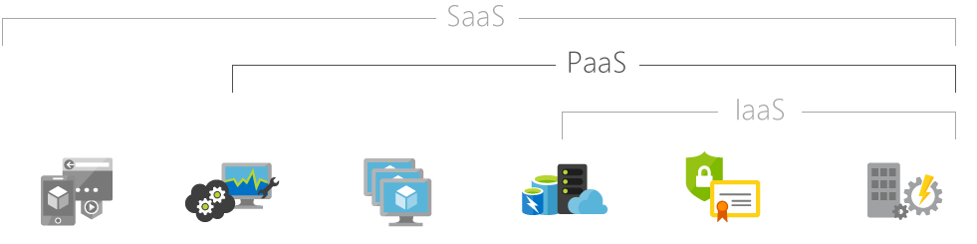

|  |  |  |  |  |  |
| --- | --- | --- | --- | --- | --- |
| Hosted applications/apps | Development tools, database management, business analytics | Operating systems | Servers and storage | Networking firewalls/security | Data center physical plant/building |

## Common PaaS scenarios

Organizations typically use PaaS for these scenarios:

**Development framework.** PaaS provides a framework that developers can build upon to develop or customize cloud-based applications. Similar to the way you create an Excel macro, PaaS lets developers create applications using built-in software components. Cloud features such as scalability, high-availability, and multi-tenant capability are included, reducing the amount of coding that developers must do.

**Analytics or business intelligence.** Tools provided as a service with PaaS allow organizations to analyze and mine their data, finding insights and patterns and predicting outcomes to improve forecasting, product design decisions, investment returns, and other business decisions.

**Additional services.** PaaS providers may offer other services that enhance applications, such as workflow, directory, security, and scheduling.

## Advantages of PaaS

By delivering infrastructure as a service, PaaS offers the same advantages as IaaS. But its additional features—middleware, development tools, and other business tools—give you more advantages:

**Cut coding time.** PaaS development tools can cut the time it takes to code new apps with pre-coded application components built into the platform, such as workflow, directory services, security features, search, and so on.

**Add development capabilities without adding staff.** Platform as a Service components can give your development team new capabilities without your needing to add staff having the required skills.

**Develop for multiple platforms—including mobile—more easily.** Some service providers give you development options for multiple platforms, such as computers, mobile devices, and browsers making cross-platform apps quicker and easier to develop.

**Use sophisticated tools affordably.** A pay-as-you-go model makes it possible for individuals or organizations to use sophisticated development software and business intelligence and analytics tools that they could not afford to purchase outright.

**Support geographically distributed development teams.** Because the development environment is accessed over the Internet, development teams can work together on projects even when team members are in remote locations.

**Efficiently manage the application lifecycle.** PaaS provides all of the capabilities that you need to support the complete web application lifecycle: building, testing, deploying, managing, and updating within the same integrated environment.