### **1. User Flow Diagram**

* 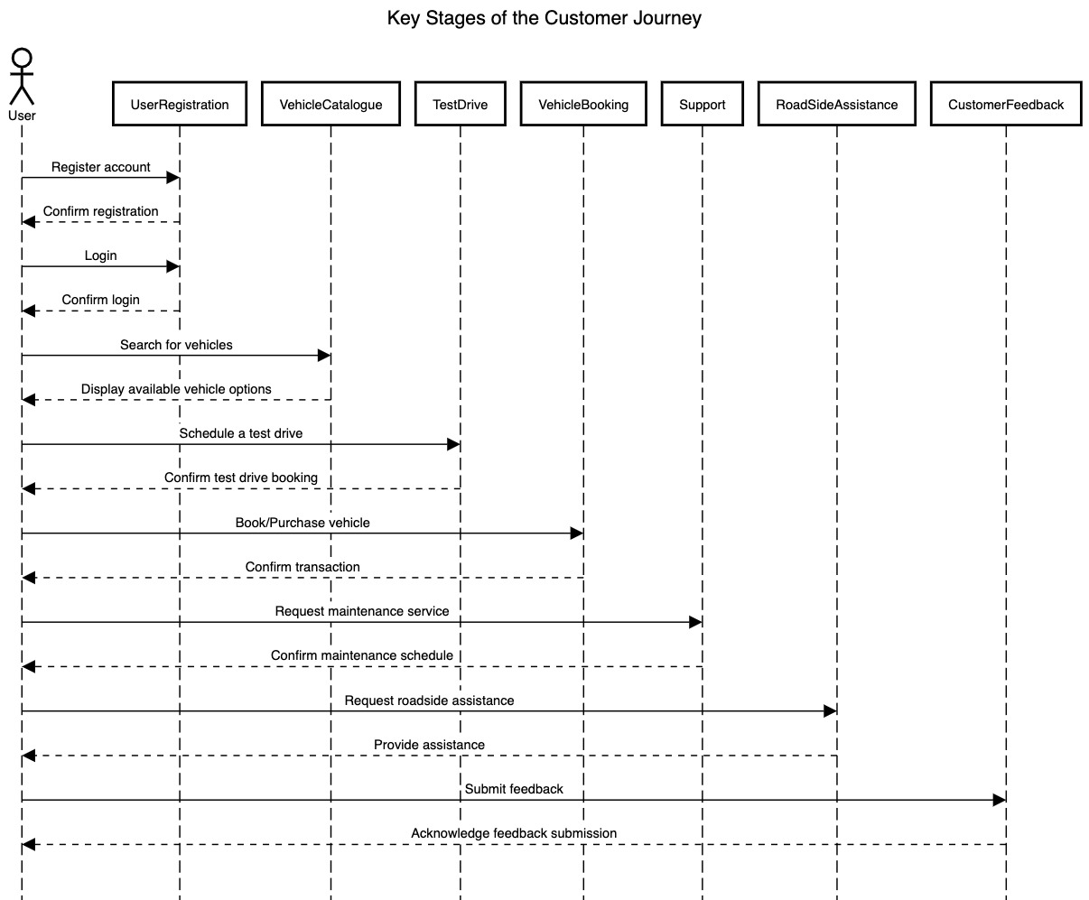

### **2. Screen Details with API Endpoints**

#### **1. User Registration and Login**

* **Screens**:
  + **Registration Screen**: Fields for username, email, password.
  + **Login Screen**: Fields for username and password.
* **API Endpoints**:
  + **Register**: POST /auth/register
  + **Login**: POST /auth/token
* **Flow**:
  + User registers via the registration screen using /auth/register.
  + After registration, they log in using /auth/token to obtain an access token.

#### **2. Customer Dashboard**

* **Screens**:
  + **Dashboard**: Overview of customer profile, their vehicles, recent test drives, and service history.
* **API Endpoints**:
  + **Get Customer Data**: GET /customers
  + **Get Customer Vehicles**: GET /vehicles
  + **Retrieve Test Drives**: GET /testdrives
  + **Service History**: GET /service/history
* **Flow**:
  + The dashboard screen calls the above endpoints to gather information on the user’s profile, vehicles, test drives, and post-sale service history.

#### **3. Vehicle Management**

* **Screens**:
  + **Vehicle List Screen**: Displays a list of customer vehicles, with filters for make, model, and year.
  + **Vehicle Details Screen**: Shows detailed information about a selected vehicle.
* **API Endpoints**:
  + **Retrieve Vehicles**: GET /vehicles with optional query parameters (make, model, year).
  + **Retrieve Vehicle by ID**: GET /vehicles/{vehicle_id}
* **Flow**:
  + User views a list of vehicles on the **Vehicle List** screen, using filters as needed.
  + Selecting a vehicle displays detailed information via /vehicles/{vehicle_id}.

#### **4. Test Drive Booking**

* **Screens**:
  + **Test Drive Booking Screen**: Allows users to schedule test drives for vehicles.
* **API Endpoints**:
  + **Schedule Test Drive**: POST /testdrives
* **Flow**:
  + User selects a vehicle and schedules a test drive using the **Test Drive Booking** screen.
  + **POST /testdrives** is called to confirm the test drive booking.

#### **5. Post-Sale Service Management**

* **Screens**:
  + **Service Request Screen**: Form for scheduling a post-sale service for a vehicle.
  + **Service History Screen**: Shows past service requests.
* **API Endpoints**:
  + **Schedule Service**: POST /service/schedule
  + **Retrieve Service History**: GET /service/history
* **Flow**:
  + User schedules a new service request through **Service Request Screen**.
  + They can view past service history on **Service History Screen** using /service/history.

#### **6. Roadside Assistance**

* **Screens**:
  + **Request Assistance Screen**: Users submit requests for roadside assistance.
  + **Assistance Status Screen**: Displays the status of an active assistance request.
* **API Endpoints**:
  + **Request Assistance**: POST /rsa/request
  + **Check Assistance Status**: GET /rsa/status/{requestId}
* **Flow**:
  + User initiates a request on the **Request Assistance Screen**.
  + The **Assistance Status Screen** allows users to monitor the status of the roadside assistance request via /rsa/status/{requestId}.

#### **7. Customer Feedback**

* **Screens**:
  + **Submit Feedback Screen**: Form for users to submit feedback about services or experiences.
  + **View Feedback Screen**: Users can view feedback they previously submitted.
* **API Endpoints**:
  + **Submit Feedback**: POST /feedback/submit
  + **Retrieve Feedback**: GET /feedback/{id}
* **Flow**:
  + User submits feedback on the **Submit Feedback Screen**.
  + **View Feedback Screen** allows users to retrieve specific feedback entries via /feedback/{id}.

### **Example Flow Diagram**

Here's a simplified outline of the flow:

1. **Authentication Flow**
   * Register → Login → Dashboard
2. **Customer Dashboard Flow**
   * Dashboard → View Customer Vehicles → View Test Drives → View Service History
3. **Vehicle Management Flow**
   * View Vehicles → View Vehicle Details
4. **Test Drive Booking Flow**
   * View Vehicle → Book Test Drive
5. **Service Request Flow**
   * View Vehicle → Request Service → View Service History
6. **Roadside Assistance Flow**
   * Request Assistance → Check Assistance Status
7. **Feedback Flow**
   * Submit Feedback → View Feedback