**HUMIDITY AND TEMPERATURE READINGS ON MIT APP.**

**Pictures-**

 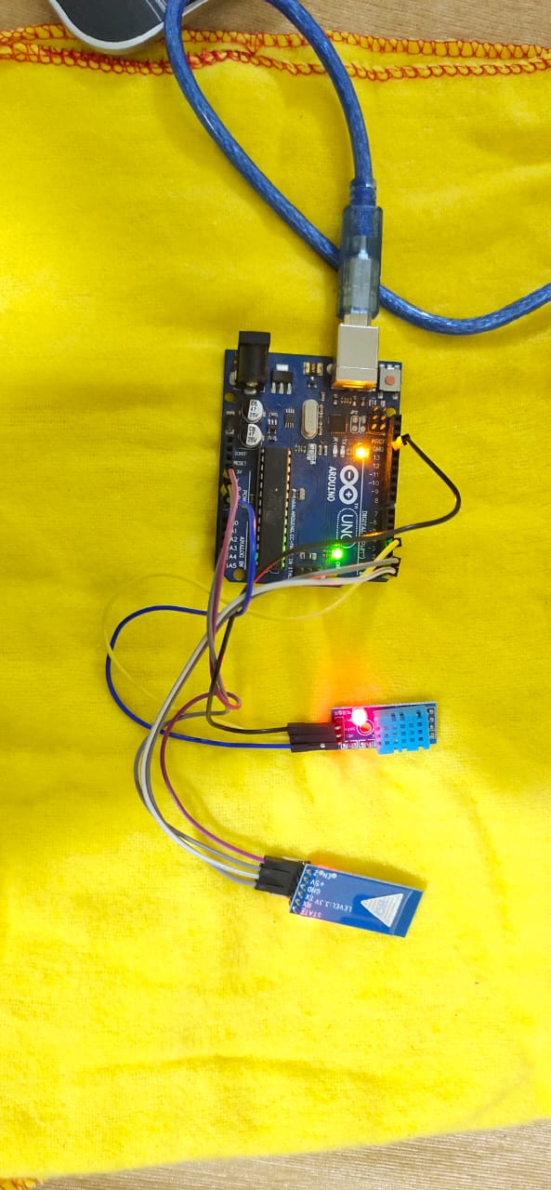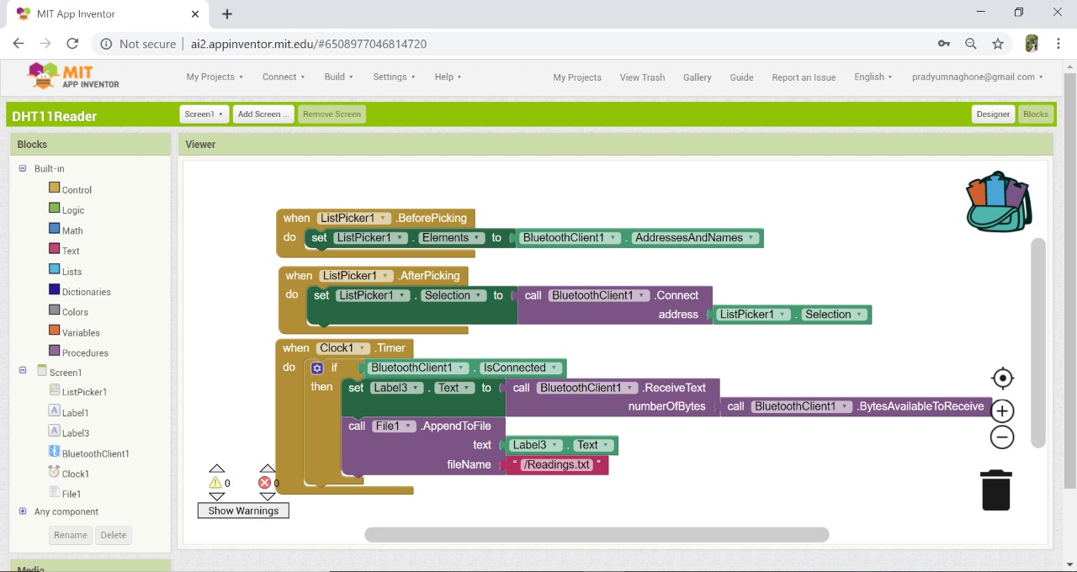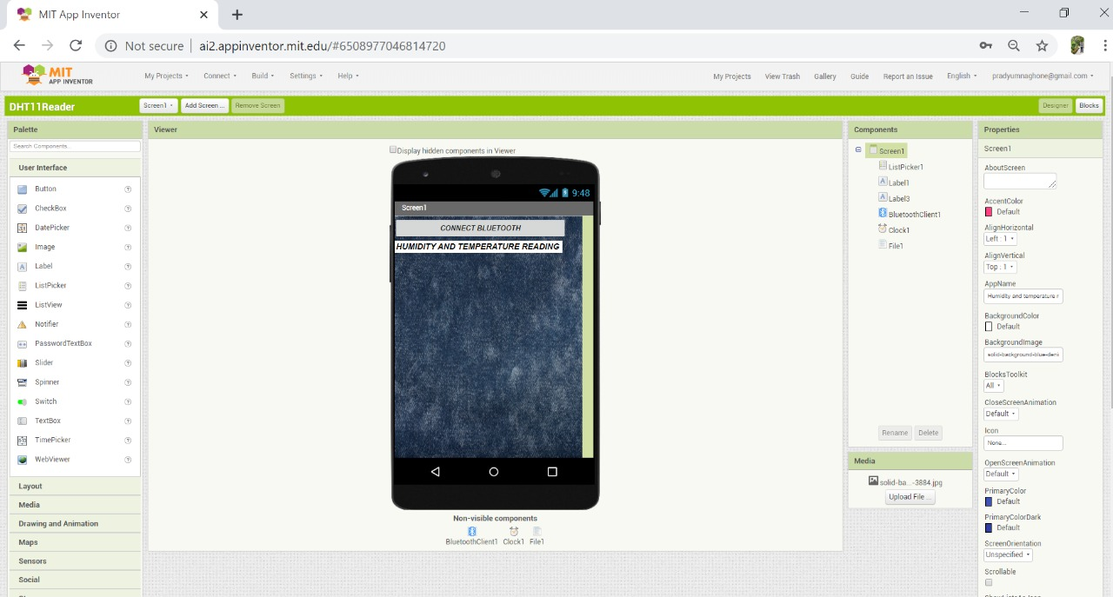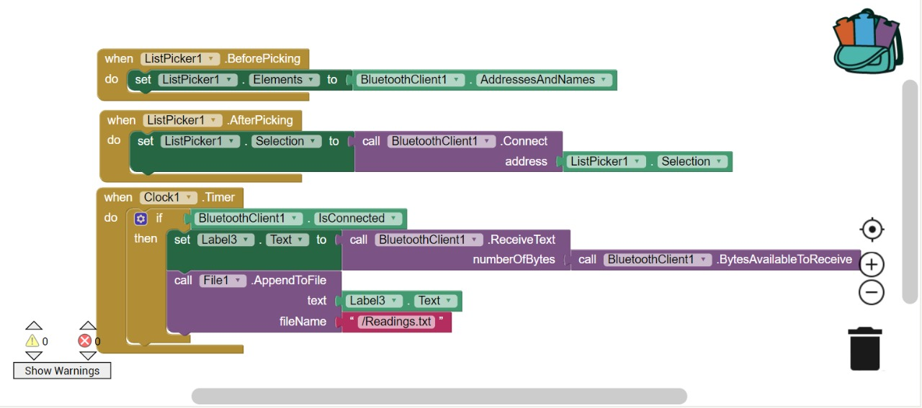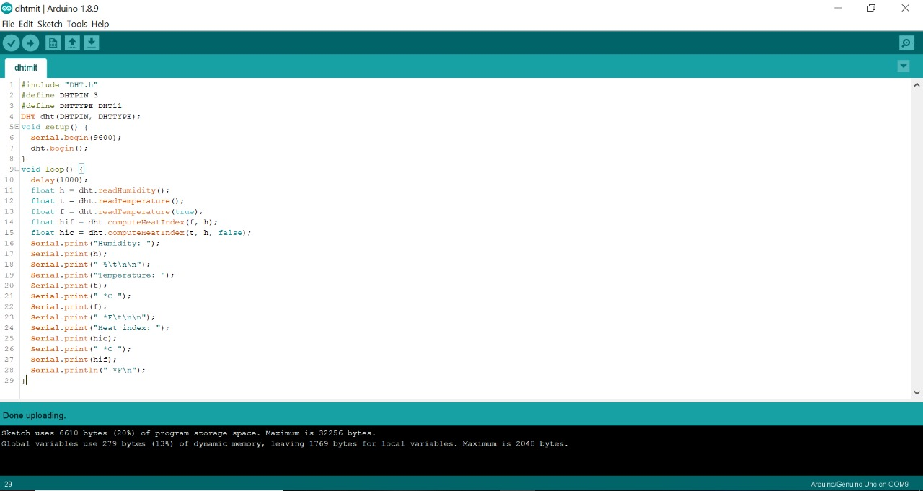

**Program-**

#include "DHT.h"

#define DHTPIN 2 .

#define DHTTYPE DHT11 // DHT 11

DHT dht(DHTPIN, DHTTYPE);

void setup() {

Serial.begin(9600);

Serial.println(F("DHTxx test!"));

dht.begin();

}

void loop() {

// Wait a few seconds between measurements.

delay(2000);

// Reading temperature or humidity takes about 250 milliseconds!

// Sensor readings may also be up to 2 seconds 'old' (its a very slow sensor)

float h = dht.readHumidity();

// Read temperature as Celsius (the default)

float t = dht.readTemperature();

// Read temperature as Fahrenheit (isFahrenheit = true)

float f = dht.readTemperature(true);

// Check if any reads failed and exit early (to try again).

if (isnan(h) || isnan(t) || isnan(f)) {

Serial.println(F("Failed to read from DHT sensor!"));

return;

}

// Compute heat index in Fahrenheit (the default)

float hif = dht.computeHeatIndex(f, h);

// Compute heat index in Celsius (isFahreheit = false)

float hic = dht.computeHeatIndex(t, h, false);

Serial.print(F("Humidity: "));

Serial.print(h);

Serial.print(F("% Temperature: "));

Serial.print(t);

Serial.print(F("°C "));

Serial.print(f);

Serial.print(F("°F Heat index: "));

Serial.print(hic);

Serial.print(F("°C "));

Serial.print(hif);

Serial.println(F("°F"));

}