**Experiment-9**

**Aim: Creating TCP sockets and datagram sockets for client server communication**

**TCP Sockets**

**Program for communication on Server Side**

//Importing .net.* to access all the network classes

import java.net.*;

import java.io.*;

public class testServer {

  public static void main(String args[])throws Exception{

//Create server socket

 ServerSocket ss = new ServerSocket(5000);

 Socket s1 = ss.accept();

//create input and output stream

 InputStream is = s1.getInputStream();

 OutputStream os = s1.getOutputStream();

os.write(65);

os.write(66);

os.write(67);

os.write(68);

int x1 = is.read();

while( x1 != -1)

{

char ch2 = (char)x1;

System.out.println(ch2);

x1 = is.read();

}

 s1.close();

 ss.close();

}

}

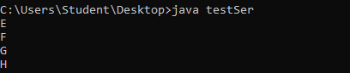

**Program for Communication**

import java.net.*;

import java.io.*;

public class testClient{

public static void main(String args[])throws Exception{

 Socket cs = new Socket("127.0.0.1", 5000);

 InputStream in = cs.getInputStream();

 OutputStream out = cs.getOutputStream();

 out.write(69);

 out.write(70);

 out.write(71);

 out.write(72);

int x = in.read();

while( x != -1)

{

char ch1 = (char)x;

System.out.println(ch1);

 x = in.read();

 }

cs.close();

 }

}

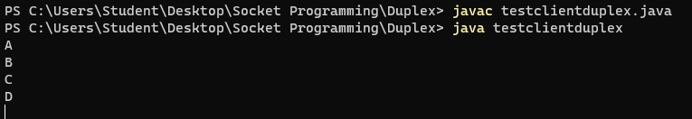

**Datagram Sockets**

**Program for DatagramClient**

import java.net.*;

public class DGClient {

    public static void main (String args[]) throws Exception{

       byte buf[] = new byte[5];

       DatagramSocket ds = new DatagramSocket(3000);

       InetAddress ip;

       DatagramPacket dp = new DatagramPacket(buf, 5);

       ds.receive(dp);

       buf = dp.getData();

       for(int i =0; i<5; i++)

        System.out.println(buf[i]);

       System.out.println(dp.getAddress().toString());

       System.out.println(dp.getPort());

    }

}

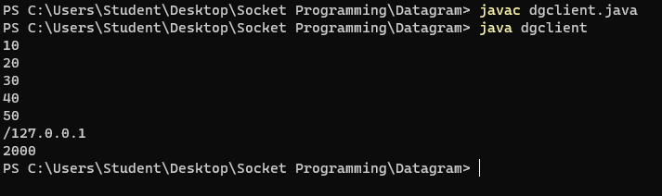

**Program  for  Datagram  Server**

//import java.io.*;

import java.net.*;

public class DGServer {

    public static void main (String args[]) throws Exception{

       byte [] buf= new byte[5];

       buf[0] = 10;

       buf[1] = 20;

       buf[2] = 30;

       buf[3] = 40;

       buf[4] = 50;

       DatagramSocket ds = new DatagramSocket(2000);

       InetAddress ip = InetAddress.getByName("127.0.0.1");

       DatagramPacket dp = new DatagramPacket(buf, 5);

       dp.setPort(3000);

       dp.setAddress(ip);

       ds.send(dp);

    }

}

