Course: High Performance Computing Lab

Practical No 1

PRN:22510063
Name:Pradum Yelame
Batch:B8

Title: Introduction to OpenMP

Problem Statement 1 – Demonstrate Installation and Running of OpenMP code in C
Recommended Linux based System:
Following steps are for windows:
OpenMP – Open Multi-Processing is an API that supports multi-platform shared-memory multiprocessing programming in C, C++ and Fortran on multiple OS. OpenMP uses a portable, scalable model that gives programmers a simple and flexible interface for developing parallel applications for platforms ranging from the standard desktop computer to the supercomputer.

To set up OpenMP,
We need to first install C, C++ compiler if not already done. This is possible through the MinGW Installer.
Reference: Article on GCC and G++ installer (Link)
Note: Also install `mingw32-pthreads-w32` package.

Then, to run a program in OpenMP, we have to pass a flag `-fopenmp`.
Example:
To run a basic Hello World,
#include <iostream>
#include <omp.h>
using namespace std;

int main() {
#pragma omp parallel
cout << "Hello, world." << endl;
return 0;
}

gcc -fopenmp test.c -o hello
.\hello.exe
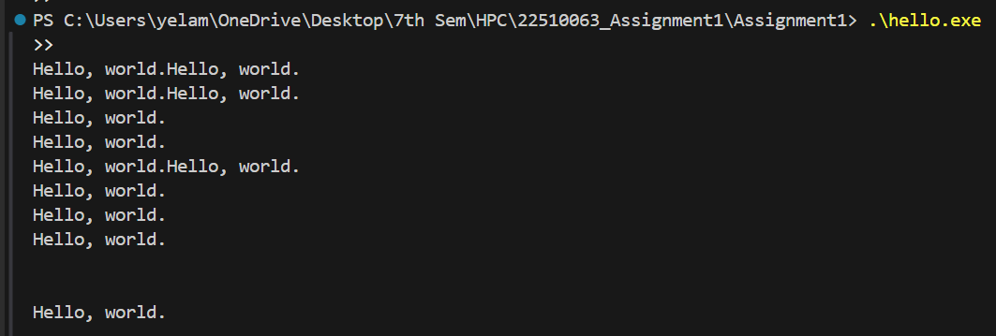

Problem Statement 2 – Print ‘Hello, World’ in Sequential and Parallel in OpenMP
We first ask the user for number of threads – OpenMP allows to set the threads at runtime. Then, we print the Hello, World in sequential – number of times of threads count and then run the code in parallel in each thread.

Code snapshot:
#include <iostream>
#include <omp.h>
using namespace std;

int main() {
int n;
cout << "Enter number of threads: ";
cin >> n;

// Sequential output
cout << "\nSequential Hello:\n";
for (int i = 0; i < n; i++) {
cout << "Hello, World from thread " << i << endl;
}

// Parallel output
cout << "\nParallel Hello:\n";
omp_set_num_threads(n);

#pragma omp parallel
{
int ID = omp_get_thread_num();
#pragma omp critical // To avoid jumbled output
cout << "Hello, World from thread " << ID << endl;
}

return 0;
}

Output snapshot:
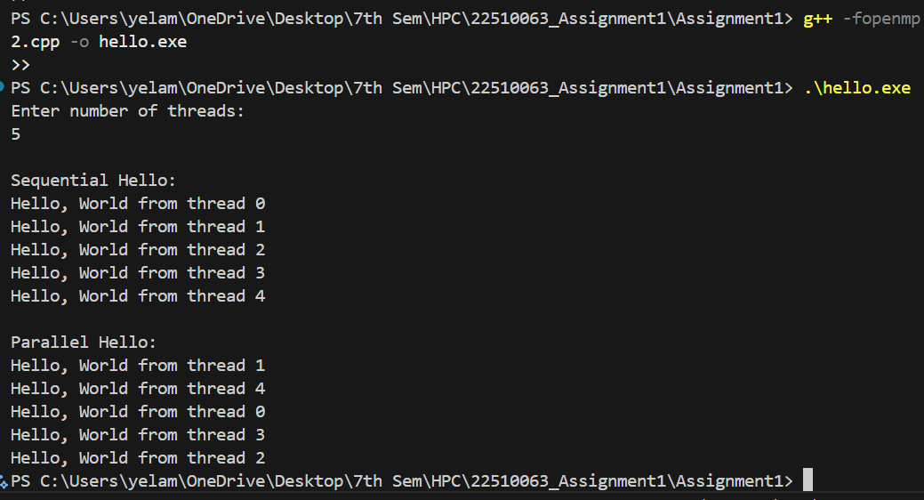
Analysis:

- Sequential Execution prints messages in fixed order using a loop.
- Parallel Execution uses OpenMP’s #pragma omp parallel, and each thread prints independently.
- The thread number is obtained using omp_get_thread_num().

GitHub Link: https://github.com/pradyumyelame/HPCL/tree/main/Assignment1

Problem statement 3: Calculate theoretical FLOPS of your system on which you are running the above codes.

Theoretical FLOPS =
No. of cores × Clock speed (Hz) × FLOPs per cycle per core
Processor: Intel Core i5-1135G7
Cores: 4 physical, 8 threads
Clock Speed: 2.4 GHz (base), up to 4.2 GHz (turbo)
FLOPs per Cycle per Core (for AVX-512 or similar): Assume 16 FLOPs/cycle

FLOPS = 4 cores × 2.4 × 10^9 Hz × 16 = 153.6× 10^9 FLOPS
=153.6 GFLOPS

