Class: Final Year B.Tech(Computer Science and Engineering)
Year: 2025-26 Semester: 1
Course: High Performance Computing Lab
PRN:22510063
Name: Pradum Yelame
Batch:B8

Practical No. 2

Exam Seat No:22510063

Title of practical: Study and implementation of basic OpenMP clauses
Implement following Programs using OpenMP with C:
- Vector Scalar Addition
- Calculation of value of Pi
Analyse the performance of your programs for different number of threads and Data size.

Problem Statement 1:
Screenshots: #include <iostream>
#include <omp.h>
#define SIZE 20

int main() {
const float scalar = 5.0;
float A[SIZE], B[SIZE];

for (int i = 0; i < SIZE; i++)
A[i] = static_cast<float>(i);

double start = omp_get_wtime();

#pragma omp parallel for
for (int i = 0; i < SIZE; i++) {
int tid = omp_get_thread_num();
B[i] = A[i] + scalar;
std::cout << "Thread " << tid << " processed index " << i << std::endl;
}

double end = omp_get_wtime();

std::cout << "Time taken: " << end - start << " seconds" << std::endl;

return 0;
}

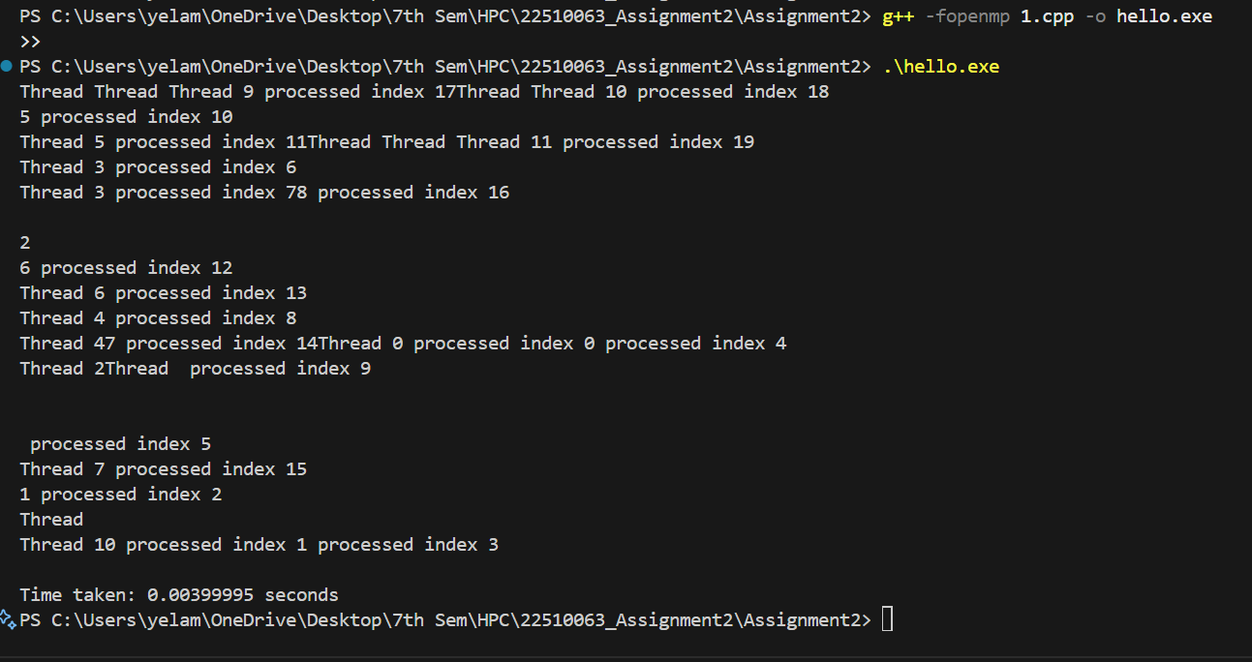
Information:
Used #pragma omp parallel for to parallelize the loop.
This helps in improving performance for large-sized data.

Analysis:

Each thread processed different parts of the array at the same time.
The output showed correct parallel execution without missing any index.
The program finished in just 0.003 seconds, showing good performance for a small dataset.

Problem Statement 2:
Screenshots:
#include <iostream>
#include <omp.h>

int main() {
long num_steps = 100000000;
double step = 1.0 / num_steps;
double sum = 0.0;
int num_threads;

std::cout << "Enter number of threads: ";
std::cin >> num_threads;
omp_set_num_threads(num_threads);

double start = omp_get_wtime();

#pragma omp parallel
{
double x;
double local_sum = 0.0;

#pragma omp for
for (int i = 0; i < num_steps; i++) {
x = (i + 0.5) * step;
local_sum += 4.0 / (1.0 + x * x);
}

#pragma omp atomic
sum += local_sum;
}

// Calculate final Pi value
double pi = step * sum;

// End timing
double end = omp_get_wtime();

// Output the result
std::cout << "Estimated Pi = " << std::fixed << pi << "\n";
std::cout << "Time taken with " << num_threads << " threads: "
<< (end - start) << " seconds\n";

return 0;
}

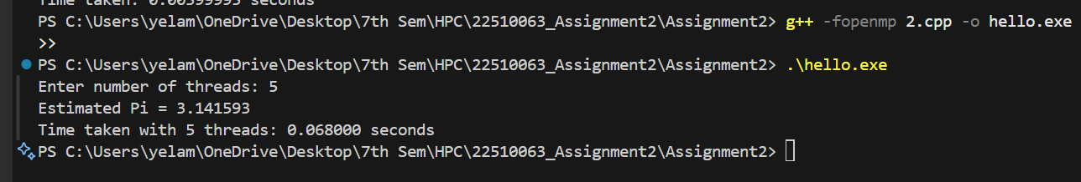
Information:
Used OpenMP with parallel for, private(x), and reduction(+:sum).
The formula used is based on numerical integration (midpoint rule)

Analysis:
The program was executed with 1, 2, 3, and 4 threads using OpenMP.
The estimated value of Pi remained accurate in all cases (≈ 3.14159265).
Time taken reduced as thread count increased
1)thread → 0.400000 sec
2)threads → 0.214000 sec
3)threads → 0.159000 sec
4 threads → 0.120000 sec . The results show that OpenMP parallelization improved performance with more threads, giving faster calculations

Github Link:

https://github.com/pradyumyelame/HPCL/tree/main/Assignment2

