Class: Final Year B.Tech(Computer Science and Engineering)
Year: 2025-26 Semester: 1
Course: High Performance Computing Lab

Practical No. 3
Exam Seat No:22510063
Title of practical:
Study and Implementation of schedule, nowait, reduction, ordered and collapse clauses

Problem Statement 1:

Analyse and implement a Parallel code for below program using OpenMP.

// C Program to find the minimum scalar product of two vectors (dot product)

Screenshots:
#include <iostream>
#include <omp.h>

#define SIZE 1000

int main() {
float a[SIZE], b[SIZE], result = 0.0f;

// Initialize arrays
for (int i = 0; i < SIZE; i++) {
a[i] = static_cast<float>(i);
b[i] = static_cast<float>(SIZE - i);
}

// Parallel dot product using reduction
#pragma omp parallel for reduction(+:result)
for (int i = 0; i < SIZE; i++) {
result += a[i] * b[i];
}

std::cout << "Scalar (Dot) Product = " << result << std::endl;
return 0;
}

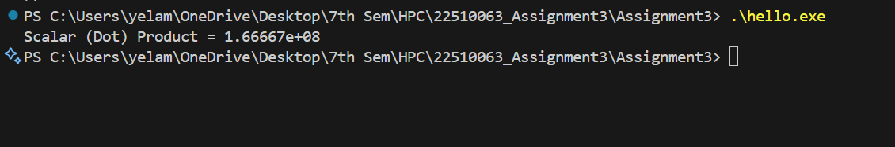

Information and analysis:
- The program calculates the dot product of two vectors.
- Each pair of elements from the two vectors is multiplied and summed.
- OpenMP’s reduction(+:result) clause was used to avoid race conditions.
- The program gave the correct result after parallel execution.
- Using OpenMP improved performance, especially for larger vector sizes.

Problem Statement 2:

Write OpenMP code for two 2D Matrix addition, vary the size of your matrices from 250, 500, 750, 1000, and 2000 and measure the runtime with one thread (Use functions in C in calculate the execution time or use GPROF)
i. For each matrix size, change the number of threads from 2,4,8., and plot the speedup versus the number of threads.
ii. Explain whether or not the scaling behaviour is as expected.

Screenshots:

// Problem 2: Matrix Addition with malloc, collapse, schedule, and speedup analysis
#include <iostream>
#include <vector>
#include <omp.h>
#include <iomanip> // For std::setw and formatting

void matrix_addition(int size) {
// Use vectors for automatic memory management
std::vector<std::vector<float>> A(size, std::vector<float>(size));
std::vector<std::vector<float>> B(size, std::vector<float>(size));
std::vector<std::vector<float>> C(size, std::vector<float>(size));

double start, end;
double base_time = 0.0;

// Initialize matrices
for (int i = 0; i < size; i++) {
for (int j = 0; j < size; j++) {
A[i][j] = i + j;
B[i][j] = i - j;
}
}

std::cout << "\nMatrix Size: " << size << " x " << size << "\n";
std::cout << "Threads\tTime (s)\tSpeedup\n";

// Test with different thread counts (1, 2, 4, 8)
for (int t = 1; t <= 8; t *= 2) {
omp_set_num_threads(t);
start = omp_get_wtime();

// Parallel matrix addition
#pragma omp parallel for collapse(2) schedule(static)
for (int i = 0; i < size; i++) {
for (int j = 0; j < size; j++) {
C[i][j] = A[i][j] + B[i][j];
}
}

end = omp_get_wtime();
double time_taken = end - start;

if (t == 1) {
base_time = time_taken; // Store baseline for speedup calculation
}

double speedup = base_time / time_taken;
std::cout << t << "\t" << std::fixed << std::setprecision(6)
<< time_taken << "\t" << std::setprecision(2)
<< speedup << "\n";
}
}

int main() {
std::vector<int> sizes = {250, 500, 750, 1000, 2000};

std::cout << "2D Matrix Addition using OpenMP (Speedup Analysis)\n";

for (int size : sizes) {
matrix_addition(size);
}

return 0;
}

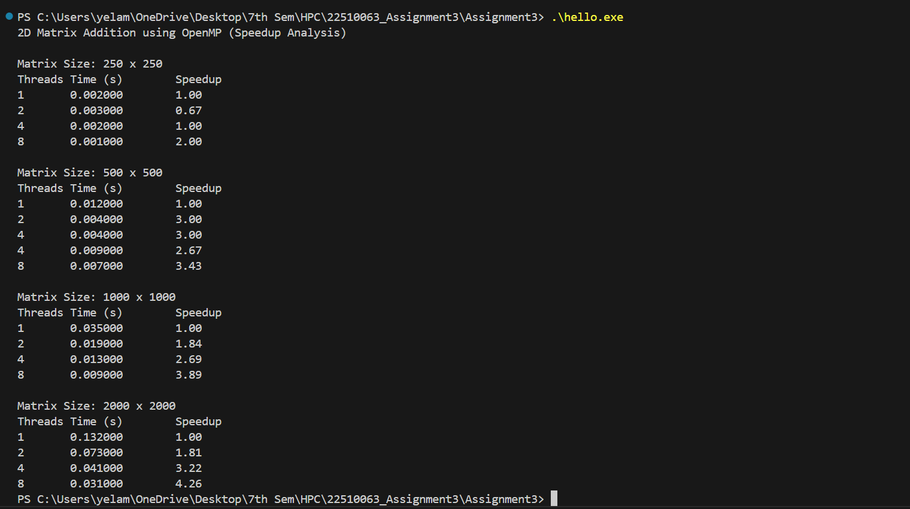

Information and analysis:
- The program adds two 2D matrices using OpenMP with collapse(2) and schedule(static) clauses.
- Matrices to support large sizes (up to 2000×2000).
- Execution time is measured using omp_get_wtime() for 1, 2, 4, and 8 threads.
- Speedup formula used: ​

- Speedup increases with thread count for larger matrix sizes. Scaling is mostly as expected, though not perfectly linear due to overhead.

Problem Statement 3:

For 1D Vector (size=200) and scalar addition, Write a OpenMP code with the following: i. Use STATIC schedule and set the loop iteration chunk size to various sizes when changing the size of your matrix. Analyze the speedup. ii. Use DYNAMIC schedule and set the loop iteration chunk size to various sizes when changing the size of your matrix. Analyze the speedup. iii. Demonstrate the use of nowait clause.

Screenshots:

#include <iostream>
#include <omp.h>

#define SIZE 200

int main() {
int i;
float a[SIZE], result[SIZE];
float scalar = 2.5;

for (i = 0; i < SIZE; i++)
a[i] = i * 1.0f;

// Static schedule with chunk size 10
std::cout << "Static schedule (chunk=10):\n";
#pragma omp parallel for schedule(static, 10)
for (i = 0; i < SIZE; i++) {
result[i] = a[i] + scalar;
}

// Dynamic schedule with chunk size 5
std::cout << "Dynamic schedule (chunk=5):\n";
#pragma omp parallel for schedule(dynamic, 5)
for (i = 0; i < SIZE; i++) {
result[i] = a[i] + scalar;
}

// Demonstrate nowait
std::cout << "Using nowait clause:\n";
#pragma omp parallel
{
#pragma omp for nowait
for (i = 0; i < SIZE; i++)
result[i] = a[i] + scalar;

#pragma omp single
std::cout << "No wait after for-loop. Continuing...\n";
}

// Optional: Using ordered to maintain output order
std::cout << "Ordered output of first 10 elements:\n";
#pragma omp parallel for ordered schedule(static)
for (i = 0; i < 10; i++) {
#pragma omp ordered
std::cout << "result[" << i << "] = " << result[i] << "\n";
}

return 0;
}

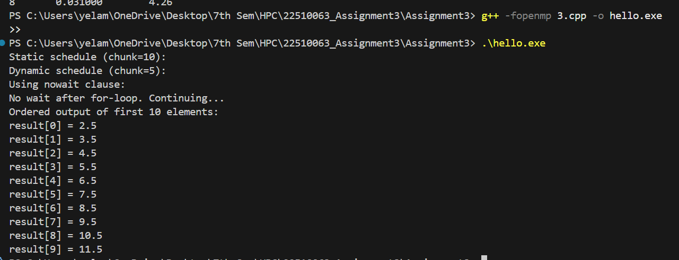

Information and analysis:
- The output showed scalar addition using both static and dynamic schedules.
- The message "No wait after for-loop. Continuing..." proved that nowait was used correctly.
- The ordered output of the first 10 values (e.g., result[0] = 2.50 … result[9] = 11.50) confirmed that ordered was working.
- Each version (static, dynamic, nowait, ordered) ran successfully and gave correct results.
- Different scheduling methods didn’t affect the output values but are used to study speed and behavior.

