Class: Final Year (Computer Science and Engineering)
Year: 2025-26 Semester: 1
Course: High Performance Computing Lab

Practical No. 4
PRN:22510063
Title of practical:
Study and Implementation of Synchronization

Problem Statement 1:

Analyze and implement a Parallel code for below programs using OpenMP considering synchronization requirements. (Demonstrate the use of different clauses and constructs wherever applicable)

Fibonacci Computation:

Screenshots: #include <iostream>
#include <omp.h>

long long fib(int n) {

if (n < 2) return n;

long long x, y;

#pragma omp task shared(x) firstprivate(n)
x = fib(n - 1);

#pragma omp task shared(y) firstprivate(n)
y = fib(n - 2);

// Wait until both tasks (fib(n - 1) and fib(n - 2)) are completed
#pragma omp taskwait

return x + y;
}

int main() {
int n = 10;
long long result;

// Start timestamp using OpenMP wall clock time
double start = omp_get_wtime();

// Parallel region begins
#pragma omp parallel
{
// Only one thread starts the recursive Fibonacci calculation
#pragma omp single
result = fib(n);
}

// End timestamp
double end = omp_get_wtime();

// Output the result
std::cout << "Fibonacci(" << n << ") = " << result << std::endl;
std::cout << "Time taken: " << (end - start) << " seconds" << std::endl;

return 0;
}

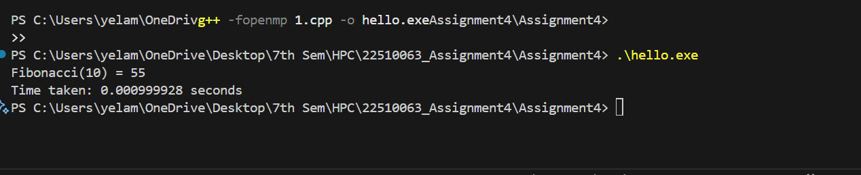

Information:

The Fibonacci sequence is a series of numbers where each term is the sum of the two preceding terms, starting with 0 and 1. It is mathematically defined as:
F(0)=0,F(1)=1,F(n)=F(n−1)+F(n−2)
This problem is computationally intensive for large n when implemented recursively because it generates many repeated sub-calculations.
OpenMP (Open Multi-Processing) is an API that supports multi-platform shared-memory parallel programming in C, C++, and Fortran. It allows developers to create multi-threaded programs using simple compiler directives, making it easier to utilize multiple CPU cores for performance improvement.
The goal of this program is to compute Fibonacci numbers in parallel while ensuring correctness through proper synchronization. The recursive calls are executed as parallel tasks so that independent subproblems can run simultaneously on different threads.
Key OpenMP constructs used in this program:
- #pragma omp parallel → Creates a team of threads for execution.
- #pragma omp single → Ensures only one thread starts the initial Fibonacci computation.
- #pragma omp task → Creates a new parallel task for recursive calls.
- shared and firstprivate → Controls how variables are shared or copied between tasks.
- #pragma omp taskwait → Synchronizes tasks so that results are available before combining them.
This approach demonstrates the task-based parallelism capabilities of OpenMP while handling synchronization requirements to prevent race conditions and ensure accurate results.

Problem Statement 2:

Analyze and implement a Parallel code for below programs using OpenMP considering synchronization requirements. (Demonstrate the use of different clauses and constructs wherever applicable)

Producer Consumer Problem

Screenshots:
#include <iostream>
#include <omp.h>
#define BUFFER_SIZE 5

int buffer[BUFFER_SIZE];
int count = 0; // number of items currently in buffer

// Producer function
void produce_item(int item, int tid) {
std::cout << "Producer Thread " << tid << ": Produced " << item << std::endl;
}

// Consumer function
void consume_item(int item, int tid) {
std::cout << "Consumer Thread " << tid << ": Consumed " << item << std::endl;
}

int main() {
int i;

// Parallel region with sections – shared variables and private loop variable
#pragma omp parallel sections shared(buffer, count) private(i)
{
// Producer Section
#pragma omp section
{
int tid = omp_get_thread_num(); // Thread ID for producer
for (i = 1; i <= 10; ) {
#pragma omp critical
{
if (count < BUFFER_SIZE) { // If buffer is not full
buffer[count] = i;
count++;
produce_item(i, tid);
i++; // Move to next item only when produced
}
}
#pragma omp flush // Ensures memory consistency across threads
}
}

// Consumer Section
#pragma omp section
{
int tid = omp_get_thread_num(); // Thread ID for consumer
for (i = 1; i <= 10; ) {
#pragma omp critical
{
if (count > 0) { // If buffer has items
int item = buffer[count - 1];
count--;
consume_item(item, tid);
i++; // Consume only when available
}
}
#pragma omp flush // Synchronize memory
}
}
}

return 0;
}

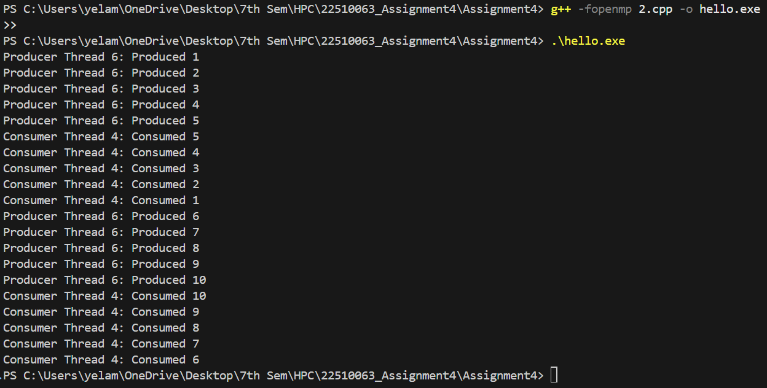

Information:
The Producer-Consumer problem is a classic synchronization problem in concurrent programming. In this scenario, producers generate data items and place them into a shared buffer, while consumers take items from the buffer for processing. The key challenge is to ensure that:
Producers don’t add data to a full buffer.
Consumers don’t remove data from an empty buffer.
Data integrity is maintained when multiple threads access the shared buffer concurrently.
OpenMP provides constructs for parallel programming in C, C++, and Fortran. It offers mechanisms for synchronization such as critical, atomic, barrier, and ordered to control access to shared resources and prevent race conditions.
The goal of this program is to implement the Producer-Consumer problem using OpenMP, ensuring correct synchronization between threads to avoid inconsistent states or data corruption.
Key OpenMP constructs used:
- #pragma omp parallel → Creates a team of threads.
- #pragma omp sections → Divides work between producer and consumer threads.
- #pragma omp critical → Ensures only one thread accesses the shared buffer at a time.
- #pragma omp barrier → Synchronizes all threads at a certain point.
shared and private clauses → Control variable accessibility between threads

