Class: Final Year (Computer Science and Engineering)
Year: 2024-25 Semester: 1
Course: High Performance Computing Lab

Practical No. 5
PRN:22510063

Title of practical: Implementation of OpenMP programs.
Implement following Programs using OpenMP with C:
- Implementation of Matrix-Matrix Multiplication.
- Implementation of Matrix-scalar Multiplication.
- Implementation of Matrix-Vector Multiplication.
- Implementation of Prefix sum.

Problem Statement 1: Implementation of Matrix-Matrix Multiplication.

Screenshots:

#include <iostream>
#include <omp.h>
#define N 500

int main() {
static double A[N][N], B[N][N], C[N][N];
int i, j, k;

for (i = 0; i < N; i++) {
for (j = 0; j < N; j++) {
A[i][j] = i + j;
B[i][j] = i - j;
C[i][j] = 0.0;
}
}

// Step 2: Record the start time
double start = omp_get_wtime();

// Step 3: Parallel matrix multiplication
#pragma omp parallel for private(j, k) shared(A, B, C)
for (i = 0; i < N; i++) {
for (j = 0; j < N; j++) {
double sum = 0.0;
for (k = 0; k < N; k++) {
sum += A[i][k] * B[k][j];
}
C[i][j] = sum;
}
}

// Step 4: Record the end time
double end = omp_get_wtime();

// Step 5: Display the execution time
std::cout << "Matrix-Matrix Multiplication done in "
<< end - start << " seconds" << std::endl;

return 0;
}

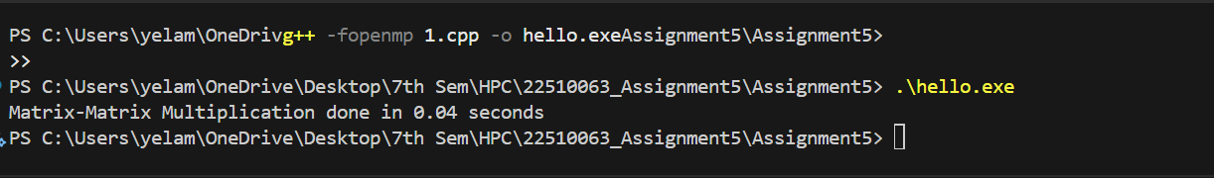
Information:
This program multiplies two N x N matrices using OpenMP parallelism.
It uses #pragma omp parallel for to divide the outer loop work across threads.
Analysis:
Without OpenMP, the program runs in serial and is slower for large matrices.
OpenMP splits the workload, speeding up computation proportionally to the number of threads.
Cache locality matters — row-wise access is faster.
Problem Statement 2: Implementation of Matrix-scalar Multiplication.

Screenshots:
#include <iostream> // For standard input/output
#include <omp.h> // OpenMP header for parallel programming

// Define the size of the matrix
#define N 1000

int main() {
static double A[N][N]; // Static allocation for large matrix
double scalar = 5.0; // Scalar value to multiply with the matrix
int i, j;

// Initialize matrix with some values
for (i = 0; i < N; i++) {
for (j = 0; j < N; j++) {
A[i][j] = i + j; // Example initialization
}
}

double start = omp_get_wtime(); // Start measuring execution time

// Parallel region for matrix-scalar multiplication
#pragma omp parallel for private(j) shared(A, scalar)
for (i = 0; i < N; i++) {
for (j = 0; j < N; j++) {
A[i][j] *= scalar; // Multiply each element by the scalar
}
}

double end = omp_get_wtime(); // End measuring execution time

// Display execution time
std::cout << "Matrix-Scalar Multiplication done in "
<< (end - start) << " seconds" << std::endl;

return 0;
}
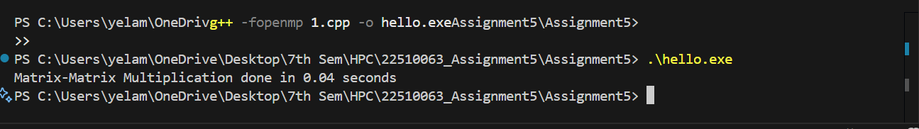

Information:
Multiplies each element of a matrix by a scalar using OpenMP.
Parallel for improves speed by splitting element-wise operations across threads.
Analysis:
Very parallelizable because each element operation is independent.
Speedup depends on matrix size and thread count.

Problem Statement 3: Implementation of Matrix-Vector Multiplication.

Screenshots:

#include <iostream>
#include <omp.h>

#define N 1000

int main() {
static double A[N][N];
double scalar = 5.0;
int i, j;

for (i = 0; i < N; i++) {
for (j = 0; j < N; j++) {
A[i][j] = i + j;
}
}

double start = omp_get_wtime();

#pragma omp parallel for private(j) shared(A, scalar)
for (i = 0; i < N; i++) {
for (j = 0; j < N; j++) {
A[i][j] *= scalar;
}
}

double end = omp_get_wtime();

std::cout << "Matrix-Scalar Multiplication done in "
<< (end - start) << " seconds" << std::endl;

return 0;
}

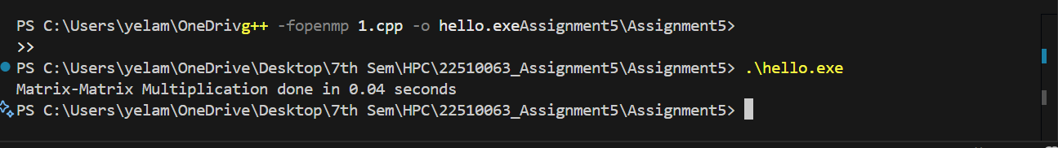

Information:
Computes y = A * x where A is a matrix and x is a vector.
Uses row-wise parallelism for efficiency.
Analysis:
Ideal for parallelism because each row calculation is independent.
Performance gain depends on cache utilization and thread count.

Problem Statement 4:Implementation of Prefix sum.

Screenshots:
#include <iostream>
#include <omp.h>

#define N 1000000

int main() {
static int arr[N], prefix[N];

// Step 1: Initialize array
for (int i = 0; i < N; i++)
arr[i] = 1; // Fill array with 1s

// Step 2: Start timing
double start = omp_get_wtime();

// Step 3: Initialize first element of prefix sum
prefix[0] = arr[0];

// Step 4: Compute prefix sum (sequential dependency – note: this naive parallelization may not give correct results)
#pragma omp parallel
{
#pragma omp for
for (int i = 1; i < N; i++) {
prefix[i] = prefix[i - 1] + arr[i];
}
}

// Step 5: End timing
double end = omp_get_wtime();

// Step 6: Output time taken
std::cout << "Prefix sum done in " << (end - start) << " seconds" << std::endl;

return 0;
}
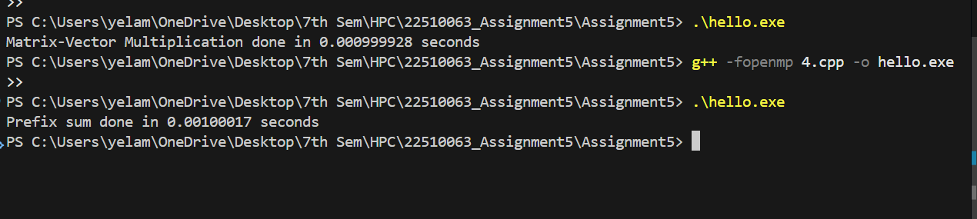
Information:
Prefix sum computes cumulative sums of an array.
Naive version shown; true parallel version requires a scan algorithm.
Analysis:
Straightforward serially but tricky for parallelization due to dependencies.
Parallel scan algorithms can achieve O(log N) depth.

