**Batch T2**

**Assignment No. 10**

**Student Name: Pradum Yelame**

**Student PRN: 22510063**

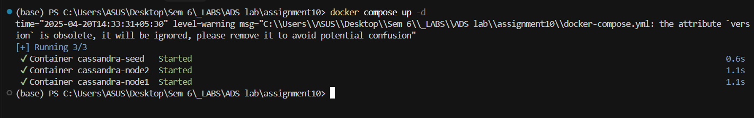

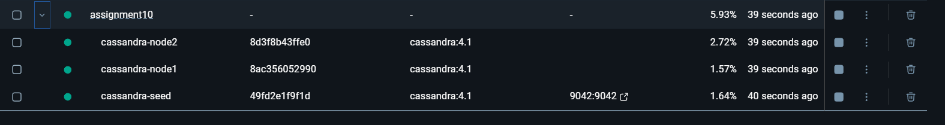

Seed Node

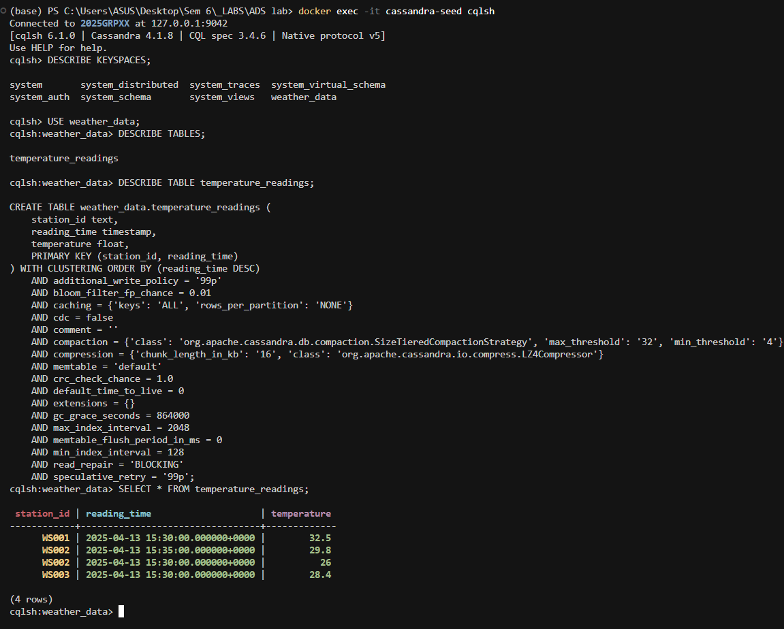

Node 1:

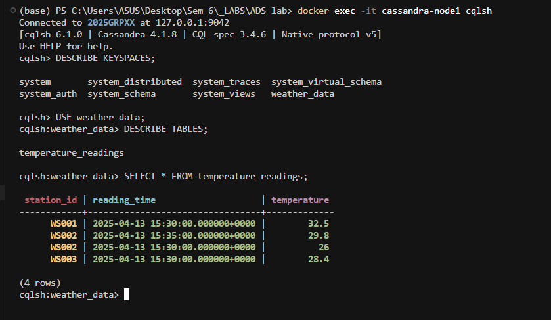

Node 2:

