Lab 3: Architectural Pattern Selection – Written Justification
Project: Blood Bank Inventory & Emergency Donor Matcher
Problem Statement #12 — Healthcare & Telemedicine

NAME: _PRADYUN P URS
SRN: PES1UG24AM195

Architecture Selection
“We chose Layered Architecture for the Blood Bank Inventory & Emergency Donor Matcher.”
Architectural Choice
We selected a Layered Architecture organised into three layers as shown in the component diagram. The Client Layer contains the Emergency Requester UI, Blood Bank Manager Console, and Donor Portal. The Application Services Layer contains the Emergency Request Manager, Inventory Management Component, Emergency Donor Matching Component, Notification Service, and Donor Eligibility Service. The Persistence Layer contains the Blood Inventory DB, Donor & Eligibility DB, and Emergency Request DB. The layers communicate through named interfaces including RequestService, InventoryService, DonorMatchService, InventoryDataAccess, DonorDataAccess, and RequestDataAccess.
Reason 1: Clear Separation of Responsibilities
The system has distinct responsibilities: emergency requests are submitted through the client layer, business rules such as inventory checking and donor matching are handled in the application layer, and blood-stock, donor, and emergency-request information is stored in the persistence layer. Layered Architecture keeps these responsibilities separate, making the system easier to understand, develop, test, and maintain.
Reason 2: Controlled Access to Critical Blood-Bank Data
The diagram makes the application-services layer the controlled path to persistence. Client components do not directly access the databases. Inventory operations pass through Inventory Management, donor information is accessed through the donor services, and emergency requests are recorded through Emergency Request Manager. This gives the system a predictable path for validation and protection of critical inventory data.
Security Advantage
Security is improved because sensitive inventory and donor information is not exposed directly to client interfaces. Application services can enforce compatibility, donor eligibility, the 10 km location constraint, authorization, and transactional inventory rules before database operations occur. This reduces the possibility of a client-side operation bypassing business validation.
Performance Benefit
For a single, well-scoped system, Layered Architecture avoids unnecessary distributed-service network hops. Emergency requests can be processed through the application services and database access paths, while Notification Service can initiate emergency SMS alerts with the required target of 30 seconds. This provides a straightforward processing path without the operational overhead of a microservices deployment.
Key Scenario Constraints Reflected in the Design
• Real-time cross-checking of emergency blood requests against current inventory.
• Monitoring of blood-component stock and shelf lives.
• Matching of compatible and eligible donors within a 10 km radius.
• Emergency SMS notification target of 30 seconds.
• Transactional inventory handling to prevent simultaneous allocation of the same blood bag.

Component Diagram: Blood Bank Inventory & Emergency Donor Matcher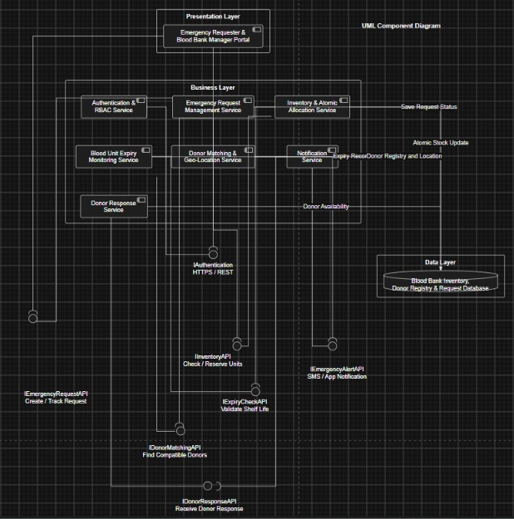
Layered Architecture

