Lab 2: Blood Bank Inventory & Emergency Donor Matcher

Project Name: Blood Bank Inventory & Emergency Donor Matcher
Student Name: PRADYUN P URS
SRN: PES1UG24AM195
Section: D

1. Project Overview
Problem Context: Blood banks require a real-time stock-management system that monitors blood-component shelf life and supports geo-targeted emergency donor matching during critical shortages.
Target Stakeholders / Actors: Emergency Requester and Blood Bank Manager.
The project requirement identifies real-time blood inventory and geo-targeted emergency notifications to compatible donors within a 10 km radius. It also requires transactional consistency to prevent simultaneous allocation of the same blood bag.
This Lab 2 submission converts the project into an Agile Jira backlog, estimates work using Fibonacci story points, prioritizes the backlog, and organizes all 12 stories into two one-week sprints.
2. Epics and User Stories
Epic ID | Epic Name | Summary
EPIC-1 | Emergency Request Handling | Manage emergency blood requests, including submission and validation.
EPIC-2 | Real-Time Blood Inventory | Maintain current blood stock information and inventory updates.
EPIC-3 | Emergency Donor Matching | Identify compatible donors and nearby eligible donors within 10 km.
EPIC-4 | Blood Unit Allocation | Reserve compatible blood units and prevent duplicate allocation.
EPIC-5 | Notifications & Request Tracking | Notify eligible donors and track emergency request progress.
EPIC-6 | Security, Performance & Reporting | Provide secure access and operational reports.

3. Complete User Story Table
ID | Epic | Summary | User Story | Priority | SP
1.1 | Emergency Request Handling | Submit Emergency Blood Request | As a Emergency Requester, I want to submit an emergency blood request with blood group, component, quantity and urgency so that the blood bank can process my requirement quickly. | Highest | 5
1.2 | Emergency Request Handling | Validate Emergency Request | As a Blood Bank Manager, I want to validate emergency request details so that incomplete or incorrect requests are not processed. | High | 3
2.1 | Real-Time Blood Inventory | View Blood Inventory | As a Blood Bank Manager, I want to view real-time blood availability by group and component so that I can identify available blood. | Highest | 5
2.2 | Real-Time Blood Inventory | Update Blood Stock | As a Blood Bank Manager, I want to add, update and remove blood-unit records so that inventory remains accurate. | High | 5
3.1 | Emergency Donor Matching | Match Compatible Donors | As a Blood Bank Manager, I want to find compatible donors so that suitable donors can be contacted for emergency requirements. | Highest | 8
3.2 | Emergency Donor Matching | Find Donors Within 10 km | As a Blood Bank Manager, I want to identify compatible donors within 10 km so that nearby donors can respond quickly. | Highest | 5
4.1 | Blood Unit Allocation | Reserve Blood Unit | As a Blood Bank Manager, I want to reserve a compatible blood unit so that it is held for an approved emergency request. | Highest | 5
4.2 | Blood Unit Allocation | Prevent Duplicate Blood-Bag Allocation | As a Blood Bank Manager, I want to prevent the same blood bag from being allocated to multiple requests simultaneously so that inventory remains consistent. | Highest | 8
5.1 | Notifications & Request Tracking | Send Emergency SMS Alerts | As a Blood Bank Manager, I want to send SMS alerts to compatible nearby donors so that they can respond quickly. | Highest | 5
5.2 | Notifications & Request Tracking | Track Emergency Request Status | As a Emergency Requester, I want to view my request status so that I know whether it is pending, matched, fulfilled or closed. | High | 3
6.1 | Security, Performance & Reporting | Secure System Access | As a Blood Bank Manager, I want secure authentication and authorization so that sensitive donor and blood-bank information is protected. | High | 5
6.2 | Security, Performance & Reporting | Generate Blood Bank Reports | As a Blood Bank Manager, I want reports on inventory, shortages and emergency requests so that I can monitor operations. | Medium | 5
Total backlog = 62 story points. Fibonacci values used: 3, 5 and 8 according to relative effort, complexity and uncertainty.
4. Story Point Estimation & Planning Poker
Story points estimate relative effort, complexity and uncertainty rather than hours. The Fibonacci scale is used because uncertainty increases with complexity. Standard workflow activities are generally 3–5 points, while donor matching and duplicate-allocation protection are 8-point items.
Story | SP | Estimation Rationale
Submit Emergency Blood Request | 5 | Moderate workflow, integration or data-management complexity.
Validate Emergency Request | 3 | Standard workflow and validation.
View Blood Inventory | 5 | Moderate workflow, integration or data-management complexity.
Update Blood Stock | 5 | Moderate workflow, integration or data-management complexity.
Match Compatible Donors | 8 | Higher complexity/risk involving matching logic or transactional consistency.
Find Donors Within 10 km | 5 | Moderate workflow, integration or data-management complexity.
Reserve Blood Unit | 5 | Moderate workflow, integration or data-management complexity.
Prevent Duplicate Blood-Bag Allocation | 8 | Higher complexity/risk involving matching logic or transactional consistency.
Send Emergency SMS Alerts | 5 | Moderate workflow, integration or data-management complexity.
Track Emergency Request Status | 3 | Standard workflow and validation.
Secure System Access | 5 | Moderate workflow, integration or data-management complexity.
Generate Blood Bank Reports | 5 | Moderate workflow, integration or data-management complexity.
5. Prioritized & Ranked Backlog
Rank | User Story | Priority | SP
1 | Submit Emergency Blood Request | Highest | 5
2 | View Blood Inventory | Highest | 5
3 | Match Compatible Donors | Highest | 8
4 | Find Donors Within 10 km | Highest | 5
5 | Send Emergency SMS Alerts | Highest | 5
6 | Reserve Blood Unit | Highest | 5
7 | Prevent Duplicate Blood-Bag Allocation | Highest | 8
8 | Validate Emergency Request | High | 3
9 | Update Blood Stock | High | 5
10 | Track Emergency Request Status | High | 3
11 | Secure System Access | High | 5
12 | Generate Blood Bank Reports | Medium | 5

6. Jira Evidence — Epics
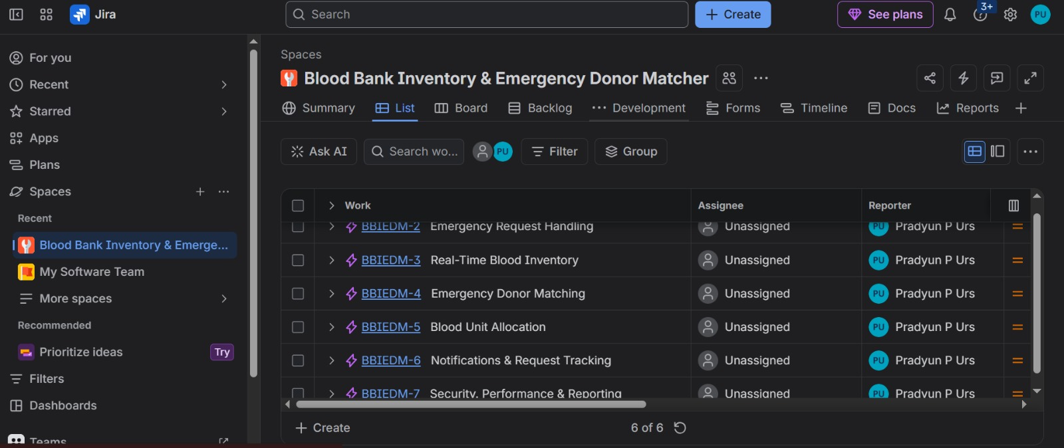
Figure 1. Jira List showing the six project Epics.

7. Sprint 1 — Core Emergency Matching
Duration: 1 week | Committed work: 28 Story Points
Sprint Goal: Implement the core emergency request, inventory, compatible-donor matching, 10 km filtering and SMS notification flow.
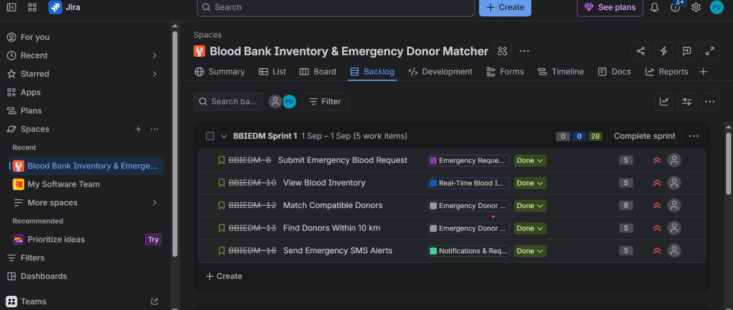
Figure 2. Jira Sprint 1 showing five work items and 28 story points.

8. Sprint 2 — Allocation & Management
Duration: 1 week | Committed work: 34 Story Points
Sprint Goal: Complete validation, stock updates, safe allocation, duplicate-allocation prevention, request tracking, security and reporting.
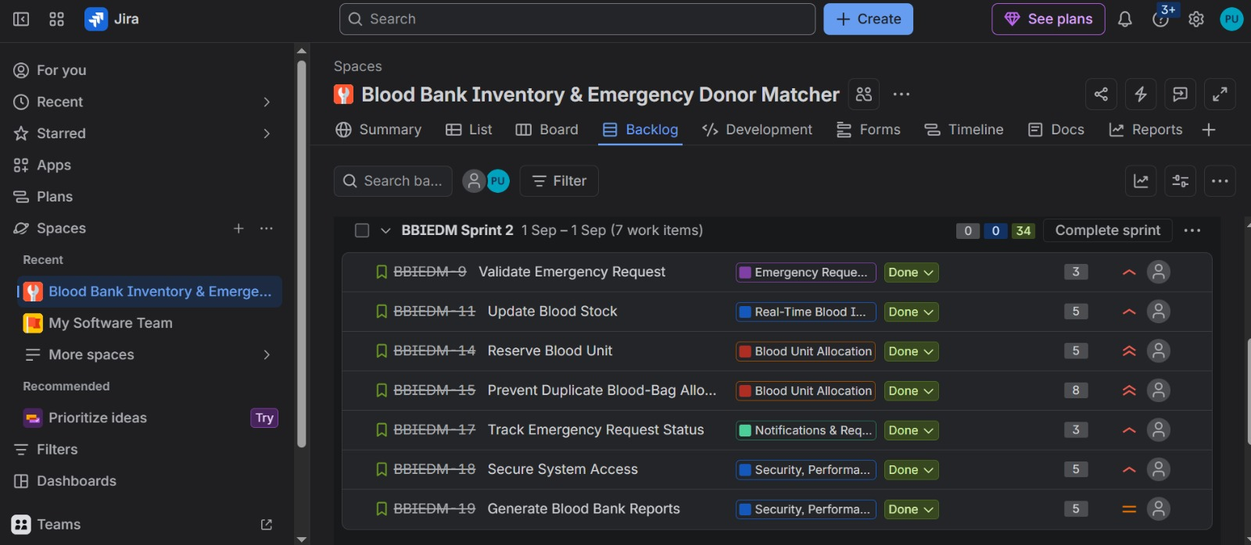
Figure 3. Jira Sprint 2 showing seven work items and 34 story points.

9. Jira Progress — Status Overview
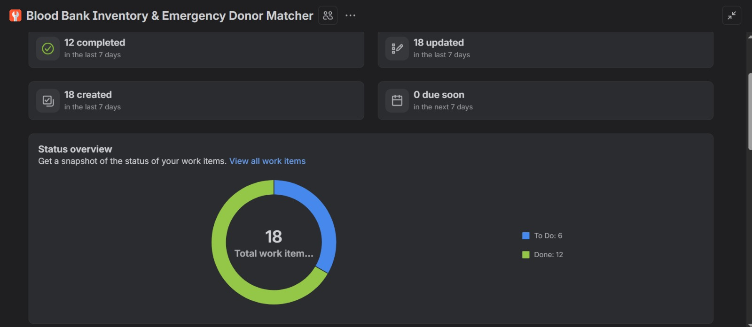
Figure 4. Jira Summary — status overview and recent activity.

9. Jira Progress — Epic Progress
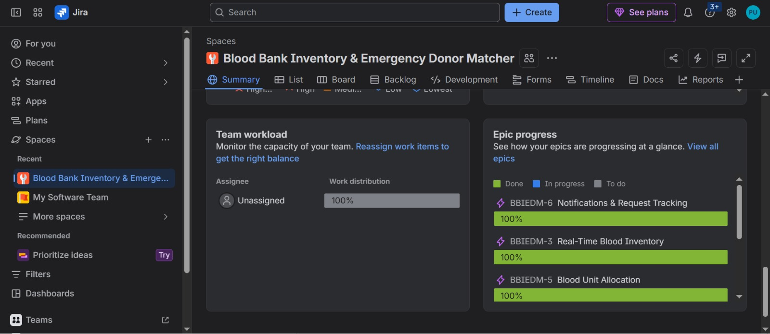
Figure 5. Jira Summary — team workload and Epic progress.

10. Burndown Chart Evidence — Capture 1
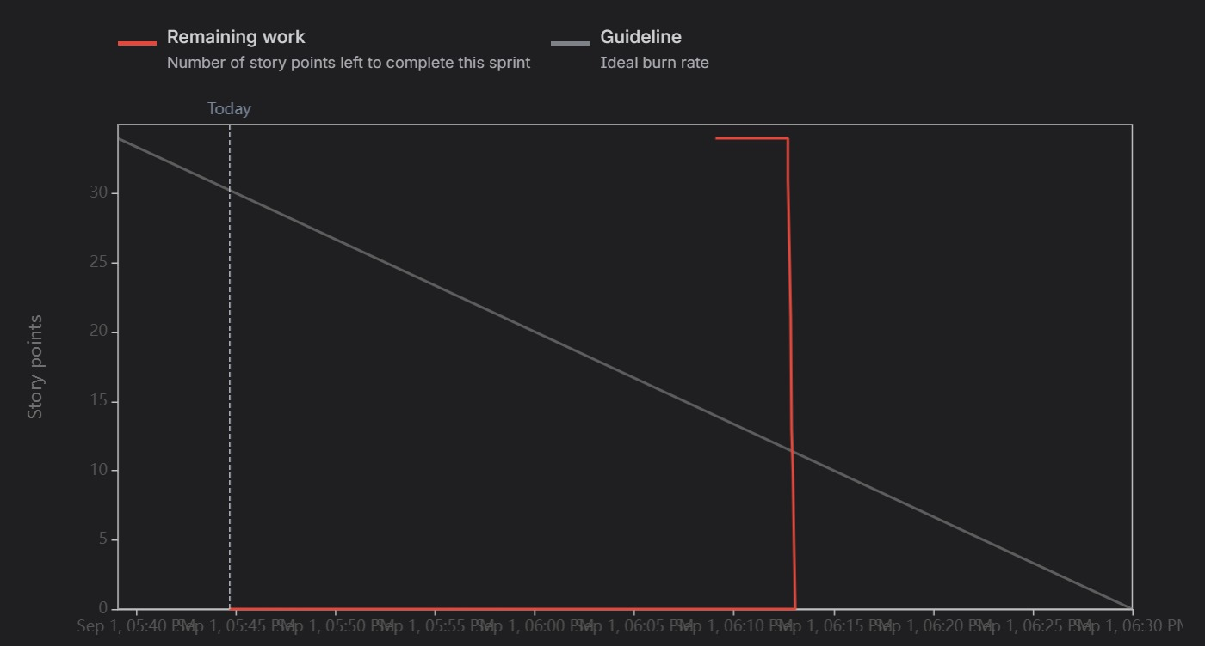
Figure 6. Supplied Jira Burndown Chart evidence — capture 1.

10. Burndown Chart Evidence — Capture 2
Figure 7. Supplied Jira Burndown Chart evidence — capture 2.

11. Sprint Summary & Reflection
Sprint 1 focuses on the highest-value emergency workflow: submitting a request, viewing current inventory, matching compatible donors, applying the 10 km proximity condition, and sending emergency SMS alerts.
Sprint 2 completes the operational management layer by adding request validation, stock updates, blood-unit reservation, duplicate-allocation protection, request-status tracking, secure access and reporting.
Agile reflection: Breaking the system into six Epics and twelve User Stories makes requirements easier to manage and prioritize. Fibonacci story points capture relative complexity and uncertainty. The two-sprint structure supports incremental delivery, while Jira status tracking and Burndown reporting provide visibility into sprint progress and remaining work.

