
ASSIGNMENT COVER SHEET
Student’s Details
Student’s FULL Name |  |  | Student ID
FIRST Name |  | FAMILY Name
Jatuporn |  | Thongmo | 20103510
Unit Code | ISYS6013
Unit Title | Business Intelligence and Analytics
Name of Assignment | Assignment 03: BIA Project
Due Date | Monday 18th May, 23:59

Student declaration:
- This assignment is my own original work, except where I have appropriately cited the original source.
- Where I have used Gen-AI, I have included a statement about the nature and extent of its use and a copy of the text generated by the Gen-AI tool.
- This assignment has not previously been submitted in any form for this or any other unit, degree or diploma at any university or other institute of tertiary education.
- I acknowledge that it is my responsibility to check that the file I have submitted is:
  - a) readable,
  - b) the correct file, and
  - c) fully complete.

Executive Summary
This report examines how renewable energy adoption in Thailand has changed since 2005. The analysis focuses on understanding Thailand’s use of renewable energy in the electricity generation sector. The energy dataset comes from Our World in Data (OWID), and Power BI is used to analyze the proportion of renewable electricity in Thailand. The report also compares 2005 and 2024 to investigate how the balance of renewable energy sources has changed, including solar power, bioenergy, wind power and hydropower. In addition, Thailand is compared with Indonesia, Malaysia and Vietnam which are in the same region, and the report provides a forecast of Thailand’s renewable electricity generation to 2035.
According to the government aims to increase renewable energy generation capacity and the use of renewable energy as a part of its long-term planning. Understanding of the past trend has an advantage, helping the country move in the right direction when making investments and energy policies decisions. Furthermore, the analysis helps identify where Thailand is performing well and where further development may be needed, especially as electricity demand continues to increase. Therefore, renewable electricity generation is an important issue to monitor for future planning.
The scope of this study is limited to the electricity generation sector. This means that the result of the analysis focuses on renewable electricity generation and its proportion rather than total renewable energy generation across all sectors such as industrial fuel, transportation and heating. Due to the existing dataset from OWID, there is consistent yearly data for electricity generation by country and renewable source. Although Thailand’s data is available up to 2025 in the dataset, the comparison country which is Indonesia, does not have complete data for 2025. Therefore, this study uses 2024 as the latest comparison year to keep the analysis consistent across four countries.
The dashboard shows that the overall of Thailand’s renewable electricity share has increased since 2005. In 2024, Thailand generates electricity from a variety of renewable sources, which accounted for 14.8% of total electricity generation. Although the increase was not steady every year, the overall trend illustrates growth, especially after 2017. The type of renewable electricity used in Thailand also changed between 2005 and 2024. Bioenergy has increased the most, while solar and wind power became more visible in 2024. For hydropower, the growth was smaller compared with the other sources.
When comparing to Vietnam, Malaysia and Indonesia in 2024, Thailand produced the lowest renewable electricity. On the other hand, Vietnam produced the highest amount, followed by Indonesia and Malaysia. The result shows that Thailand has made progress, but it can still further develop renewable energy generation compared with other countries in the same region.
The forecast suggests that Thailand’s renewable electricity generation is likely to continue increasing toward 2035. However, the prediction should be interpreted carefully because future results can be affected by various factors such as government policies, investment, energy demands and grid infrastructure. These reasons should be used as guidance for planning rather than a fixed prediction.
Overall, Thailand should continue to support and expand renewable electricity generation, especially from solar and wind power. This can help support future electricity demand in different sectors. Hydropower and bioenergy should also continue to be used because they already contribute to Thailand’s renewable electricity sources.

Table of Contents
1.Introduction 4
2.Data and Method 5
3.Report Findings 7
3.1 Question 1: Proportion of Thailand’s electricity generated from renewable sources 7
3.2 Question 2: Change in Thailand’s renewable electricity sources changed 8
3.3 Question 3: Comparison with selected countries………………………………………….…….9
3.4 Question 4: Forecast of Thailand’s Renewable Electricity Generation to 2035 10
4.Conclusion 11
5.Appendices 13
Appendix A: Data Access and Collection Process 13
Appendix B: Data Source Metadata 13
Appendix C: ETL Process and Data model documentation 14
Appendix D: Data decision Log 15
Appendix E: DAX Measures 16
Appendix F: Dashboard design notes 17
Reference 18
Gen AI-Use 19

1.Introduction
Recently, renewable energy has become an important power source because many countries need to prepare for future energy demand and reduce the use of fossil fuels. Even though fossil fuels are still widely used, this energy type can create issues including uncertain energy price, energy security concerns and environmental impacts. Fossil fuels energy consumption is related to greenhouse gas emissions. This is one of the main reasons that why long-term planning for the use of renewable energy is important (Wang & Azam, 2024).
According to the International Energy Agency (2026), energy security is also another important factor that has an impact on renewable energy. Due to the security is not limited to only oil, but also natural gas, electricity and clean energy supply chains. In addition, IEA also notes that electricity supports economies and societies. The demand for electricity is expected to increase strongly in the future. Therefore, electricity generation sector is an important area to study when considering renewable energy adoption.
For Thailand, renewable energy is also connected to national electricity planning. Thailand Power Development Plan 2018-2037 shows that electricity planning is a part of the country’s long-term energy direction, including the production of electricity from renewable energy sources and the improvement of electricity system (Energy & Planning, 2018). This makes the electricity generation sector relevant to the study of Thailand’s use of renewable energy.

The purpose of this report to analyze how renewable energy adoption in Thailand has changed since 2005, with a focus on the electricity generation sector. The objectives are:
- To examine the proportion of Thailand’s electricity generated from renewable sources and how this has changed since 2005.
- To investigate how Thailand’s renewable electricity sources has changed between 2005 and 2024.
- To compare Thailand with Indonesia, Malaysia and Vietnam in terms of renewable electricity generation.
- To forecast Thailand’s renewable electricity generation to 2035 and discuss how the forecast should be interpreted.
The scope of this study focuses on renewable energy adoption in electricity generation sector. This scope was selected because renewable energy sources such as solar, wind, hydropower and bioenergy are commonly used to produce electricity. This focus is also relevant because IRENA describes renewable power in relation to power plants that use renewable energy sources to produce electricity (International Renewable Energy, 2026). For this reason, renewable electricity generation is used as the main measure in this report.
The use of dataset in this report comes from Our World in Data (OWID). OWID energy dataset has different types of energy information, including energy consumption, energy mix, electricity mix and other related indicators (data, n.d.). For this report, the electricity generation sector is selected because the data provides consistent yearly by country and renewable source. Thus, the data allows the report to compare Thailand’s changes over time and compare Thailand with selected countries in the same region. Power BI is used to clean, model and visualize the data in a dashboard.
However, this report has a scope limitation. The finding focuses on renewable electricity generation, and renewable electricity share rather than total renewable energy use across all sectors such as transportation, heating and industrial fuel use. This limitation is important because it is only one part of the wider energy system. In addition, although Thailand has data available up to 2025, Indonesia does not have complete data for 2025. Therefore, 2024 is used as the latest comparison year to keep the analysis consistent across all four selected countries.
The report is organized into six sections, including Executive Summary, Introduction, Data and Method, Report Findings, Conclusion and Appendices. The next section explains the data sources, data preparation process and main measures used in the Power BI dashboard. The finding section then presents the main results from the dashboard, followed by the forecast and discussion of uncertainty. The final sections summarize the key findings, limitations and overall conclusions of the project.

2.Data and Method
The data used in this report comes from Our World in Data (OWID). OWID energy dataset. This dataset was selected because there is yearly energy data by country, including total electricity generation, renewable electricity generation, renewable electricity share and renewable electricity generation by source (data, n.d.). The main country in this study is Thailand. Indonesia, Malaysia and Vietnam are selected as comparison countries because they are in the same region, Southeast Asia. This helps compare Thailand’s renewable electricity generation with nearby countries.
The analysis uses data from 2005 to 2024. Although Thailand has data available up to 2025 in the OWID dataset, Indonesia does not have complete data for 2025. Therefore, 2024 is used as the latest comparison year. This decision helps keep the analysis consistent across all four countries and avoids comparing Thailand with countries that have missing data in the same year.
During data collection, Thailand’s national energy dataset was also considered, but some of these sources were difficult to access from outside Thailand. Some datasets use different formats. For this reason, the OWID energy dataset was selected as the main dataset because there is yearly data for all countries in the same structure and units. This makes the analysis easier to compare and reproduce.
The data was prepared in Power BI, using Power Query. The OWID dataset was filtered to keep only Thailand, Indonesia, Malaysia and Vietnam. Then, the year range was filtered to include 2005 to 2024. The main table (Energy_Main) was used to store country, year, total electricity generation, renewable electricity generation and renewable electricity share. A second table (Renewable_source_Long) was created to analyze renewable electricity generation by sources. This table was changed the renewable sources column to be a long format, helping compare the main renewable electricity sources used in the Question 2 visual, including hydropower, wind power, solar power and bioenergy.
Table 1. The table shows the main data field used in the analysis
Data variable | The purpose
Total Electricity Generation TWh | Used as the total value to divide renewable electricity generation and calculate the renewable electricity share
Renewable Electricity Generation TWh | Used to measure renewable electricity generation in Thailand and comparison countries
Renewable Electricity Share % | Used to show how much electricity comes from renewable sources
Hydro Electricity TWh | Used to analyze hydropower in Thailand’s renewable electricity generation
Solar Electricity TWh | Used to analyze solar power in Thailand’s renewable electricity generation
Wind Electricity TWh | Used to analyze wind power in Thailand’s renewable electricity generation
Bioenergy Electricity TWh | Used to analyze bioenergy in Thailand’s renewable electricity
Country and Year | Used to filter the data, compare countries and analyze changes over time

Dimension tables were created for country and year. The Country_Dim table connects to both Energy_main and Renewable_Source_Long through the country field. The Year_Dim table connects to both tables through the year field. These relationships were set as one to many (1:*). The dimension tables contain unique country and year values, while the main data tables contain multiple records for each country and year. This method helps the dashboard filter data consistently across visuals. For example, when a country or year is chosen, the related charts can respond correctly because the tables are connected through the same country and year dimensions.

Table 2. The table shows DAX measures to calculate the main values used in the dashboard
DAX Measure | The purpose in dashboard
Total Electricity TWh | To calculate total electricity generation
Renewable Electricity TWh | To calculate electricity generated renewable sources
Renewable Share | To calculate renewable electricity as a proportion of total electricity generation
Source Generation TWh | To calculate renewable electricity generation by source

DAX Measure was also created to calculate the main values used in the dashboard.
- The Renewable share measure was calculated by dividing renewable electricity generation by total electricity generation. This is for answering the first question by showing what proportion of Thailand’s electricity was generated from renewable sources.
- The Renewable Electricity TWh measure was used for the country comparison and the forecast.
- The Source Generation TWh measure was used to compare the renewable electricity by source between 2005 and 2024.
For Power BI, it is used for creating the dashboard. In addition, it is used for representing the four main analysis questions.
- A line chart, it was used to show Thailand’s renewable electricity share over time because this chart type is suitable for showing yearly trends.
- A clustered column chart was used to compare the renewable electricity sources changed in 2005 and 2024 because it allows each energy source to be compared side by side.
- A bar chart was used to compared renewable electricity generation across Thailand, Indonesia, Vietnam and Malaysia in 2024 because it is easy to read for country comparison.
- A forecast line chart was used to predict Thailand’s renewable electricity generation in 2035.
A slicer was not used in the dashboard because the analysis answer fixed questions. Each visual was filtered to match the specific question it to answers. This can help to keep Q1 trend, Q2 2005 and 2024 comparison, Q3 2024 country comparison and Q4 forecast clear and consistent.

The forecast was created in Power BI by using historical annual data from 2005 to 2024 and Power BI forecasting instead of linear regression model. The purpose is to show a possible future trend to 2035 in a clear format rather than a statistical relationship between 2 variables. This method was selected because the data is time based and shows a yearly trend (Microsoft, 2026). However, this prediction is based on the past patterns and it does not include future change such as government policies, electricity demands and so on. Therefore, this forecast should only be a planning guide rather than a fixed prediction. Due to this reason, any decision making should be explained clearly.

Finally, ETL steps details, metadata and data decision will be included in the appendices. These can help other analysts understanding the dataset and continuing the project.

3.Report Findings
This section presents the findings from Power BI dashboard. The findings are organized according to four questions. In each question will be answered by using visualization, data measure and the interpretation from the dashboard. The main goal in this section is not only what the dashboard shows, but also why the result is useful for a government client when considering renewable energy planning.
3.1 Question 1: Proportion of Thailand’s electricity generated from renewable sources
The first question asks what proportion of Thailand’s electricity is produced from renewable sources and how this changed since 2005. In this report, the question is answered through the electricity generation sector. Therefore, the measure used is Renewable Share which calculates renewable electricity generation as a proportion of total electricity generation.
To answer this question, a card visual was used to show the latest renewable electricity share for Thailand in 2024. In addition, the trend of how Thailand’s renewable electricity share changed from 2005 to 2024 will be represented as a line chart. The reason is the line chart is suitable for the question by showing the trend across the time. The reader can see whether the proportion has increased, decreased or stayed stable.
According to the dashboard, it was founded that Thailand’s renewable electricity share increased overall between 2005 and 2024, renewable sources accounted for 14.8% of Thailand’s total electricity generation. This increase was not steady every year, but the overall trend shows growth. The share remained relatively low in the earlier year, but it increased clearly after around 2017. This suggests that renewable electricity has become more important as a part of Thailand’s electricity generation mix over time.
This finding is useful for the government client because it shows whether Thailand is moving toward greater use of renewable sources in electricity generation. The result shows that Thailand is progressing, but the proportion in 2024 reflects the electricity produced still comes from non-renewable or other sources. Therefore, Thailand may need further policy supports, investment and more planning in electricity system.

Figure 1. The picture shows Thailand’s renewable electricity share, 2005-2024
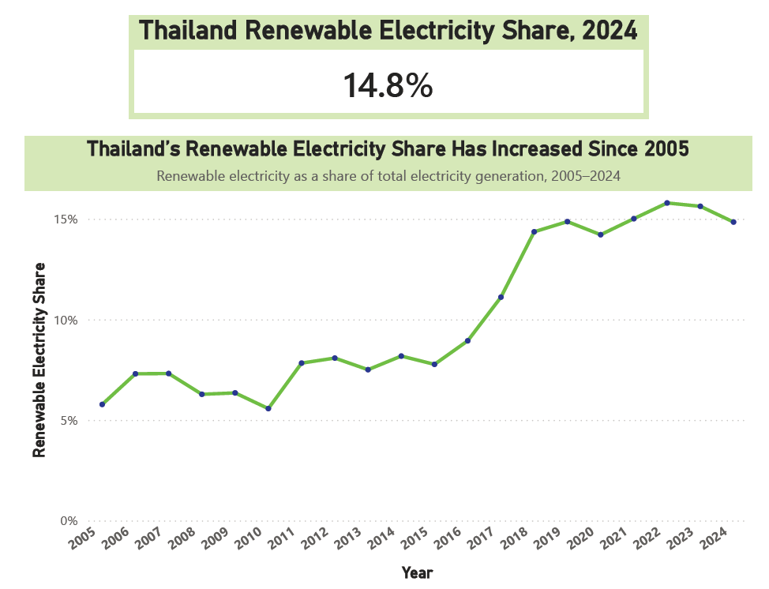

3.2 Question 2: Change in Thailand’s renewable electricity sources changed
The second question asks how the make-up of renewable sources has changed since 2005. In this report, the question is answered by comparing Thailand’s renewable electricity generation by source in 2005 and 2024. The visual used for this question is a clustered column chart because each renewable source should be compared side by side across two chosen years.
The measure used in this visual is Source Generation TWh. It calculates renewable electricity generation by source. The sources include hydropower, solar power, wind power and bioenergy. This helps to show whether renewable electricity increased overall and the renewable source which is more important over time.
The dashboard shows that Thailand’s renewable electricity sources changed between 2005 and 2024. Bioenergy showed the largest increase and became the strongest contributor among the renewable sources. For hydropower, it was already a part of Thailand’s renewable electricity sources in 2005, but the growth was smaller compared with bioenergy. Solar and wind power were less visible in 2005, but they became higher by 2024. This suggests that Thailand has become more diverse rather than depending only on older renewable sources such as hydropower.
This change is important for the government client because the sources affect future energy planning. If renewable electricity growth depends mainly on one or two sources, the electricity system may face risks from resource availability, weather conditions or infrastructure limits. More diverse resources can help to balance electricity systems.
In addition, Thailand’s Power Development Plan 2018-2037 helps to support the result that electricity planning is a part of Thailand’s long-term energy direction, including the development of electricity from renewable energy sources and improvement of the electricity system (Energy & Planning, 2018). This policy context links to the dashboard where solar and wind energy became more visible by 2024 while bioenergy remained a major source.
However, policy direction alone may not be enough. According to the policy by ASEAN Centre for Energy and NUPI (2024) explained that Thailand attracted more than 10.7 billion USD in renewable energy investment from 2006-2018, but it is slowed during 2018-2019 due to uncertainty around energy sector reform, regulation and feed in tariffs. This affects the new investment of solar and wind power projects (Vakulchuk et al., 2020). These reasons help support why solar and wind energy shows more clearly by 2024 but were still smaller than bioenergy in the dashboard.
Overall, this shows that renewable electricity sources in Thailand is linked to both long term national planning and investment conditions. Also, the dashboard represents progress in renewable electricity diversification, but the future growth of newer sources such as solar and wind power may still depend on clear regulation, investor confidence and electricity system readiness.

Figure 2. The picture shows Thailand’s renewable electricity sources changed, 2005 and 2024
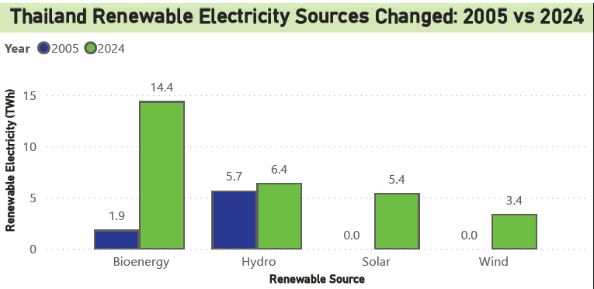

3.3 Question 3: Comparison with selected countries
The third question asks how Thailand compares with three other countries in terms of renewable energy generation. In this report, the comparison focuses on renewable electricity generation in 2024. Thailand is compared with Indonesia, Malaysia and Vietnam. These countries are in Southeast Asia.
The measure used is Renewable Electricity TWh. It calculates the total amount of electricity generated from renewable sources. The comparison will be used as a bar chart because it can be shown in each country to be compared clearly. In addition, the chart will be filtered to 2024 because this is the latest year with consistent data across the four selected countries.
From the dashboard, Vietnam produced the highest amount of renewable electricity in 2024, followed by Indonesia and Malaysia. In terms of Thailand, it had the lowest renewable electricity generation among the four selected countries. Therefore, the result shows that Thailand has developed renewable electricity generation, but it is still lower than the selected regional comparison countries.
This finding is useful for the government because it shows Thailand’s position compared with nearby countries. The result does not mean Thailand has made no progress, but it suggests that Thailand need to have more opportunity for expanding renewable electricity generation. Comparing Thailand with other countries in the same region can help decision makers understand that Thailand is keeping pace with regional development in renewable energy. However, this comparison uses total renewable electricity generation in TWh. This means that countries with larger electricity systems demand may naturally produce more renewable electricity. Therefore, the result should not be used alone to judge whether one country is more successful than another. It should be read together with Question 1.
Overall, Thailand had the lowest renewable electricity generation among the four countries in 2024. Vietnam had the highest amount, following by Indonesia and Malaysia. This shows that Thailand has made progress, but it can still further increase renewable electricity generation compared to other countries in Southeast Asia,

Figure 3. The picture shows Renewable electricity generation by country in 2024
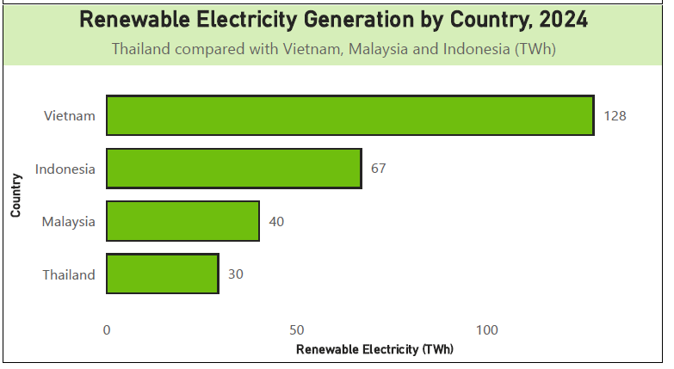

3.4 Question 4: Forecast of Thailand’s Renewable Electricity Generation to 2035
The fourth question asks for the forecast of Thailand’s renewable electricity generation in 2035. In this report, the forecast focuses on renewable electricity generation because the scope of the anakysis is limited to the electricity generation sector. The measure used for this question is Renewable Electricity TWh which shows the amount of electricity generated from renewable sources.
To answer this question, line chart was chosen because the data is time based. It can show yearly change from 2005 to 2024. Using Power BI to forecast because it can use the historical trend to estimate future values. According to the dashboard, Thailand’s renewable electricity generation is likely to continue increasing toward 2035. This is because the past data from 2005 to 2024 shows an overall upward trend. However, the forecast should be read carefully because it is only based on the past data. It does not include future changes such as government policies, electricity demand, fuel price and so on. These factors can change the real result in the future.
For the government, it is useful because this prediction can give a possible direction for Thailand’s renewable energy generation. The grey area in the chart is important because it shows that the future value is uncertain and maybe higher or lower than the forecast line. It can support planning and discussion about investment, infrastructure and policy. However, the forecast cannot guarantee as a fixed prediction. It should be used as guidance for planning only.
Furthermore, when presenting this forecast, ethical considerations should be considered. If the uncertainty is not explained clearly, decision makers may misunderstand the forecast (Xepapadeas, 2024). For example, they may think renewable electricity generation will increase automatically without further actions, leading to weak planning or delayed investment. To avoid this issue, the analyst should explain the assumption about the uncertainty range where possible and state that the forecast depends on future conditions.
Overall, the forecast suggests a positive direction for Thailand’s renewable electricity generation. However, Thailand still needs continued planning, investment and infrastructure to support making this growth more reliable.

Figure 4. The picture shows The Forecast of Thailand’s renewable electricity generation to 2035
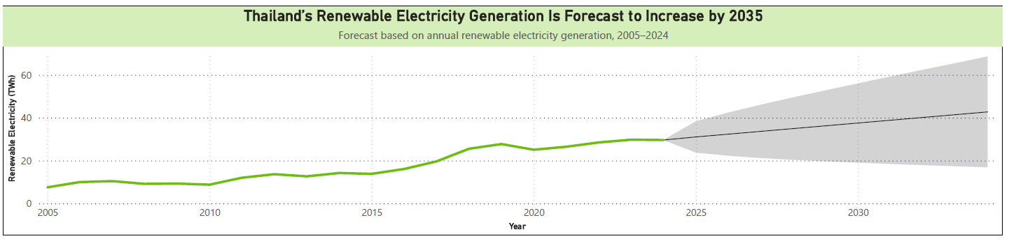

4.Conclusion
In conclusion, this report shows that renewable energy adoption in Thailand has changed since 2005, especially in the electricity generation sector. The analysis used the Our World in Data (OWID) Energy dataset and Power BI to examine Thailand’s renewable electricity share, the change in renewable electricity sources, country comparison and forecast of Thailand’s renewable electricity generation to 2035.
The findings shows that Thailand’s renewable electricity share has increased since 2005. In 2024, renewable sources accounted for 14.8% of Thailand total electricity generation. This means that renewable electricity has become more important in Thailand’s electricity generation system. However, the result also shows that renewable electricity is still not the main source of total electricity generation in Thailand. Therefore, Thailand has made progress, but further development is still needed.
The report also found that the balance between renewable electricity sources changed between 2005 and 2024. Bioenergy became the largest source in the dashboard, while solar and wind energy became more visible by 2024. Hydropower was still a part of Thailand’s renewable electricity sources, but its growth was smaller when compared with bioenergy. Thus, this shows that Thailand has started to use a wide range of renewable electricity sources instead of relying mainly on older sources. However, the future growth of solar and wind power may depend on regulation, investors confidence and electricity system.
In terns of regional comparison, Thailand had the lowest renewable electricity generation among four countries in 2024. Vietnam had the highest amount following by Indonesia and Malaysia. This means that Thailand still has an opportunity to increase renewable electricity generation when compared its nearby countries. In addition to this, it does not mean that Thailand has no progress.
For the forecast, it suggests that Thailand’s renewable electricity generation may continue to increase toward 2035. Due to this result, it should not be a certain future result because the forecast is based on the past data. Also, it does not include future changes such as new policies, fuel prices, investment, electricity demand and so on. For these reasons, this prediction can be only as a guide for planning for the decision makers. Furthermore, the explanation should be explained this uncertainty clearly to protect misunderstanding.
There are some limitations in this project. Firstly, the analysis focuses only on renewable electricity generation, not a total renewable energy use across all sectors such as transportation or industrial fuel. Secondly, 2024 was used as the latest comparison year because Indonesia did not have the data in 2025. Thirdly, the forecast is limited because it is based on the past data trends. It does not include the future policy, market changes and technology changes. Therefore, future analysis can include more recent data when it becomes available for all selected countries. It can also include other factors such as renewable energy investments, electricity demands and installed capacity.
Due to the finding above, the report suggests that Thailand has improved its renewable electricity adoption since 2005, but the progress still needs to be strengthened. Thailand should continue to support renewable energy and electricity generation especially solar and wind power. They should also maintain existing sources such as bioenergy and hydropower. Finally, planning, investment and infrastructure are still important. Thailand needs a clear planning to support future renewable energy and electricity growth, more investment to develop solar and wind power, and better infrastructure to connect renewable electricity into the power system. Without these supports, the country’s project may continue to grow, but the progress may be slower than expected.

5.Appendices
Appendix A: Data Access and Collection Process
A1: Data Access Flow Chart

A2: Detailed Data Access Steps
Step | Action | Output
1 | Opened the Our World in Data website | Accessed the main data website
2 | Browsed by topics and selected “Energy and Environment” | Found the Energy topic area
3 | Selected “Energy” | Opened the OWID Energy page
4 | Clicked “Download all data in energy” | Opened the OWID Energy-data GitHub repository
5 | Downloaded owid-energy-data.csv | Saved the main raw dataset for Power BI and kept the original dataset unchanged
6 | Downloaded owid-energy-codebook.csv | Saved the codebook file for metadata documentation and appendix
7 | Imported owid-energy-data.csv into Power BI using Get Data > Text/CSV | Opened the dataset preview in Power BI
8 | Selected Transform Data instead of Load | Opened Power Query for filtering and cleaning before loading the data model
9 | Kept to original file unchanged | To protect the original dataset for checking and future use
10 | Loaded the prepared table into the Power BI | Created the data model and dashboard visuals

Appendix B: Data Source Metadata
Item | Description
Dataset name | OWID Energy Dataset
Dataset file | owid-energy-data.csv
Metadata/Codebook file | owid-energy-codebook.csv
Access Platform | Our World In Data
Underlying electricity data provider | Ember Yearly Electricity Data
Main use | Main quantitative dataset for Power BI dashboard and report
Time period used | From 2005 onwards
Countries used | Thailand as the main country  Vietnam, Malaysia, Indonesia as comparison countries
Main variable used | Total electricity generation, Renewable electricity share, Renewable electricity generation, hydroelectricity, solar electricity, wind electricity, bioenergy electricity
Units used | Percentage (%) and Terawatt-hours (TWh)
Reason for selection | The dataset includes the variables for answering 4 assignment questions in one consistent structure
Main limitation | The report focuses only on the electricity generation sector, not total renewable energy use across all sectors
Additional limitation | Other renewables are not shown separately in Thailand source comparison because Thailand data mainly shows hydropower, solar power, wind power and bioenergy for 2005 and 2024. Other renewables may appear for some comparison countries, but Question 2 focuses on Thailand, so they are not analysed separately.

Appendix C: ETL Process and Data model documentation
C1: ETL Process in Power Query
Step | Process | Reason
1 | Imported owid-energy-data.csv into Power BI | To use the OWID Energy dataset as the main data source
2 | Opened the data in Power Query | To clean and filter the data before loading
3 | Filtered the country column to Thailand, Indonesia, Malaysia and Vietnam | To keep only the countries needed for the report
4 | Filtered the year column from 2005 to 2024 | To match the required period and keep the comparison consistent
5 | Kept only the columns needed for analysis | To reduce unnecessary fields and make the model easier to manage
6 | Created the main table as Energy_Main | To store total electricity generation, renewable electricity generation and renewable share
7 | Created Renewable_Source_Long table | To analyze renewable electricity generation by source
8 | Changed renewable source columns into long format | To compare hydro, solar, wind, bioenergy and other renewables in one visual
9 | Checked data types for year and numeric columns | To make sure calculations and relationships work correctly
10 | Loaded the prepared tables into dashboard | To create data models and dashboard

C2: Data model documentation
Table | Type | Purpose
Energy_Main | Fact table | Stores yearly electricity generation data by country
Renewable_Source_Long | Fact table | Stores renewable electricity generation by source
Country_Dim | Dimension table | Provides unique country values for filtering
Year_Dim | Dimension table | Provides unique year values for filtering
Measures_table | Measure table | Stores DAX measures used in the dashboard

C3: Relationship
From Table | To table | Relationship | Purpose
Country_Dim[Country] | Energy_Main[Country] | 1 : * | Allows country filters to apply to the main energy table
Country_Dim[Country] | Renewable_Source_Long[Country] | 1 : * | Allows country filters to apply to the renewable source table
Year_Dim[Year] | Energy_Main[Year] | 1 : * | Allows year filters to apply to the main energy table
Year_Dim[Year] | Renewable_Source_Long[Year] | 1 : * | Allows year filters to apply to the renewable source table

Appendix D: Data decision Log
No | Decision | Reason
1 | Selected Thailand as the main country | There are a variety of renewable energy sources, including biomass, solar power and wind power. It is suitable to answer question 2 which is the mixing of renewable energy source changed.
2 | Using Our World In Data (OWID) dataset as the main dataset | The datasets provide yearly electricity data in one consistent structure (TWh/Percentage), helping reduce data inconsistency. In addition, there are electricity generation data covering 2005 until the recent year.
3 | Focused on electricity generation | The dataset provides consistent yearly data for renewable electricity generation by country and source
4 | Used Vietnam, Malaysia and Indonesia as the comparison countries | These countries are in Southeast Asia the same as Thailand, so it is more relevant to Thailand.
5 | Used 2005 as the starting year | The assignment focuses on how renewable generation has changed since 2005.
6 | Used 2024 as the latest comparison year | Indonesia does not have complete data for 2025, so 2024 was used to keep the comparison consistent
7 | Used renewable electricity generation instead of installed capacity as the main measure | The assignment focuses on generation and change over time, while installed capacity does not show actual electricity produced
8 | Used OWID instead of relying only on Thailand national datasets | Some Thailand specific national sources were difficult to access from outside Thailand and some datasets used different formats
9 | Created Renewable_Source_Long table | Long format makes it easier to compare renewable electricity sources in one visual
10 | Created Country_Dim and Year_Dim tables | Dimension tables help the dashboard filter data consistently across visuals
11 | Used Power BI forecast for Question 4 | The data is time based and Power BI can use historical yearly trends to estimate future values
12 | Used ASEAN Centre for Energy and NUPI policy brief as a supporting source | The brief provides Thailand specific context about renewable energy investment, regulation and feed-in tariff uncertainty
13 | Treated the forecast as a planning guide, not a fixed prediction | Forecast results are uncertain and do not include all future policy, market or technology changes
14 | Used a bar chart for country comparison | Bar chart is easier to compare renewable electricity generation across countries
15 | Used a line chart for trend and forecast | Line chart is suitable for showing change over time
16 | Used tooltips as the main interaction | This tool helps users to check exact values without changing the main charts
17 | Excluded “Other renewables” from the Question 2 Thailand source comparison | “Other renewables” did not show a clear value for Thailand. Thus, the Q2 chart focus on hydropower, bioenergy, solar and wind energy.

Appendix E: DAX Measures
Measure Name | DAX formular | Purpose
Measure table | Measures_Table = ROW("Measure", "Measures") | Creates table to store dashboard measures
Total electricity TWh | Total Electricity TWh = SUM(Energy_Main[Total Electricity Generation TWh]) | Calculating total electricity generation
Renewable Electricity TWh | Renewable Electricity TWh = SUM(Energy_Main[Renewable Electricity Generation TWh]) | Calculates electricity generated from renewable sources
Renewable Share | Renewable Share = DIVIDE([Renewable Electricity TWh], [Total Electricity TWh]) | Calculates renewable electricity as a proportion of total electricity generation
Source Generation TWh | Source Generation TWh = SUM(Renewable_Source_Long[Generation TWh]) | Calculating renewable electricity generation by source

Appendix F: Dashboard design notes
Design | Explanation
Used a single dashboard page | The viewer can see the 4 questions in one place and keep analysis simple
Used card visual for the renewable electricity share | To help the viewer quickly see the latest renewable electricity share for Thailand
Used line chart for trend analysis (Q1) | It is suitable to show how renewable electricity share changed over time
Used clustered column chart for renewable sources (Q2) | It is suitable to show how renewable electricity sources to be compared side by side
Used bar chart for country comparison (Q3) | It is easier to compare Thailand with other countries
Used forecast line chart for 2035 forecast (Q4) | To show the expected direction of Thailand’s renewable electricity generation
Used limited colors | Reduced clutter and makes the dashboard easier to rea
Did not use slicer | It was not used because the dashboard answer fixed questions. A year slicer could change the Q1 trend, Q2 2005 vs 2024 comparison, and Q4 forecast which may make the analysis less clear
Used clear visual titles | Viewer can understand quickly
Used interactive tooltips | Users can hover over the visual to see exact values. This gives interaction without changing the main analytical views.
Used fixed visual filters | To match the specific question it answer. This can help to prevent the dashboard from changing in a way that could make the analysis unclear in each visual
Used visual-level filters for Q2 | The question asks how Thailand’s renewable electricity sources changed between these two years. So, Q2 chart was filtered to Thailand and the years 2005 and 2024
Used visual-level filters for Q3 | The Q3 chart was filtered to Thailand. Indonesia, Vietnam and Malysia, and the written analysis focuses on 2024 as the latest consistent comparison year.

Reference
data, O. w. i. (n.d.). Data on energy by Our World in Data (Our World in Data. https://github.com/owid/energy-data
Energy, A. C. f. (2024). Thailand. Country Profile. https://aseanenergy.org/knowledge-hub/country/thailand
Energy, P., & Planning, O. (2018). Thailand Power Development Plan 2018-2037. https://climate-laws.org/documents/thailand-power-development-plan-2018-2037_aa8f
International Energy, A. (2026). Energy security. https://www.iea.org/topics/energy-security
International Renewable Energy, A. (2026). Renewable capacity statistics 2026 (978-92-9260-725-8). https://www.irena.org/-/media/Files/IRENA/Agency/Publication/2026/Mar/IRENA_DAT_RE_capacity_statistics_2026.pdf
Microsoft. (2026). Use the Analytics pane in Power BI. Microsoft Learn. https://learn.microsoft.com/en-us/power-bi/transform-model/desktop-analytics-pane
Vakulchuk, R., Chan, H.-Y., Kresnawan, M., Merdekawati, M., Overland, I., Sagbakken, H., Suryadi, B., Utama, N. A., & Yurnaidi, Z. (2020). Thailand: Improving the Business Climate for Renewable Energy Investment. https://doi.org/10.13140/RG.2.2.16512.66568
Wang, J., & Azam, W. (2024). Natural resource scarcity, fossil fuel energy consumption, and total greenhouse gas emissions in top emitting countries. Geoscience Frontiers, 15(2), 101757. https://doi.org/https://doi.org/10.1016/j.gsf.2023.101757
Xepapadeas, A. (2024). Uncertainty and climate change: The IPCC approach vs decision theory. Journal of Behavioral and Experimental Economics, 109, 102188. https://doi.org/https://doi.org/10.1016/j.socec.2024.102188

Gen AI use
Gen-AI was used only to help check DAX syntax errors in Power BI. I used it to understand why some formulas did not work and how to fix the formula structure. The final DAX measures, dashboard, data preparation, analysis and written report were checked and completed by me.

