AI-Driven Prior Authorization

Solution Architecture for a Large US Health Plan

Paul Prae | Principal AI Engineer & Architect
www.paulprae.com

The Problem & Opportunity

The Problem
Manual PA costs $10.97/transaction provider-side (CAQH 2024), $3.52 payer-side vs $0.05 electronic. 93% of physicians say PA delays care (AMA 2024).

The Opportunity — Altais + Autonomize AI (Feb 2026)
Metric | Result
PA review time reduction | 45%
Manual error reduction | 54%
Auto-determination rate | 50%

Why Autonomize AI
• Live at 3 of the 5 largest US health plans
• PA Copilot on Azure Marketplace — Microsoft Pegasus Program member
• ServiceNow partnership extends reach into payer workflows
• CMS-0057-F deadline (Jan 2027) creates urgency

PA Request Lifecycle
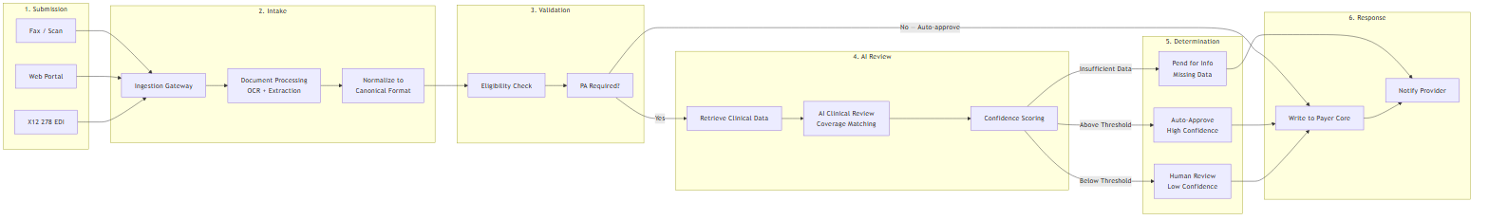
Submit → Intake (OCR) → Validate (eligibility) → AI Review (coverage matching + confidence) → Route (auto-approve / human review / pend) → Respond (payer core + provider notification)

Demo — Proof of Concept
LIVE DEMO: Working proof of concept — demonstrates core clinical review (steps 4-5 of the lifecycle).
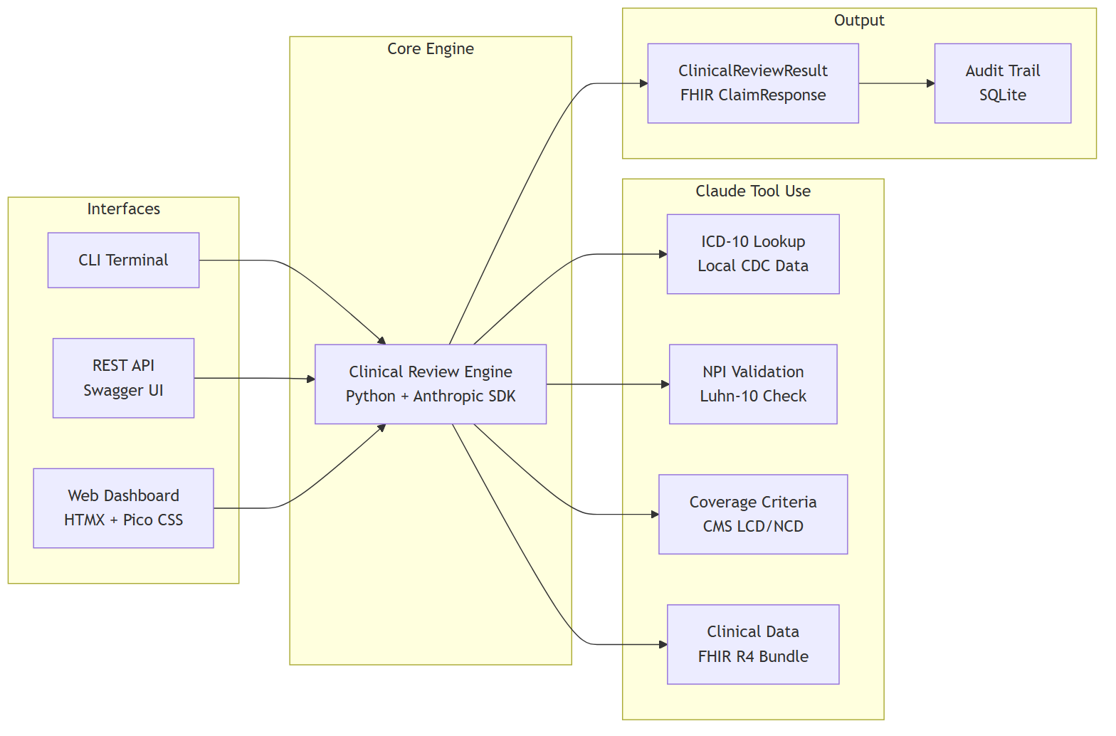
Demo Scope (Phase 0) | Production Differences
5 PA cases with real ICD-10/CPT codes | Mock eligibility → Payer Core integration
AI reviews in ~30s via Claude tool use | Local criteria → CMS Coverage Database API
FHIR R4 data models (fhir.resources R4B) | Synthetic data → real clinical records via FHIR
CLI, REST API + Swagger, Web Dashboard | Single-user → Azure Container Apps + auto-scale

System Context
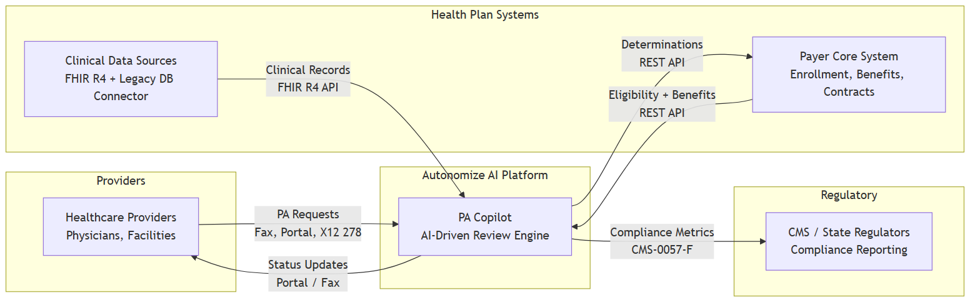
Actor | Role | Integration
Healthcare Providers | Submit PA requests | Fax, Portal, X12 278
Autonomize AI Platform | AI-driven clinical review | PA Copilot on Genesis
Health Plan Systems | Eligibility, benefits, clinical data | REST API, FHIR R4
Regulators (CMS) | Compliance reporting | CMS-0057-F metrics

Solution Architecture
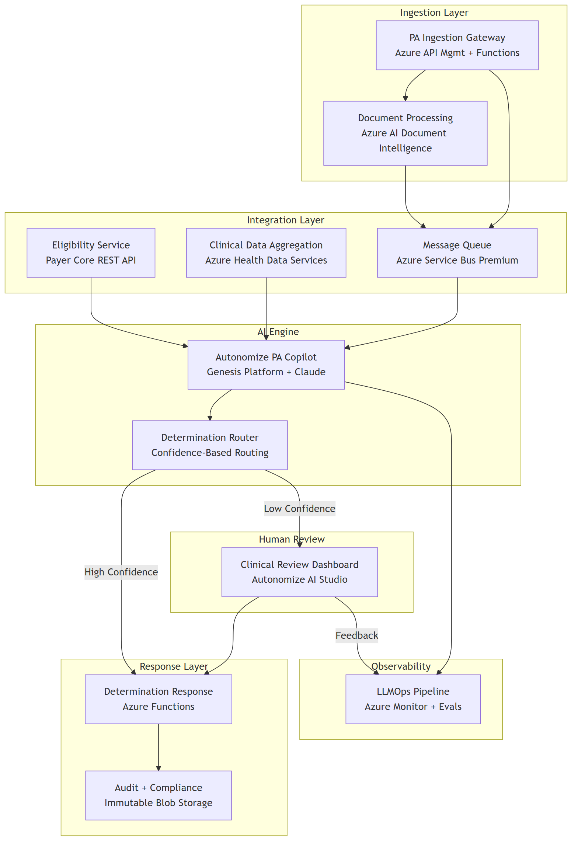
Component | Azure Service | Purpose
Ingestion Gateway | API Mgmt + Functions | Receives all PA channels
Document Processing | AI Document Intelligence | OCR for faxes
Eligibility Service | Payer Core REST API | Member validation
Clinical Data Aggregation | Health Data Services (FHIR R4) | Unified clinical context
PA Copilot | Genesis Platform + Claude | AI clinical review
Determination Router | Functions + Rules | Confidence-based routing
Clinical Review Dashboard | Autonomize AI Studio | Human reviewer interface
Determination Response | Azure Functions | Payer Core writeback
LLMOps Pipeline | Azure Monitor + Evals | Performance monitoring
Audit & Compliance | Immutable Blob Storage | Tamper-proof audit trail

Why This Architecture
• Safety-first routing — confidence thresholds route low-certainty cases to human reviewers; no auto-deny without clinical review
• Configurable thresholds — start conservative, tune with real performance data
• CMS-0057-F compliance — FHIR R4 foundation meets Jan 2027 API deadline without re-architecture
• Azure-native — leverages Autonomize's Azure ecosystem, Pegasus Program, and Marketplace presence
• Full audit trail — every determination records model version, input hash, reasoning, evidence, and confidence for 7-year retention

Top 3 Security Risks & Mitigations
# | Risk | Architectural Mitigation | Operational Mitigation
1 | PHI exposure through AI pipeline | PHI tokenization before LLM — AI sees clinical facts without patient identity | Zero data retention for model training (enterprise terms)
2 | Prompt injection via clinical docs | Document sanitization + system prompt isolation | Output validation requires evidence citations
3 | Untraceable AI decisions | Tamper-proof audit: model version, input hash, reasoning, confidence | Immutable 7-year retention, append-only writes

Additional controls: Entra ID RBAC, AES-256 at rest, TLS 1.2+ in transit, private endpoints, no auto-deny without human review.

Progressive Delivery
Phase | Focus | Key Deliverable
Phase 0: Demo | Prove the concept | Working AI PA review with mock data
Phase 1: MVP | Single LOB, single channel | Production PA processing with human review
Phase 2: Scale | Multi-channel, multi-LOB | Fax OCR, legacy data, LOB configuration
Phase 3: Enterprise | Full scale, compliance | All channels, 20 LOBs, CMS reporting

Design principle: Each phase produces a deployable, demonstrable system. Decision gates between phases use real performance data to scope the next phase.

Discussion Starters

Business Strategy
• How does the ServiceNow partnership change payer integration strategy?
• What is the target auto-determination rate for Phase 1?

Technical Depth
• How does the Genesis Platform handle coverage criteria updates?
• What's the Azure AI Foundry Agent Service integration status?

Implementation
• Which LOB is the ideal Phase 1 candidate?
• What's been the biggest integration challenge with existing payer deployments?

Appendix A: Clinical Data Integration
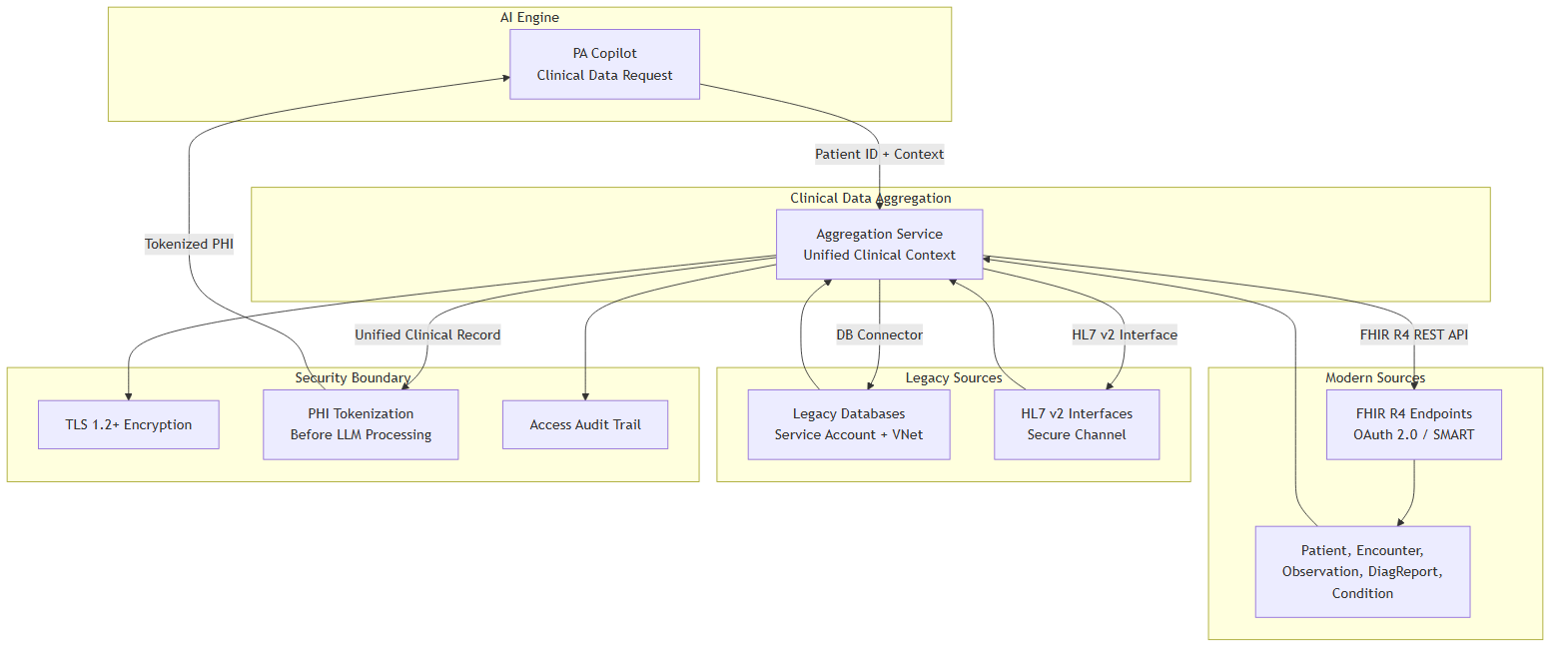
Source | Protocol | Auth
Modern EMRs | FHIR R4 REST API | OAuth 2.0 / SMART on FHIR
Legacy DB Connector | DB connector / HL7 v2 | Service account + VNet

FHIR R4: Interoperability standard for clinical data. Modern sources expose natively; legacy data normalized before AI processing.
Security: All clinical data passes through PHI tokenization before reaching the AI engine.

Appendix B: AI Model Monitoring & Feedback
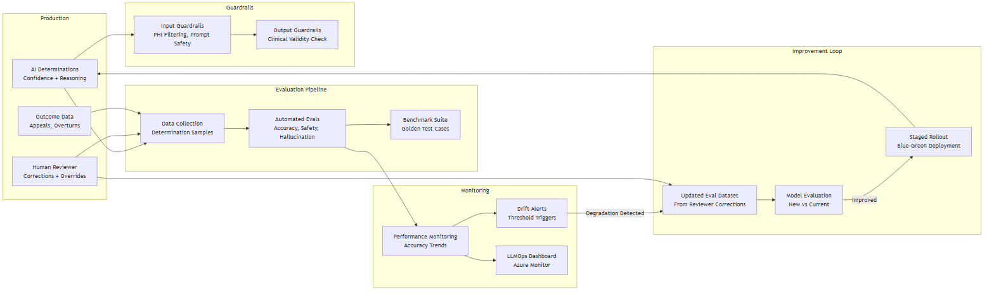

Detect drift
• Overturn rate monitoring (human overrides AI), appeal rate, accuracy trends
• Automated evals — golden test cases benchmarked on schedule
• Confidence distribution shifts signal model or data changes

Feedback loop
1. Reviewer corrections → updated eval dataset 2. Benchmark new vs current 3. Staged blue-green rollout 4. Guardrails always active

Appendix C: Scaling to 20 LOBs
Approach | Cost | Isolation | Complexity
Multi-tenant | Lower | Logical | Lower
Multi-instance | Higher | Physical | Higher

Recommendation: Start multi-tenant with per-LOB config. Genesis Platform supports it. Separate instances only where regulation requires physical isolation.
Honest unknowns: The right answer depends on actual LOB rule complexity and regulatory requirements — both are discovery questions.

Sources & References
# | Claim | Source
1 | $10.97 manual PA labor cost (provider) | CAQH 2024 Index, p. 9
2 | $3.52 manual PA labor cost (payer) | CAQH 2024 Index, p. 9
3 | ~$0.05 electronic PA cost (payer) | CAQH 2024 Index, p. 9
4 | 45% PA review time reduction | Altais + Autonomize AI (BusinessWire Feb 2026)
5 | 54% manual error reduction | Altais + Autonomize AI (BusinessWire Feb 2026)
6 | 50% auto-determination rate | Altais + Autonomize AI (BusinessWire Feb 2026)
7 | 93% physicians say PA delays care | AMA 2024 Prior Auth Survey, p. 5
8 | CMS-0057-F Phase 1 Jan 2026 | CMS Interoperability Final Rule Fact Sheet
9 | CMS-0057-F Phase 2 Jan 2027 | CMS Interoperability Final Rule Fact Sheet
10 | Live at 3 of 5 largest US plans | Autonomize AI (BusinessWire Feb 2026)
11 | PA Copilot on Azure Marketplace | Azure Marketplace listing
12 | ServiceNow partnership | BusinessWire Mar 2026
13 | Claude in Azure AI Foundry | Microsoft Learn
14 | Genesis Platform | GlobeNewsWire Apr 2025
15 | Microsoft Pegasus Program | BusinessWire Nov 2025

