AI-Driven Prior Authorization — Solution Architecture

Autonomize AI | Paul Prae | www.paulprae.com
9 slides + appendix | Priority-tiered for conversational format | Under 30 minutes
Tier A (Must Present): Slides 1-3 + Live Demo | Tier B (Architecture): Slides 4-8 | Tier C (Appendix): Appendix slides

Slide 1: Title & Introduction

AI-Driven Prior Authorization

Solution Architecture for a Large US Health Plan
Paul Prae | Principal AI Engineer & Architect www.paulprae.com

Slide 2: PA Request Lifecycle
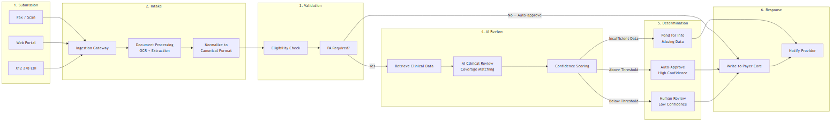
Diagram: flowchart LR
6-step process: Submit → Intake (OCR/extraction) → Validate (eligibility) → AI Review (coverage matching + confidence scoring) → Route (auto-approve / human review / pend) → Respond (payer core writeback + provider notification)

Slide 3: Demo — Proof of Concept
“I built a working proof of concept to validate this architecture. It demonstrates the core clinical review flow — steps 4 and 5 of the lifecycle.”
What the demo implements:
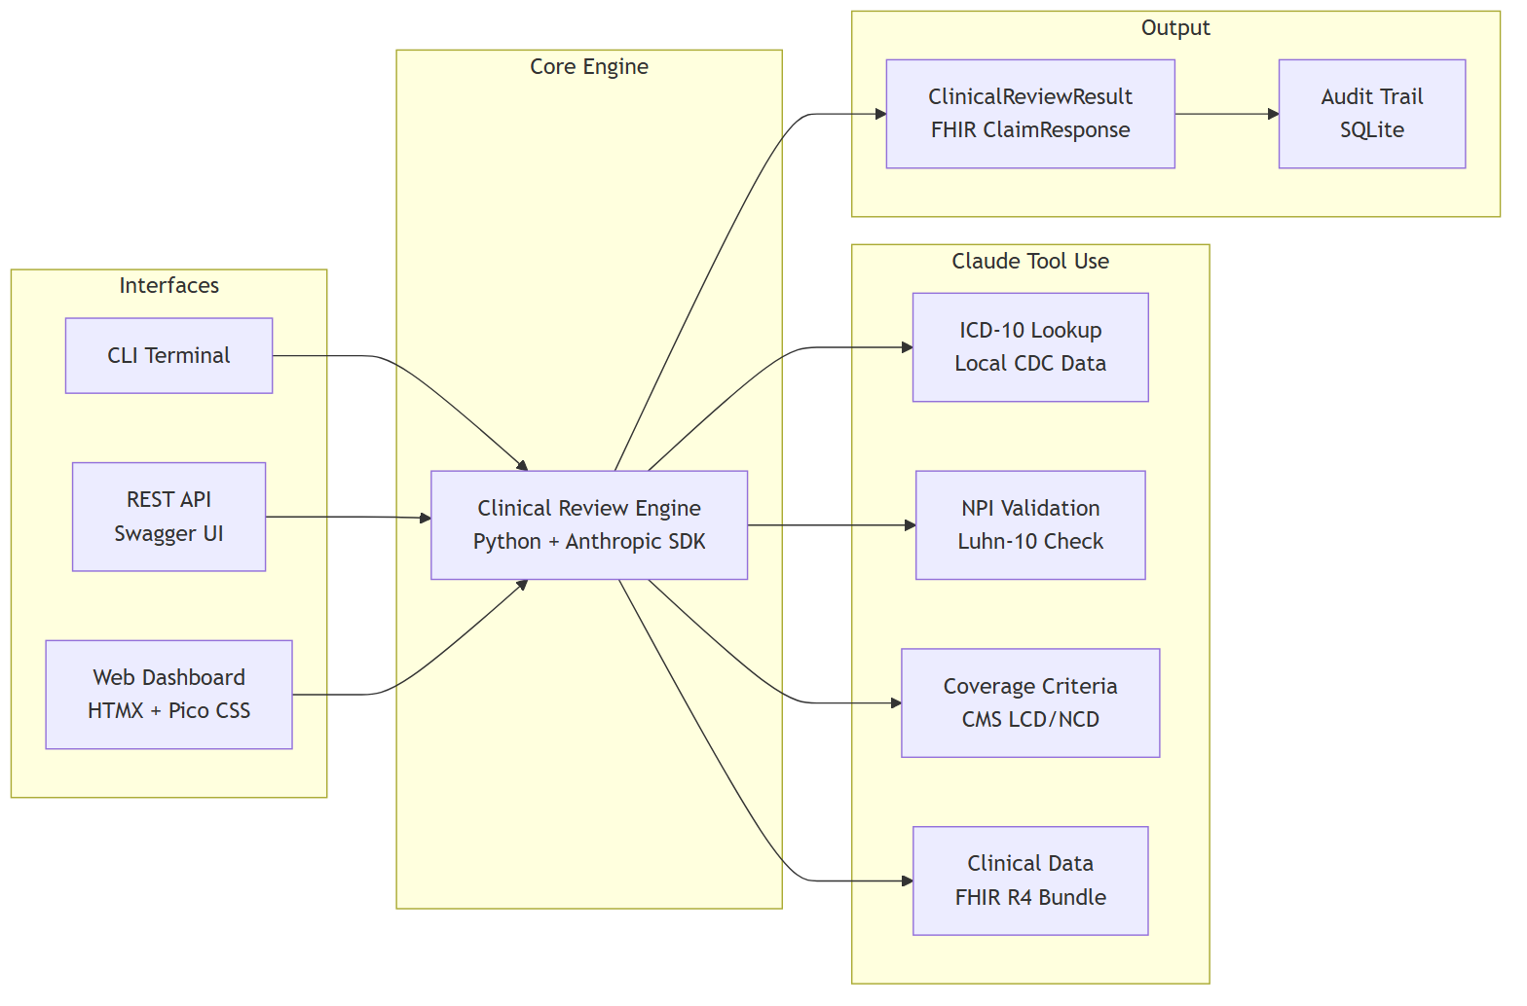
Diagram: flowchart LR
Demo scope (Phase 0):
- 5 realistic PA cases with real ICD-10/CPT codes
- AI reviews each case in ~30 seconds using Claude tool use
- FHIR R4 data models throughout (fhir.resources R4B)
- Three independent interfaces: CLI, REST API + Swagger, Web Dashboard
Honest limitations:
- Mock eligibility service (production: Payer Core System integration)
- Local coverage criteria (production: CMS Coverage Database API)
- Synthetic patient data (production: real clinical records via FHIR)
- Single-user demo (production: Azure Container Apps with auto-scaling)
[LIVE DEMO] — See demo-script.md for the 5-minute CLI walkthrough

Slide 4: System Context
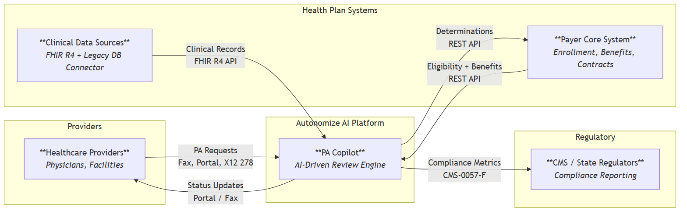
Diagram: flowchart LR
Actor | Role | Integration
Healthcare Providers | Submit PA requests via multiple channels | Fax, Portal, X12 278
Autonomize AI Platform | AI-driven clinical review engine | PA Copilot on Genesis
Health Plan Systems | Eligibility, benefits, clinical data | REST API, FHIR R4
Regulators (CMS) | Compliance reporting and oversight | CMS-0057-F metrics

Slide 5: Component Architecture
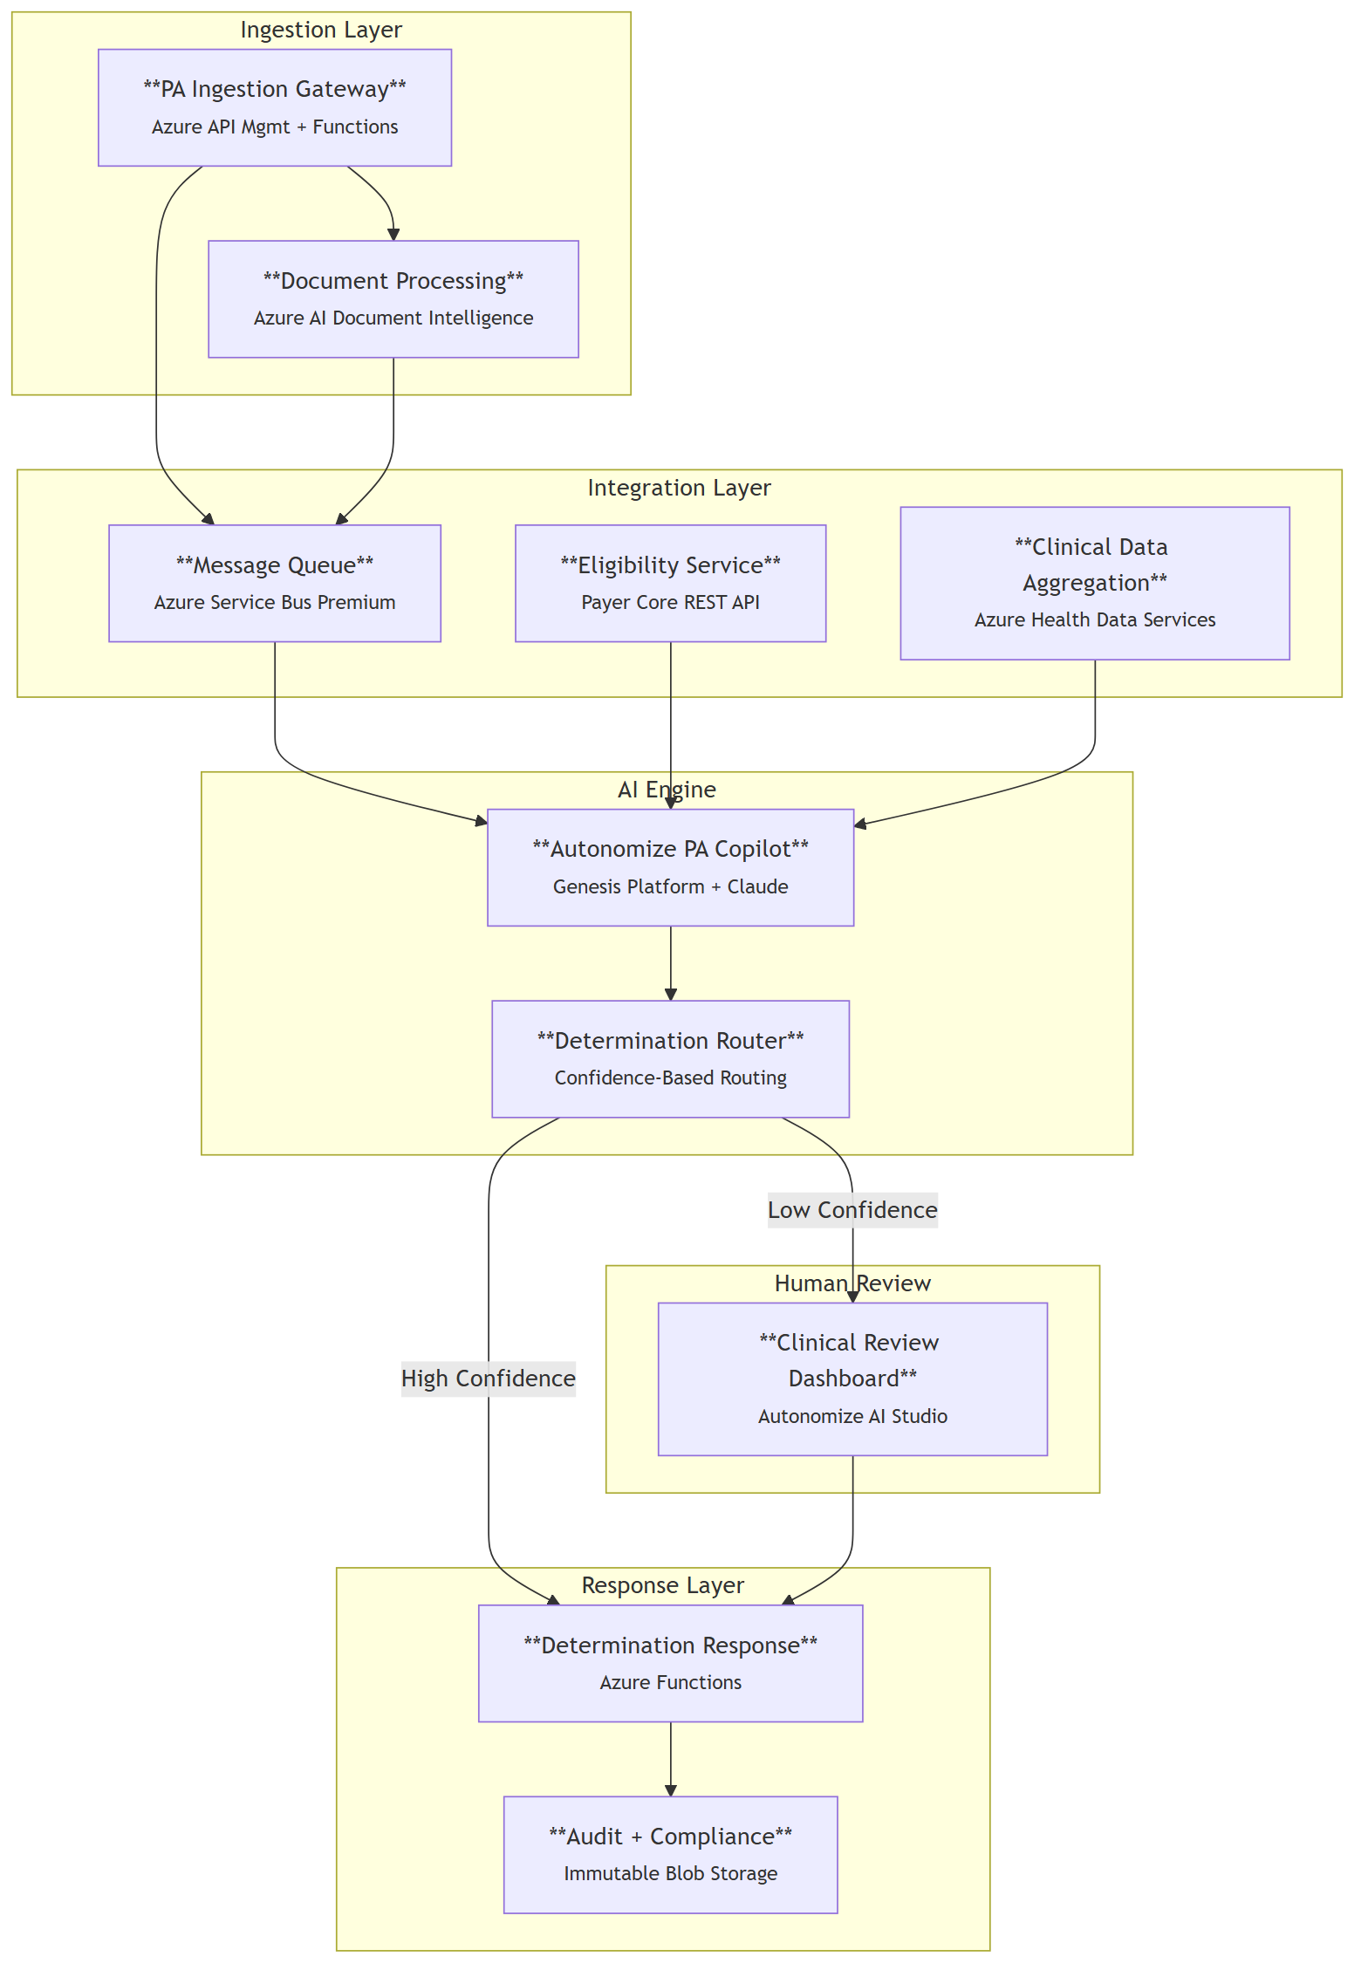
Diagram: flowchart TB
Component | Azure Service | Purpose
Ingestion Gateway | API Management + Functions | Receives all PA channels
Document Processing | AI Document Intelligence | OCR for faxes
Eligibility Service | Payer Core REST API | Member validation
Clinical Data Aggregation | Health Data Services (FHIR R4) | Unified clinical context
PA Copilot | Genesis Platform + Claude | AI clinical review
Determination Router | Functions + Rules | Confidence-based routing
Clinical Review Dashboard | AI Studio | Human reviewer interface
Audit & Compliance | Immutable Blob Storage | Tamper-proof audit trail

Slide 6: Why This Architecture
Now that you’ve seen the architecture and the demo, here’s why these specific choices matter.
The Problem: Manual PA processing costs $10.97 in labor per provider transaction (CAQH 2024 Index, Prior Authorization row), takes days, and burns out clinical staff — 93% of physicians say PA delays patient care (AMA 2024 Survey, p. 5).
The Opportunity — Altais + Autonomize AI (BusinessWire Feb 2026):
- 45% reduction in PA review time
- 54% reduction in manual errors
- 50% auto-determination rate
Why These Specific Choices:
- AI-driven clinical review with human oversight — confidence thresholds route low-certainty cases to human reviewers, never auto-deny
- Configurable confidence thresholds — start conservative, tune with real data
- CMS-0057-F compliance readiness — FHIR R4 foundation meets Jan 2027 deadline
- Azure-native deployment — leverages Autonomize’s Azure ecosystem

Slide 7: Top 3 Security Risks & Mitigations
# | Risk | Mitigation 1: Architectural | Mitigation 2: Operational
1 | PHI exposure through AI pipeline | PHI tokenization before LLM — AI sees clinical facts without patient identity | Anthropic API usage ensures zero data retention for model training (per enterprise terms)
2 | Prompt injection via clinical documents | Document sanitization + system prompt isolation | Output validation requiring evidence citations — hallucinated or injected claims fail verification
3 | Untraceable AI decisions | Tamper-proof audit trail: model version, input hash, reasoning, evidence, confidence | Immutable 7-year retention with append-only writes
Additional controls: Entra ID RBAC, AES-256 at rest, TLS 1.2+ in transit, private endpoints, no auto-deny without human review.

Slide 8: Progressive Delivery
Phase | Focus | Key Deliverable
Phase 0: Demo | Prove the concept | Working AI PA review with mock data
Phase 1: MVP | Single LOB, single channel | Production PA processing with human review
Phase 2: Scale | Multi-channel, multi-LOB | Fax OCR, legacy data, LOB configuration
Phase 3: Enterprise | Full scale, compliance | All channels, 20 LOBs, CMS reporting
Each phase produces a deployable, demonstrable system. Decision gates between phases use real performance data to scope the next phase.

Slide 9: Discussion Starters
Business Strategy:
- How does the ServiceNow partnership change the payer integration strategy?
- What is the target auto-determination rate for Phase 1?
Technical Depth:
- How does the Genesis Platform handle coverage criteria updates?
- What’s the Azure AI Foundry Agent Service integration status?
Implementation:
- Which LOB is the ideal Phase 1 candidate?
- What’s been the biggest integration challenge with existing payer deployments?

Appendix

Appendix A: Clinical Data Integration
Source | Protocol | Auth
Modern EMRs | FHIR R4 REST API | OAuth 2.0 / SMART on FHIR
Legacy DB Connector | DB connector / HL7 v2 | Service account + VNet
FHIR R4 role: Interoperability standard for clinical data exchange. Modern sources expose it natively. Legacy data normalized to FHIR-compatible format before AI processing. Deep FHIR implementation is a discovery-phase activity with the implementation team.
Security boundary: All clinical data passes through PHI tokenization layer before reaching the AI engine.

Appendix B: AI Model Monitoring & Feedback
Detect drift:
- Outcome monitoring — track overturn rate (human overrides AI), appeal rate, accuracy trends
- Automated evals — golden test cases benchmarked on schedule
- Confidence distribution — shifts signal model or data changes
Feedback loop:
- Human reviewer corrections → updated eval dataset
- Eval dataset → benchmark new model versions vs current
- If improved → staged blue-green rollout
- Guardrails always active: input filtering, output validation, clinical safety

Appendix C: Scaling to 20 LOBs
Approach | Cost | Isolation | Complexity
Multi-tenant | Lower | Logical | Lower
Multi-instance | Higher | Physical | Higher
Recommendation: Start multi-tenant with per-LOB configuration. Autonomize Genesis Platform already supports it. Deploy separate instances only where regulation requires physical isolation.
Honest unknowns: The right answer depends on actual LOB rule complexity and regulatory requirements — both are discovery questions.

Sources
# | Claim | Source | Notes
1 | $10.97 manual PA labor cost (provider) | 2024 CAQH Index, p. 9 | Prior Authorization row; weighted avg labor cost (salaries + benefits + overhead) per manual transaction; excludes system costs
2 | $3.52 manual PA labor cost (payer) | 2024 CAQH Index, p. 9 | Prior Authorization row; weighted avg labor cost per manual transaction, health plan side
3 | ~$0.05 electronic PA cost (payer) | 2024 CAQH Index, p. 9 | Fully electronic transaction cost
4 | 45% PA review time reduction | Altais + Autonomize AI press release (Feb 2026) | Headline metric from joint press release
5 | 54% manual error reduction | Altais + Autonomize AI press release (Feb 2026) | Headline metric from joint press release
6 | 50% auto-determination rate | Altais + Autonomize AI press release (Feb 2026) | Headline metric from joint press release
7 | 93% of physicians say PA delays care | AMA 2024 Prior Authorization Survey, p. 5 | Survey of 1,000 practicing physicians, Dec 2024
8 | CMS-0057-F Phase 1 operational Jan 2026 | CMS Interoperability & Prior Authorization Final Rule Fact Sheet | Operational provisions: decision timeframes, metrics reporting
9 | CMS-0057-F Phase 2 APIs due Jan 2027 | CMS Interoperability & Prior Authorization Final Rule Fact Sheet | API requirements: Patient Access, Provider Access, Payer-to-Payer, Prior Authorization APIs
10 | Autonomize live at 3 of 5 largest US health plans | Autonomize AI leadership hires press release (Feb 2026) | Exact wording: “live at three of the five largest U.S. health plans”
11 | Autonomize Prior Auth Copilot on Azure Marketplace | Azure Marketplace listing | SaaS product listing
12 | Autonomize + ServiceNow partnership | Autonomize + ServiceNow press release (Mar 2026) | AI-driven healthcare solutions for payers
13 | Claude models available in Azure AI Foundry | Microsoft Learn: Deploy Claude in Microsoft Foundry | Opus, Sonnet, Haiku model families via global standard deployment
14 | Autonomize Genesis Platform | Autonomize AI Prior Authorization Copilot press release (Apr 2025) | PA Copilot “built on the Genesis Platform”; Compound AI architecture
15 | Autonomize in Microsoft Pegasus Program | Autonomize AI joins Pegasus Program (Nov 2025) | Invite-only Microsoft for Startups program; up to 24-month enterprise acceleration

