PAI Packaging Automation PoC — Solution Architecture
Prepared for: Adobe PAI Interview Panel (Principal Engineers + Hiring Manager) Engagement: PAI Packaging Automation PoC — R162394 Senior Platform & AI Engineer Author: Paul Prae Date: March 20, 2026 Repository: https://github.com/praeducer/pai-take-home-exercise Version: 2.1 (final — post image quality overhaul)

1. Executive Summary
This document describes the architecture of a fully functional AI-native packaging automation pipeline that accepts a structured SKU brief (JSON) and produces multi-format, regionally adapted packaging images using AWS Bedrock generative AI models. The system generates front labels (1:1), back labels (9:16), and wraparound designs (16:9) for multiple product variants, organized in S3 by SKU, region, and format. Every line of Python, every test, every CloudFormation resource, and every CI/CD workflow in the repository was written by Claude (Sonnet 4.6 / Opus 4.6) under human architectural direction — demonstrating the same AI-assisted development philosophy that the pipeline itself embodies.
The implementation takes an AI-native approach at every layer: Claude Code custom skills replace traditional CLI frameworks as the user interface; Claude Sonnet 4.6 generates brand-specific visual direction via structured tool use to ensure coherence across all images in a run; Claude Sonnet 4.6 also enhances prompts for better Bedrock image model compatibility; and Amazon Nova Canvas generates high-fidelity packaging photography. The entire system is an exercise in “dog-fooding” — the AI tool that runs the pipeline is the same AI that designed and built it.
Business Value: A global CPG manufacturer generating hundreds of regional packaging variants monthly can reduce design agency engagement from days to minutes. This PoC demonstrates $0.20 for 24 high-quality packaging variants — front label, back label, and wraparound — across 4 global markets (US West, LATAM, APAC, EU), with culturally adapted visual direction generated per region. At production scale of 1,000 variants/month, the projected cost is ~$95/month versus traditional agency creative fees of $5,000-50,000/month — a 98%+ cost reduction per variant.

2. Problem Statement & Business Goals

Scenario
A global consumer packaged goods (CPG) manufacturer — modeled here as Alpine Harvest, a fictional Pacific Northwest trail mix brand — launches hundreds of localized product packaging variants monthly across regional markets. The exercise demonstrates one brand, one product line (Organic Trail Mix in Original and Dark Chocolate flavors), and four regional markets (US West, LATAM, APAC, EU) to prove culturally adapted packaging generation at scale.

Pain Points
- Manual packaging design overload — Creating and localizing design variants for hundreds of SKUs per month is slow, expensive, and error-prone.
- Inconsistent quality & compliance — Risk of off-brand, non-compliant, or low-quality packaging due to decentralized design processes and multiple agencies.
- Slow approval cycles — Bottlenecks in regulatory review and brand approval with multiple stakeholders in each region and market.
- Difficulty tracking compliance at scale — Siloed design files and manual compliance checking hinder learning and prevent non-compliant designs from reaching production.
- Resource drain — Skilled design and brand teams are overloaded with repetitive layout and resizing requests instead of strategic creative work.

Business Goals
Goal | How This PoC Demonstrates It
Accelerate time-to-market | Single pipeline run generates 6 variants (2 products x 3 formats) in under 60 seconds; 4 regional runs complete in under 3 minutes
Ensure brand consistency | Brand profile generated once per brief (via Claude Sonnet 4.6 tool use) ensures all 6 images share coherent visual identity — photography style, color palette, and cultural elements
Maximize local relevance | region, audience, and cultural_context fields in each SKU brief drive regionally adapted prompts and visual direction
Optimize packaging ROI | GenAI generation at $0.008-0.08/variant vs. hours of manual agency work per variant
Gain actionable insights | JSON manifest per run captures model IDs, generation duration, errors, and run metadata for analytics

3. Solution Overview
The PAI Packaging Automation PoC is a multi-step generative AI pipeline that transforms structured SKU briefs into production-quality packaging images. It chains three AI model calls per image — brand profiling, prompt enhancement, and image generation — then composites text overlays using Pillow, and delivers organized outputs to S3 with full run manifests.
Metric | Value
Pipeline modules | 8 Python modules in src/pipeline/
Interface | 8 Claude Code custom skills (zero argparse)
Image models | Nova Canvas v1:0 (primary), Titan Image V2:0 (dev/fallback)
Text reasoning models | Claude Sonnet 4.6 (brand profile via tool_use + prompt enhancement)
Test coverage | 46 unit tests across 8 test files
CI/CD | GitHub Actions — lint (ruff) + test (pytest) + security audit (pip-audit) + CloudFormation deploy
Demo output | 24 images = 4 regions x 2 products x 3 formats
Total PoC cost | ~$2.21

4. System Architecture

Context Diagram
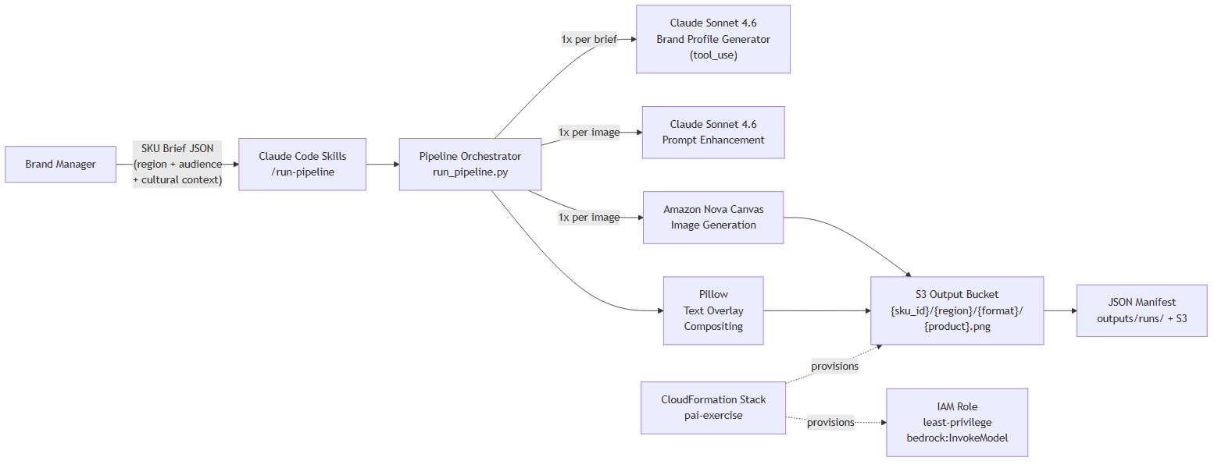 ### Key Architectural Characteristics
- Stateless pipeline — No persistent process. Each /run-pipeline invocation is a complete, self-contained execution.
- Per-image error isolation — One image failure does not abort the run. Errors are captured in the manifest and the pipeline continues to the next product/format combination.
- Three-tier model system — dev ($0.01/img, Titan V2), iterate ($0.08/img, Nova Canvas standard), final ($0.08/img, Nova Canvas premium). Tier selection via --model-tier flag.
- Disk-based caching — SHA-256 hash of (prompt + dimensions + model_id + negative_prompt) prevents redundant Bedrock API calls across runs.

5. Multi-Step Generation Pipeline (The Key Innovation)
The pipeline makes 3 AI calls per image (not just 1), plus a shared brand profiling call per brief. This multi-step approach produces significantly better results than a single generic prompt because each step serves a distinct purpose in the creative chain.

5.1 Step 1: Brand Profile Generation (Once per Brief)
- Model: Claude Sonnet 4.6 (anthropic.claude-sonnet-4-6) via structured tool use — tool_choice: {"type": "tool", "name": "set_brand_profile"} guarantees schema-conformant JSON output without brittle markdown parsing
- Input: brand_name, packaging_type, region, audience, cultural_context from the SKU brief
- Output: JSON with 6 keys: photography_style, color_palette, regional_visual_elements, background_description, packaging_hero_shot, negative_guidance
- Why: Ensures ALL images in a run (typically 6: 2 products x 3 formats) share a coherent visual identity. Without this step, each image would be generated independently, producing inconsistent brand representation. Tool use eliminates JSON parse errors vs. the old markdown-fence-stripping approach.
- Fallback: Returns a default neutral profile on any error — the pipeline never fails due to brand profiling.
- Cost: ~$0.006 per brief (~550 input tokens × $0.003/1K + ~280 output tokens × $0.015/1K)

5.2 Step 2: Format-Specific Prompt Construction (Per Image, Zero Cost)
Uses prompt_constructor.py with 3 distinct template builders dispatched by aspect ratio:
Builder | Ratio | Composition Strategy
_build_front_label_prompt() | 1:1 square | Centered hero shot, clean studio background, single package, front-facing
_build_back_label_prompt() | 9:16 portrait | Three-quarter angle, ingredients/texture visible, lifestyle context, vertical
_build_wraparound_prompt() | 16:9 wide | Panoramic brand story, ingredients artfully scattered, cinematic horizontal
Each builder returns a (positive_prompt, negative_prompt) tuple. The negative prompt universally blocks: text/letters/words (prevents AI text hallucination on packaging), cartoon/illustration, duplicate packages, watermarks, and low quality artifacts. Brand-specific negative guidance from Step 1 is appended.
All SKU brief fields are sanitized via _sanitize() before interpolation to prevent prompt injection.

5.3 Step 3: Prompt Enhancement via Claude Sonnet 4.6 (Per Image)
- Model: Claude Sonnet 4.6 (anthropic.claude-sonnet-4-6) via AnthropicBedrock client
- Purpose: Refines the format-specific prompt for better Bedrock image model compatibility — improving specificity, visual language, and composition instructions
- System prompt: "You are a packaging design expert. Improve the following image generation prompt for better visual quality. Return ONLY the improved prompt text, nothing else."
- Fallback: Returns base prompt on any error — prompt enhancement is a non-critical optimization path
- Cost: ~$0.001 per call (256 max tokens)

5.4 Step 4: Image Generation via Nova Canvas (Per Image)
- Model: Amazon Nova Canvas v1:0 (primary) or Titan Image V2:0 (dev fallback)
- Quality setting: "premium" for Nova Canvas (vs. "standard" default) — produces better composition, lighting, and detail
- cfgScale: 8.5 — higher prompt adherence reduces AI text hallucination on packaging surfaces
- Negative prompts: Passed via negativeText parameter (Nova Canvas native feature)
- Dimensions: 1024x1024 (1:1), 576x1024 (9:16), 1024x576 (16:9) — all native Nova Canvas resolutions
- Retry: 3 attempts with exponential backoff (2^n seconds); falls back to dev tier on persistent throttling
- Caching: SHA-256(prompt + width + height + model_id + negative_prompt) as disk cache key at ~/.cache/pai-pipeline/
- Cost: $0.08/image (premium) or $0.01/image (Titan dev)

5.5 Step 5: Text Overlay Compositing (Per Image)
- Engine: Pillow (PIL) with RGBA alpha compositing
- Content: Brand name, product flavor, up to 4 attribute badges (e.g., ORGANIC, NON-GMO, HIGH-PROTEIN, GLUTEN-FREE), and regulatory footer text
- Layout: Format-aware positioning — 3 distinct layout configurations for 1:1, 9:16, and 16:9 aspect ratios with different font sizes, Y-positions, and strip heights
- Style: Semi-transparent background strips behind title and regulatory text; solid white pill badges for attributes
- Font fallback chain: arial.ttf -> DejaVuSans.ttf -> LiberationSans-Regular.ttf -> Pillow default bitmap font

6. Data Flow

Sequence Diagram
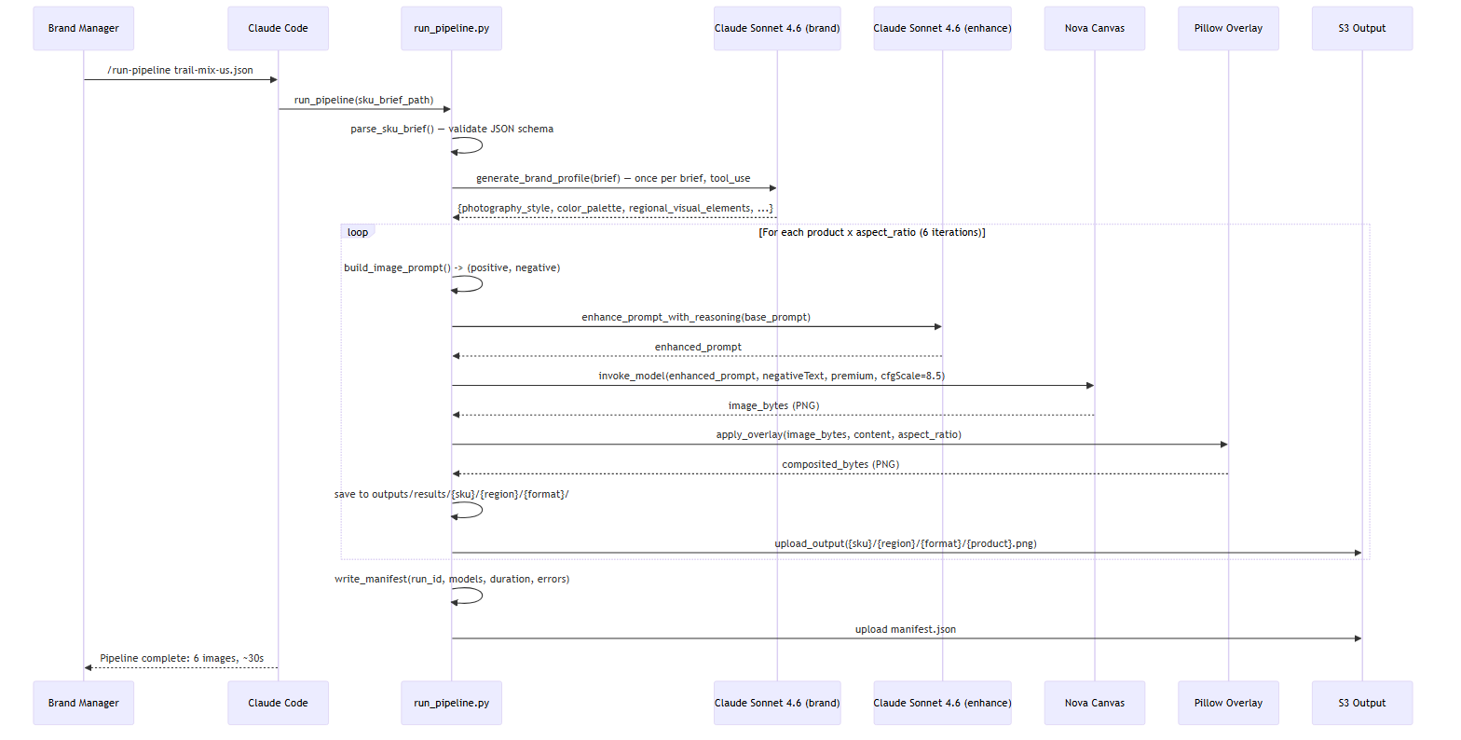 ### S3 Output Structure
<OUTPUT_BUCKET>/
alpine-harvest-trail-mix/
us-west/
front_label/
original.png (1024x1024)
dark-chocolate.png (1024x1024)
back_label/
original.png (576x1024)
dark-chocolate.png (576x1024)
wraparound/
original.png (1024x576)
dark-chocolate.png (1024x576)
manifest.json
latam/
...
apac/
...
eu/
...

7. Component Design
Component | Technology | Notes
Interface | 8 Claude Code skills | /run-pipeline, /health-check, /deploy, /teardown, /view-results, /pipeline-status, /run-tests, /generate-demo
SKU Parser | jsonschema | Validates against src/schemas/sku_brief_schema.json
Asset Manager | boto3 S3 | Key builder: {SKU}/{region}/{format}/
Prompt Constructor | Python f-strings | 3 format-specific builders; _sanitize() on all inputs
Image Generator | boto3 Bedrock runtime | 3-attempt retry, tier fallback, SHA-256 disk cache
Text Overlay | Pillow | 3 layouts (1:1/9:16/16:9), RGBA alpha compositing
Output Manager | JSON + boto3 S3 | Manifest: run_id, models, duration, errors
Text Reasoning | anthropic[bedrock] | Sonnet 4.6 prompt enhancement (non-critical fallback path)
Brand Profiling | anthropic[bedrock] | Sonnet 4.6 via tool_use; structured JSON guaranteed; once per brief
IaC | CloudFormation YAML | S3×2, IAM role, Budget alarm
CI/CD | GitHub Actions | Lint + test + pip-audit + CloudFormation deploy

8. AWS Well-Architected Assessment
Pillar | Score | Key Evidence
Operational Excellence | 9/10 | CI/CD on every push; --dry-run mode; JSON manifests; 46 unit tests; auto-lint hooks
Security | 8/10 | IAM least-privilege + explicit Deny; SSE-S3; Block Public Access; pip-audit in CI; SHA-pinned Actions
Reliability | 7/10 | 3-attempt retry with backoff; tier fallback; per-image error isolation; graceful fallbacks
Performance Efficiency | 8/10 | SHA-256 disk cache (~1950x speedup); Nova Canvas premium; brand profile once per run
Cost Optimization | 9/10 | 3 model tiers; Budget alarm at $20/$25; disk caching; dry-run mode; PoC total ~$2.21
Sustainability | 7/10 | Caching reduces API calls; dev tier for iteration; on-demand only
Overall: 8.0/10 — improved from initial proposal baseline of 6.8/10.

9. Security Posture
Control | Implementation
IAM Least Privilege | bedrock:InvokeModel scoped to 3 specific model ARNs only; S3 read on input bucket, read/write on output bucket; explicit Deny on s3:DeleteObject, s3:DeleteBucket, s3:PutBucketPolicy, and iam:* — cannot be overridden by Allow statements
No Hardcoded Credentials | Profile-based auth via boto3.Session(profile_name='pai-exercise'); AnthropicBedrock(aws_region='us-east-1') uses the same credential chain; no secrets in source code
Encryption at Rest | SSE-S3 (AES-256) on both input and output buckets via CloudFormation ServerSideEncryptionConfiguration
S3 Block Public Access | All four block settings enabled (BlockPublicAcls, IgnorePublicAcls, BlockPublicPolicy, RestrictPublicBuckets) on both buckets
Dependency Audit | pip-audit --severity high runs in CI on every push; blocks merge on known vulnerabilities
Supply Chain | GitHub Actions pinned to full SHA hashes (e.g., actions/checkout@11bd71901bbe5b1630ceea73d27597364c9af683) — prevents tag substitution attacks
Bash Guard Hook | PreToolUse hook in .claude/settings.json requires explicit confirmation for destructive AWS commands (aws.*delete, aws.*remove, etc.) and sensitive secret-read operations
Public Repo Safety | .gitignore excludes .env, credentials, settings.local.json; no AWS account IDs or real bucket names in committed files; demo data uses fictional brands only
Network | No VPC (PoC scope); Bedrock accessed via public HTTPS endpoints with TLS 1.2+; no inbound network exposure
Input Sanitization | _sanitize() applied to all SKU brief fields before prompt interpolation; max length enforcement prevents oversized prompt injection

10. Cost Model

PoC Cost Breakdown
Item | Unit Cost | PoC Volume | Total
Nova Canvas (premium quality) | $0.08/image | 24 demo images | $1.92
Claude Sonnet 4.6 (brand profile, tool_use) | ~$0.006/call | 4 brief runs | ~$0.02
Claude Sonnet 4.6 (prompt enhancement) | ~$0.006/call | 24 enhancement calls | ~$0.15
Amazon Titan V2 (dev tier iteration) | $0.01/image | ~12 dev images | ~$0.12
S3 storage + requests | negligible | ~500 operations | <$0.01
Total PoC cost |  |  | ~$2.21

Production Cost Projection
At 1,000 regional packaging variants per month (typical for a mid-size global CPG operation):
Item | Monthly Cost
Nova Canvas premium generation (1,000 images) | $80
Claude Sonnet 4.6 brand profiling (~100 briefs, tool_use) | ~$0.60
Claude Sonnet 4.6 prompt enhancement (1,000 calls) | ~$6
S3 storage + data transfer | ~$5
CloudFormation + IAM | $0
Total projected monthly | ~$92
Comparison: Traditional agency creative fees for packaging design range from $50-100/hour per variant, with typical turnaround of 2-5 business days. At 1,000 variants/month, agency costs range from $5,000-50,000/month depending on complexity.
ROI: 98%+ cost reduction per variant. Pipeline execution time: under 30 seconds per variant (vs. days for agency turnaround).

11. Assumptions & Limitations
Limitation | Production Mitigation
Single AWS region (us-east-1) | Multi-region deployment when Nova Canvas expands
Titan V2 generates 1024×1024 for all ratios | Nova Canvas supports native resolutions; dev tier is for iteration only
System fonts, not brand typography | Font library integration with proper licensing
Placeholder regulatory text | Jurisdictional compliance database integration
Sequential generation (~30s for 6 images) | Async generation with Lambda fan-out
No Bedrock invocation logging | CloudTrail data events for audit trail
Prompt injection: _sanitize() provides basic protection | Input validation layer + content moderation on outputs
Full design decisions and trade-offs: docs/design-decisions.md. Production roadmap: BACKLOG.md.

Document prepared by Paul Prae using Claude Code (Claude Sonnet 4.6).

