1.1

public class P11 {

public static void main(String P[]) {

int P1=Integer.parseInt(P[0]);

int P2=Integer.parseInt(P[1]);

int P3=Integer.parseInt(P[2]);

System.out.println( "Plus="+(P1+P2+P3));

System.out.println( "Minus="+(P1-P2-P3));

System.out.println( "Multi="+(P1\*P2\*P3));

System.out.println( "Div="+(P1/P2/P3));

}

}

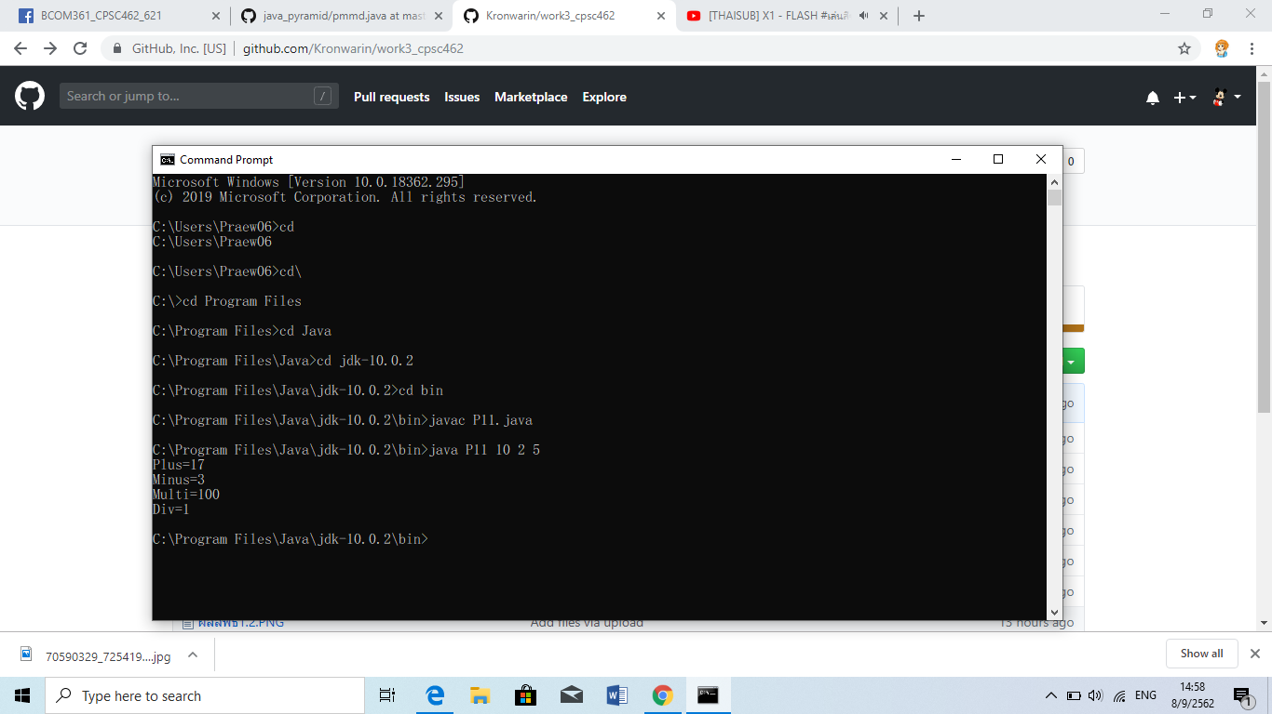

1.2

public class P12{

public static void main(String args[]) {

boolean P1=true;

byte P2=20;

short P3=-9;

double P4=11.50;

long P5=59;

float P6 = 11008f;

int P7=12;

char P8='P';

System.out.println(P1);

System.out.println(P2);

System.out.println(P3);

System.out.println(P4);

System.out.println(P4);

System.out.println(P5);

System.out.println(P6);

System.out.println(P7);

}

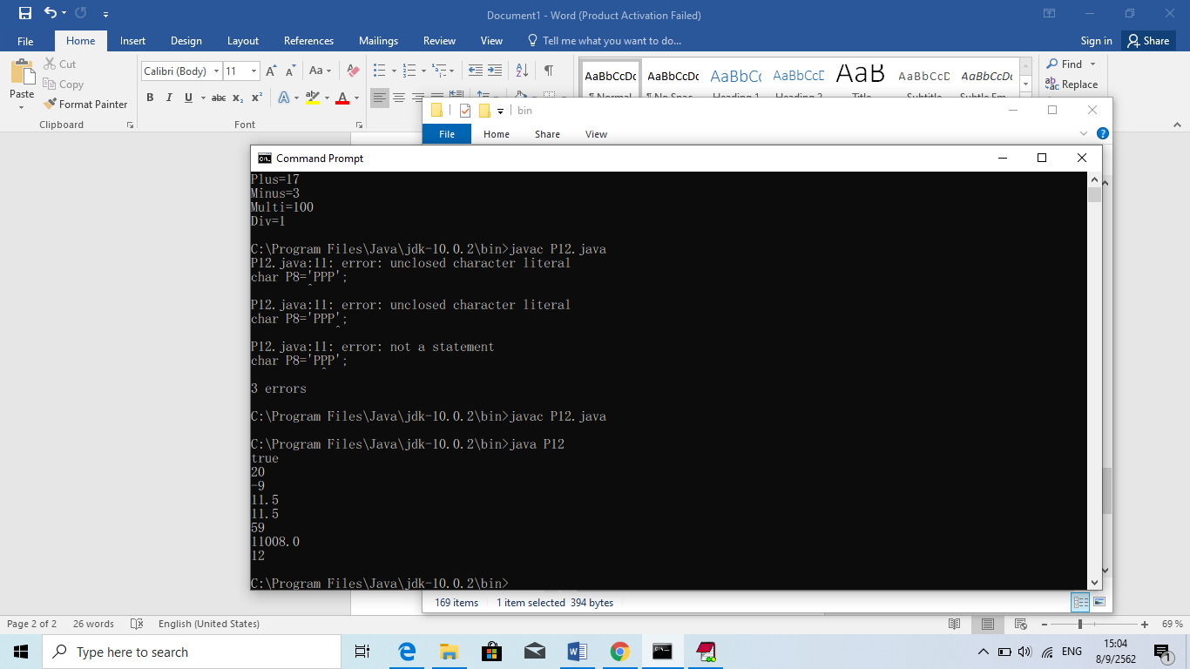}

1.3

public class P13{

public static void main(String args[]) {

int P[]={3,50,20,29,65,8,69};

int max=0;

int min=999;

int total=0;

for(int P1=0;P1<P.length;P1++){

if(max<P[P1]) max=P[P1];

if(min>P[P1]) min=P[P1];

total+=P[P1];

}

System.out.println("max="+max);

System.out.println("min="+min);

System.out.println("total="+total);

}

}

