Java Assignment: Inheritance

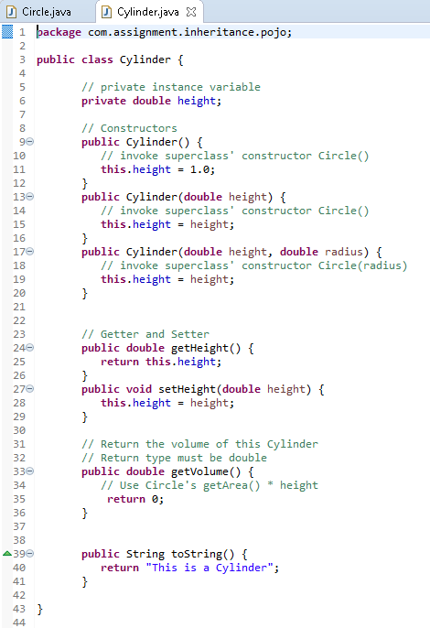

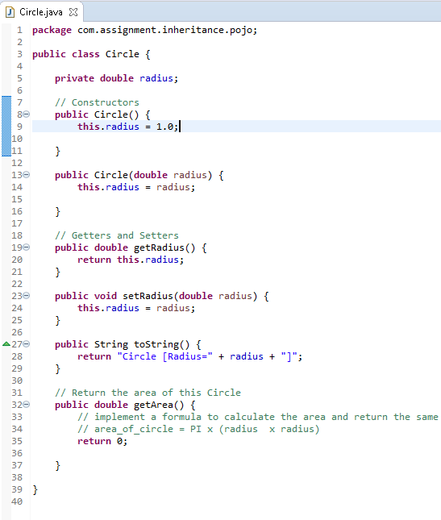Reusability is one of the most important properties of OOP. Here, subclass called Cylinder is derived from the superclass Circle.

What’s Provided

1. Pojo’s
2. Interface

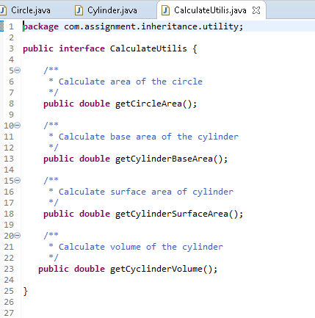

What You need to do

1. You need to implement correct formula in Circle class and Cylinder class to calculate area and volume respectively.
2. The inherited method getArea() in a Cylinder class computes the base area of the cylinder. To calculate surface area of the cylinder, you will need to override the getArea() method in the subclass Cylinder. The formula is given below.
3. You need to start writing implementation to calculate:
   1. Surface Area of the Circle instance (πr2)
   2. Base Area of the Cylinder instance (πr2)
   3. Surface Area of the Cylinder instance (2πrh \* πr2)
   4. Volume of Cylinder instance (πr2h)
4. You also need to use proper keyword (super, extends, etc) in Cylinder class to make Circle the super class for Cylinder.

What You don’t need to do

Test cases are already provided. You can debug or run the test cases for your satisfaction. Once through, click on the Submit button on the test window and the system will auto run the test cases and submit the results to appropriate authority.

Test Cases